Economics 100 Name ___________________________
Spring 2015
Quiz #2

Write legibly please! Show all work.

- Suppose that Juan and Menzie are the only two individuals in an economy and that both Juan and Menzie produce bicycles and calculators. The table below provides you with information about the maximum amount of bicycles and calculators each of these individuals can produce given their resources, technology and time if they only produce either paper or calculations.

 | Maximum Number of Bicycles that can be Produced if only Bicycles are Produced | Maximum Number of Calculators that can be Produced if only Calculators are Produced
Juan | 100 | 50
Menzie | 50 | 200

- (1 point) In the space below provide two graphs. In the first graph draw Juan's PPF measuring bicycles on the vertical axis and calculators on the horizontal axis. In the second graph draw Menzie's PPF with the same axis labeling. Make sure your graphs are completely and carefully labeled for full credit.

- (1/2 point) Juan's opportunity cost of producing 5 calculators is equal to _______________ (make sure you provide a numeric value as well as the units of measurement in your answer).

- (1/2 point) Menzie's opportunity cost of producing 5 bicycles is equal to ________________________________ (make sure you provide a numeric value as well as the units of measurement in your answer).

- (1 point) Given the above information, who has the comparative advantage in the production of bicycles? _________________________

- (1 point) In the space below draw the joint PPF for Menzie and Juan based upon the above information. Measure bicycles on the vertical axis and calculators on the horizontal axis. Identify the numeric values for each intercept as well as the coordinate values (calculators, bicycles) for any "kink" point. Make sure your graph is clearly and completely labeled.

- (1 point) Provide a depiction using the number line approach for the trading range of prices measured in calculators for 10 bicycles. Make sure your number line also identifies Menzie's perspective as well as Juan's perspective with respect to this potential trade.

- (3 points) In the space below describe one example of something good that government does and one example of something that government does poorly. Base your discussion on Chapters 3 and 4 of the Wheelan book, Naked Economics. Don’t just cite the example, but include a paragraph on each example and why it is a good illustration of the particular issue with regard to the government.

- The graph below represents the market for gasoline. You will note that there are two supply curves in the graph and you need to help your buddy figure out what is happening in this market for gasoline. Besides the graph, you also know that the group of gasoline exporting countries that are in a cartel have decided to sell gasoline at a lower price than they did initially.
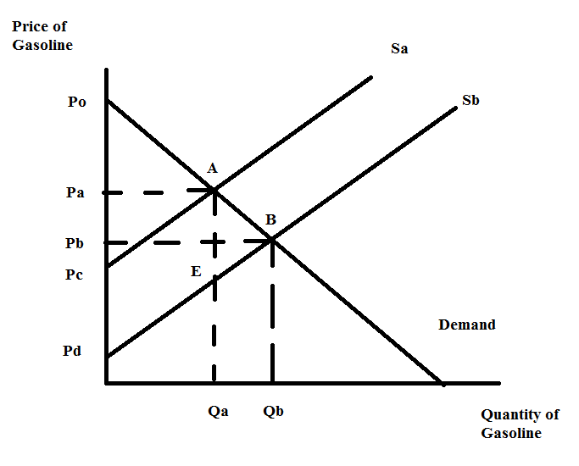
- (1 point) Given the above information, which supply curve represents the initial supply curve before the gasoline exporting countries decide to sell gasoline at a lower price?

- (1/2 point) What is the area that corresponds to consumer surplus initially? Use letters from the graph to identify this area.

- (1/2 point) What is the area that corresponds to consumer surplus once the gasoline exporting countries decide to sell gasoline at a lower price? Use letters form the graph to identify this area.

