Economics 100 Name _________________________
Spring 2015
Answers to Quiz #3

In answering this question refer to the figure below. The figure depicts the market for bananas in a small, closed economy. The figure also provides the world price of bananas, $1. Assume that both the demand and the supply curves are linear in this market.
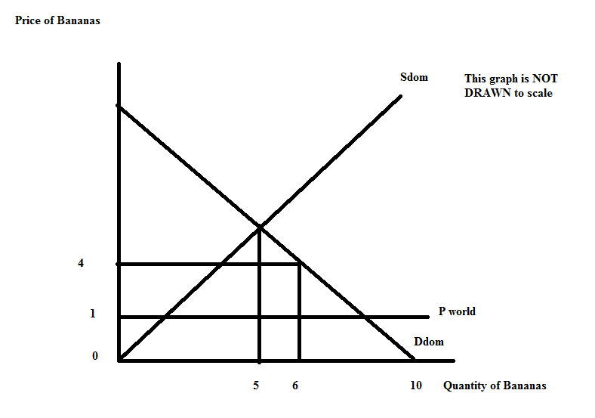
a. (1 point) Given the above figure, write an equation for the domestic demand curve, Ddom. Show your work.

b. (1 point) Given the above figure, write an equation for the domestic supply curve, Sdom. Show youar work.

c. (1 point) Given the above figure, if this market for bananas opens to trade, what is the value of consumer surplus, CSopen? Show your work.

d. (1 point) Given the above figure, if this market for bananas opens to trade, what is the value of producer surplus, PSopen? Show your work.

e. (1 point) Suppose the market for bananas opens to trade, but a tariff is placed on bananas so that the price of the bananas with the tariff is now $3. How many bananas will be imported with this tariff? Show your work.

f. (1 point) Given the tariff described in (e), what is the value of consumer surplus with the tariff, CStariff? Show your work.

g. (1 point) Given the tariff described in (e), what is the value of producer surplus with the tariff, PStariff? Show your work.

h. (1 point) Given the tariff described in (e), what is the value of government tariff revenue with the tariff, Govt. Tariff Rev.? Show your work.

i. (1 point) What is the value of total surplus with the tariff, TSsurplus? Show your work.

j. (1 point) What is the value of the deadweight loss due to using a less efficient, higher cost producer? Show your work.

