Economics 100 Name _____________________________
Fall 2013 TA Name __________________________
10/9/13 Discussion Section #_________________
First Midterm with Answers Student ID # _______________________

Version 1

DO NOT BEGIN WORKING UNTIL THE INSTRUCTOR TELLS YOU TO DO SO
READ THESE INSTRUCTIONS FIRST.

You have 75 minutes to complete the exam. The exam consists of 40 multiple choice questions. Each multiple choice question is worth 2.5 points for a total of 100 points.
- Answer all questions on the scantron sheet with a #2 pencil

NO CELL PHONES, CALCULATORS, OR FORMULA SHEETS ARE ALLOWED.
PICK THE BEST ANSWER FOR EACH QUESTION.

How to fill in the scantron sheet:

- Print your last name, first name, and middle initial in the spaces marked "Last Name," "First Name," and "MI." Fill in the corresponding bubbles below.
- Print your student ID number in the space marked "Identification Number." Fill in the bubbles.
- Write the number of the discussion section you’ve been attending under "Special Codes" spaces ABC, and fill in the bubbles. You can find the discussion numbers below on this page.
- Write the version number of your exam booklet under "Special Codes" space D, and fill in the bubble. The version number is on the top of this page.

If there is an error on the exam or you do not understand something, make a note on your exam booklet and the issue will be addressed AFTER the examination is complete. Since we will be administering multiple versions of the exam it is impossible for us to answer questions during the exam without it being highly disruptive: read each question and then pick the best answer (assume that there is always an answer!) No questions regarding the exam can be addressed while the exam is being administered.

When you are finished, please get up quietly and bring your scantron sheet and this exam booklet to the place indicated by the instructors.

Discussion sections are as follows:
DIS 301 SOC SCI 4322 08:50 AM - 09:40 AM
DIS 302 SOC SCI 6240 01:20 PM - 02:10 PM
DIS 303 SOC SCI 4308 09:55 AM - 10:45 AM
DIS 305 BASCOM 55 11:00 AM - 11:50 AM
DIS 306 SOC SCI 6116 12:05 PM - 12:55 PM
MULTIPLE CHOICE QUESTIONS: (40 QUESTIONS WORTH 2.5 POINTS EACH)

1. Suppose a diagram has two PPF curves. Relative to the origin, Curve A is above Curve B.
Which curve represents the greater level of potential output?
a) The point farthest to the right on the curve closer to the origin
b) The point farthest to the left on the curve further away from the origin
c) The point at the intersection of the vertical and horizontal axes
d) Curve B
e) Curve A

2. As we move from left to right along an economy’s PPF curve, what happens to the amount of resources available in the economy depicted by this PPF?

a) Capital increases

b) Labor increases

c) Entrepreneurial ability increases

d) Answers (a), (b) and (c) are all true

e) The amount of resources remains the same

3. Suppose that of the approximately $2.6 trillion spent per year on health care in the U.S., that 0.3 trillion is spent on providing health care to those under 5 years old, $0.8 trillion goes to providing health care to those 6-64 years old and $1.5 trillion goes to providing health care to those over 65. Advocates for children point out that the United States has one of the highest infant mortality rates among developed countries and they advocate spending an additional $0.2 trillion ($200 billion) to increase care for those under age 5. A majority of Congress insists on an overall decrease in health care spending of $0.3 trillion and they want any reductions to come out of spending for those over 65. They insist on no change on health care spending for the 6-64 age group. Suppose Congress approves both the increase in spending on young children and the overall decrease in health care spending paid for by decreases in spending on those over 65. Which of the following statements is true?

- This would be inconsistent with the Congress’s other health care priorities.
- This would require a reduction of $0.5 trillion in health care spending for the 65 and older group.
- This would require a reduction of $0.3 trillion in health care spending for the 65 and older group.
- This would require no reduction in health care spending for the 65 and older group.
- Congress’s desire for no change on health care spending for the 6-64 age group is inconsistent with their other priorities.

4. The civil war in Syria is destroying capital in the Syrian economy. Holding everything else constant, this shifts the Syrian PPF ___________ and ____________ the level of attainable production for the Syrian economy.

- inward; reduces
- inward; increases
- outward; reduces
- outward; increases

5. Congress in the United States is considering a bill that would ease immigration restrictions on people with scientific and technical skills. Holding everything else constant, this would cause the PPF for the United States to shift ________________ and __________________ the level of attainable production for the economy of the United States.

- inward; reduce
- inward; increase
- outward; reduce
- outward; increase

6. Increasingly we see bar code scanners in gas stations, grocery stores, and airports reducing the number of employees needed to check out customer purchases or check in airline passengers. Holding everything else constant, the effect of this in the long run will cause the PPF for the United States to shift ________________ and __________________ the level of attainable production for the economy of the United States.

- inward; increase
- outward; increase
- inward; reduce
- outward; reduce

7. Suppose government policy—such as low interest rates—caused people to go on a borrowing and spending binge on consumption goods to the point that savings became negative. Holding everything else constant, such a policy would __________ the production of capital goods this year which would ______________ the level of attainable production for this economy in the PPF diagram for next year.

- increase; increase
- increase; decrease
- decrease; increase
- decrease; decrease

8. Which of the following statements is true?
a) If the demand for pizza is a downward sloping straight line, then as we move from left to right along this line, the elasticity of demand for pizza does not change.
b) Toothpaste will tend to have a more elastic demand than will automobiles.
c) The market for gym shoes will have a more elastic demand than will the market for Nike gym shoes.
d) Many door to door sales people have offers that are good only if you buy the day of the offer. The sales people recognize that with more time to consider your purchase your demand will become more elastic.

9. Mario pays tuition of $10,000 for a year of college instead of staying in a job that pays $8/hour for 30 hours a week for 45 weeks. Holding everything else constant, his opportunity cost of going to college is:
a) The dollar amount he spends on tuition and room and board
b) $10,000
c) $10,800
d) $20,800
e) $1,350

10. Peter is a star athlete attending UW. He currently pays $14,000 in tuition for a year of schooling. Peter at the end of his junior year of college could return for his senior year or sign for $600,000 to go professional now. Holding everything else constant, the opportunity cost of Peter’s staying in school is equal to
a) Tuition, the cost of his textbooks, and room and board.
b) Tuition and the cost of his textbooks.
c) $600,000.
d) $614,000 and the cost of his textbooks.
e) $614,000, the cost of his textbooks, and his room and board.

11. Suppose two countries produce two goods. Holding everything else constant, which of the following statements is true?
a) Only the country that can produce both goods less expensively than the other country will benefit from trade.
b) The poorer country must lose overall to the richer country if the two countries trade since the richer country is more efficient at producing both goods.
c) Both countries will gain if they specialize according to comparative advantage even if they don’t trade with one another.
d) Both countries can gain overall if they specialize according to their comparative advantage and then trade with one another.

Use the information below of an economy’s PPF for year 1 to answer the next TWO (2) questions.

In Figure 1 “Guns” refers to defense spending by the government and “Butter” refers to non-defense discretionary spending.

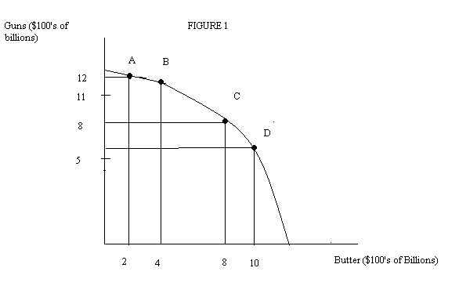
12. Suppose this economy is initially producing at Point A on the above PPF. If this economy decides to increase its butter production by $200 B then this increase in production by $200 B will
a) Have a greater opportunity cost than if this economy was initially at Point C.
b) Have the same opportunity cost than if this economy was initially starting at Points A, B, or D.
c) Have approximately the same opportunity cost than if this economy was starting from Point D.
d) have a lower opportunity cost than if this economy was starting from Point D.

13. Figure 1 illustrates the law of increasing opportunity cost because:
a) As one increases the output of butter one must decrease the output of guns.
b) As one increases the output of guns one must decrease the output of butter.
c) Answers (a) and (b) are both correct answers to this question
d) The amount of guns you give up moving from C to B is twice the amount of guns you give up moving from A to B.
e) The amount guns you give up moving from C to D is larger than the amount of guns you give up moving from A to B.

14. Deadweight loss is the
a) net loss in consumer or producer surplus.
b) net loss in consumer surplus only.
c) net loss in producer surplus only.
d) sum of the distributional consequences of a policy plus the net loss in consumer surplus.

15. A difference between luxuries and necessities is that
a) luxuries are not purchased by low-income people.
b) rich people buy fewer necessities than do poor people.
c) the demand for luxuries is more elastic than the demand for necessities.
d) all necessities are inferior foods and all luxuries are normal goods.
Use the table below to answer the next THREE (3) questions.

The table provides two possible production combinations for the two countries: a combination based upon the two countries not specializing and not trading with one another and another combination based upon the two countries specializing and then trading with one another. These two points are just two of many potential production combinations.

Countries | Without Specialization and Without Trade |  | With Specialization and Trade
 | Soybeans* | Rice* | Soybeans* | Rice*
Lowland | 40 | 35 | 38 | 37
Highland | 20 | 15 | 22 | 14
Total | 60 | 50 | 60 | 51
*Units are millions of tons

16. If Highland and Lowland decide to specialize and then trade with one another, Lowland should produce more ________. This specialization and trade results in overall soybean production staying constant while rice production ______________.

a) soybeans; increases
b) rice; remains the same
c) soybeans; remains the same
d) rice; increases

17. For both countries to share in the benefits of specialization, they must
a) Use comparative advantage to specialize and they must allow trade to occur between the two countries.
b) Use comparative advantages to specialize and they will both need to protect domestic production with import restrictions.
c) Allow trade to occur between the two countries although basing trade upon comparative advantage is optional.
d) Use comparative advantage without specialization and both countries will need to protect domestic production with high tariffs.

18. Compared to no specialization and trade, if the countries do use specialization and trade, the combined production possibility frontier for the two countries
a) Would allow for more soybeans but not more rice.
b) Would not be altered by allowing this specialization and trade.
c) Would allow for more rice but not more soybeans.
d) Would allow for more rice and more soybeans.

19. In a supply and demand diagram, with price on the vertical axis and quantity on the horizontal axis,
- The demand curve would slope up going from left to right.
- The demand curve shows how much people would buy at each price.
- The supply curve would slope up going from left to right.
- The supply curve shows how much people would buy at each price.
- Answers (b) and (c) are both correct answers.

20. In a market if the price is above the equilibrium level then there is an _________________ and we can anticipate from this information that price will move _____________ toward equilibrium.
- excess supply; up
- excess demand; down
- excess supply; down
- excess demand; up

21. In the market for economics textbooks suppose the typical price is $130 per book and typically students buy 2 million textbooks. Then consumer expenditure on textbooks is ______________, which is ________ the producer revenue on textbooks.
a) $260 million; equal to
b) $260 million/2; equal to
c) $260 million; greater than
d) $260 million /2; less than
e) $260 million; less than

22. Suppose the overall economy begins expanding faster and this economic expansion results in more people having jobs and greater overall income in the economy. Holding everything else constant, the effect on the market for new cars would be a shift to the __________________ in the _____________ curve and a(n) ___________ in the price and a(n) _____________ in the equilibrium quantity of new cars. Assume new cars are a normal good.
a) Right; supply; decrease; increase
b) Right; demand; increase; increase
c) Left; supply; increase; decrease
d) Left; demand; decrease; decrease

Answer the next THREE (3) questions using the information below.

Figure 2 depicts the market for pizza where the initial price for pizza is $8 per pizza. Suppose that the pizza providers form a cartel (basically the providers meet and decide on the price that they will all charge for pizza) and decide to sell pizza for $12 per pizza.
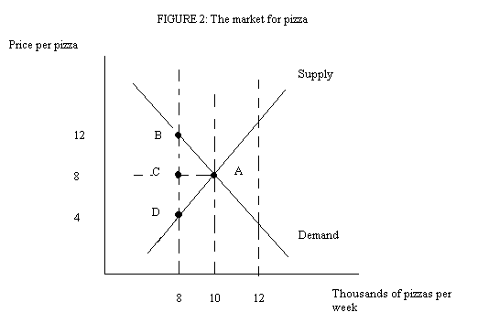

23. When the pizza providers form their cartel and decide to sell pizza for $12 per pizza the market in Figure 2 moves from point A to point B. The movement from point A to point B in this case is
a) Due to a shift in the demand curve and no shift in the supply curve.
b) Due to a shift in the supply curve and no shift in the demand curve.
c) Due to the quantity supplied changing because of a shift in the demand curve.
d) Due to the quantity demanded changing because of a shift in the demand curve.
e) Due to a change in the price of the good which causes a movement along the demand curve.

24. Once the cartel is formed, total revenue per week to pizza makers ___________ from ___________ to ____________.
a) Falls; $96,000; $80,000
b) Falls; $96,000; $32,000
c) Rises; $32,000: $96,000
d) Rises; $80,000; $96,000
e) Rises; $64,000; $96,000

25. Recall that the initial price of pizza is $8 a pizza. Once the cartel agreement is in place and, holding everything else constant, consumer surplus per week ____________ by ____________ and producer surplus per week ________________ by ______________.
a) decreases; $32,000; increases; $28,000
b) decreases; $4,000; increases; $32,000
c) increases; $32,000; decreases; $28,000
d) increases; $36,000; increases, $28,000
e) decreases; $36,000; increases; $28,000

26. Suppose the City Council in Madison imposes an effective price ceiling in the rental market for apartments. Given this price ceiling, the _______________ side of the market would determine the quantity that is consumed and there will be an _____________________ in the market.
a) supply; excess demand
b) supply; excess supply
c) demand; excess demand
d) demand; excess supply

27. To be effective—have an impact—a price ______________ must be set _______________ the equilibrium price in the market, and a price _____________must be set _________________.
a) Floor; below: ceiling; below
b) Ceiling; below: floor; above
c) Ceiling; above: floor; above
d) Floor; above; ceiling; above

28. When Thomas Carlyle referred to economics as “the dismal science” he was focusing on
a. How depressing economic forecasts and predictions tend to be.
b. How economists lack a sense of humor.
c. How the study of economics rarely helps individuals achieve a better understanding of the world they live in.
d. The idea that due to scarcity we all must make choices and that our choices always involve a cost.

29. Charles Wheelan insists that “the concept of cost is far richer…than the dollars and cents you hand over at the cash register.” To support this idea his example is
a) His mother standing in line in the rain for six hours in order to get free concert tickets.
b) His mother advising him to purchase shoes at a discount outlet and Wheelan deciding instead to purchase his shoes locally since the true costs of the outlet shoes is greater than the cost of the locally purchased shoes when he considers the value of his time and the work he will give up while traveling to purchase the discounted shoes.
c) Someone choosing to teach math instead of working as a marketing representative for cigarettes.
d) Someone shoplifting a book rather than purchasing the book.

30. Black rhinos in Africa are an endangered species because
a) They are typically communal property rather than private property.
b) Many people who derive a benefit from saving the species may free ride and not contribute to efforts to protect and preserve this endangered species.
c) Firms that might benefit from saving the black rhino (for example, eco-tourism firms) have an incentive to free ride since spending money to protect and preserve the black rhino will increase the costs of doing business for any firm acting alone to help save the black rhino.
d) Answers (a), (b) and (c) are all true statements.
e) Answers (b) and (c ) are true statements.

31. Most public school teachers receive salaries based upon their years of experience and their level of educational achievement. Economists believe this payment system will likely result in
a) The least talented teachers leaving the public school system.
b) The most talented teachers leaving the public school system.
c) No impact on the quality of teaching in the public school system since incentives are not important to educators.
d) “Perverse incentives” where the most qualified individuals elect to continue teaching in the public school system.

32. Another way of referring to “perverse incentives” is
a) The Law of Intended Consequences.
b) The Law of Possible Consequences.
c) The Law of Potential Consequences.
d) The Law of Unintended Consequences.

33. Requiring the use of car seats on airplanes when transporting infants will
a) Mean that families will have to purchase an additional ticket for a seat for their infant if they choose to fly with their infant.
b) Holding everything else constant, increase the cost of taking an airplane trip for a family traveling with an infant.
c) Likely result in more infant deaths as families with infants substitute, significantly more dangerous, car travel for plane travel.
d) Answers (a), (b) and (c) are all true statements.
e) Answers (b) and (c) are both true statements.

34. Answer this question based on your reading of Naked Economics. When there is a positive externality in a market, the market left alone will
a) Produce too much of the good.
b) Produce too little of the good.
c) Produce just the right amount of the good.
d) At times produce too much of the good, too little of the good, or just the right amount of the good.

35. A tax on gasoline can be justified
a) Because driving a car generates negative externalities in the form of congestion, pollution, and other social costs.
b) Because it will create a lot of good incentives: the tax will likely result in lower consumption of gasoline, the tax will raise revenue, and the tax will provide an incentive to buy a more fuel-efficient vehicle.
c) Because it raises the cost of driving a car with low fuel efficiency while still allowing each individual to decide if it is worth this additional cost to drive that gas guzzler.
d) Answers (a), (b) and (c) are all true answers.
e) Answers (b) and (c) are both true answers.

36. Suppose Jane has two exams back to back (i.e. there is no time between the two exams) at the beginning of the next day, one in English and one in history, and she has five hours left to study. Holding everything else constant, the opportunity cost of spending two hours studying English is:
a) Three hours not studying history
b) Two hours not studying history

Use the information below to answer the next THREE (3) questions.

Figure 3 represents the labor market in Wisconsin for people age 16 to 24 years old, a group that is particularly affected by minimum wage laws since these workers are often just starting their labor market participation and are apt to have less developed labor skills.

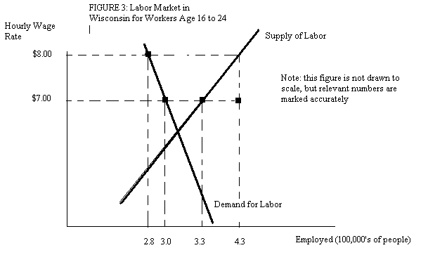

37. If the minimum wage is initially at $7.00 per hour, then the number of unemployed (surplus) people is, ___________________, the number employed is __________________.
a) 50,000; 330,000
b) 280,000; 300,000
c) 28,000; 272,000
d) 30,000; 300,000

38. If the minimum wage is raised from $7.00 to $8.00 per hour, then the number of unemployed (surplus) people is ______________, and the fall in the number of employed people is ______________________.
a) 130,000; 20,000
b) 150,000; 20,000
c) 100,000; 50,000
d) 100,000; 30,000

39. If the minimum wage is raised from $7.00 to $8.00 per hour, then the number of employed people _____________ by ____________ people, and the income of employed people ____________ by $___________
a) decreases; 20,000; increases; $140 thousand per hour of work
b) decreases; 20,000; decreases; $140 thousand per hour of work
c) decreases; 50,000; increases; $240 thousand per hour of work
d) increases; 30,000; increases; $240 thousand per hour of work

40. The amount of deadweight loss that results from an excise tax of a given size is determined by
a) whether the excise tax is levied on buyers or sellers.
b) the number of buyers in the market relative to the number of sellers.
c) the price elasticities of demand and supply in the market.
d) the ratio of the excise tax per unit to the effective price received by sellers.
Answers:

1. E
2. E
3. B
4. A
5. D
6. B
7. D
8. D
9. D
10. D
11. D
12. D
13. E
14. A
15. C
16. D
17. A
18. D
19. E
20. C
21. A
22. B
23. E
24. D
25. E
26. A
27. B
28. D
29. B
30. D
31. B
32. D
33. D
34. B
35. D
36. B
37. D
38. B
39. A
40. C

