Economics 100
Spring 2015
Answers to Quiz #1

Write legibly please! Show all work.

- (five points) Use the graph of Econoland’s production possibility below to answer this set of questions.

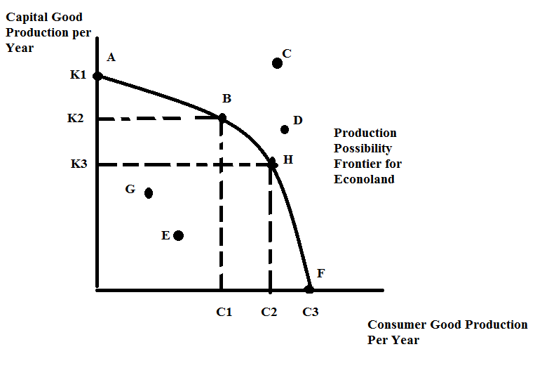

- Econoland is currently producing at point B. What is the opportunity cost of moving to point H? Provide the units of measurement as well as a numeric value. ____________________________Answer: K2 – K3 units of capital goods
- Econoland is currently producing at point H. What is the opportunity cost of moving to point A? Provide the units of measurement as well as a numeric value.Answer: C2 units of consumer goods
- Suppose that economic growth is highly esteemed in Econoland. Given that Econoland must have some consumer goods each year, which point in the above graph is the best on for Econoland to choose this year if their goal is to maximize their economic growth next year? _______________________Answer: Point B
- Provide a point that represents the concept of scarcity for Econoland. ________________Answer: Point C or Point D
- Provide a point that represents the concept of inefficiency for Econoland. _____________Answer: Point E or Point G

- (3 points) In the space below describe one example from the Wheelan book, Naked Economics,that you remember. Provide a statement explaining what you thought was interesting about this example.

Answer: Lots of possibilities here:
*1 points for the example
*2 points for the explanation

- (2 points) For each of the following statements determine whether the statement is positive or normative:

- The Governor of Wisconsin is considering running for the President of the United States. _________________________Answer: Positive

- The state government of Wisconsin should not cut the UW system's budget by 15%. _________________________Answer: Normative

- Economic policy aimed at our current economic woes should first address the unacceptable levels of unemployment. _____________________Answer: Normative

- In my opinion, politicians rarely understand economics. ________________Answer: Normative

- It is commonly believed that the bald eagle population is growing. _____________Answer: Positive

- Economic policy to address homelessness should provide housing for everyone who does not have shelter. ________________________Answer: Normative

