Economics 100
Answers to Homework #6
Due December 10, 2013

Directions: The homework will be collected in a box before the lecture. Please place your name, TA name and section number on top of the homework (legibly). Make sure you write your name as it appears on your ID so that you can receive the correct grade. Late homework will not be accepted so make plans ahead of time. Please show your work. Good luck!

Please realize that you are essentially creating “your brand” when you submit this homework. Do you want your homework to convey that you are competent, careful, professional? Or, do you want to convey the image that you are careless, sloppy, and less than professional. For the rest of your life you will be creating your brand: please think about what you are saying about yourself when you do any work for someone else!

1. Suppose that GDP per capita is $20,000 in Xandu in 2013 and the yearly growth rate of GDP per capita in Xandu is constant and equal to 3.5%. In Yurdu, in contrast, the GDP per capita is $4,000 in 2013 and the yearly growth rate of GDP per capita in Yurdu is constant and equal to 7%. Assume that neither country experiences inflation in this problem.

a. Draw a time line that illustrates the level of GDP per capita in Xandu in 20 year increments for the next 100 years. Draw a time line that illustrates the level of GDP per capita in Yurdu in 10 year increments for the next 100 years. Given your analysis what can you say about the relationship between the level of GDP per capita in Xandu and Yurdu over the next century?

Answer:
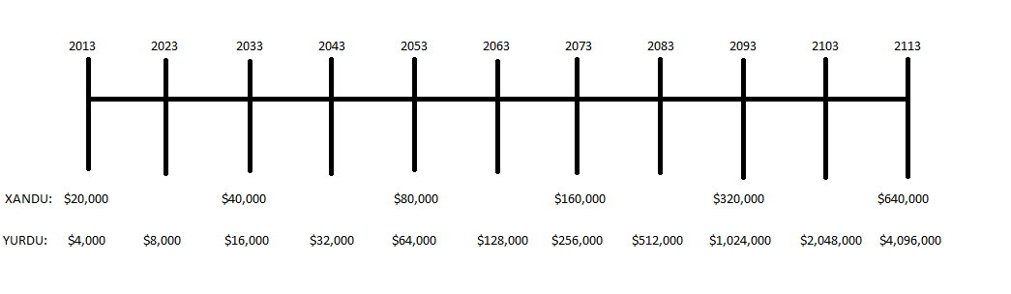
Initially Xandu’s GDP per capita is much greater than Yurdu’s GDP per capita, but over time because the two countries have very different growth rates for their GDP per capita Yurdu’s GDP per capita increases and surpasses Xandu’s GDP per capita. From the rule of 70 we can approximate that it takes Xandu about 20 years for their GDP per capita to double while it takes Yurdu only 10 years for its GDP per capita to double. From the timeline we can see that by 2053, Yurdu has almost “caught up” with Xandu, and that by 2073 the GDP per capita in Yurdu is greater than the GDP per capita in Xandu. Growth rates matter over time.

b. Xandu in 2013 has substantially higher GDP per capita than Yurdu. Will this always be the case? Explain your answer fully and completely.

Answer:
No, Xandu will not always have a higher GDP per capita than Yurdu given the growth rates that are specified. As we saw in the first question to this problem the GDP per capita in Yurdu eventually caught up to and then surpassed the GDP per capita in Xandu. Growth rates matter.

c. Currently US GDP per capita is substantially higher than China’s GDP per capita (2012 figures from the World Bank measured in 2012 U.S. dollars: $49,965 versus $6188) If these two countries GDP per capita grow at a constant and fixed annual rate of 2% and 5% per year, respectively, what will be the approximate number of years that will pass before the two countries have roughly equivalent GDP per capita? (Use the rule of 70 to get an approximate answer to this question.) Explain fully how you found your answer.

Answer:
I approached this problem by first rounding the GDP per capita figures to $50,000 and $6,000 for the U.S. and China, respectively. Then I used the rule of 70 to approximate the number of years it would take for the GDP per capita in each country to double. Thus, for the U.S. I had 70/2 = 35 years to double; and for China I had 70/5 = 14 years to double. I then made a timeline for each country and got the following:
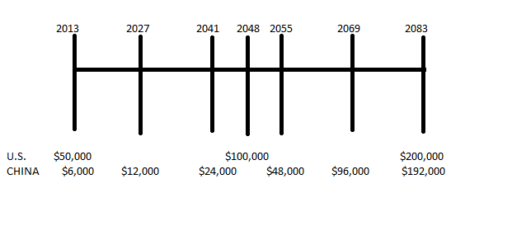
In approximately 70 years the two countries GDP per capita will be quite similar: another 35 years (2118) and the relative position of the two countries will be reversed with China’s GDP per capita greater than U.S. GDP per capita.

2. Suppose that you are told that a country’s aggregate production function can be expressed as Y = 2K^{1/2}L^{1/2}. (Let me remind you that K^{1/2} is the same as taking the square root of K; and L^{1/2} is the same as taking the square root of L.) In this equation Y is real GDP, K is the units of capital, and L is the units of labor.
a. Using the above information fill in the following table:

Units of Capital | Units of Labor | Real GDP
100 | 0
100 | 1
100 | 4
100 | 9
100 | 16

Answer:
Units of Capital | Units of Labor | Real GDP
100 | 0 | 0
100 | 1 | 20
100 | 4 | 40
100 | 9 | 60
100 | 16 | 80

b. Draw a graph of the relationship between the amount of labor, L, and the level of real GDP using the data from your table in (a). Measure labor on the x-axis and real GDP on the y-axis. Plot each point that you have in the table and then draw a smooth curve connecting these points to construct the aggregate production function for this country. Note this graph is a little different than the one we had in class: in class we had real GDP per unit of labor on the vertical axis (Y/L) and labor per unit of capital on the horizontal axis (L/K). The graph I want you to draw will be similar but will entail a lot less math. (You might find it fun to figure out how to do this with Excel!)

Answer:

c. In your own words describe what happens to output as you increase the amount of labor hired in this economy while assuming that the level of capital is unchanged.

Answer:
Output increases as you hire more units of labor, but it increases at a decreasing rate. You can see this in the graph in (b): the aggregate production function flattens out as the level of labor used gets bigger.

d. Now, suppose that the amount of capital increases to 144 units. Fill in the following table using this information.

Units of Capital | Units of Labor | Real GDP
144 | 0
 | 1
 | 4
 | 9
 | 16

Answer:

Units of Capital | Units of Labor | Real GDP
144 | 0 | 0
144 | 1 | 24
144 | 4 | 48
144 | 9 | 72
144 | 16 | 96

e. Draw a new graph of the relationship between the amount of labor, L, and the level of real GDP using the data from your table in (a) and (d). Measure labor on the x-axis and real GDP on the y-axis. Plot each point that you have in the table and then draw a smooth curve connecting these points to construct the aggregate production function for this country. On this second graph you should end up with two lines depicting two different aggregate production functions for this economy: 1) the initial one when capital is equal to 100 units; and 2) the second one when capital is equal to 144 units. Label your new graph carefully and completely.

Answer:
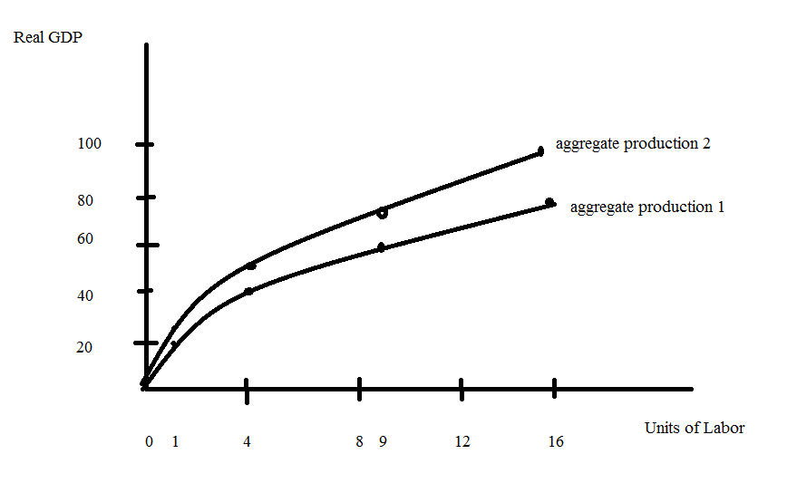

f. In your own words describe what happens to this economy when the amount of capital available increases from 100 units to 144 units for a given amount of labor. Is the amount of capital an economy has important? Explain your answer.

Answer:
At every level of labor greater than zero this economy finds it can produce a greater real GDP now that it has more capital. This exercise is intended to illustrate the importance of capital for an economy.

3. Describe in your own words what the term “leakages” mean when discussing the aggregate economy. In your explanation be sure to discuss the relationship between income, spending, and leakages.

Answer:
In the aggregate economy total spending equals total income provided there are no leakages. Leakages occur when some of the income earned in the aggregate economy does not get spent in the aggregate economy: this results in the level of spending being less than the level of income. Leakages include income that is saved, income that is used to pay taxes, and income that is used to pay for imported goods (goods not produced in the aggregate economy we are focused on).

4. Describe in your own words what the term “injections” mean when discussing the aggregate economy. In your explanation be sure to discuss the relationship between income, spending, injections, and leakages.

Answer:
Injections refer to any kind of spending in the aggregate economy that comes from some other source or sector besides household consumption spending. This additional spending, or injections of dollars into the aggregate economy, may come from spending by the government sector (G), spending by the business sector (I), or spending by the foreign sector through purchases of exports from the aggregate economy (X).

Provided that the sum of all injections equals the sum of all leakages it will be true that total income in an economy will equal total spending in that same economy.

5. Consider the following graph depicting a long-run equilibrium in an economy using the aggregate demand-aggregate supply model.
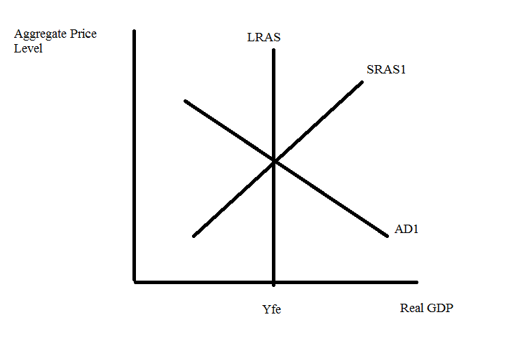
a. If you wanted to illustrate long-run economic growth using this model, how would you do that?

Answer:
You can depict long-run economic growth in this model by drawing a new LRAS curve to the right of the initial one (LRAS1 vs. LRAS2). This indicates this economy can now produce a higher level of real GDP when it operates at full employment.

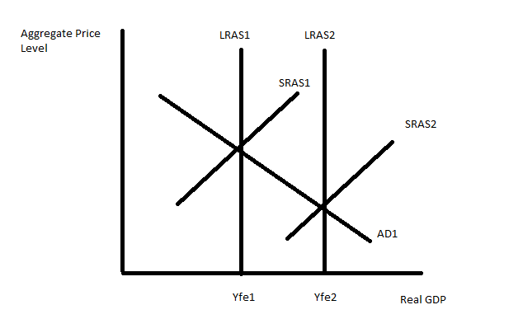
Notice that in the graph the SRAS curve has also shifted: as the ability of the economy to produce a higher level of output occurs this results in the initial equilibrium transforming into a short-run equilibrium: we know this since the economy could be producing at Yfe2 but is instead producing at Yfe1. Over time nominal wages will fall given Yfe1<Yfe2 and we can anticipate the SRAS shifting right from SRAS1 to SRAS2. The economy will eventually settle at Yfe2 once it reaches its new long-run equilibrium.

b. Go back to the original graph. Holding everything else constant, if the government increases government spending what will be the short-run impact on this economy of this change? What will be the long-run impact on this economy of this change? Use a graph as well as a verbal description to explain your answer.

Answer:
In the short-run an increase in government spending holding everything else constant will cause the aggregate demand curve to shift to the right from AD1 to AD2: at every aggregate price level the increase in government spending results in a higher level of aggregate spending in the economy (Y2). The economy in the short-run produces above its full employment level of output: the economy is in a boom (Y2 > Yfe).

In the long-run we can expect nominal wages to increase as the aggregate economy struggles to maintain its level of production above the full employment level. As nominal wages increase the SRAS curve shifts to the left from SRAS1 to SRAS2: the economy returns to Yfe but with a higher aggregate price level than it had initially (P2 > P1).

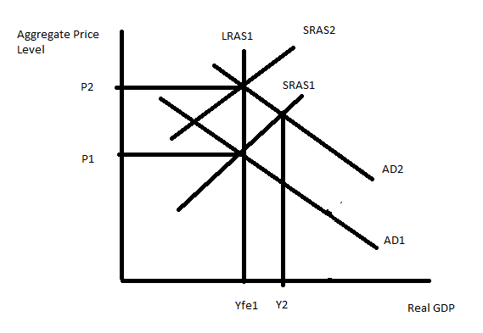

c. Go back to the original graph. Holding everything else constant, if households decrease their spending (perhaps due to a real estate bubble bursting, or a stock market bubble bursting, or just because individuals feel less confident about how the economy is doing), what will be the short-run impact on this economy of this change? What will be the long-run impact on this economy of this change? Use a graph as well as a verbal description to explain your answer.

Answer:
In the short-run a decrease in consumption spending by households holding everything else constant will cause the AD curve to shift to the left from AD1 to AD2: at every aggregate price level the decrease in consumption spending results in a lower level of aggregate spending in the economy (Y3). The economy in the short-run produces below its full employment level: the economy is in a recession (Y3 < Yfe).

In the long-run we can expect nominal wages to decrease as the aggregate economy’s unemployed people over time become willing to accept lower wages in order to return to work. As nominal wages decrease the SRAS curve shifts to the right from SRAS1 to SRAS3: the economy returns to Yfe but with a lower aggregate prce level then it had initially (P3 < P1).
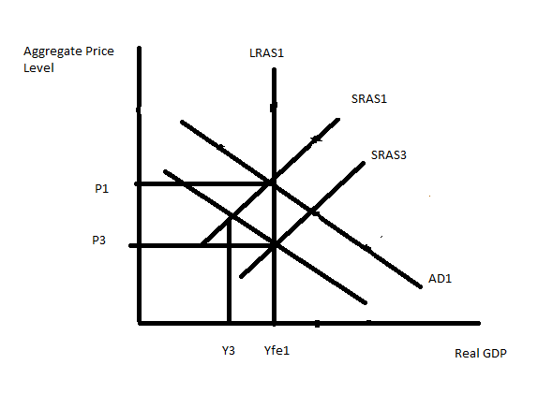

d. Given the analysis you have done in this problem, what policies might you suggest if the economy is in a recession? Explain how these policies would impact the economy using the framework provided by the aggregate demand-aggregate supply model.

Answer:
If the economy is in a recession this implies that the current level of production of real GDP is less than the full employment level of real GDP. It also implies that there is cyclical unemployment as well as frictional and structural unemployment: we know that the actual unemployment rate is greater than the natural rate of unemployment if this economy is currently in a recession. The policy choices are as follows:

1) Wait out the recession and do nothing: eventually unemployed individuals will accept lower nominal wages as the price of getting a job. This will cause the SRAS curve to shift to the right restoring this economy to the full employment level of output. This choice may entail significant hardship on those who are unemployed and a significant amount of time for the economy to adjust its way back to full employment.

2) Engage in activist monetary policy: in this case this would entail the central bank acting to expand the money supply which in turn will reduce interest rates and stimulate both greater consumption spending and greater investment spending. With greater consumption spending and greater investment spending, the AD curve will shift to the right helping this economy return to the full employment level of output. There may be significant time lags entailed in i) recognizing that there is a problem in the economy; and ii) waiting for the monetary policy to have an impact on the economy.

3) Engage in activist fiscal policy: in this case you could increase government spending or decrease taxes or do some combination of these two types of policy. The effect of these changes would be to provide more income for households and businesses (in the case of tax reductions) that they could then spend in the economy; or to provide more spending (government enhances the overall level of spending by spending more). This policy change would shift the AD curve to the right helping this economy return to the full employment level of output. There may be significant time lags entailed in 1) recognizing that there is a problem in the economy; ii) debating and enacting the legislation needed to change spending and tax policy; and iii) waiting for the fiscal policy to have an impact on the economy.

Bottom line: there are activist things one can do to lessen the hardship of a recession; one need not just sit and wait for the hard times to end.

6. Briefly describe three functions that money serves in an economy. You may find it helpful to consult your textbook or Wheelan for help on this one! Make sure you describe these functions: your answer should explain what each function means.

Answer:
Money serves as a medium of exchange, a unit of account, and a store of value.

Money is used as a medium of exchange: money enables us to make transactions with one another with far greater ease than would be the case if there were no money. If, instead of money, we bartered with one another we would find it far more difficult to get the variety of goods and the highly specialized goods that we are able to get because we use money to facilitate transactions.

Money is a unit of account because money provides a scale by which we can compare the prices of different goods to one another. This makes it far easier for us to know when an item is a “good buy” because we can compare the price of the item to the prices of other items we might be interested in purchasing.

Money is a store of value because we can hold money over time in order to make purchases at some future date. A seller who accepts money today can become a buyer who spends the money tomorrow. Of course, money is not the only store of value. Non-monetary assets, such as Picasso paintings, are also stores of value.

If you compare money and non-monetary assets you will find two important differences relating to the first two functions of money. First, various stores of value differ in their liquidity. As Wheelan discusses in Chapter 7, liquidity refers to how quickly and predictably something can be turned into cash. Selling a Picasso painting requires a lot of time and effort, and the price the painting will be sold is not perfectly predictable. So, money is much more liquid than a Picasso painting. Actually, money is the most liquid store of value available. Second, the value of money is more directly related to the price level in the economy than most other stores of value are. When the economy experiences high inflation, the real value of the money in your wallet drops a lot, while the real value of a Picasso painting may hardly be affected.

7. Wheelan discusses in Chapter 10 the idea that governments sometimes pursue inflationary policies. What kind of reasons does Wheelan provide for why a government might pursue this kind of policy? Use your own words to answer this question.

Answer:
If a government has substantial debt it may pursue inflationary policies as a way to reduce the economic cost of repaying that debt. By inflating prices the government effectively reduces the purchasing power of the dollars it repays to its lenders.

The government may find it helpful to pay its supporters for their support, but this may lead to the government printing too much money and thereby creating a high level of inflation.

Another thing worth noting is that only those countries which can use their central bank to control their own circumstances can apply this inflationary policy discussed above. Since a lot of countries in Europe share a common currency now, these countries are limited in using this inflationary policy. That is why Greece, Portugal, Spain, and some other European countries which have heavy government debt can not get rid of their debt by simply printing money.

Besides expansionary monetary policies, inflationary policies also include expansionary fiscal policies. When an economy is in a recession, expansionary fiscal policies can increase aggregate demand and then stimulate the economy. Tax cuts and government spending increases can expand aggregate output and lower unemployment for a while, but at the cost of higher inflation over time. Although the decrease in unemployment is not a long term effect, it is necessary for an economy in deep recession. These inflationary policies may also be motivated by political reasons since the short term political gain of an economic expansion just prior to the election may be worth the subsequent inflation in the economy.

8. If the government increases its purchases by $100 billion, how will this shift the aggregate demand curve? Under what circumstances would it shift horizontally by exactly $100 billion, more than $100 billion, and less than $100 billion? Hint: this question is one that we may not fully cover in class, but it is a nice one for you to think about and ponder!

Answer:

This is a change in government spending. Since government spending is one component of aggregate demand, this increase will shift the aggregate demand curve to the right. The size of the shift may be larger or smaller than the increase in purchases itself. There is a multiplier effect that tends to make it larger, and also a crowding-out effect that tends to make it smaller. The horizontal shift of aggregate demand would therefore be exactly $100 billion only if these two effects happened to exactly cancel each other.

To explain further, the multiplier effect works because any increase in purchases, when it leads to increased production, causes incomes of producers (wages and profits) to rise as well. These producers typically spend a large fraction of this increase in income on consumption, which is also a component of aggregate demand. Thus aggregate demand shifts to the right by not just the amount of the increased government spending, but also by the amount of the induced increase in consumption. And since each increase in consumption also causes a further increase in production, income, and therefore consumption, the multiplier effect includes a whole chain of increases in consumption as well as the increase in government spending.

The crowding-out effect, in contrast, works through the short-run money market, the interest rate, and investment. As income rises due to the increase in government spending and induced increases in consumption, demand for money rises to finance these transactions. Assuming that the central bank holds the money supply constant and also (since we are looking now at the horizontal shift of aggregate demand and thus at a fixed price level) that the price level also remains unchanged, this rise in demand for money will require a rise in the interest rate to clear the money market. The rise in the interest rate will in turn reduce investment, which is yet another component of aggregate demand. This is why the crowding-out effect acts to reduce the size of the horizontal shift of aggregate demand due to the increase in government spending.

