Economics 100
Spring 2015
Answers to Homework #4
Due April 9, 2015

Directions: The homework will be collected in a box before the lecture. Please place your name on top of the homework (legibly). Make sure you write your name as it appears on your ID so that you can receive the correct grade. Late homework will not be accepted so make plans ahead of time. Please show your work. Good luck!

Please realize that you are essentially creating “your brand” when you submit this homework. Do you want your homework to convey that you are competent, careful, and professional? Or, do you want to convey the image that you are careless, sloppy, and less than professional. For the rest of your life you will be creating your brand: please think about what you are saying about yourself when you do any work for someone else!

1. For each of the following situations draw a graph that represents the situation. In your graph label the curve that represents the Marginal Social Cost (MSC) of producing the good, the Marginal Private Cost (MPC) of producing the good, the Marginal Social Benefit (MSB) of consuming the good, the Marginal Private Benefit (MPB) of consuming the good, the market provided quantity of the good (Qmkt), the socially optimal amount of the good (Qsoc opt), and the deadweight loss (DWL). Note that some graphs may not include each of these items.

a. Running red lights creates potential danger to pedestrians as well as other drivers. But, people run lights all the time because they consider just their additional private benefits from getting through the intersection a bit quicker than if they slow down and wait through a light's cycle. Provide a graph of the market outcome for running lights as well as depicting what the socially optimal amount of light running is. Indicate all the terms mentioned in the intro to this question in your answer.

b. NASA has pioneered many new technologies required for space exploration. Consider the market for robots. The work that NASA did in basic research and robot development has proved to have transferable effects for many production processes. Analyze the overall market for robots given these spillover effects. Provide a graph of the market outcome for robots as well as depicting what the socially optimal amount of robots is. Indicate all the terms mentioned in the intro to this question in your answer.

c. Joe and his group of freshmen friends (50 guys) really enjoy having a noisy good time starting on Thursday afternoon and running through the entire weekend. Most weekends this pack of guys drinks way too much and the result is that this group is often loud, raunchy, and very often violently sick. The group does not consider the impact of their actions on those who live around him. Provide a graph of the market outcome for alcohol consumption given this information. Make sure you identify the socially optimal amount of alcohol consumption. Indicate all the terms mentioned in the intro to this question in your answer.

Answer:
a.
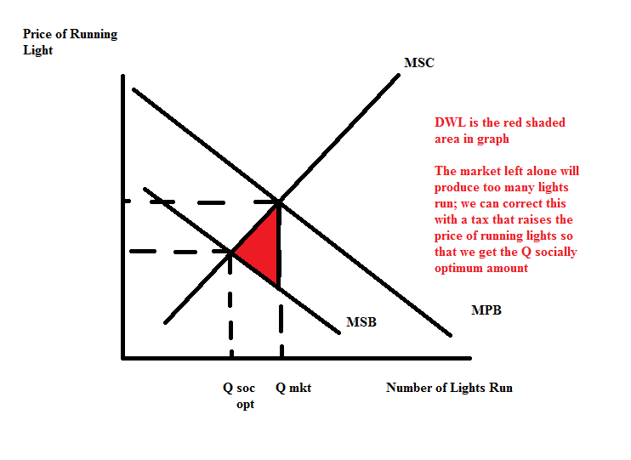
b.
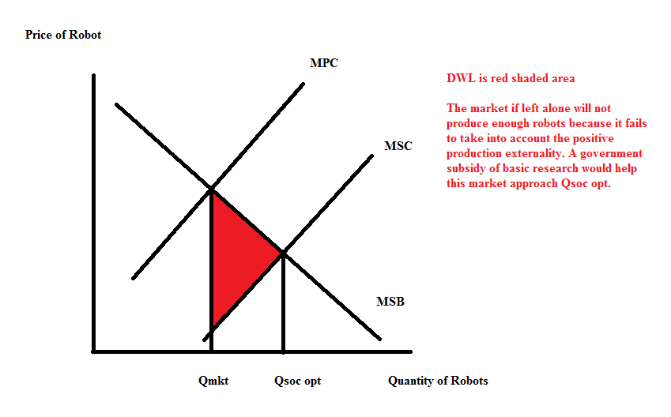
c.
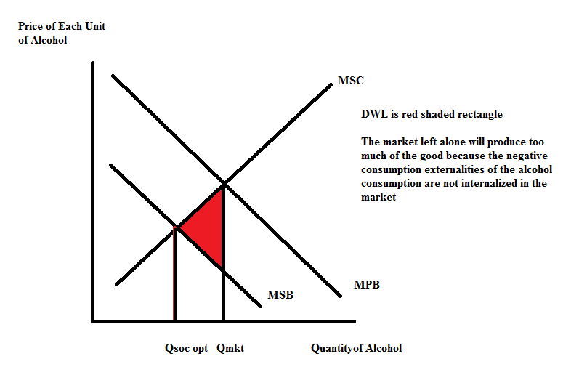

2. Consider the town of Morningside. Current debate in City Hall is over how many streetlights should be put up in the community. What is it about a streetlight that makes it a public good? (Hint: there should be two aspects of the streetlight that makes it a public good.) Why is the market unlikely to provide Morningside with the optimal number of streetlights?
Answer:
The streetlights are a public good if they possesses the property of non-rivalness and non-excludability. So, let’s consider each of these properties in turn.

A good is non-rival if a person can consume the good without diminishing the ability of another person to consume the same good. Clearly a streetlight is non-rival: I can walk down the street and enjoy the benefits of the light provided by the streetlight without diminishing the benefits someone else gets from walking down the street and using this same light. My use of the streetlight does not diminish another individual's ability to benefit from the streetlight.

A good is non-excludable if a person can be prevented from using the good. Although we can imagine a scenario where the streetlight is turned off when Samantha, who was unwilling to pay for the streetlight, is walking down the street, this is an unlikely scenario. Lacking the technology to recognize that non-payer and knowing that the technology is apt to be expensive to implement if we have it, it is much more likely that we simply turn on the streetlight at dusk and turn it off at daybreak. We may have some users of the streetlight that did not pay for the service, but by keeping the light on throughout the dark night we insure that its benefits are readily available to all who traverse down the street. Once the streetlight is erected and turned on it is likely that many people will be able to use the light even though they did not pay to have the streetlight erected.

3. Economists are interested in the idea of the free ride and how free ridership can prevent a market from providing the socially optimal amount of the good. We have discussed several examples of free ridership in class (attending a review session even though you have not prepared any questions in hopes that you can "free ride" on the efforts of other students, walking past the kitchen garbage can when it was full and hoping that someone else will empty the garbage allowing you to "free ride" on their efforts, etc.); now, think of at least three examples where you have been a "free rider". Discuss the example and then discuss how you were a free rider. Is the problem with being a free rider a problem of the good being non-rival or non-excludable? Explain your answer.

Answer:
Answers here will vary, but hopefully you can think of some places where you have been a free rider. Let me see if I can think of a few:

a) Perhaps the politicians are doing something that you are very concerned about because you fear that these political actions may result in damage to institutions you care about or to your lifestyle and the lifestyle of people like you. You think about writing a letter to your elected official, go volunteering at the local political office that most closely projects your viewpoint, but you do nothing. You hope that others of like mind will step forward and do the work and persuasion that needs to be done for your perspective to prevail.
The individual is a free rider here because they are letting others do the work that needs to be done. They reason that once a group expresses their opinion then all is good: their personal opinion has been expressed without the individual having to do any work. The problem here is one of non-excludability: the individual cannot be excluded from the benefits that are provided by the advocacy group even if the individual does not contribute to the support or work that the advocacy group does.
b) You love hiking in the state parks each weekend during the spring, summer and fall. In fact, you take for granted that you are lucky enough to live in a state that has managed its resources well for a very long time (think John Muir, Aldo Leopold, and other leaders in the environmental movement) and you never consider the need to continue to advocate for land preservation and the support of these state parks.
The individual is a free rider here because they are taking for granted the provision of this good (the state parks) without any need to put forth effort to sustain the provision of this good. The individual reasons that once the park is provided they can continue to enjoy the use of the park even though they have done little to support its provision. It helps us understand why the state collects taxes in order to fund this type of public good. The problem here is again one of non-excludability: the individual cannot be excluded from the benefits provided by the park even if they have not contributed to advocating for the park.
c) You are a student and you want a good grade but you hope that this will not actually involve spending time working through the materials your professor provides. You hope that you will be able to "get the material" by attending lecture and "free riding" on the professor's presentation of the material.
The individual is a free rider here because they are free riding on the professor's efforts. The student, once registered for the class, cannot be excluded from enjoying the professor's efforts: this effort is non-excludable-yes, the student has to pay to be enrolled, but there is no way for the professor to collect a "payment" in the form of a commitment to study and engage in the material. The student because of this will likely not get the right amount of education in the subject material: they are free riding and that leads to an under-provision of the good. Lack of engagement and commitment to the educational process leads to a reduced level of education.

4. In class we discussed the Tragedy of the Commons and how it was first used as a term to discuss the over use of grazing ground in England. Let's return to Charles Wheelan's black rhinos in Chapter Two: how is the story of the black rhino an illustration of the Tragedy of the Commons? Write a nice, short essay explaining this to your Great Uncle Bernie who is trying hard to see how college is helping you have a better understanding of the issues facing the world. In your essay identify some solutions that might help address this problem.

Answer:
Over grazing of the Commons occurred because the Commons were not owned by anyone. Since the property rights for the Commons were not well specified there was an incentive for everyone to use the Commons even though this overuse would eventually destroy the value of these Commons. Too many sheep grazed on the land and the land became unable to provide food for the sheep. This example is one of a negative externality.

We see the same issues with regard to the black rhino: in general, no one owns the highly valuable black rhinos of the world leading to an incentive for everyone to use (and by "use" we essentially mean "kill") the black rhinos. The result is that black rhinos are facing extinction because everyone has an incentive to "harvest" the black rhino for its prized horn.

This externality could be addressed by assigning the property rights to the black rhinos to someone who could then ration the use of these animals. The rhinos could also be regulated by the government so that overuse did not occur: the government could accomplish this by issuing a limited number of permits each year to hunters of black rhinos. It is likely that private ownership of the black rhinos will prove more successful than state control of the hunt: but, the key here is to try to find an effective means to prevent the overuse of this resource.

Here are some other possible solutions to protect the black rhino:
- "give local people some reason to want the animals alive rather than dead" [page 32]
- "capture black rhinos, saw off their horns, and then release the animals back into the wild" [page 33]-if the black rhino has no horn, it has no value
- limit trade in products that use the black rhino horn

You may be able to provide some other remedies to this problem.

5. Mandy and Bob are Maine "lobstermen"; that is, both Mandy and Bob own lobster boats and they go out during the lobster season daily to catch lobsters. Mandy and Bob are aware that the overfishing of our coastal waters is an issue and they meet frequently with other people in the business to discuss what ought to be done. Bob knows that if he catches lobsters without restriction that his daily revenues during the season will be $1400. Mandy knows that if she catches lobsters without restriction that her daily revenues during the season will be $1000. If they catch lobster in this manner, in five years there will be no lobsters left to harvest. If both Mandy and Bob catch lobsters in a socially responsible manner, Bob's daily revenues will be $600 while Mandy's daily revenues will be $400 and these daily revenues will continue perpetually. If Bob hunts to his heart's content while Mandy hunts in a socially responsible manner, then Bob's daily revenues will be $1200 and Mandy's daily revenues will be $500. If Mandy hunts to her heart's content while Bob hunts in a socially responsible manner, then Mandy's revenues will be $900 and Bob's daily revenues will be $700. Catching lobsters in a socially responsible manner means taking into account the benefits of having a healthy population of lobsters in the future for their enjoyment, their children's enjoyment, and the enjoyment of other future consumers of lobster. Assume that Mandy and Bob only consider the value of the lobster they catch when deciding how they are going to run their businesses.

a. What are the two lobstering choices that Bob has to choose between given the above information?
Answer:
Bob is choosing between "Catching Lobster" and "Socially Responsible Lobster Catching".

b. What are the two lobstering choices that Mandy has to choose between given the above information?

Answer:
Mandy is choosing between "Catching Lobster" and "Socially Responsible Lobster Catching".

c. Draw a payoff matrix illustrating the payoffs that Mandy and Bob face when considering their decision about how they catch lobster. Put Mandy on the left hand side of the matrix and Bob on the top of the matrix. In the matrix record the payoffs as (Mandy’s payoff, Bob’s payoff) in each cell.

Answer:
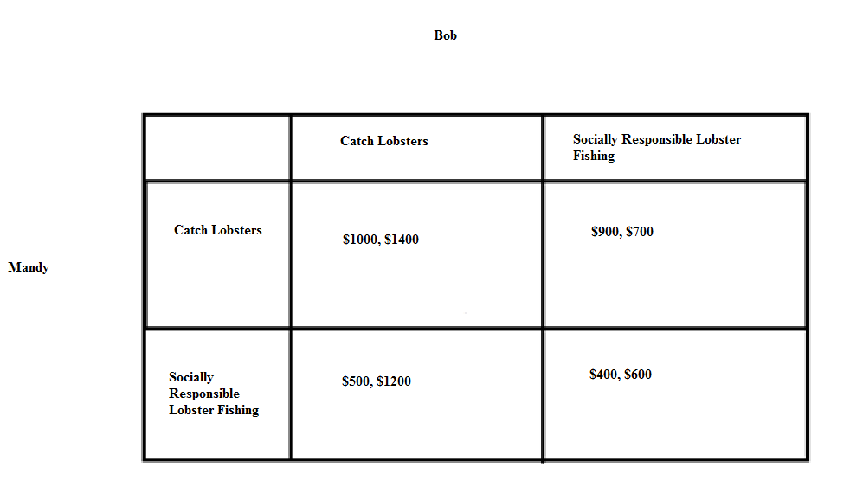

d. Given the above information and your analysis, what lobster catching choice will Bob make?

Answer:
To analyze Bob's lobster catching choice think about this decision as two separate rows with Bob analyzing each row to determine what his optimal lobster fishing strategy is.

On the first row, he assumes that Mandy no matter what he does is going to “Catch Lobsters”: given this assumption Bob can earn $1400 worth of lobster if he does “Catch Lobster” or $700 worth of lobster if he does “Socially Responsible Lobster Fishing”. Bob will realize that his optimal strategy if Mandy is “Catch Lobster” is to also be “Catch Lobster”.

On the second row, he assumes that Mandy no matter what he does is going to “Socially Responsible Lobster Fishing”: given this assumption Bob can earn $1200 worth of lobster if he does “Catch Lobster” or $600 worth of lobster per day forever if he does “Socially Responsible Lobster Fishing”. But, remember Bob only considers the value of the lobster per day and so he chooses to “Catch Lobster” even if Mandy is choosing the “Socially Responsible Lobster Fishing”.

Bob will choose "Catch Lobster".

e. Given the above information and your analysis, what fishing choice will Mandymake?

Answer:
To analyze Mandy’s fishing choice think about this decision as two separate columns with Mandy analyzing each column to determine what her optimal fishing strategy is.

On the first column, she assumes that Bob no matter what she does is going to "Catch Lobster": given this assumption Mandy can earn $1000 worth of lobster if she does "Catch Lobster" or $500 worth of lobster if she does "Socially Responsible Lobster Fishing". Mandy will realize that her optimal strategy if Bob is "Catch Lobster" is to also be "Catch Lobster".

On the second column, she assumes that Bob no matter what she does is going to "Socially Responsible Lobster Fishing": given this assumption Mandy can earn $900 worth of lobster if she does "Catch Lobster" or $400 worth of lobster per day forever if she does "Socially Responsible Lobster Fishing". But, remember Mandy only considers the value of the lobster for today and so she chooses to "Catch Lobster" even if Bob is choosing the "Socially Responsible Lobster Fishing".

Mandy will choose to "Catch Lobster".

f. How does this example illustrate the Prisoner’s Dilemma? Is the fishing outcome that occurs the optimal one from the perspective of Bob and/or Mandy? Explain your answer.

Answer:
The Prisoner’s Dilemma illustrates how two individuals acting logically can end up with a result that is not optimal. In this example it would be optimal, from both a personal and a societal point of view, for the two individuals to choose to fish in a socially responsible way. But, when each of these individuals only considers today's payoffs they elect to engage in “Catch Lobster” and they decimate the lobster population. This example is meant to illustrate the tragedy of the commons-a story of overharvesting of a common resource.

6. Suppose you are the President of a small country and you have decided to provide health insurance to all the residents of your country. You plan to provide this health insurance by first assessing how much money you will need to set aside per year to cover the health costs of your citizens; second, figuring out what each person would need to contribute if everyone contributed the same amount to insure that all would get health insurance coverage; third, figuring out how big a subsidy per person would need to be paid by the government in order that all could afford the health insurance; and fourth, figuring out how much more needs to be collected from the affluent in order to cover the costs of these subsidies for the lower income individuals.

Luckily you do have some information:
- The population of your country is 20 people; this population is constant over time.
- 5% of your population in any given year will have significant healthcare costs of $100,000 per person; 40% of your population in any given year will have some healthcare costs of $20,000 per person; and 55% of your population in any given year will have low healthcare costs of $2000 per person. No one in the population knows with certainty whether or not they will have significant healthcare costs, some health care costs, or low healthcare costs each year.
- You also have the following information about each individual in your country:

Individual | Income Available to be spent on health insurance (this is related to total gross income of the individual)
Joe | $8,000
Amber | $8,000
Jose | $8,000
Mary | $9,000
Sue | $10,000
Mabel | $10,000
Maria | $12,000
Clyde | $12,000
Lee | $12,000
Zhihao | $13,000
Jaeho | $13,000
Josephine | $13,000
Sylvester | $14,000
Yoshi | $14,000
Moshi | $16,000
Gwen | $18,000
Owen | $20,000
Abigail | $20,000
Samantha | $30,000
Cletus | $30,000

a. Given the above information calculate the amount of money you will need to collect in order to cover this year’s health care costs in your country. Use the following table to help you calculate these costs.

% of population with health issue | Number of people with particular health issue | Cost per person of this particular health issue | Total cost for this health issue
5% of population have significant health costs
40% of population have some health costs
55% of population have low health costs
TOTAL COST OF COVERING ALL HEALTH ISSUES | ----- | -----

Answer:

% of population with health issue | Number of people with particular health issue | Cost per person of this particular health issue | Total cost for this health issue
5% of population have significant health costs | 1 | $100,000 per person | $100,000
40% of population have some health costs | 8 | $20,000 per person | $160,000
55% of population have low health costs | 11 | $2000 per person | $22,000
TOTAL COST OF COVERING ALL HEALTH ISSUES | ----- | ----- | $282,000

b. If everyone in the country is required to pay an equal amount for health insurance and the President wishes to collect a sufficient amount of funds to cover all health costs for the year, what payment will each individual be required to make?

Answer:
Since you need to collect $282,000 per year and there are 20 people in your country, you will need to collect $282,000/20 people are $14,100 per person.

c. Now that you have calculated the amount of money per person (the healthcare insurance premium) you will need to collect to cover the costs of the year’s health care, take the time to calculate how much additional money you will need to collect from the affluent in order to subsidize the lower income individuals when they go to purchase their health insurance. You will find it helpful to use the following table. Note: lest you think that this is an all-together dumb plan (against the Affordable Care Act) recall that in the U.S. our policy has been to provide healthcare even if you do not have insurance-and this healthcare cost does get past on to someone who has to pay in the form of a combination of higher taxes and higher medical costs.

Individual | Income Available to be spent on health insurance (this is related to total gross income of the individual) | Amount of subsidy required in order for the individual to be able to afford the healthcare insurance premium for the year
Joe | $8,000
Amber | $8,000
Jose | $8,000
Mary | $9,000
Sue | $10,000
Mabel | $10,000
Maria | $12,000
Clyde | $12,000
Lee | $12,000
Zhihao | $13,000
Jaeho | $13,000
Josephine | $13,000
Sylvester | $14,000
Yoshi | $14,000
Moshi | $16,000
Gwen | $18,000
Owen | $20,000
Abigail | $20,000
Samantha | $30,000
Cletus | $30,000
 | TOTAL ADDITIONAL AMOUNT OF MONEY THAT MUST BE COLLECTED TO COVER SUBSIDY TO LOWER INCOME INDIVIDUALS

Answer:

Individual | Income Available to be spent on health insurance (this is related to total gross income of the individual) | Amount of subsidy required in order for the individual to be able to afford the healthcare insurance premium for the year
Joe | $8,000 | $6100
Amber | $8,000 | $6100
Jose | $8,000 | $6100
Mary | $9,000 | $5100
Sue | $10,000 | $4100
Mabel | $10,000 | $4100
Maria | $12,000 | $2100
Clyde | $12,000 | $2100
Lee | $12,000 | $2100
Zhihao | $13,000 | $1100
Jaeho | $13,000 | $1100
Josephine | $13,000 | $1100
Sylvester | $14,000 | $100
Yoshi | $14,000 | $100
Moshi | $16,000 | $0
Gwen | $18,000 | $0
Owen | $20,000 | $0
Abigail | $20,000 | $0
Samantha | $30,000 | $0
Cletus | $30,000 | $0
 | TOTAL ADDITIONAL AMOUNT OF MONEY THAT MUST BE COLLECTED TO COVER SUBSIDY TO LOWER INCOME INDIVIDUALS | $41,400

d. Suppose the cost of the healthcare insurance subsidy is divided among those who have more income available for health insurance than the amount of required premium. Start by divvying up the healthcare insurance premium so that no one supports the subsidy beyond the level of income they have available for health insurance; and then divide any remaining subsidy needed evenly among those individuals who still have funds available (you will need to think carefully here). Show how you found your answer. Also fill in the following table to consolidate your work in this problem. Remember that each individual cannot spend more than the amount of their income they have available for health insurance: this implies that you may have to do some thinking about the amount of subsidy that is being paid by lower income individuals.

Individual | Income Available to be spent on health insurance (this is related to total gross income of the individual) | Amount of subsidy required in order for the individual to be able to afford the healthcare insurance premium for the year | Healthcare Insurance Premium (what the individual paid for their healthcare insurance) | Additional charge per person to cover healthcare subsidy costs | Total Payment per person for Healthcare Insurance (includes premium plus subsidy)
Joe | $8,000
Amber | $8,000
Jose | $8,000
Mary | $9,000
Sue | $10,000
Mabel | $10,000
Maria | $12,000
Clyde | $12,000
Lee | $12,000
Zhihao | $13,000
Jaeho | $13,000
Josephine | $13,000
Sylvester | $14,000
Yoshi | $14,000
Moshi | $16,000
Gwen | $18,000
Owen | $20,000
Abigail | $20,000
Samantha | $30,000
Cletus | $30,000
COLUMN TOTALS | ---

Answer:

Our earlier work indicated that the healthcare insurance premium is $14,100 per person. Now, we also need to collect $41,400 to cover the cost of the subsidy for lower income individuals. There are 6 people (Moshi, Gwen, Owen, Abigail, Samantha, and Cletus) who can fully fund their health insurance plus contribute a bit toward a subsidy support for those individuals who do not sufficient income available to pay the full amount of their health insurance premium. So, we start the process of getting the needed $41,400 from these six individuals: Moshi can only contribute $1900 since that is the difference between the income he has available for health insurance and the $14,100 he must pay for his own insurance; A similar calculation for Gwen finds that she can contribute $3900; Owen and Abigail can each contribute $5900. At this point these four individuals can provide $17,600 of the needed subsidy; so this implies that Samantha and Cletus must provide a total of $23,800 in order for the amount to equal the required subsidy of $41,400. Dividing $23,800 by 2 we get that Samantha and Cletus will need to contribute an additional $11,900 to help provide this subsidy. From this exercise I hope that you see that there is a redistribution of income that occurs with this program: poorer people cannot afford the health insurance and they are given a subsidy so that they be insured. (Do remember that prior to ACA, our default was to provide healthcare to those without insurance and then pass on this cost to insured people who paid higher prices.)

Here is the completed table: notice that if you sum the last column you do get $$282,000, which is the total amount of dollars that must be collected in order to provide healthcare to everyone in this country for the year.

Individual | Income Available to be spent on health insurance (this is related to total gross income of the individual) | Amount of subsidy required in order for the individual to be able to afford the healthcare insurance premium for the year | Healthcare Insurance Premium (what the individual paid for their healthcare insurance) | Additional charge per person to cover healthcare subsidy costs | Total Payment per person for Healthcare Insurance (includes payment plus additional charge)
Joe | $8,000 | $6100 | $14,100 | $0 | $8,000
Amber | $8,000 | $6100 | $14,100 | $0 | $8,000
Jose | $8,000 | $6100 | $14,100 | $0 | $8,000
Mary | $9,000 | $5100 | $14,100 | $0 | $9,000
Sue | $10,000 | $4100 | $14,100 | $0 | $10,000
Mabel | $10,000 | $4100 | $14,100 | $0 | $10,000
Maria | $12,000 | $2100 | $14,100 | $0 | $12,000
Clyde | $12,000 | $2100 | $14,100 | $0 | $12,000
Lee | $12,000 | $2100 | $14,100 | $0 | $12,000
Zhihao | $13,000 | $1100 | $14,100 | $0 | $13,000
Jaeho | $13,000 | $1100 | $14,100 | $0 | $13,000
Josephine | $13,000 | $1100 | $14,100 | $0 | $13,000
Sylvester | $14,000 | $100 | $14,100 | $0 | $14,000
Yoshi | $14,000 | $100 | $14,100 | $0 | $14,000
Moshi | $16,000 | $0 | $14,100 | $1900 | $16,000
Gwen | $18,000 | $0 | $14,100 | $3900 | $18,000
Owen | $20,000 | $0 | $14,100 | $5900 | $20,000
Abigail | $20,000 | $0 | $14,100 | $5900 | $20,000
Samantha | $30,000 | $0 | $14,100 | $11,900 | $26,000
Cletus | $30,000 | $0 | $14,100 | $11,900 | $26,000
COLUMN TOTALS | --- | $41,400 | $282,000 | $41,400 | $282,000

e. To further complicate this issue let’s imagine that people in this group actually know more about their healthcare situation than does the President. The following table tells us what they privately know about their healthcare situation for the coming year (assume that this information is completely accurate).

Individual | Income Available to be spent on health insurance (this is related to total gross income of the individual) | Private Information the individual has about his healthcare for this year
Joe | $8,000 | Low Healthcare costs
Amber | $8,000 | Significant Healthcare costs
Jose | $8,000 | Some Healthcare costs
Mary | $9,000 | Low Healthcare costs
Sue | $10,000 | Some Healthcare costs
Mabel | $10,000 | Low Healthcare costs
Maria | $12,000 | Some Healthcare costs
Clyde | $12,000 | Some Healthcare costs
Lee | $12,000 | Low Healthcare costs
Zhihao | $13,000 | Low Healthcare costs
Jaeho | $13,000 | Low Healthcare costs
Josephine | $13,000 | Low Healthcare costs
Sylvester | $14,000 | Some Healthcare costs
Yoshi | $14,000 | Low Healthcare costs
Moshi | $16,000 | Some Healthcare costs
Gwen | $18,000 | Low Healthcare costs
Owen | $20,000 | Low Healthcare costs
Abigail | $20,000 | Some Healthcare costs
Samantha | $30,000 | Low Healthcare costs
Cletus | $30,000 | Some Healthcare costs

Given your answers in (b) and (d), make a prediction about whether or not each of these individuals will be willing to voluntarily pay into the healthcare pool. Assume that all individuals in this country consider only the financial costs to themselves of buying the healthcare insurance and their private healthcare information (that is, no one is altruistic in this community!). Use the following table to consolidate your predictions. Explain your answers.

Individual | Income Available to be spent on health insurance (this is related to total gross income of the individual) | Private Information the individual has about his healthcare for this year | Projected Total Payment per person for Healthcare Insurance (includes premium as well as any share of subsidy cost) from (d) | Projected Healthcare costs for the year | Prediction as to participation in healthcare insurance program if given option to participate or not
Joe | $8,000 | Low Healthcare costs
Amber | $8,000 | Significant Healthcare costs
Jose | $8,000 | Some Healthcare costs
Mary | $9,000 | Low Healthcare costs
Sue | $10,000 | Some Healthcare costs
Mabel | $10,000 | Low Healthcare costs
Maria | $12,000 | Some Healthcare costs
Clyde | $12,000 | Some Healthcare costs
Lee | $12,000 | Low Healthcare costs
Zhihao | $13,000 | Low Healthcare costs
Jaeho | $13,000 | Low Healthcare costs
Josephine | $13,000 | Low Healthcare costs
Sylvester | $14,000 | Some Healthcare costs
Yoshi | $14,000 | Low Healthcare costs
Moshi | $16,000 | Some Healthcare costs
Gwen | $18,000 | Low Healthcare costs
Owen | $20,000 | Low Healthcare costs
Abigail | $20,000 | Some Healthcare costs
Samantha | $30,000 | Low Healthcare costs
Cletus | $30,000 | Some Healthcare costs

Answer:

From (d) you know the projected total payment per person for healthcare insurance (includes the amount of the premium the individual pays as well as any share of subsidy cost shouldered by the individual). You also can now project healthcare costs based on private information. When you compare these two columns there are three possibilities: the payment for coverage will be either be greater than, equal to, or less than the projected healthcare costs. So, if the payment for coverage is greater than the projected healthcare costs you will opt out of coverage and instead self-insure; if the payment for coverage is less than the projected healthcare costs you will opt in for coverage; and it the payment for coverage is equal to the projected healthcare costs, the costs to you are the same whether you join the insurance pool or opt to self-insure.

Clearly if people have the right to opt in or opt out the ability to cover the medical costs of the country collapses as the amount collected from the payments made by people who opt in will be insufficient to provide enough funds to cover the costs of healthcare. This explains why there is an Individual Mandate in the Affordable Care Act (“Obamacare”): the healthcare insurance market is a market that will clearly have a tendency to fall apart due to the adverse selection problem. People electing to purchase insurance are adversely selected: they are a more expensive pool of individuals to insure than would be the case if the whole population was included in the insurance pool.

Individual | Income Available to be spent on health insurance (this is related to total gross income of the individual) | Private Information the individual has about his healthcare for this year | Projected Total Payment per person for Healthcare Insurance (includes premium as well as any share of subsidy cost) from (d) | Projected Healthcare costs for the year | Prediction as to participation in healthcare insurance program if given option to participate or not
Joe | $8,000 | Low Healthcare costs | $8,000 | $2000 | NOT Participate
Amber | $8,000 | Significant Healthcare costs | $8,000 | $100,000 | Participate
Jose | $8,000 | Some Healthcare costs | $8,000 | $20,000 | Participate
Mary | $9,000 | Low Healthcare costs | $9,000 | $2000 | NOT Participate
Sue | $10,000 | Some Healthcare costs | $10,000 | $20,000 | Participate
Mabel | $10,000 | Low Healthcare costs | $10,000 | $2000 | NOT Participate
Maria | $12,000 | Some Healthcare costs | $12,000 | $20,000 | Participate
Clyde | $12,000 | Some Healthcare costs | $12,000 | $20,000 | Participate
Lee | $12,000 | Low Healthcare costs | $12,000 | $2000 | NOT Participate
Zhihao | $13,000 | Low Healthcare costs | $13,000 | $2000 | NOT Participate
Jaeho | $13,000 | Low Healthcare costs | $13,000 | $2000 | NOT Participate
Josephine | $13,000 | Low Healthcare costs | $13,000 | $2000 | NOT Participate
Sylvester | $14,000 | Some Healthcare costs | $14,000 | $20,000 | Participate
Yoshi | $14,000 | Low Healthcare costs | $14,000 | $2000 | NOT Participate
Moshi | $16,000 | Some Healthcare costs | $16,000 | $20,000 | Participate
Gwen | $18,000 | Low Healthcare costs | $18,000 | $2000 | NOT Participate
Owen | $20,000 | Low Healthcare costs | $20,000 | $2000 | Participate
Abigail | $20,000 | Some Healthcare costs | $20,000 | $20,000 | Participate
Samantha | $30,000 | Low Healthcare costs | $26,000 | $2000 | NOT Participate
Cletus | $30,000 | Some Healthcare costs | $26,000 | $20,000 | NOT Participate

f. Given your work in this problem, provide a brief explanation of why the Affordable Care Act (“Obamacare”) includes both a subsidy for low income individuals as well as an Individual Mandate that requires everyone to purchase healthcare insurance.

Answer:
The adverse selection problem exists in the market of health insurance because of asymmetric information. People know more about their health and their potential health care issues than do insurers, so even when insurance companies do their homework about how much someone will cost them to insure, they can only know so much. When only sick people or people with a higher likelihood of becoming sick buy insurance, their costs of care will be relatively high compared to a more diverse (in terms of healthcare needs) pool of people and the insurance company will need to collect relative high insurance premiums for this group. Higher premiums make insurance even less attractive for healthy people, causing even more of them to drop out of the healthcare insurance market. As this problem continues to become a bigger problem it leads to coverage becoming too expensive for almost everyone and the healthcare insurance market fails. This is what we have now in our example - a market failure for individual health insurance.

There are two types of subsidies in Obamacare. First, the affluent members are subsidizing the poor members. This transfer payment makes health insurance affordable for everyone. Second, the healthy low-cost members are subsidizing the sick high-cost members. It is another transfer payment from those who might need health care but don’t yet, to those who do need it now. For Obamacare to Work, an individual mandate is necessary. Requiring all people to either purchase plans or face a penalty is a way to broaden the risk pool and avoid the adverse selection problem. A broader risk pool means that people become part of large, actuarially stable groups so that the average cost is affordable.

7. In class we have discussed trade using the production possibility frontier framework as well as the supply and demand model. You have also read your textbook on this topic as well as Chapters 12 and 13 in Naked Economics by Charles Wheelan. Write an essay on how your understanding of trade and its benefits has been affected by your work and reading in Economics 100. Be careful here: you know that your grader will want you to write crisply, concisely, and with clarity and your grade will be apt to quicker notice when you seem to be confused and befuddled in your explanations!

Answer:
No one correct answer here. But, a good essay would talk about the benefits from trade: total surplus increases. And, the essay would also discuss that trade has distributional consequences. An essay might provide arguments for why we should shelter some industries and the essay might explore how a failure to be open to trade appears to have led to less economic development in some countries (e.g., before India adopted more pro-trade policies the country grew very little).

8. Read Chapter 13 of Naked Economics by Charles Wheelan. Then, write a short outline of the chapter using standard outline format (in previous assignments I just said "outline", this time we will go with "standard outline format"). As always, if you quote from the text make sure you provide a reference: for this assignment the reference can take the form of "(page xxx)" following the quoted material. By standard outline format I mean that each level of outline must have a minimum of two entries and that we will go with the following style:

A.
1.
2.
3.
B.
C.

A.
B.
III.

Answer:

Outline for Chapter 13: "Development Economics"

I. Development economics matters (opening stories-pages 294-6)
A. Lots of malnourished children in the world
B. Infant mortality
II. Policies that matter: policies that encourage economic development
A. Good government institutions (page 296)
1. Laws, court systems, basic infrastructure, ability to collect taxes, citizen support for government
2. Society with reasonable levels of honesty and low levels of corruption
B. Establishment and maintenance of property rights (page 298)
1. Ownership of property allows you to build collateral and use that collateral to access capital
2. Well defined property rights frees up personal resources from defending your property to more productive economic activities
C. Appropriate levels of regulation (page 299)
D. Improvements in human capital: beware of brain drain though for poor countries (page 301)
E. Geography: Climate can make development difficult: tropics versus temperate zones-disease and food production issues (page 303)
F. Open the country's economy to trade (page 305)
G. Responsible fiscal and monetary policy (page 306)

