Economics 100
Fall 2013
Answers to Homework #4
Due Tuesday, November 5, 2013

Directions: The homework will be collected in a box before the lecture. Please place your name, TA name and section number on top of the homework (legibly). Make sure you write your name as it appears on your ID so that you can receive the correct grade. Late homework will not be accepted so make plans ahead of time. Please show your work. Good luck!
Please realize that you are essentially creating “your brand” when you submit this homework. Do you want your homework to convey that you are competent, careful, professional? Or, do you want to convey the image that you are careless, sloppy, and less than professional. For the rest of your life you will be creating your brand: please think about what you are saying about yourself when you do any work for someone else!

1. For each of the following situations draw a graph that represents the situation. In your graph label the curve that represents the Marginal Social Cost (MSC) of producing the good, the Marginal Private Cost (MPC) of producing the good, the Marginal Social Benefit (MSB) of consuming the good, the Marginal Private Benefit (MPB) of consuming the good, the market provided quantity of the good (Qmkt), the socially optimal amount of the good (Qsoc opt), and the deadweight loss (DWL). Note that some graphs may not include each of these items.

a. Consider the market for soft drinks. Suppose recent studies show that consumption of soft drinks results in significant health costs to society due to the ingestion of high levels of high fructose corn syrup. Currently consumers of soft drinks do not take into account these health costs when determining the level of soft drinks to consume.

Answer:
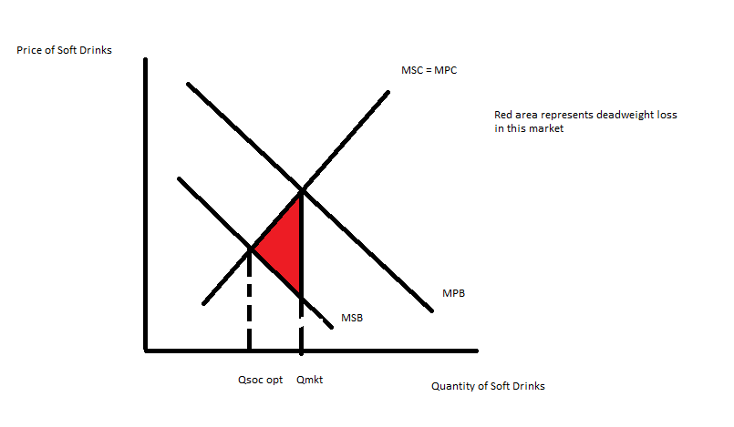
b. Consider the market for cars. Suppose that car manufacturers develop sophisticated robots to help in assembling cars and as a result of the spillover effect of these robots, other industries in the economy benefit from this technological improvement. Draw a graph of the car market and illustrate this spillover effect in your graph.

Answer:
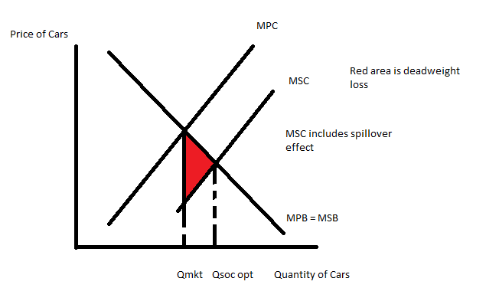
c. Consider the market for lobsters. Lobsters are delicious and people enjoy them immensely. However, current regulations place no restriction on the harvesting of lobsters and this leads to overharvesting of lobster from a societal point of view. Draw a graph of the lobster market and illustrate this overharvesting in your graph.

Answer:
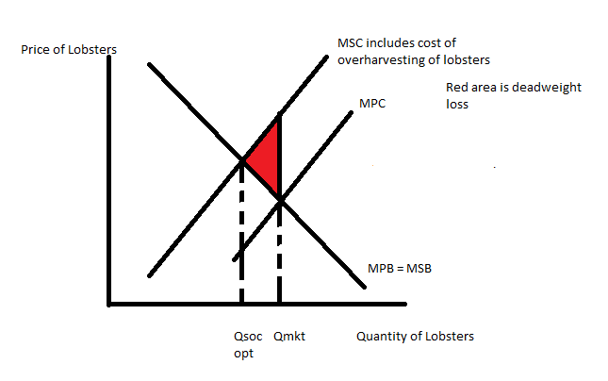
d. Consider the market for cigarettes. Cigarette smoking creates second-hand smoke which is definitely a negative consumption externality; but, cigarette smoking also results in premature death of smokers which reduces societal health care costs (a positive consumption externality). How would you analyze these two effects in the market for cigarettes and are there any conclusions you might draw from your analysis? Illustrate your analysis with a graph.

Answer:
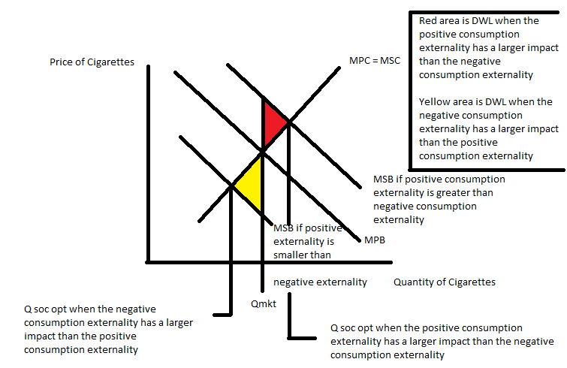
It is also possible that the two externalities cancel one another leaving you with the socially optimal quantity equaling the market determined quantity. In this case there would be no deadweight loss.

2. Consider a lighthouse that is located in a Oceanside community that is subject to gales, possesses a rocky shoreline, and often has dense fog. What is it about the lighthouse that makes it a public good? Make sure you discuss two aspects of the lighthouse that makes it a public good.

Answer:
This lighthouse is a public good if it possesses the property of non-rivalness and non-excludability. So, let’s consider each of these properties in turn.

A good is non-rival if a person can consume the good without diminishing the ability of another person to consume the same good. Clearly a lighthouse is non-rival: I can be at sea and use the guiding light of the lighthouse to come safely to shore at the same time that another individual at sea, in another boat, can use the same light beam. My use of the lighthouse does not diminish another individual’s ability to benefit from the lighthouse.

A good is non-excludable if a person can be prevented from using the good. Although it is conceivable that the ligthkeeper might douse the light when he realizes that Jim, who did not contribute to the lighthouse fund, is at sea and struggling to come safely to shore due to the rocks, gales, or fog, it is unlikely that the light will be turned off. After all, in thwarting Jim from using the light we might also prevent others from using the light. Once the lighthouse is built and turned on it is likely that many people will be able to use the light even though they did not pay to have the lighthouse built.

3. The other day in class I suggested that we all have a tendency to free ride. In class the examples of free riding included attending a review session without arriving with any questions (thereby free riding on your fellow students work to identify topics that should be discussed at the session), walking by the full kitchen garbage can and hoping that someone else would empty the garbage allowing you to free ride on their effort and enjoy the newly emptied can, and free riding on other people’s efforts to create a community with activities that you and your children might benefit from. Take a moment and come up with three scenarios where you have been a free rider. Be specific in your answer here. Is free riding symptomatic of the property of being non-rival or the property of being non-excludable? Defend your response.

Answer:
Answers here will vary, but hopefully you can think of some places where you have been a free rider. Let me see if I can think of a few:

- You notice that the dishwasher “Clean” light is on and you know you really should empty the dishwasher and put away the dishes. But, that is such a crummy job and you can think of all sorts of things you would rather do-and, you know that once the dishwasher is empty you can enjoy the delight of all those clean dishes. So you walk on by and hope that if you are just a bit more patient your roommate (or spouse) will do the task. You are free riding and your free riding is based on the property of non-excludability: once the dishes are unloaded you can enjoy the benefits of the empty dishwasher, the stocked dish cupboard, and the clean glass to drink from.
- You notice an advertisement for a “Save the Lakes: Clean the Lakeshore Day” posted on a local kiosk. You love living near the lakes, walking along the shoreline, going for a paddle in the evening. But, you think-“Maybe someone else will be willing to take the time to clean up the shore, and then I can enjoy the clean shore.” You do not show up for the date, and you then enjoy the clean lake provided by your neighbors. You are a free rider. Your free riding is based on the property of non-excludability: once the lake is clean you are free to enjoy the benefits of the clean lake, the non-littered path along its shore, and the sunset at the end of the day.
- Your child’s school asks for volunteers to help in the classroom. You are a busy person and you really don’t want to go and help in the classroom. You think “Perhaps someone else will be willing to do this and thus, I will not have to waste my time and energy on this item. After all, I am a busy person.” So, you do not help in the classroom, you don’t even send in treats on that rare day that you could do so, but your child continues to go to the school and to benefit from the other parents who give their time and energy to the classroom. You are a free rider and your child will benefit from the extra hands in the classroom even though you are not contributing. Your ability to free ride is based on the property of non-excludability: once the parent volunteers come into the school you can enjoy their efforts without having to pay for those efforts.

4. The Tragedy of the Commons refers to the over use of grazing ground in England. Why did this over grazing occur? What kind of remedies could you suggest for addressing this issue now that you have studied externalities, public goods, and common resources?

Answer:
Over grazing of the Commons occurred because the Commons were not owned by anyone. Since the property rights for the Commons were not well specified there was an incentive for everyone to use the Commons even though this overuse would eventually destroy the value of these Commons. Too many sheep grazed on the land and the land became unable to provide food for the sheep. This example is one of a negative externality.

This externality could be addressed by assigning the property rights to the Commons to someone who could then ration the use of these lands. The lands could also be regulated by the government so that overuse did not occur: the government could accomplish this by issuing a limited number of permits to users of the land; or limiting the number of sheep that were allowed to graze.

The externality could also be eliminated by charging a tax on the users of the Commons: the tax would have to be set at a high enough level to discourage over use the land.

You may be able to provide some other remedies to this problem.

5. Joey and Sarah both like to hunt deer and they hunt on public hunting land. If both Joey and Sarah hunt to their hearts’ content (no limit to the number of deer they “harvest”) Joey will get $800 worth of venison (this is the term used to describe deer meat) for his family from the hunt while Sarah will get $600 worth of venison for her family from the hunt. This amount of venison will be a one-time level since when Sarah and Joey finish hunting to their hearts’ content they will have kill all the deer in the public hunting land. If Joey hunts in a socially responsible manner (that is, he limits the number of deer he kills) while Sarah continues to hunt to her heart’s content, Joey will get $400 worth of venison while Sarah will get $300 worth of venison (we can figure that Joey is out on the land scaring off deer and making it more difficult for Sarah to successfully hunt deer). If Sarah hunts in a socially responsible manner while Joey continues to hunt to his heart’s contect, Joey will get $500 worth of venison while Sarah will get $300 worth of venison. If both Joey and Sarah hunt in a socially responsible way then Sarah will get $200 worth of venison in every hunting season while Joey will get $400 worth of venison in every hunting season for the rest of their lives (as well as their children’s lives, their grandchildren’s lives, etc. provided that all hunt in a socially responsible way). Assume that Joey and Sarah only consider the value of the venison this year when deciding how they are each going to hunt.

a. What are the two hunting choices that Joey has to choose between given the above information?
Answer:
Joey is choosing between “Full Hunt” and “Socially Responsible Hunt”.

b. What are the two hunting choices that Sarah has to choose between given the above information?

Answer:
Sarah is choosing between “Full Hunt” and “Socially Responsible Hunt”.

c. Draw a payoff matrix illustrating the payoffs that Sarah and Joey face when considering their decision about how they plan to hunt. Put Sarah on the left hand side of the matrix and Joey on the top of the matrix. In the matrix record the payoffs as (Sarah’s payoff, Joey’s payoff) in each cell.

Answer:
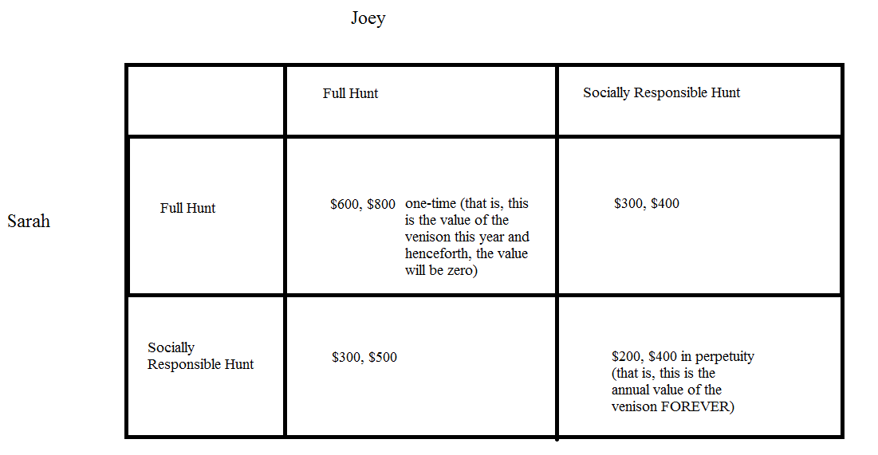

d. Given the above information and your analysis, what hunting choice will Joey make?

Answer:
To analyze Joey’s hunting choice think about this decision as two separate rows with Joey analyzing each row to determine what his optimal hunting strategy is.

On the first row, he assumes that Sarah no matter what he does is going to “Full Hunt”: given this assumption Joey can earn $800 worth of venison if he does “Full Hunt” or $400 worth of venison if he does “Socially Responsible Hunt”. Joey will realize that his optimal strategy if Sarah is “Full Hunt” is to also be “Full Hunt”.

On the second row, he assumes that Sarah no matter what he does is going to “Socially Responsible Hunt”: given this assumption Joey can earn $500 worth of venison if he does “Full Hunt” or $400 worth of venison per year forever if he does “Socially Responsible Hunt”. But, remember Joey only considers the value of the venison for this year and so he chooses to “Full Hunt” even if Sarah is choosing the “Socially Responsible Hunt”.

Joey will choose to “Full Hunt”.

e. Given the above information and your analysis, what hunting choice will Sarah make?

Answer:
To analyze Sarah’s hunting choice think about this decision as two separate columns with Sarah analyzing each column to determine what her optimal hunting strategy is.

On the first column, she assumes that Joey no matter what she does is going to “Full Hunt”: given this assumption Sarah can earn $600 worth of venison if she does “Full Hunt” or $300 worth of venison if she does “Socially Responsible Hunt”. Sarah will realize that her optimal strategy if Joey is “Full Hunt” is to also be “Full Hunt”.

On the second column, she assumes that Joey no matter what she does is going to “Socially Responsible Hunt”: given this assumption Sarah can earn $300 worth of venison if she does “Full Hunt” or $200 worth of venison per year forever if she does “Socially Responsible Hunt”. But, remember Sarah only considers the value of the venison for this year and so she chooses to “Full Hunt” even if Joey is choosing the “Socially Responsible Hunt”.

Sarah will choose to “Full Hunt”.

f. How does this example illustrate the Prisoner’s Dilemma? Is the hunting outcome that occurs the optimal one from the perspective of Joey and/or Sarah? Explain your answer.

Answer:
The Prisoner’s Dilemma illustrates how two individuals acting logically can end up with a result that is not optimal. In this example it would be optimal, from both a personal and a societal point of view, for the two individuals to choose to hunt in a socially responsible way. But, when each of these individuals only considers this year’s payoffs they elect to engage in “Full Hunt” and they decimate the deer population. This example is meant to illustrate the tragedy of the commons-a story of overharvesting of a common resource.

6. Suppose you are the President of a small country and you have decided to provide health insurance to all the residents of your country. You plan to provide this health insurance by first assessing how much money you will need to set aside per year to cover the health costs of your citizens; second, figuring out what each person would need to contribute if everyone contributed the same amount to insure that all would get health insurance coverage; third, figuring out how big a subsidy per person would need to be paid by the government in order that all could afford the health insurance; and fourth, figuring out how much more needs to be collected from the affluent in order to cover the costs of these subsidies for the lower income individuals.

Luckily you do have some information:
- The population of your country is 10 people; this population is constant over time.
- 10% of your population in any given year will have significant healthcare costs of $200,000 per person; 40% of your population in any given year will have some healthcare costs of $10,000 per person; and 50% of your population in any given year will have low healthcare costs of $2000 per person. No one in the population knows with certainty whether or not they will have significant healthcare costs, some health care costs, or low healthcare costs each year.
- You also have the following information about each individual in your country:

Individual | Income Available to be spent on health insurance (this is related to total gross income of the individual)
Joe | $10,000
Mary | $10,000
Sue | $10,000
Mabel | $20,000
Clyde | $20,000
Sylvester | $60,000
Owen | $100,000
Abigail | $100,000
Samantha | $100,000
Cletus | $100,000

a. Given the above information calculate the amount of money you will need to collect in order to cover this year’s health care costs in your country. Use the following table to help you calculate these costs.

% of population with health issue | Number of people with particular health issue | Cost per person of this particular health issue | Total cost for this health issue
10% of population have significant health costs
40% of population have some health costs
50% of population have low health costs
TOTAL COST OF COVERING ALL HEALTH ISSUES | ----- | -----

Answer:

% of population with health issue | Number of people with particular health issue | Cost per person of this particular health issue | Total cost for this health issue
10% of population have significant health costs | 1 | $200,000 per person | $200,000
40% of population have some health costs | 4 | $10,000 per person | $40,000
50% of population have low health costs | 5 | $2000 per person | $10,000
TOTAL COST OF COVERING ALL HEALTH ISSUES | ----- | ----- | $250,000

b. If everyone in the country is required to pay an equal amount for health insurance and the President wishes to collect a sufficient amount of funds to cover all health costs for the year, what payment will each individual be required to make?

Answer:
Since you need to collect $250,000 per year and there are 10 people in your country, you will need to collect $250,000/10 people are $25,000 per person.

c. Now that you have calculated the amount of money per person (the healthcare insurance premium) you will need to collect to cover the costs of the year’s health care, take the time to calculate how much additional money you will need to collect from the affluent in order to subsidize the lower income individuals when they go to purchase their health insurance. You will find it helpful to use the following table.

Individual | Income Available to be spent on health insurance (this is related to total gross income of the individual) | Amount of subsidy required in order for the individual to be able to afford the healthcare insurance premium for the year
Joe | $10,000
Mary | $10,000
Sue | $10,000
Mabel | $20,000
Clyde | $20,000
Sylvester | $60,000
Owen | $100,000
Abigail | $100,000
Samantha | $100,000
Cletus | $100,000
 | TOTAL ADDITIONAL AMOUNT OF MONEY THAT MUST BE COLLECTED TO COVER SUBSIDY TO LOWER INCOME INDIVIDUALS

Answer:

Individual | Income Available to be spent on health insurance (this is related to total gross income of the individual) | Amount of subsidy required in order for the individual to be able to afford the healthcare insurance premium for the year
Joe | $10,000 | $15,000
Mary | $10,000 | $15,000
Sue | $10,000 | $15,000
Mabel | $20,000 | $5,000
Clyde | $20,000 | $5,000
Sylvester | $60,000 | $0
Owen | $100,000 | $0
Abigail | $100,000 | $0
Samantha | $100,000 | $0
Cletus | $100,000 | $0
 | TOTAL ADDITIONAL AMOUNT OF MONEY THAT MUST BE COLLECTED TO COVER SUBSIDY TO LOWER INCOME INDIVIDUALS | $55,000

d. Suppose the cost of the healthcare insurance subsidy is divided evenly among those who can fully afford the healthcare insurance premium. What do you calculate will be the total amount per person that these individuals will need to pay for their healthcare insurance premium and their contribution to the subsidy fund? Show how you found your answer. Also fill in the following table to consolidate your work in this problem.

Individual | Income Available to be spent on health insurance (this is related to total gross income of the individual) | Amount of subsidy required in order for the individual to be able to afford the healthcare insurance premium for the year | Healthcare Insurance Premium (what the individual paid for their healthcare insurance) | Additional charge per person to cover healthcare subsidy costs | Total Payment per person for Healthcare Insurance (includes premium as well as any share of subsidy cost)
Joe | $10,000
Mary | $10,000
Sue | $10,000
Mabel | $20,000
Clyde | $20,000
Sylvester | $60,000
Owen | $100,000
Abigail | $100,000
Samantha | $100,000
Cletus | $100,000

Answer:

Our earlier work indicated that the healthcare insurance premium is $25,000 per person. Now, we also need to collect $55,000 to cover the cost of the subsidy for lower income individuals. There are 5 people who can fully fund their health insurance and now they will also need to fund the fund for the subsidy. So, ($55,000/5 people) gives us $11,000 per person. So, for these five people they will need to contribute $25,000 + $11,000 or $36,000 each in order for the healthcare fund to have sufficient funds to cover healthcare costs as well as the costs of the subsidies for low income individuals.

Here is the completed table: notice that if you sum the last column you do get $250,000, which is the total amount of dollars that must be collected in order to provide healthcare to everyone in this country for the year.

Individual | Income Available to be spent on health insurance (this is related to total gross income of the individual) | Amount of subsidy required in order for the individual to be able to afford the healthcare insurance premium for the year | Healthcare Insurance Premium (what the individual paid for their healthcare insurance) | Additional charge per person to cover healthcare subsidy costs | Total Payment per person for Healthcare Insurance (includes premium as well as any share of subsidy cost)
Joe | $10,000 | $15,000 | $10,000 | ---- | $10,000
Mary | $10,000 | $15,000 | $10,000 | ---- | $10,000
Sue | $10,000 | $15,000 | $10,000 | ---- | $10,000
Mabel | $20,000 | $5,000 | $20,000 | ---- | $20,000
Clyde | $20,000 | $5,000 | $20,000 | ---- | $20,000
Sylvester | $60,000 | $0 | $25,000 | $11,000 | $36,000
Owen | $100,000 | $0 | $25,000 | $11,000 | $36,000
Abigail | $100,000 | $0 | $25,000 | $11,000 | $36,000
Samantha | $100,000 | $0 | $25,000 | $11,000 | $36,000
Cletus | $100,000 | $0 | $25,000 | $11,000 | $36,000

e. To further complicate this issue let’s imagine that people in this group actually know more about their healthcare situation than does the President. The following table tells us what they privately know about their healthcare situation for the coming year (assume that this information is completely accurate).

Individual | Income Available to be spent on health insurance (this is related to total gross income of the individual) | Private Information the individual has about his healthcare for this year
Joe | $10,000 | Low Healthcare costs
Mary | $10,000 | Significant Healthcare costs
Sue | $10,000 | Some Healthcare costs
Mabel | $20,000 | Low Healthcare costs
Clyde | $20,000 | Some Healthcare costs
Sylvester | $60,000 | Low Healthcare costs
Owen | $100,000 | Some Healthcare costs
Abigail | $100,000 | Some Healthcare costs
Samantha | $100,000 | Low Healthcare costs
Cletus | $100,000 | Low Healthcare costs

Given your answers in (b) and (d), make a prediction about whether or not each of these individuals will be willing to voluntarily pay into the healthcare pool. Assume that all individuals in this country consider only the financial costs to themselves of buying the healthcare insurance and their private healthcare information (that is, no one is altruistic in this community!). Use the following table to consolidate your predictions. Explain your answers.

Individual | Income Available to be spent on health insurance (this is related to total gross income of the individual) | Private Information the individual has about his healthcare for this year | Projected Total Payment per person for Healthcare Insurance (includes premium as well as any share of subsidy cost) from (d) | Projected Healthcare costs for the year | Prediction as to participation in healthcare insurance program if given option to participate or not
Joe | $10,000 | Low Healthcare costs
Mary | $10,000 | Significant Healthcare costs
Sue | $10,000 | Some Healthcare costs
Mabel | $20,000 | Low Healthcare costs
Clyde | $20,000 | Some Healthcare costs
Sylvester | $60,000 | Low Healthcare costs
Owen | $100,000 | Some Healthcare costs
Abigail | $100,000 | Some Healthcare costs
Samantha | $100,000 | Low Healthcare costs
Cletus | $100,000 | Low Healthcare costs

Answer:

From (d) you know the projected total payment per person for healthcare insurance (includes premium as well as any share of subsidy cost). You also can now project healthcare costs based on private information. When you compare these two columns there are three possibilities: the payment for coverage will be either greater than, equal to, or less than the projected healthcare costs. So, if the payment for coverage is greater than the projected healthcare costs you will opt out of coverage and instead self-insure; if the payment for coverage is less than the projected healthcare costs you will opt in for coverage; and it the payment for coverage is equal to the projected healthcare costs the costs to you are the same whether you join the insurance pool or opt to self-insure.

Clearly if people have the right to opt in or opt out the ability to cover the medical costs of the country collapses as the amount collected from the payments made by people who opt in will be insufficient to provide enough funds to cover the costs of healthcare. This explains why there is an Individual Mandate in the Affordable Care Act (“Obamacare”): the healthcare insurance market is a market that will clearly have a tendency to fall apart due to the adverse selection problem. People electing to purchase insurance are adversely selected: they are a more expensive pool of individuals to insure than would be the case if the whole population was included in the insurance pool.

Individual | Income Available to be spent on health insurance (this is related to total gross income of the individual) | Private Information the individual has about his healthcare for this year | Projected Total Payment per person for Healthcare Insurance (includes premium as well as any share of subsidy cost) from (d) | Projected Healthcare costs for the year | Prediction as to participation in healthcare insurance program if given option to participate or not
Joe | $10,000 | Low Healthcare costs | $10,000 | $2000 | Will not participate
Mary | $10,000 | Significant Healthcare costs | $10,000 | $200,000 | Will participate
Sue | $10,000 | Some Healthcare costs | $10,000 | $10,000 | May or may not participate
Mabel | $20,000 | Low Healthcare costs | $20,000 | $2000 | Will not participate
Clyde | $20,000 | Some Healthcare costs | $20,000 | $10,000 | Will not participate
Sylvester | $60,000 | Low Healthcare costs | $36,000 | $2000 | Will not participate
Owen | $100,000 | Some Healthcare costs | $36,000 | $10,000 | Will not participate
Abigail | $100,000 | Some Healthcare costs | $36,000 | $10,000 | Will not participate
Samantha | $100,000 | Low Healthcare costs | $36,000 | $2000 | Will not participate
Cletus | $100,000 | Low Healthcare costs | $36,000 | $2000 | Will not participate

f. Given your work in this problem, provide a brief explanation of why the Affordable Care Act (“Obamacare”) includes both a subsidy for low income individuals as well as an Individual Mandate that requires everyone to purchase healthcare insurance.

Answer:
The adverse selection problem exists in the market of health insurance because of asymmetric information. People know more about their health and their potential health care issues than do insurers, so even when insurance companies do their homework about how much someone will cost them to insure, they can only know so much. When only sick people or people with a higher likelihood of becoming sick buy insurance, their costs of care will be relatively high compared to a more diverse (in terms of healthcare needs) pool of people and the insurance company will need to collect relative high insurance premiums for this group. Higher premiums make insurance even less attractive for healthy people, causing even more of them to drop out of the healthcare insurance market. As this problem continues to become a bigger problem it leads to coverage becoming too expensive for almost everyone and the healthcare insurance market fails. This is what we have now - a market failure for individual health insurance.

There are two types of subsidies in Obamacare. First, the affluent members are subsidizing the poor members. This transfer payment makes health insurance affordable for everyone. Second, the healthy low-cost members are subsidizing the sick high-cost members. It is another transfer payment from those who might need health care but don’t yet, to those who do need it now. For Obamacare to Work, an individual mandate is necessary. Requiring all people to either purchase plans or face a penalty is a way to broaden the risk pool and avoid the adverse selection problem. A broader risk pool means that people become part of large, actuarially stable groups so that the average cost is affordable.

7. Citizens in a small town each suffer $1 worth of irritation for each bushel of leaves that is burned in town. If the citizens haul their leaves to the town dump where they are composted there is a charge of $20 per bushel of leaves. There are 25 people living in the town, each of whom minimize their costs of getting rid of leaves, and each of these people has 10 bushels of leaves.

- If there are no restrictions of any kind on burning leaves and negotiation costs among citizens are prohibitive, what will happen to the leaves in the town?

Answer:
The private cost of burning leaves is $1-per-bushel, while the private cost of hauling is $20-per-bushel. So, all the leaves will be burned.

- What is the marginal private cost of burning a bushel of leaves? What is the marginal social cost to society of burning a bushel of leaves? For each of these questions provide an explanation for how you found the answer.

Answer:
The marginal private cost of burning an additional bushel leaves is $1 for each citizen. There are 25 people living in the town however that all suffer irritation when leaves are burned. So, the marginal social cost of burning an additional bushel of leaves is $25.

- How many dollars’ worth of total irritation will each person experience if all the leaves are burned? Is this the most efficient solution to this problem? Explain your answer.

Answer:
If all 250 bushels of leaves are burned, the total social cost of this will be $250 per person or $6250 in all. In contrast, if each person were to haul their leaves to the dump, this would cost $200 per person or $5000 in all. Hauling the leaves to the dump is a more efficient solution from a societal point of view.

- If each leaf burner had to pay the affected citizens to cover the irritation cost that these people experience, would this lead to a different decision about whether to burn leaves or not? Explain your answer.
Answer:
Yes, if each citizen had to compensate everyone for burning their leaves this would cost them $240 or ($1 of irritation costs per bushel per person)(10 bushels)(24 people). Since $240 is a lot more than the $10 of irritation costs they personally experience this would lead them to reconsider their decision to burn their leaves.

- If the citizens paid a $10-per-bushel tax on each bushel burned, would this tax cause citizens to decide to haul their leaves rather than burn them? Explain the reasoning behind your answer. If the tax were $19.50 per bushel burned, would this tax cause citizens to decide to haul their leaves rather than burn them? Explain the reasoning behind your answer.

Answer:
The $10 tax per bushel of burned leaves would not change the individual’s decision since the cost of burning leaves including the tax to the individual would still be less than the cost of hauling the bushel of leaves to the dump for the individual ($11 versus $20 per bushel). Individuals would still burn leaves.

The $19.50 tax per bushel of burned leaves would change the individual’s decision since the cost of burning leaves including the tax to the individual would now be greater than the cost of hauling the leaves to the dump for the individual ($20.50 versus $20 per bushel). Individuals with this tax would choose to haul their leaves rather than burn them.

- If you were running for mayor of the town and campaigned for a leaf-burning prohibition in the town, what do you think the response of the residents would be? That is, do you think they would vote for you?

Answer:
The citizens would vote for you because they would rather have everyone haul leaves.

8. A beekeeper lives adjacent to an apple orchard. The orchard owner benefits from the bees because each hive pollinates about one acre of apple trees. The orchard owner pays nothing for this service, however, because the bees come to the orchard without his having to do anything. Because there are not enough bees to pollinate the entire orchard, the orchard owner must complete the pollination by artificial means, at a cost of $10 per acre of trees.

Suppose that beekeeping has a marginal cost 10+2Q: that is, the addition to total cost to the beekeeper of maintaining an additional hive can be calculated as MPC = [(10 + 2Q) dollars], where Q is the number of beehives. Furthermore, suppose that each hive produces $20 worth of honey.

- Use the above information and remembering the idea that one should engage in activity as long as the marginal benefit from the activity is greater than or equal to the marginal cost of that activity to calculate the optimal number of beehives the beekeeper should maintain if he only considers his own marginal costs and marginal benefits. Explain how you got your answer.

Answer:
The optimal number of beehives from the beekeeper’s perspective is that number where the marginal benefit of having a hive ($20) is equal to the marginal cost of having a hive (10 + 2Q). So, setting these two measures equal to one another we have 20 = (10 + 2Q) or Q = 5 beehives.

- Is this the efficient number of hives from a societal perspective? That is, if you take into account any externality that occurs, would the socially optimal number of hives be the same as what you found in (a)? Explain your answer.

Answer:
From the apple grower’s perspective if there are not enough bees to pollinate the orchard, she will need to pay $10 per acre for artificial pollination. So, we can think of this as an additional social benefit of having bees: thus, the marginal private benefit of bees to the beekeeper is $20 per hive, but the marginal social benefit to the beekeeper and the orchard owner of having the bees is $30 per hive. Use this value for the marginal social benefit and set it equal to the marginal cost of having a hive to get the socially optimal number of beehives: thus, 30 = (10 + 2Q) or Q socially optimal will be equal to 10 beehives.

- What changes in this scenario might you propose that would lead to the more efficient operation with regard to the number of beehives?

Answer:
Here your answers may vary, but two possible answers are the following. A radical change that would lead to more efficient operations would be the merger of the apple orchard’s business with the beekeeper’s business. This merger would internalize the positive externality of bee pollination. Short of a merger, the orchard owner and beekeeper could enter into a contract for pollination services.

