Economics 100
Spring 2015
Answers to Homework #3
Due March 19, 2015

Directions: The homework will be collected in a box before the lecture. Please place your name on top of the homework (legibly). Make sure you write your name as it appears on your ID so that you can receive the correct grade. Late homework will not be accepted so make plans ahead of time. Please show your work. Good luck!

Please realize that you are essentially creating “your brand” when you submit this homework. Do you want your homework to convey that you are competent, careful, and professional? Or, do you want to convey the image that you are careless, sloppy, and less than professional. For the rest of your life you will be creating your brand: please think about what you are saying about yourself when you do any work for someone else!

1. Consider the market for bicycles depicted in the graph below. Both the demand and the supply curves are linear in this market.
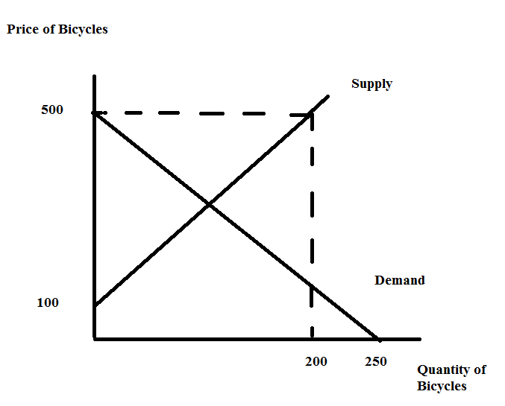
a. Using the information in the above graph, write an equation for the demand curve and an equation for the supply curve. Show how you found your answers.

b. Given the information in the above graph and your equations from (a), find the equilibrium price and quantity in this market. Show your work.

c. Given the information in the above graph, calculate the value of consumer surplus (CS) and producer surplus (PS). Show your work.

Suppose the government in this economy imposes a price ceiling of $200 in this market.

d. Given this price ceiling answer the following questions:
1. Determine how many bicycles will be sold in this market once this price ceiling is implemented.
2. Which side of the market is the "short side"?
3. Determine the value of consumer surplus with the price ceiling (CSpc) and the value of producer surplus with the price ceiling (PSpc). Show your work. Provide a well labeled graph to illustrate your answer.
4. Consider consumers and producers of bicycles: which group favors the implementation of this price ceiling? Explain your answer.

Now, suppose instead of the price ceiling, the government in this economy imposes a price floor of $400 in this market.

e. Given this price floor answer the following questions:
1. Determine how many bicycles will be sold in this market once this price floor is implemented.
2. Which side of the market is the "short side"?
3. Determine the value of consumer surplus with the price floor (CSpf) and the value of producer surplus with the price floor (PSpf). Show your work. Provide a well labeled graph to illustrate your answer.
4. Consider consumers and producers of bicycles: which group favors the implementation of this price floor? Explain your answer.

Now, suppose that the government implements neither a price ceiling nor a price floor in this market. Instead the government implements an excise tax of $100 per bicycle in this market and this excise tax is placed on producers of bicycles.

f. Given this excise tax, analyze its impact on the market for bicycles. Answer the following questions (show your work for all questions):
1. What is the quantity of bikes sold in this market after the implementation of the excise tax? What is the price in this market after implementation of the excise tax?
2. What is the tax revenue the government will earn with this excise tax?
3. What is the value of consumer surplus with the excise tax (CSet)?
4. What is the value of producer surplus with the excise tax (PSet)?
5. What is the economic incidence of the tax on consumers (Consumer Tax Incidence = CTI)?
6. What is the economic incidence of the excise tax on producers (Producer Tax Incidence = PTI)?
7. Provide a well labeled graph to illustrate your answers.

Answer:
a. Let's start with demand: the y-intercept is $500 so we can use this information to write the demand curve as follows:
Y = mX + b where this is the general formula for the slope-intercept form, m is slope and b is the y-intercept. Thus,
P = mQ + 500
Then, the slope of the demand curve is defined as slope = rise/run = -500/250 = -2. So, the demand curve can be written as P = 500 – 2Q.

The supply curve has a y-intercept of $100. So, Y = mX + b can be rewritten as:
P = mQ + 100
Then, the slope of the supply curve is defined as slope = rise/run = 400/200 = 2. So, the supply curve can be written as P = 100 + 2Q.

b. Equilibrium in this market occurs where demand intersects supply. Thus,
500 – 2Q = 100 + 2Q
400 = 4Q
Q = 100 bicycles
To find the equilibrium price use either the demand curve or the supply curve:
P = 500 – 2Q = 500 – 2(100) = $300
Or, P = 100 + 2Q = 100 + 2(100) = $300

c. CS = (1/2)($500 per bike - $300 per bike)(100 bikes) = $10,000
PS = (1/2)($300 per bike - $100 per bike)(100 bikes) = $10,000
d.
1. With the price ceiling set at $200 per bike, the quantity of bicycles supplied will be 50 bikes while the quantity of bicycles demanded will be 150 bikes. There will be an excess demand. Only 50 bikes will be consumed in this market.
2. The supply side of the market is the short side of the market.
3. CSpc = (1/2)($500 per bike - $400 per bike)(50 bikes) + ($400 per bike - $200 per bike)(50 bikes) = $2500 + $10,000 = $12,500
PSpc = (1/2)($200 per bike - $100 per bike)(50 bikes) = $2500
Here's the graph to illustrate this program:
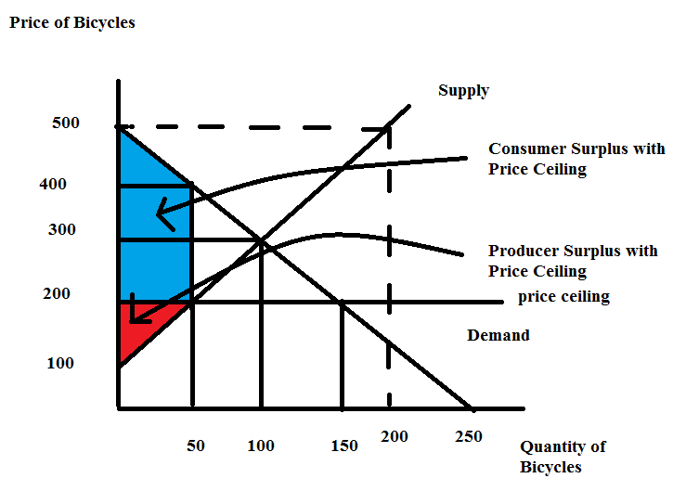
4. Consumers will favor the implementation of this price ceiling since their surplus increases from $10,000 to $12,500 with this price ceiling.
e.
1. With the price floor set at $400 per bike, the quantity of bicycles supplied will be 150 bikes while the quantity of bicycles demanded will be 50 bikes. There will be an excess supply. Only 50 bikes will be consumed in this market.
2. The demand side of the market is the short side of the market.
3. CSpf = (1/2)($500 per bike - $400 per bike)(50 bikes) = $2500 = $2,500
PSpc = (1/2)($200 per bike - $100 per bike)(50 bikes) + ($400 per bike - $200 per bike)(50 bikes) = $2500 + $10,000 = $12,500
Here's the graph to illustrate this program:
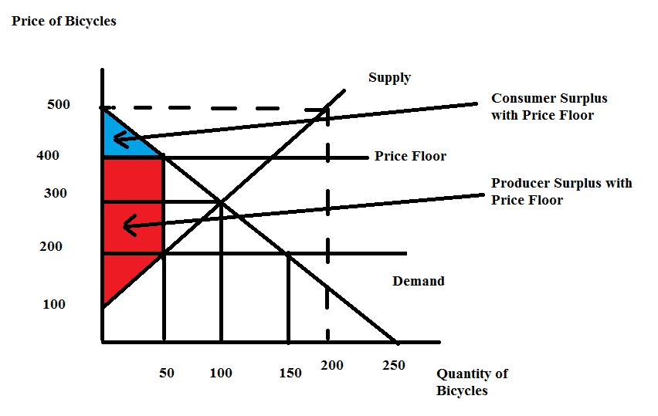

4. Producers will favor the implementation of this price ceiling since their surplus increases from $10,000 to $12,500 with this price ceiling.

f.
1. The new supply curve with the excise tax is a supply curve that has shifted to the left relative to the initial supply curve. The equation for this new supply curve is: P = 200 + 2Q. Use this new supply curve and the demand curve to find the equilibrium price and quantity once the excise tax is implemented. Thus,
500 – 2Q = 200 + 2Q
4Q = 300
Qe with the excise tax = 75 bikes
Pe with the excise tax = 200 + 2(75) = $350 per bike (using the supply curve) or
Pe with the excise tax = 500 – 2(75) = $350 per bike (using the demand curve).
2. Tax Revenue = ($100 per bike)(75 bikes) = $7500
3. CSet = (1/2)($500 per bike - $350 per bike)(75 bikes) = $5625
4. PSet = (1/2)($250 per bike - $100 per bike)(75 bikes) = $5625
5. CTI = ($350 per bike - $300 per bike)(75 bikes) = $3750
6. PTI = ($300 per bike - $250 per bike)(75 bikes) = $3750
Note: CTI + PTI = Tax Revenue
3750 + 3750 = 7500
7. Here’s the graph:
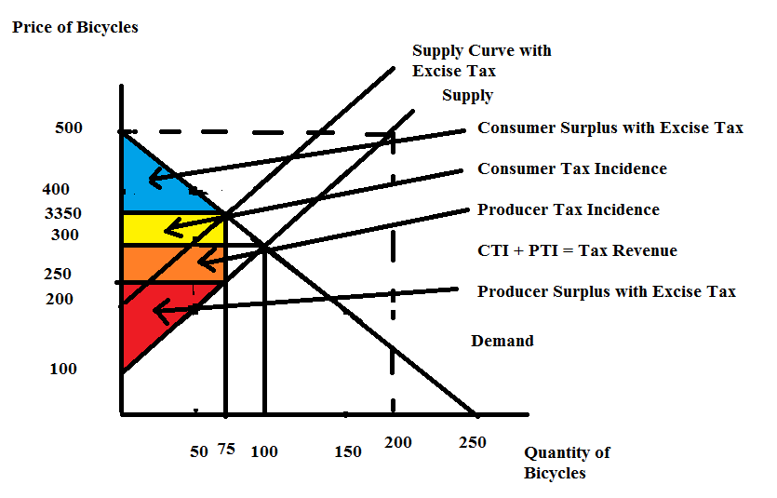

2. Return to the set-up you had in (1). Now, let's compare three different excise taxes. An excise tax levied on producers of $100 per bike, an excise tax levied on producers of $200 per bike, and an excise tax levied on producers of $300 per bike. Analyze these three different excise taxes and then organize your results in the following table where CTI is the consumer tax incidence, PTI is the producer tax incidence, CS is consumer surplus, PS is producer surplus, and deadweight loss is DWL. Show your work in space below your completed table.

Excise Tax | Qe with Excise Tax | P paid by consumers | CTI | PTI | Tax Revenue | CS | PS | DWL
$100 per bike
$200 per bike
$300 per bike

Answer:

Here is the completed table:
Excise Tax | Qe with Excise Tax | P paid by consumers | CTI | PTI | Tax Revenue | CS | PS | DWL
$100 per bike | 75 bikes | $350 | $3750 | $3750 | $7,500 | $5625 | $5625 | $1250
$200 per bike | 50 bikes | $400 | $5,000 | $5,000 | $10, 000 | $2500 | $2500 | $5,000
$300 per bike | 25 bikes | $450 | $3,750 | $3,750 | $7,500 | $625 | $625 | $11,250

For the excise tax of $100 per bike:
See answers in (1). Then, here is the DWL calculation:
DWL with $100 per bike excise tax = (1/2)($100 per bike)(100 bikes – 75 bikes) = $1250

For the excise tax of $200 per bike:
First, get the new supply curve: P = 300 + 2Q. Then solve for the new equilibrium quantity and price given this excise tax:
300 + 2Q = 500 – 2Q
4Q = 200
Q = 50 bikes
P = 500 – 2(50) = $400 per bike
CTI = ($400 per bike - $300 per bike)(50 bikes) = $5,000
PTI = ($300 per bike - $200 per bike)(50 bikes) = $5,000
Tax Revenue = ($200 per bike)(50 bikes) = $10,000
CS = (1/2)($500 per bike - $400 per bike)(50 bikes) = $2500
PS = (1/2)($200 per bike - $100 per bike)(50 bikes) = $2500
DWL = (1/2)($200 per bike)(100 bikes – 50 bikes) = $5,000

For the excise tax of $300 per bike:
First, get the new supply curve: P = 400 + 2Q. Then solve for the new equilibrium quantity and price given this excise tax:
400 + 2Q = 500 – 2Q
4Q = 100
Q = 25 bikes
P = 500 – 2(25) = $450 per bike
CTI = ($450 per bike - $300 per bike)(25 bikes) = $3,750
PTI = ($300 per bike - $150 per bike)(25 bikes) = $3,750
Tax Revenue = ($300 per bike)(25 bikes) = $7,500
CS = (1/2)($500 per bike - $450 per bike)(25 bikes) = $625
PS = (1/2)($150 per bike - $100 per bike)(25 bikes) = $625
DWL = (1/2)($300 per bike)(100 bikes – 25 bikes) = $11,250

3. Consider the market for apples in a small, closed economy. This market can be described by the following demand and supply equations where P is the price per apple measured in cents and Q is the number of apples:
Domestic Demand Curve: Q = 100 – P
Domestic Supply Curve: Q = P – 20

a. Given the above information, calculate the equilibrium price (Pe) and equilibrium quantity (Qe) in this market. Show your work.

b. Given the above information, draw a graph representing the domestic market for apples. In your graph, measure price on the vertical axis and quantity on the horizontal axis. Label the graph completely and carefully. Then, calculate the value of consumer surplus (CS) and producer surplus (PS). Label the areas of CS and PS in your graph. Calculate the value of total surplus (TS).

Suppose that the world price of apples is 40 cents per apple. This small, closed economy decides to open its apple market to trade.

c. Given that this market is now open to trade, what will be the price of apples in this small economy? How many apples will domestic producers produce? How many apples will domestic consumers consume? How many apples will be imported or exported? Explain your answers and provide a well labeled graph illustrating these answers.

d. Given that this market is now open to trade, what will be the value of CS' in the domestic market now? What will be the value of PS' in the domestic market now? Shade these new areas on the graph you drew in (c) and label them clearly. What is the value of TS' for this domestic economy when the apple market is open to trade? In this domestic economy who favors opening this market to trade and why do they hold this view? In this domestic economy who is against opening this market to trade and why do they hold this view?

e. Suppose this domestic economy opens its apple market to trade, but at the same time it implements a tariff that raises the price of an apple to 50 cents. Given this tariff, what is the value of CS", the value of PS", the tariff revenue the government earns, the value of the DWL from the implementation of the tariff, and the level of imports once the tariff is imposed on this market? Show how you found your answers. Then, provide a well labeled graph showing these areas and illustrating your analysis.

Answers:
a. To find the equilibrium price and quantity set the demand equation equal to the supply equation:
100 – Pe = Pe – 20
2Pe = 120
Pe = 40 = 60 cents per apple
To find the equilibrium quantity, use Pe in either the demand or the supply equation:
Qe = 100 – Pe = 100 – 60 = 40 apples
Or, Qe = Pe – 20 = 60 – 20 = 40 apples

b. CS = (1/2)(100 cents per unit – 60 cents per unit)(40 units) = 800 cents = $8.00
PS = (1/2)(60 cents per unit – 20 cents per unit)(40 units) = 800 cents = $8.00
TS = CS + PS = $16.00
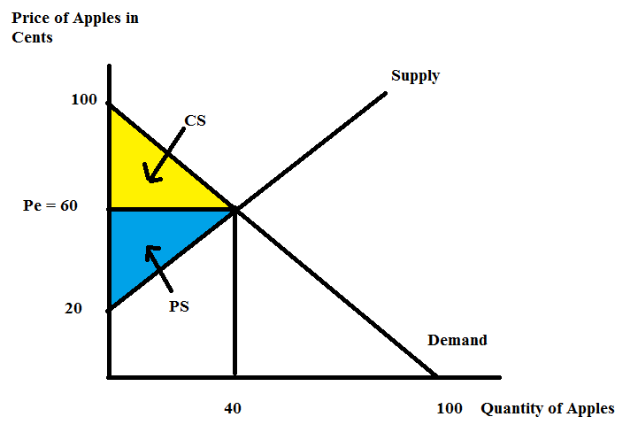
c. At the world price of 40 cents per apple, the domestic demand is 60 apples: to see this use the demand curve and the price of 40 cents per apple. Qd = 100 – Pw = 100 – 40 = 60 apples.
At the world price of 40 cents per apple, the domestic supply is 20 apples: to see this use the supply curve and the price of 40 cents per apple. Qs = Pw – 20 = 20 apples.
Thus, at the world price there is an excess demand for apples in this domestic economy and this excess demand will be satisfied through the importation of 40 apples (the difference between the quantity of apples demanded domestically and the quantity of apples supplied domestically at the world price of 40 cents per apple).
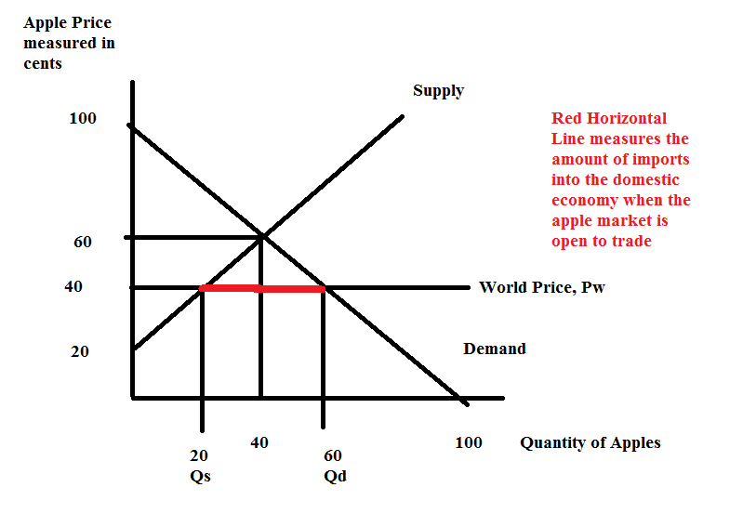
d. When this market opens to trade consumer surplus increases and producer surplus decreases. Domestic consumers will therefore favor opening this market to trade while domestic producers will be against opening this market to trade.
CS' = (1/2)(100 cents per apple – 40 cents per apple)(60 apples) = 1800 cents = $18.00
PS' = (1/2)(40 cents per apple – 20 cents per apple)(20 apples) = 200 cents = $2.00
TS' = CS' + PS' = $18 + $2 = $20.00
Notice that TS increases when this market opens to trade: trade is beneficial. But, PS decreases and CS increases when this market opens to trade: trade has distributional consequences-in this example, domestic consumers win with trade while domestic producers lose with trade.
Here's the graph:
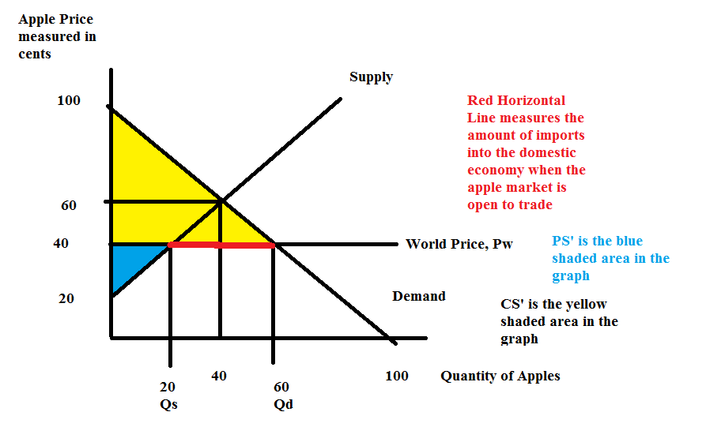
e. Let's start by calculating the quantity demanded domestically at the tariff price of 50 cents per apple: P = 100 – Qd and therefore 50 = 100 – Qd or the quantity demanded domestically with the tariff is 50 apples.
The quantity supplied domestically at the tariff price of 50 cents per apple: P = 20 + Qs and therefore 50 = 20 + Qs or the quantity supplied domestically with the tariff is 30 apples.
Imports with the tariff will now be 50 apples – 30 apples of 20 apples.
CS" = (1/2)(100 cents per apple – 50 cents per apple)(50 apples) = $12.50
PS" = (1/2)(50 cents per apple – 20 cents per apple)(30 apples) = $4.50
Government revenue from the tariff = (increase in price due to tariff)(number of imports with tariff) = (10 cents per apple)(20 apples) = $2.00
TS" = CS" + PS" + government tariff revenue = $12.50 + $4.50 + $2.00 = $19.00
Note that TS" is less than TS': the total surplus with the tariff is $1.00 less than the total surplus when the market is opened to trade: so our DWL calculation should be equal to $1.00.
DWL = (1/2)(50 cents per apple – 40 cents per apple)(30 apples – 20 apples) + (1/2)(50 cents per apple – 40 cents per apple)(60 apples – 50 apples) = $1.00!
Here's the graph:
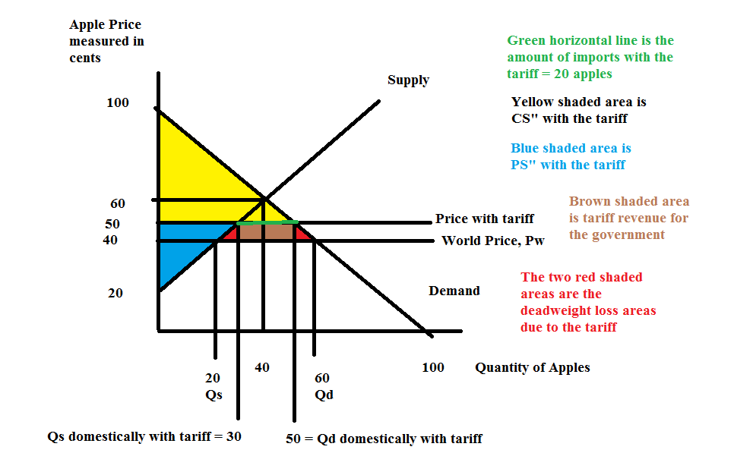

4. Consider the market for apples in a small, closed economy. This market can be described by the following demand and supply equations where P is the price per apple measured in cents and Q is the number of apples:
Domestic Demand Curve: Q = 100 – P
Domestic Supply Curve: Q = P – 20
Suppose that the world price of apples is 40 cents per apple. This small, closed economy decides to open its apple market to trade. (Note: that this is the same apple market you just analyzed in the last question.)

a. Suppose this domestic economy opens its apple market to trade, but at the same time it implements an import quota of 20 apples. Draw a graph of this market that illustrates this import quota by representing the import quota as a new supply curve that includes this import quota. Label the graph carefully and completely and make sure that all points of intersection have their coordinates identified.

b. Write an equation for the new supply curve that includes the initial supply plus the import quota.

c. Use the new supply curve and the initial demand curve to solve for the new equilibrium quantity and equilibrium price with this import quota. Show your work. How many apples will be consumed? How many apples will be produced domestically? How many apples will be imported?

d. Calculate the value of consumer surplus with the import quota (CS*), producer surplus with the import quota (PS*), license holder revenue, and the deadweight loss (DWL*) from the implementation of this import quota. Show your work. Then, provide a well labeled graph that illustrates these areas.

e. Given the import quota described in this problem, what is the maximum amount an importer would pay for the license rights to import apples given this import quota? Explain your answer.

Answers:
a.
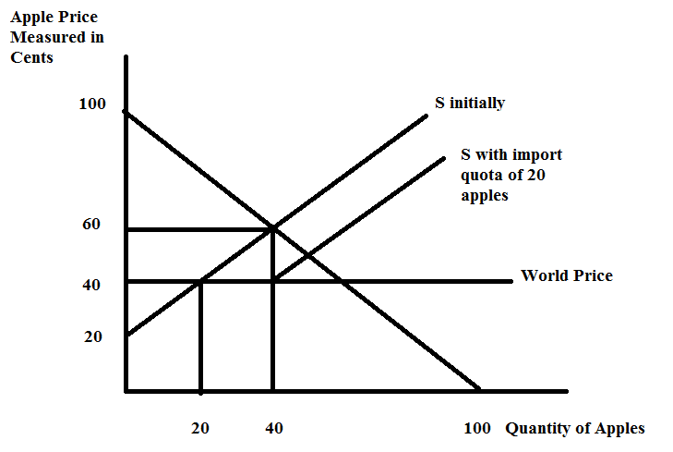
b. The S with the import quota of 20 apples can be written as follows. The initial supply curve is:
Q = P – 20
Rewrite this in slope-intercept form:
P = Q + 20 and note that the slope of this initial supply curve is 1. The new supply curve will have the same slope since the two lines are parallel. Thus,
P = Q + b is the base for the new supply curve equation. Now, plug in a point that you know sits on this new supply curve to solve for the new y-intercept of this curve. Points (Q, P) that sit on this line include (40, 40) and (60, 60): so choose one of these.
Thus, 40 = 40 + b or b = 0. The equation for the supply curve that includes the import quota can be written as:
P = Q

c. Use the demand curve, Q = 100 – P and the new supply curve with the import quota, Q = P, to find the new equilibrium. Thus,
100 – P = P
2P = 100
P = 50 cents per apple with the import quota
Q demanded domestically with the import quota is 50 apples.
The Q supplied domestically with the import quota is found by using the original supply equation and the price with the import quota: Q = P – 20 = 50 – 20 = 30 apples supplied domestically with the import quota.
Number of apples imported will be the 20 apples that are allowed with the import quota. Note: the quantity supplied domestically with the import quota plus the import quota is 30 + 20 or 50 apples, which is exactly the quantity demanded domestically at a price of 50 cents per apple.

d. CS* = (1/2)(100 cents per apple – 50 cents per apple)(50 apples) = $12.50
PS* = (1/2)(50 cents per apple – 20 cents per apple)(30 apples) = $4.50
License Holder Revenue from the import quota = (increase in price due to import quota)(number of imports with import quota) = (10 cents per apple)(20 apples) = $2.00
TS* = CS* + PS* + license holder revenue = $12.50 + $4.50 + $2.00 = $19.00
Note that TS* is less than TS' (the Total Surplus if this market is open to trade: see last problem where you calculated this value): the total surplus with the import quota is $1.00 less than the total surplus when the market is opened to trade: so our DWL calculation should be equal to $1.00.
DWL = (1/2)(50 cents per apple – 40 cents per apple)(30 apples – 20 apples) + (1/2)(50 cents per apple – 40 cents per apple)(60 apples – 50 apples) = $1.00!
Here's the graph (notice that this graph is very much like the one we had in the last problem where we analyzed a tariff that resulted in imports of 20 apples!):
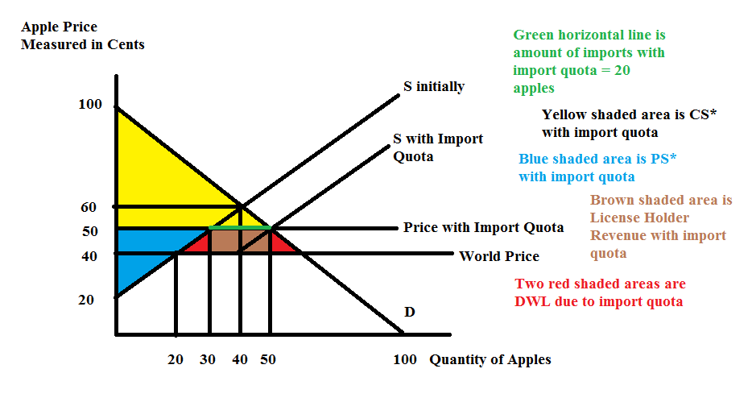
e. If you are lucky enough to be the importer allowed to import the 20 apples into this market you find that you increase your revenue by $2.00 since you are now selling those 20 apples at a price of 50 cents each instead of the world price of 40 cents each. So, having this license provides you with an additional $2.00 in revenue and this $2.00 would be the maximum you would be willing to pay for the license. If you pay this full amount you would still be able to sell the apples effectively at the world price and that is as good a deal as you can get if you have to pay in full for the license to import the good.

5. Let's do some work with the externality issue. For each for the following situations analyze what the market outcome is and what the socially optimal amount of the good should be. I will do a sample one for you first.

Sample: A community is situated on the banks of a pristine river. Upstream there is a beer producer who uses this beautiful water to brew its beer and then discharges the industrial waste from its production back into the river. This has resulted in fish kills, strong and unpleasant smells, and the closing of the community's beach. Depict the beer market's current market outcome as well as what the socially optimal outcome would look like. Explain your analysis. In your analysis make sure you identify any deadweight loss (DWL) that is occurring. The simplest solution will be either a tax on the good or a subsidy on the good: please advise as to which policy is needed!

Sample Answer:
The current market outcome is that too much beer is being produced because the beer producer is not taking into account the full costs of the beer production. If these costs were internalized in this market, the beer producer would see a shift in the supply curve for beer to the left, resulting in a higher price for beer and a lower quantity of beer being produced. Here's the graph:
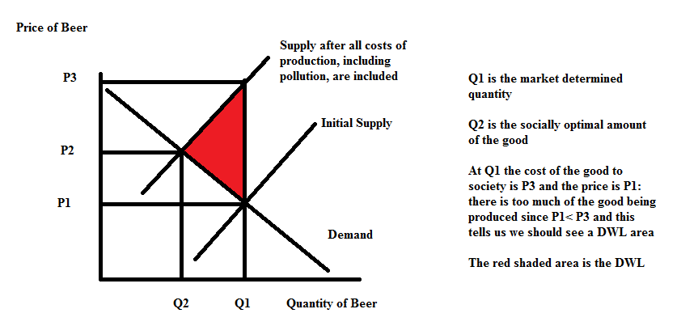
In this case we need a tax on the good to shift the supply curve from its initial position to the left.

a. Suppose Amanda's Mechanics has pioneered a new robotic technology that has been immensely important for her business, but is also potentially providing large spillover effects to other non-related businesses that will be able to use the robotic technology in different settings than the one initially imagined by Amanda's Mechanics. Given these spillover effects analyze what's happening in the market for good X when the market does not take into account these spillover effects. Then analyze what would happen if the market internalized these spillover effects. Label your graph clearly and completely.

b. Researchers have discovered that regular aerobic exercise provides substantial benefits to the individuals who engage in this activity. These benefits also impact the whole community because healthcare costs fall dramatically when individuals engage in regular aerobic exercise. Given this information analyze what's happening in the market for exercise when the market does not take into account these social benefits. Then analyze what would happen if the market internalized these social benefits gleaned from consumption of aerobic exercise. Label your graph clearly and completely.

c. Each year Josie's neighbors put up a tasteful selection of holiday lights. These holiday lights bring welcome cheer to all the neighbors who live nearby. Josie's neighbors only consider the private benefits they get from enjoying the consumption of these lights. Analyze the market for holiday lights when the market does not take into account the social benefits that others receive from enjoying the lights. Then analyze what would happen if the market internalized these social benefits. Label your graph clearly and completely.

Answer:
a.

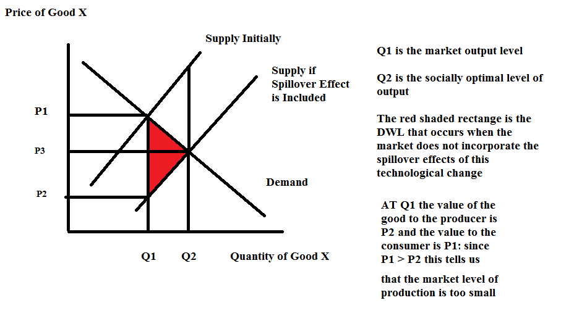
b.
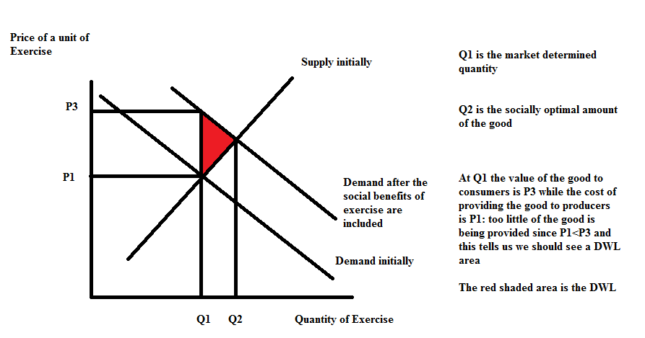
c.

6. For this question go to the blog "Life's Curiosities: An Economist's Perspective". You can find this blog at http://www.billkellyassociates.com/. Once you are at the site, look around a bit and then proceed to this question.

Looking on the "Contents" page scroll down until you find "6. What's a Student to Do?" and "7. Amazing Career Database".

a. Read the whole entry "What's a Student to Do?" and then read the entry "Check Out an Occupation”. Study these articles carefully. What would you say are the two most important things to know from these articles? Write a short paragraph that highlights at least two points that you found interesting in these two entries. How did these readings impact you? Did you learn something or did you find your thinking about your education altered because of these readings? Be thoughtful here. If you would like, shoot Bill Kelly a short (or long) email about the experience: his email is bkelly@bus.wisc.edu. (We want you to be part of our "focus group".)

Answer:
Here's is Bill's quick response:

The two most important things I found out was first that I can benefit economically from learning what I would be especially good at, and second I can probably do better economically if I pay attention to the high and low end of salary ranges for each occupation I consider rather than comparing the median salaries across different occupations. I was impressed that I should focus on what occupation I am best at rather than what occupation has a higher median salary.

b. Now go to the websites discussed in the article “Check Out an Occupation". Use the websites that are referred to in this article to research a potential career you think you are interested in. Find out information about this career from this data set. What is the salary for the top 10% of earners in this career? What is the salary for the bottom 10% of earners in this career? What particular skills and attributes are necessary to work in this profession?

Answer:
Here's is Bill's (and mine-I was curious to see how "good a fit" there was for me in this profession!) quick response:

I checked out being a post-secondary teacher of economics. The 90th and 10th percentiles in salaries are, respectively $174,000 and $50,900, in Wisconsin. Speaking, writing, critical thinking, and administration are necessary to work in this profession. [Note from Professor Kelly: reflecting on the work I do on a regular basis I found the description of the work a post-secondary teacher of economics does is very accurate!)

c. Repeat this process for another career that you think you might be interested in pursuing. I want you to look into careers that you find attractive or compelling since we are talking about YOUR LIFE.

d. For each of the careers you explored in (b) and (c) write separate paragraphs where you evaluate your current strengths, interests and attributes with regard to the specific career you researched. Do you think you are a potentially good fit for the career you researched? If yes, explain why. If no, explain why. There should be two paragraphs minimum here since you are researching two different careers.

Answer:
From Bill: I think I am very good at critical thinking, good at writing and reasonably good at speaking. I am not so good at the administrative tasks involved.
From Professor Kelly: I think I am quite strong on the verbal, whether oral or written communication. I think I am very organized and therefore a strong administrator. I also think that I have a set of social skills that allows me to work well with large groups of students and in motivating large groups of students. I believe I am a very strong fit for the occupation that was described in the website.

e. Write a final paragraph about how this experience impacted you. Did you learn anything from the experience? Were you introduced to datasets that were new to you? Did you find the undertaking an insightful experience? Expand on your answers here.

From Bill: I was surprised when I first discovered this data base with how thorough and relevant it was, and how potentially useful. I didn’t have any idea that this much information on any one occupation was so readily available. It was insightful to see how much people earned at the top and bottom of the salary range, not just in the middle.

7. For this question go to the blog "Life's Curiosities: An Economist's Perspective". You can find this blog at http://www.billkellyassociates.com/. Once you are at the site, look around a bit and then proceed to this question. I am interested in your feedback about these materials because our goal is to provide informative analysis to our readers: so here is your chance to experience being part of a "focus group".

a. Select any one of the articles listed in the contents section posted on this website (except the two mentioned in problem (6)) and read the article. Then do a critique of the article. Was it interesting? Was it thought provoking? What was good about the article? What was missing? What questions were raised in your mind after reading the article? What would you advise to improve the experience you had? Just a paragraph or two paragraphs here.

From Bill: As a writer of this blog this is a weird question to answer so I proceeded from the assumption that I was just a reader who had stumbled across this website and enjoyed reading a few entries. From this perspective of a reader (and not the author) I read “College Loans: Tread Carefully”. It was interesting because I found it helpful to know how loans worked—I was surprised I could end up paying more in interest than I did in tuition. Lots of people I know have used student loans so it was relevant to me. It did make me think—about much debt could I afford? It would have been interesting to have examples of particular people with their stories of using student loans. It would improve the experience to have some real world examples of actual experiences where people got into trouble with loans and why that happened.

b. For the article you read: did you learn anything? Did you find the article made you think about something in a new or different way? Explain what you learned and how this experience impacted you. Just a paragraph or at most two paragraphs here.
From Bill: I learned that the total interest paid was a lot more than just the interest rate times the total amount borrowed. I learned to think about how much paying back the loan sooner would lower my total interest cost. The experience that impacted me most was that loans are not as easy as I thought to understand. For example, cutting the interest rate in half reduced the total interest paid on the loan by MORE than half, yet it reduced the loan payment each month by much LESS than half.

c. If so motivated, send Bill Kelly your thoughts (this is not required for the homework-just trying to encourage you to feel free to comment!). His email is bkelly@bus.wisc.edu. We have tough hides and will not take your feedback personally: you may help us grow and learn-and we think that is really fun and exciting (and encourage you to like growing and learning).

8. Suppose that the market for widgets is described by the following two equations where P is the price per widget and Q is the quantity of widgets:
Demand: P = 20 – 2Q
Supply: P = 4 + 6Q
Furthermore, you are told that the production of widgets involves a negative externality of $4 per widget that the market is currently not taking into account.

a. Given this information, what is the equilibrium price and output in the market for widgets? Show your work.

b. Given this information, what is the value of consumer surplus (CS), producer surplus (PS), and the total cost of the externality that arises from producing the widgets. Provide a graph that illustrates CS and PS. Then, provide a second graph that illustrates CS, PS, and the externality cost. Label these graphs carefully and clearly.

c. The total surplus (TS) in this market will be equal to: TS = CS + PS – total externality cost. Calculate the value of TS.

d. Suppose that the government imposes an excise tax on producers so that the externality cost associated with producing widgets is completely internalized in the market. How big would this excise tax need to be? Explain your answer. Given this perfect excise tax to take care of this externality what would be the equation for the new supply curve that contains this excise tax?

e. What will be the socially optimum amount of widgets to produce? Find the new price and the new quantity associated with this social optimum. Then, calculate CS' and PS'. (Hint: you will find it helpful to draw a graph to illustrate CS' and PS'!) Then calculate the excise tax revenue, and the externality cost. Then, calculate TS' which can be found using the following equation: TS' = CS' + PS' + (excise tax revenue) – externality cost. Show your work for all of these calculations.

f. Compare TS from (c) with TS' from (e). What happened to TS after correcting for the externality? Provide a graph that illustrates the deadweight loss due to this externality if the externality is not corrected for in the market.

Answers:
a. 20 – 2Q = 4 + 6Q
8Q = 16
Qe = 2 widgets
Pe = 20 – 2Q = 20 – 2(2) = $16 per widget
Or, Pe = 4 + 6Q = 4 + 6(2) = $16 per widget

b. CS = (1/2)($20 per widget - $16 per widget)(2 widgets) = $4
PS = (1/2)($16 per widget - $4 per widget)(2 widgets) = $12
Total cost of externality = (Cost of Externality per widget)(Number of Widgets)
Total cost of externality = ($4 per widget)(2 widgets) = $8

Here's the first graph with just CS and PS:
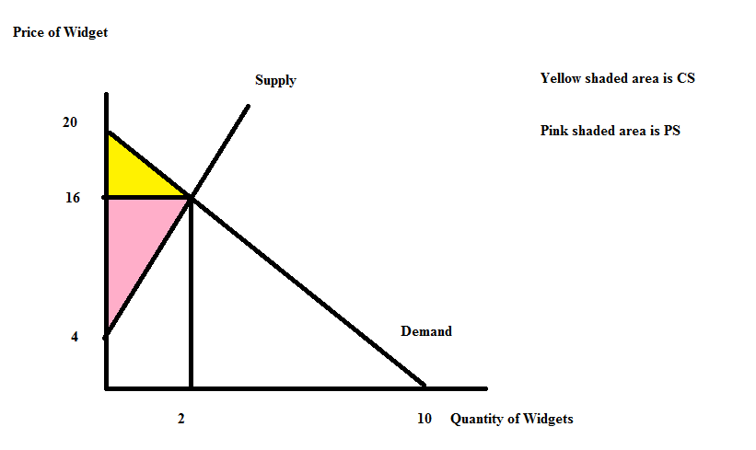
Here's the second graph with CS, PS and the total cost of the externality:
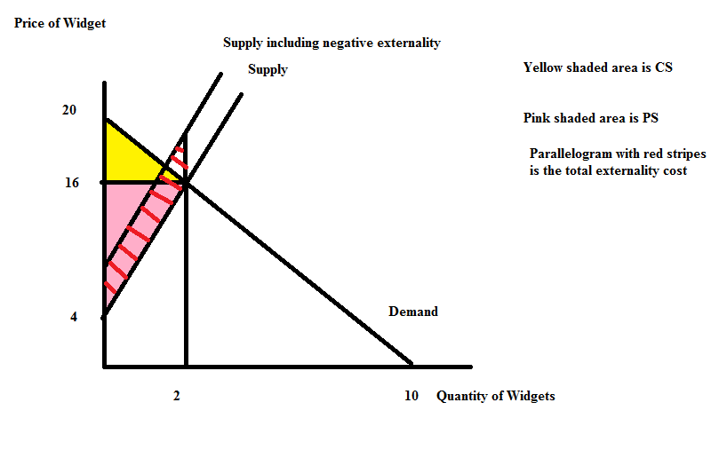
c. TS = CS + PS – Total Externality Cost
TS = $4 + $12 - $8 = $8

d. Since the externality is $4 per widget, the excise tax would need to be $4 per widget in order for the full externality cost to be internalized in this market. The new supply curve with the excise tax is: P = 8 + 6Q.

e. Start with the new supply curve, P = 8 + 6Q and the initial demand curve, P = 20 – 2Q. Use these two curves to solve for the new equilibrium:
8 + 6Qe' = 20 – 2Qe'
8Qe' = 12
Qe' = 1.5 widgets
Pe' = 20 – 2Qe' = 20 – 2(1.5) = $17
Or, Pe' = 8 + 6(Qe') = 8 + 6(1.5) = $17
CS' = (1/2)($20 per widget - $17 per widget)(1.5 widgets) = $2.25
PS' = (1/2)($13 per widget - $4 per widget)(1.5 widgets) = $6.75
Here's a graph to illustrate CS' and PS':
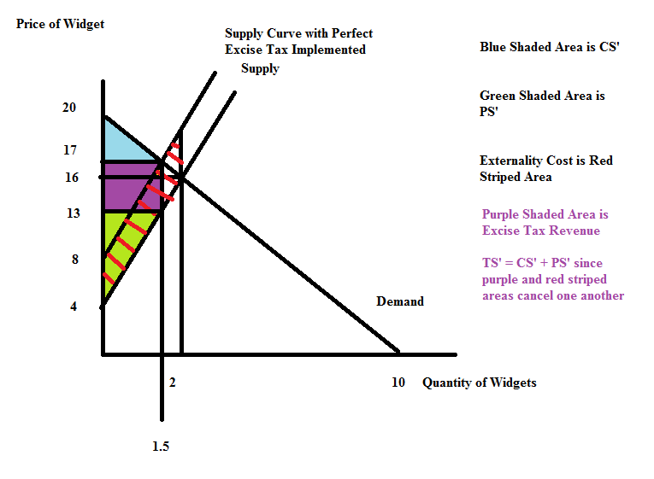
Excise Tax Revenue = (Excise Tax per unit)(Number of units) = ($4 per unit)(1.5 units) = $6
Total Externality Cost = (Externality per unit)(Number of units) = ($4 per unit)(1.5 units) = $6
TS' = CS' + PS' + Excise Tax Revenue – Total Externality Cost = $2.25 + $6.75 + $6 - $6 = $9

f. TS = $8 and TS' = $9 and this implies that the DWL should be $1. Where is the DWL? DWL = (1/2)($20 per widget - $16 per widget)(2 widgets – 1.5 widgets) = $1
Here's the DWL area illustrated in a graph:
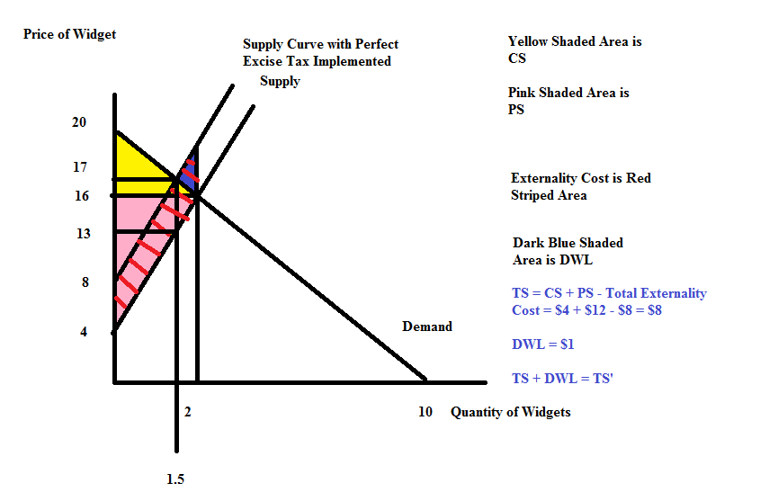

9. Revisit Chapter 12 of Charles Wheelan's Naked Economics. Write a brief memo summarizing the key concept(s) from this chapter for your imaginary boss. Imagine that your boss is a busy person who does not have a lot of free time but wants to be well informed. What points do you want to communicate to this boss and how will you express these points? [Do not simply provide a list of the statements in bold in the chapter for this memo.] Since you are writing this for your boss that may influence what you want to stress in your presentation.

Answer:
Dear Sir/Madam:

The issue of international trade is an important, and at times, controversial issue. Primarily the controversy arises because, although trade is beneficial, trade also has distributional consequence where someone people are benefitted by the trade and other people are hurt by the trade. These distributional consequences result in the topic of trade being particularly sensitive. In addition, some groups find the global homogenization that is a natural outcome of trade worrisome: from a public relations standpoint our company may need to be sensitive to this issue.

In general for our company if the trade opens up markets for us as producers we will find the trade beneficial. Where it confronts our company with greater, low cost competition we will find trade harmful. If this competition is strong enough it may mean that our company will not continue into the future: this is an example of what economists called "creative destruction".

10. At this point you have read at least six chapters in the Charles Wheelan Naked Economics. [Chapters 1 through 5 and Chapter 12] Write a book report no longer than five paragraphs expressing an overview of the book from your perspective, noting both its strengths and weaknesses as well as how this book has impacted your thinking. At the end give a recommendation about whether you would recommend this book to someone interested in learning more about economics.

Answer:
There is no right or wrong answer here. Just want you to be thoughtful in your writing.

