Economics 100
Fall 2013
Answers to Homework #3
Due Tuesday, October 22, 2013

Directions: The homework will be collected in a box before the lecture. Please place your name, TA name and section number on top of the homework (legibly). Make sure you write your name as it appears on your ID so that you can receive the correct grade. Late homework will not be accepted so make plans ahead of time. Please show your work. Good luck!
Please realize that you are essentially creating “your brand” when you submit this homework. Do you want your homework to convey that you are competent, careful, professional? Or, do you want to convey the image that you are careless, sloppy, and less than professional. For the rest of your life you will be creating your brand: please think about what you are saying about yourself when you do any work for someone else!

1. Consider the following graph of the market for gadgets where Pe is the equilibrium price and Qe is the equilibrium quantity.

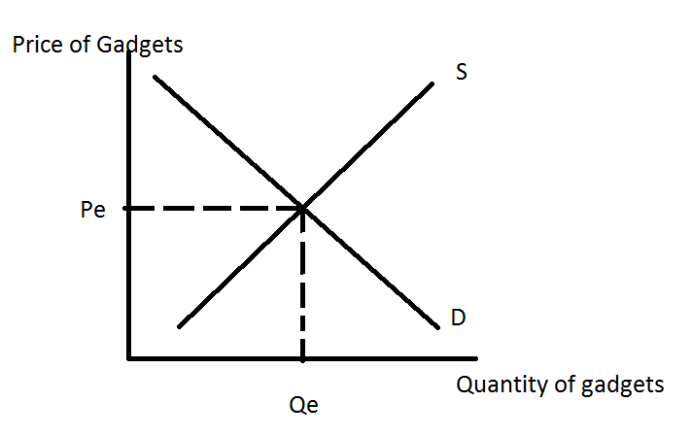

a. Redraw the graph illustrating an effective price ceiling, P1. Describe what must be true for this price ceiling to be effective. With an effective price ceiling, which side of the market is the short side? What is the effect of the price ceiling on the market and could this effect be a problem?

Answer:
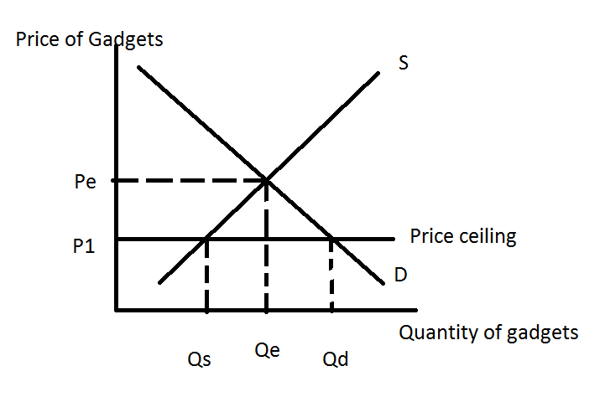
For a price ceiling to be effective, the government must set the price ceiling, or maximum allowable price for the good, at a price less than the equilibrium price. The short side of the market is the supply side since the supply curve determines how many units of the good will be consumed when there is an effective price ceiling. The price ceiling, when effective, will create a situation of excess demand where there is a shortage of units of the good. People will want more of the good than the market will provide. This shortage results in a need to establish some way to ration the good: in a freely operating market, price acts as the method of rationing the good to different consumers. With a price ceiling in effect there will be a need to find some other method of rationing: the black market, standing in line, awarding the rights to purchase the good to some consumers and not to other consumers.

b. Redraw the graph illustrating an effective price floor, P2. Describe what must be true for this price floor to be effective. With an effective price floor, which side of the market is the short side? What is the effect of the price floor on the market and could this effect be a problem?

Answer:
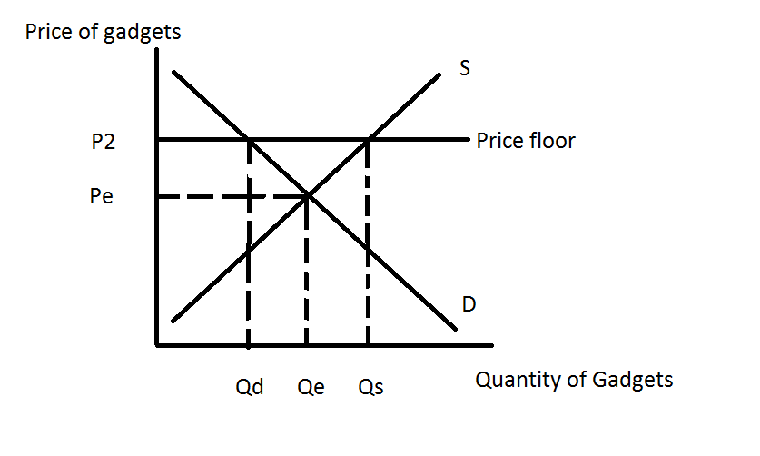
For a price floor to be effective, the government must set the price floor, or minimum allowable price for the good, at a price greater than the equilibrium price. The short side of the market is the demand side since the demand curve determines how many units of the good will be consumed when there is an effective price floor. The price floor, when effective, will create a situation of excess supply where there is a surplus of units of the good. People will want less of the good than the market will provide. This surplus results in a need to establish some way to deal with the excess amount of the good produced: in a labor market this surplus implies unemployment, in a market for a good this surplus may result in the government having to buy and store the surplus in order to enforce the price floor price.

c. Suppose the government decides to limit the consumption of this good to Q1 units by imposing an excise tax. Assume that Q1 is a smaller amount of the good than Qe. Redraw the graph and label Q1. Then, on the graph indicate the price consumers will pay for the good once the tax is imposed, Pc; the price producers will receive after the tax is paid to the government, Ps; and the amount of the tax per unit.

Answer:
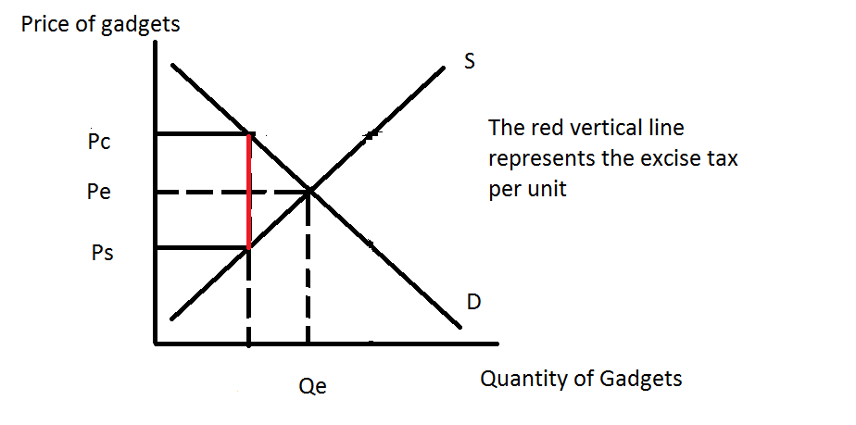
d. Write an equation using the labels you used in (c) that describes the tax revenue the government receives when it imposes an excise tax on gadgets.
Answer:
Tax revenue = (Excise tax per unit)(# of units consumed with the tax)
Tax revenue= (Pc – Ps)(Q1)

2. Use the graph below of the market for widgets to answer this question. This market is initially in equilibrium at a quantity of 2.5 units and a price of $5 per widget. The demand and supply curves are both straight lines.
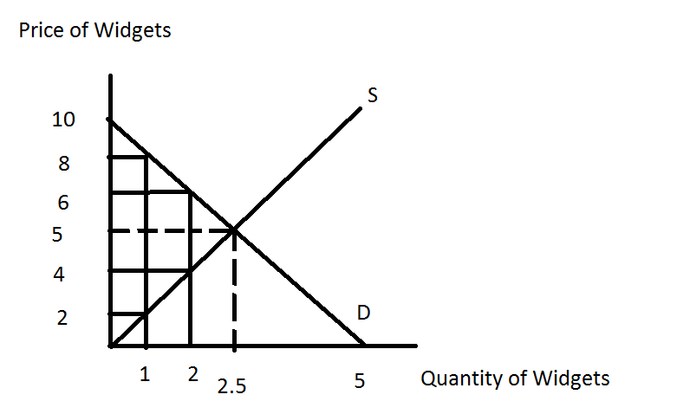
a. The government is considering imposing an excise tax in this market. It is trying to decide between an excise tax of $2 per unit, an excise tax of $6 per unit, or an excise tax of $10 per unit. Using the above graph fill in the table below.

Excise Tax | Quantity Consumed with Tax | Price Consumers Pay with Tax | Price Producers Keep with Tax | Tax Revenue | Deadweight Loss from Tax
$2/unit
$6/unit
$10/unit

Answer:

Excise Tax | Quantity Consumed with Tax | Price Consumers Pay with Tax | Price Producers Keep with Tax | Tax Revenue | Deadweight Loss from Tax
$2/unit | 2 | $6 per widget | $4 per widget | $4 | $0.50
$6/unit | 1 | $8 per widget | $2 per widget | $2 | $4.50
$10/unit | 0 | $10 per widget | $0 per widget | $0 | $12.50

b. Summarize from your table what happens to tax revenue in this market as the size of the excise tax increases. In your answer be sure to incorporate the concept of price elasticity of demand.

Answer:
As the excise tax per unit increases, the amount of tax revenue decreases. As taxes increase, raising the price of the good in the elastic region of the demand curve, we see tax revenue decline.

c. Summarize from your table what happens to deadweight loss in this market as the size of the excise tax increases.
Answer:
The deadweight loss gets bigger as the excise tax gets bigger. The larger the excise tax, the greater it distorts the behavior of both consumers and producers. The excise tax pushes both consumers and producers away from what they would choose to do if there were no excise tax.

3. Question 2 provides an example of an excise tax that raises zero revenue for the government but where the deadweight loss from the excise tax is positive (if you did not get these results in #2, go back and rework the problem). Is it possible that an excise tax could have zero deadweight loss while raising positive tax revenue for the government? If you think it is impossible, please use one or two sentences to
explain your answer. If you think it is possible, please provide an example.

Answer:
It is possible to have an excise tax imposed on a market that creates zero deadweight loss while raising positive tax revenue for the government. If the excise tax is placed on a market where either the demand curve or the supply curve is perfectly inelastic you will get this result. Since the excise tax does not change the quantity demanded or supplied in the market, there will not be a deadweight loss. The excise tax will however still generate tax revenue for the government.

4. Suppose that a small, closed economy opens its market for bananas to free trade. If the world price of bananas is greater than the domestic price of bananas what do you predict will be the impact on this small economy of opening this market to trade?

Answer:
If the world price of bananas is greater than the domestic price of bananas in the small closed economy, then opening this small economy to trade in this market will result in this economy exporting bananas to the rest of the world. Producers in the small economy will want to sell their bananas at the higher world price. Opening this market to trade will increase the size of producer surplus relative to the closed market, decrease the size of consumer surplus relative to the closed market, and increase the size of total surplus relative to the closed market.

5. In the space below are two graphs: the graph on the left represents the world market for oranges while the graph on the right represents a small, closed economy’s market for oranges. Note that although the horizontal axes in both graphs measure quantity, the quantity in the world market is in trillions of oranges while the quantity in the small economy is in oranges.

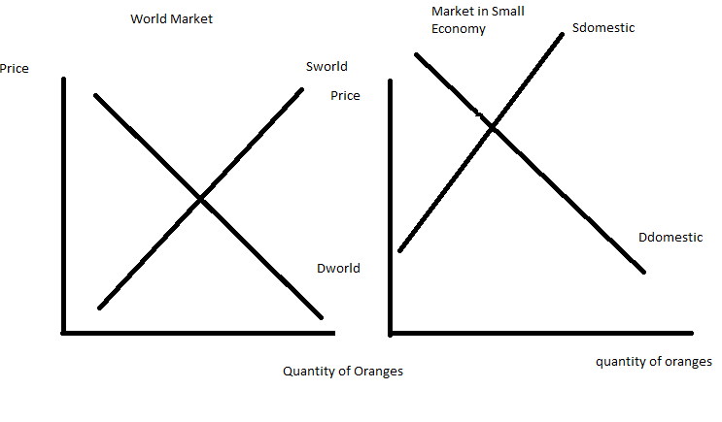
a. Given the above graphs, identify the world price of oranges (Pworld); the domestic price of oranges if the small economy is a closed economy (Pdomestic); and the level of imports or exports that will occur in this market if the small economy opens its orange market to trade. In the graph label the imports or exports clearly. In your own words, explain what determines whether this small country imports or exports the good when this market opens to trade.

Answer:
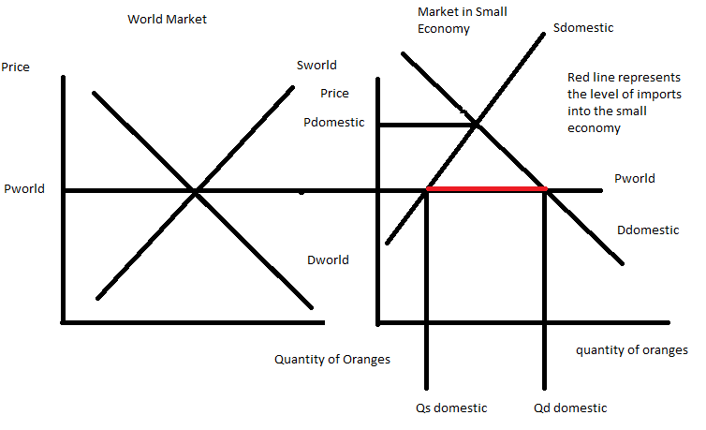

The small economy imports oranges when this market is open to trade since at the world price of the good, the quantity demanded domestically in this economy is greater than the quantity supplied domestically in this economy. The level of imports in this economy is equal to (Qd domestic – Qs domestic). The small economy imports oranges when this market opens to trade because at the world price the small economy experiences an excess demand for oranges, or in other words, a shortage of oranges, and this shortage can be satisfied by importing oranges into the economy.

b. In the space below draw two graphs based on the initial information you were given. In the first graph draw the small, closed economy and label the area of consumer surplus (CS closed) and producer surplus (PS closed) when the orange market is closed to trade. In the second graph draw the small economy after it opens the orange market to trade: label the areas of consumer surplus with trade (CS trade) and producer surplus with trade (PS trade). Provide an argument about whether trade is beneficial using these graphs as references. If this market opens to trade are there winners and losers in the small economy when this decision is made? Explain your answer using your graphs as reference points.

Answer:
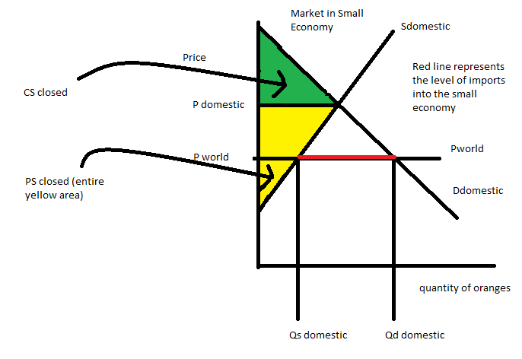

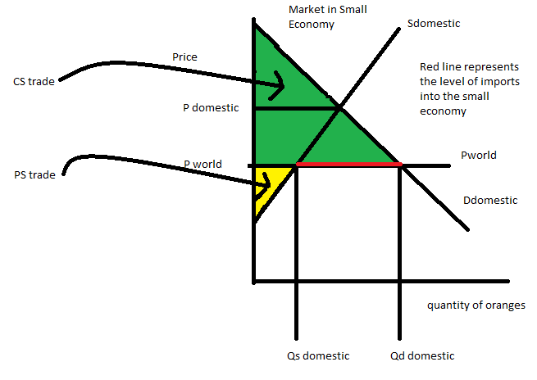
Examination of these two graphs reveals that when this economy opens to trade in the orange market the area of total surplus (the sum of both consumer and producer surplus) gets bigger: this implies that trade is beneficial to this economy since it enlarges the area of total surplus. But, we can also note that when this market is opened to trade, the area of consumer surplus increases while the area of producer surplus decreases: this implies that domestic consumers benefit from opening this market to trade-they consume more oranges and they pay a lower price for each orange; and domestic producers are hurt by opening this market to trade-they sell fewer oranges and they sell these oranges at a lower price for each orange.

c. Suppose that the orange market in the small economy opens to trade, but that the domestic producers of oranges in this economy successfully lobby the government to impose an effective tariff on the market for oranges. Draw a graph of the small economy’s orange market and represent the world price (Pworld), the tariff price (Ptariff), the level of imports with the tariff, the area that represents tariff revenue that the government receives (tariff rev), the area(s) that represent the deadweight loss from the tariff (DWL), the area of consumer surplus with the tariff (CS tariff), and the area of producer surplus with the tariff (PS tariff). What happens to the level of imports when the tariff is imposed relative to the level of imports when this market opens to trade? When the government imposes a tariff and collects tariff revenue, who bears the economic incidence of this tariff? Explain your answer.

Answer:

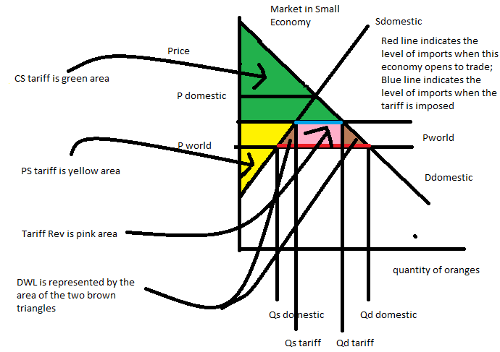
From the graph we can see that the level of imports in this economy falls when the tariff is imposed. Prior to the imposition of the tariff, the level of imports into this economy when the orange market was opened to trade was (Qd domestic – Qs domestic) or the distance represented by the red line in the above graph; with the imposition of the tariff, the level of imports into this economy falls to (Qd tariff – Qs tariff) or the distance represented by the blue line in the above graph.

When the government imposes the tariff they collect tariff revenue represented by the pink rectangle in the above graph. If you go back and look at this area in the graph that represents when happens when this market is open to trade but where there is no tariff you can see that consumers considered this area as part of their consumer surplus. The government, by imposing the tariff, is able to “capture” some of the consumer surplus: the economic incidence of the tariff is borne by domestic consumers who now buy fewer oranges and at a higher price per orange because of the tariff.

d. Suppose that the government decides it wants to achieve the same result as it got with the tariff in (c), but would prefer to use an import quota. What would the level of the import quota need to be in order for the two policies to be equivalent? How much per unit of import should the government charge the licensed importer in order to collect the same amount of revenue from this import quota as it did from the tariff described in (c)?

Answer:
The level of the import quota would need to be equal to the level of imports the economy has if it imposes the tariff. From (c) we know that the level of imports with the tariff was (Qd tariff – Qs tariff) and that is the level of imports that the government must decree is the maximum amount of imports that will be allowed into this economy with this program. The government, in order to secure the same level of revenue with the quota program, will need to collect (Ptariff – Pworld) for each unit of imported oranges. When the government does this, then the quota policy will result in government revenue of (Ptariff-Pworld)(Qd tariff –Qs tariff) which is exactly the same area as you have in (c), the pink rectangle.

6. Suppose that there is a manufacturer of Cool River Gingerale that produces a wonderful gingerale using the fresh, clean waters of Cool River. However, when this company produces the gingerale they also produce dirty, polluted water that they discharge back into the river. Since the river flows away from the company’s plant this polluted water does not affect the company’s ability to produce their amazing product, but it does make life less pleasant and healthy for everyone who lives and works below the plant. In a graph represent a diagram that illustrates this company’s view of the situation. Your graph should provide a demand curve for the product that follows the Law of Demand, a supply curve that represents Cool River Gingerale’s perception of the relationship between the price of the good and the quantity they will supply at each price, and a curve that represents the true cost of providing the good if we include the costs of pollution. Label your graph carefully and fully. In your graph indicate the quantity of gingerale that the company will produce as well as the optimal amount of gingerale from a social (societal) perspective. Given the above scenario and no intervention into this market, will the company produce too much or too little gingerale from a social perspective? Explain your answer. Is there a deadweight loss associated with the company’s choice of production level? Explain your answer.

Answer:
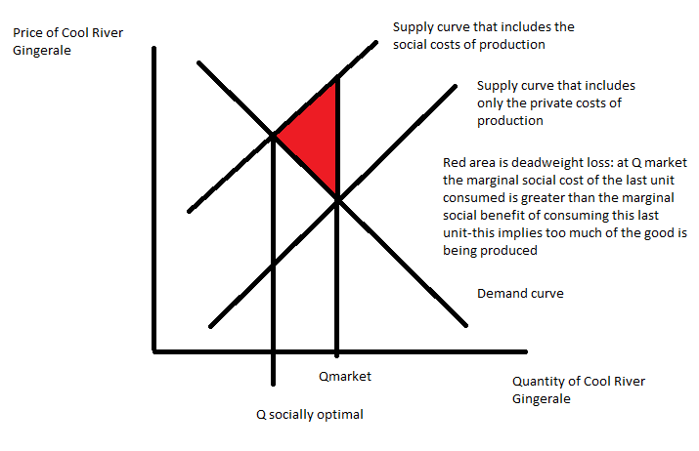
Given this scenario, Cool River Gingerale will produce too much of the good (Qmarket) because it fails to consider the full cost of production of the gingerale. If the company were to internalize all of the costs of production, including the pollution costs, it would perceive its supply curve had shifted to the left. For a given demand curve, the company would produce a lower quantity of the good (Qsocially optimal) once it included the pollution costs. The market level of production generates a deadweight loss (the red area in the above graph) because the marginal social benefit (as measured by the demand curve) for the last unit consumed is less than the marginal social cost (as measured by the supply curve that includes the social costs of production) for the last unit produced. The market, failing to incorporate these pollution costs, provides too much of the good.

7. In class last week we discussed briefly the used car market, or the market for lemons. This idea was developed by George Akerlof who posited that if buyers and sellers had different information about the quality of the product (is the used car a “lemon” (a car that is of poor quality) or a “cherry” (a car that is of high quality)) that the market for this product would break down and not work well. This idea led me to think a bit about the dating market: it seems to me that the dating market is rife with information problems-how do you determine if the individual you think is attractive and interesting is a good choice or a bad choice (like the decision you would make in a used car market)? So, in the space below please spend a bit of time discussing (and let’s be thoughtful here):
i) In the dating market are there information problems? And, if so, describe or provide some examples of these information problems.
ii) How would you address these information problems if you were interacting in this market?
iii) It seems to me that this is a far more important decision than the selection of a used car, so my last question to you is this-does the “market for lemons” make you think a bit harder about the decisions one makes in the dating market?

Answer:
Your answers here will vary, but here is one possible response!
In the dating market people possess a lot of private information about themselves (although some people are in “denial” about who they are and what they are like) and lack information about the people they are considering dating. At a young age, it is hard to estimate the value of a person over their entire lifetime. Due to the lack of access to reliable private information about the members of our dating pool, there is the potential for this asymmetric information leading to a significant adverse selection problem. How to determine if the individual I am interested in is a good choice is a challenge; how to attract someone to me is also a challenge. We can note that the members of the dating pool most “into me” may represent worse outcomes for me than I might realize due to information asymmetries.

So, what to do? I could use two different strategies to both survive and succeed in the dating pool where I recognize that asymmetric information may cause many mismatches. First, I can use a strategy of signaling. For example, my educational attainment and my possession of a good job can signal to a potential suitor my intellect, my diligence, my attractiveness as an employee to my employer, my willingness to work hard, my reliability, etc. Second, I can use a strategy of screening: I will think twice before accepting a invitation for a date. I will be picky about finding someone who possesses the style of communication, the values and the family goals that are similar to mine. As I think about this I find myself recognizing that the dating market is risky and that one should proceed with caution. But, I also recognize that if I am interested in finding a partner I may want to act before my youth disappears: it will be impossible for me to wait until I collect enough information to know with certainty that I have chosen well. Sense and sensibility are both important in this undertaking!

8. Wheelan discusses government regulation in his book. His analysis suggests that government regulation is a fairly complex topic with both arguments to support regulation as well as arguments against regulation. In the space below provide a recap of the arguments that would support some level of regulation as well as the arguments that would argue against regulation. How has the reading of the Wheelan text changed your perception of the issues of government regulation? Provide some examples that support your explanation/answer for this last question.

Answer:

Here are some arguments that would support some level of regulation:
- Externalities can have an impact on society when the production or consumption of a good produces either a cost or a benefit that the market does not fully account for. When there’s a huge gap between the private and social costs of behavior then people have an incentive to engage in activities that make themselves better off at the expense of others. In this situation the market “fails” to produce the right amount of the good or service: regulation can improve the market outcome.
- Governments regulate activities which cause externalities by sometimes taxing the offending behavior rather than banning it.
- Government makes a market economy possible through measures such as defining and protecting property rights which enables individuals to have confidence that behaviors like investing in your property can be profitable, investing in one’s human capital will yield a return, and that investment you make will enable you to increase your future consumption. Government regulation in the form of systems of law and order are vital to the functioning of a market economy.
- Government lowers the cost of doing business by circulating currency, providing infrastructure, providing oversight with organizations such as the SEC to enable confidence that companies and traders are not engaging in fraud.
- Government provides public goods. Public goods are considered things that would make us better off but would not otherwise be provided by the private sector.
- Government redistributes wealth through its taxation policy and its subsidy policies. The market may not provide a distribution that is the right one for members of our society and the government through its regulation can step in to alter the distribution to a more just one.
Here are some arguments that would argue against regulation:
- The government should not be the sole provider of a good or service unless there is a compelling reason to believe that the private sector will fail in that role. Government monopoly is not a good thing unless the private sector is unable or unwilling to provide the good.
- When government funds are directed by lobbyists the economy does not develop as quickly or efficiently because credit is channeled away from worthwhile projects. Allocation of scarce resources through political process will not be as efficient as allocation of resources by the market.
- Every regulation carries a cost. Sometimes the regulation is worth the cost and sometimes it is not worth the cost. There is always a tradeoff.
- Regulation can disturb the movement of capital and labor, raise the cost of goods and services, inhibit innovation and otherwise shackle the economy. This can all result from regulations with good intentions. At worst, regulation can become a powerful tool for self-interest as firms work the political system to their own benefit.

Reading Naked Economics has helped me see that the issue of government regulation is not a simple issue: regulations can improve market outcomes but regulation always comes with a cost. Wheelan makes me stop and think about the benefit from the proposed regulation as well as the cost of the proposed regulation: in an ideal world one would favor regulations where the benefit of the regulation exceeds the cost of the regulation.

As an example of a difficult regulatory issue consider Wheelan’s footnote (page 68) about AIDS drugs in Africa. Wheelan advocates for making these drugs inexpensive in Africa in order to insure that individuals who will otherwise die have access to life saving treatment. Although Wheelan recognizes that such a policy may result in the development of a black market for taking these now artificially cheap drugs from Africa to other parts of the world, he still offers this as an example where government regulation can improve the market outcome.

9. Wheelan discusses the Hope Scholarship Program that was briefly supported during the Clinton Administration. In the space below describe how this program would work in your own words and then discuss the concept of adverse selection in the context of this program. Why did the Clinton Administration abandon this program?

Answer:
According to Wheelan’s discussion, the Hope Scholarship Program was doomed from the beginning due to adverse selection. Because payment back into the scholarship program demanded one pay a certain
percentage of their income rather than a certain amount per year, it turned out that people who
earned more would have to pay back more. Those students who expected that they could
get higher paying jobs did not apply for the Hope Scholarship Program while those students who expected that they would get lower paying jobs did apply for the Hope Scholarship Program: this led to an adversely selected pool of applicants, most of whom expected to make lower salaries than the overall pool of students. This meant that the program was doomed since the cost of financing these students education exceeded the projected amount they would have paid if the pool had included individuals likely to earn high incomes as well as individuals likely to earn low incomes. The program quickly did not have enough funds to finance itself.

Although the Clinton Administration abandoned the Hope Scholarship, similar student loan
programs are working well in Australia and Britain. And, in the United States, income-contingent repayment is available now. This is potentially one way to make higher education more affordable for less advantaged students.
10. Suppose an economy has two groups of people, group A and group B. Group A-types have a perfectly elastic supply of labor at an equilibrium wage rate of $10 per hour. Group B-types have a perfectly inelastic supply of labor, and their equilibrium wage rate is $100 per hour. If an income tax is introduced into this economy, what will happen to the wage rates and employment levels of the two groups?

Answer:
Since Group A-types have a perfectly elastic supply of labor, their after-tax wage rate will remain at
$10 per hour, and fewer A-type workers will be employed. Since Group B-types have a perfectly inelastic
supply of labor, their after-tax wage rate will fall by the amount of the tax, but employment of Group B-type workers will not change with the imposition of the tax.

