Economics 100
Fall 2013
Answers to Homework #2
Due Tuesday, October 1, 2013

Directions: The homework will be collected in a box before the lecture. Please place your name, TA name and section number on top of the homework (legibly). Make sure you write your name as it appears on your ID so that you can receive the correct grade. Late homework will not be accepted so make plans ahead of time. Please show your work. Good luck!
Please realize that you are essentially creating “your brand” when you submit this homework. Do you want your homework to convey that you are competent, careful, professional? Or, do you want to convey the image that you are careless, sloppy, and less than professional. For the rest of your life you will be creating your brand: please think about what you are saying about yourself when you do any work for someone else!

1. Josie and Mark produce two goods: cakes (C) and gadgets (G). Both Josie and Mark’s production possibility frontiers are linear and they both have the same amount of resources available to them to produce these two goods. If Josie produces only cakes she can produce 100 cakes; if she produces only gadgets she can produce 500 gadgets. If Mark produces only cakes he can produce 200 cakes; if he produces only gadgets he can produce 800 gadgets.

a. Given this information draw two graphs: a graph of Josie’s production possibility frontier and a graph of Mark’s production possibility frontier. In your graphs measure cakes on the horizontal axis and gadgets on the vertical axis.

Answer:
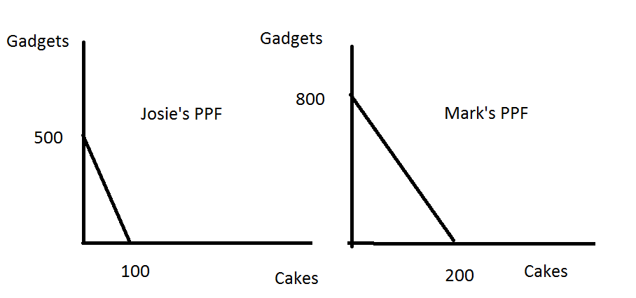
b. Given the above information, who has the absolute advantage in producing cakes?

Answer:
From the same set of resources Mark is able to produce absolutely more gadgets and more cakes than can Josie. Mark has the absolute advantage in the production of both goods: he is able to produce more from an available set of resources than can Josie.

c. Given the above information, who has the absolute advantage in producing gadgets?

Answer:
From the same set of resources Mark is able to produce absolutely more gadgets and more cakes than can Josie. Mark has the absolute advantage in the production of both goods: he is able to produce more from an available set of resources than can Josie.

d. Given the above information, who has the comparative advantage in producing cakes? Explain your answer.

Answer:
Comparative advantage in the production of cakes looks to identify who can produce cake with the lowest opportunity cost. In this example, the opportunity cost of producing one cake for Josie is 5 gadgets while the opportunity cost of producing one cake for Mark is 4 gadgets. Mark has the comparative advantage in the production of cakes since he can produce a cake at lower opportunity cost than can Josie.

e. Given the above information, who has the comparative advantage in producing gadgets? Explain your answer.

Answer:
Comparative advantage in the production of gadgets looks to identify who can produce a gadget with the lowest opportunity cost. In this example, the opportunity cost of producing one gadget for Josie is 1/5 cake while the opportunity cost of producing one gadget for Mark is 1/4 cake. Josie has the comparative advantage in the production of gadgets since she can produce a gadget at lower opportunity cost than can Mark.

f. Suppose that current production of cakes and gadgets are given in the table below. What happens to total production of cakes and gadgets if Josie and Mark specialize according to comparative advantage and change their production of cake from its initial level to the level given in the second table? (Note: in this example, we are just “pushing” Josie and Mark a bit towards their comparative advantage and not moving them to complete specialization.) Fill in the missing values from the second table. Assume that both Josie and Mark continue to produce on their respective PPFs when answering this question.

 | Cakes | Gadgets
Josie | 50 | 250
Mark | 50 | 600
Total Production | 100 | 850

 | Cakes | Gadgets
Josie | 20
Mark | 80
Total Production | 100

Answer:
When Josie produces 20 cakes she is able to produce 400 gadgets with her available resources. One way to figure this out is to write an equation for her PPF: G = 500 – 5C. If C = 20 then you have G = 500 – 5(20) or G = 400.
When Mark produces 80 cakes he is able to produce 480 gadgets with his available resources. One way to figure this out is to write an equation for his PPF: G = 800 – 4C. If C = 80 then you have G = 800 – 4(80) or G = 480.
Thus, the second table will be:

 | Cakes | Gadgets
Josie | 20 | 400
Mark | 80 | 480
Total Production | 100 | 880

By specializing according to comparative advantage the overall level of production can be increased from its initial level: in this case, the total production of cakes is unchanged, but the total production of gadgets has been increased by 30 gadgets.

g. Draw the joint production possibility frontier for Josie and Mark. In your graph identify the coordinates for any “kink” point as well as the x-axis and y-axis intercepts. (Note: the “kink” point is that point where both Mark and Josie fully specialize according to their comparative advantages.)
Answer:
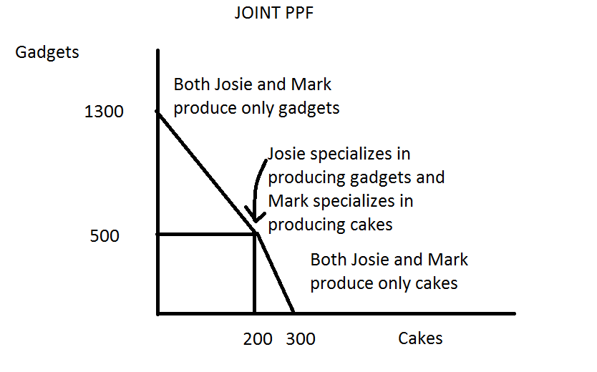
h. What will be the acceptable range of trading prices in terms of cakes for 100 gadgets?
Answer:
The opportunity cost of producing 1 gadget is 1/5 cake for Josie and ¼ cake for Mark. Therefore the acceptable range of trading prices for 1 gadget will fall between 1/5 cake and 1/4 cake. But, what about 100 gadgets? The acceptable range of trading prices for 100 gadgets will fall between (100)(1/5)cake and (100)(1/4)cake or between 20 cakes and 25 cakes.

2. For each of the following situations assume the described market is initially in equilibrium with the equilibrium quantity, Q1, and the equilibrium price, P1. Analyze the impact on the equilibrium quantity and price, holding everything else constant, for each of the described scenarios. You might find it helpful to sketch a graph illustrating each situation. In your answer identify any supply and demand curves that shift and the direction of that shift.

a. In the market for cigarettes the government increases the excise tax on cigarette producers by $2.00 per package.
Answer:
The supply curve will shift to the left: at every price the quantity of cigarettes supplied will decrease. The equilibrium price of cigarettes will increase and the equilibrium quantity of cigarettes will decrease. The graph below illustrates this situation.
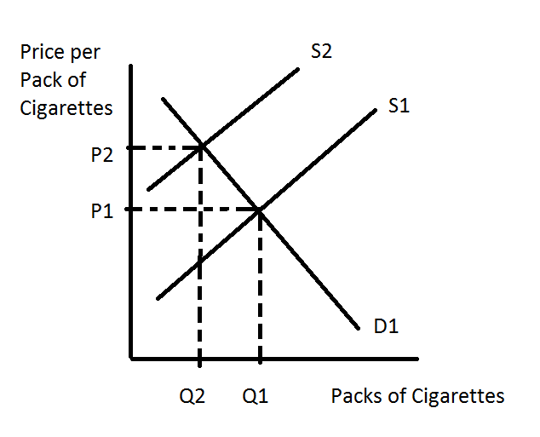
b. In the market for “Zipcar”, a community based company that allows members of the Zipcar community to rent cars for short periods of time and utilizes app technology to facilitate this, the price of car insurance for car owners increases dramatically. Assume this is the insurance you would need to buy if you personally owned a car; assume that Zipcar carries their own car insurance for their fleet of cars and this insurance is not impacted by this change.

Answer:
When the price of car insurance increases dramatically for those who privately own cars, this price increases will result in the demand curve for Zipcar memberships shifting to the right. Private car insurance and the Zipcar are related goods: they are substitutes for one another. So, when the price of private car insurance increases this causes people to reduce the quantity of private car insurance they demand and to increase their demand at every price for the Zipcar. The demand curve for Zipcar will shift to the right and result in a higher price for the Zipcar and a greater equilibrium quantity. The graph below illustrates this situation.
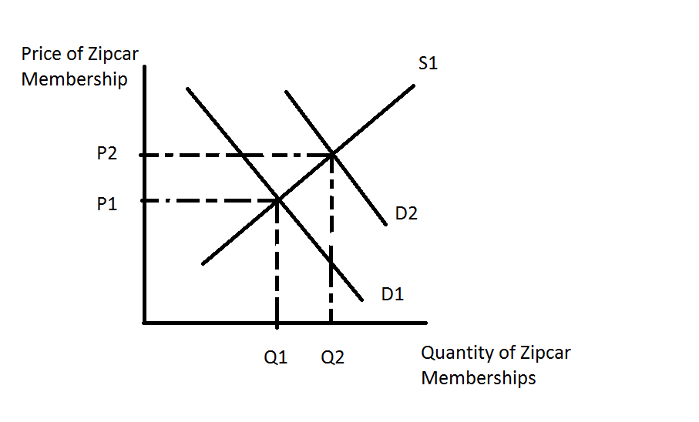
c. Consider the market for soft drinks. Corn syrup, a major ingredient in soft drinks, becomes cheaper at the same time that the Surgeon General announces that drinking soft drinks is a major contributor to obesity.
Answer:
In the market for soft drinks the decrease in the price of corn syrup will cause the supply curve to shift to the right as the cost of producing soft drinks decreases. At every price, the quantity of soft drinks supplied will increase. But, the Surgeon General’s report will also affect this market: this announcement will alter people’s tastes and preferences for soft drinks. The demand curve for soft drinks will shift to the left with this announcement: at every price the quantity of soft drinks demanded will decrease. So, both the supply and demand curves shift: this shifting of both curves creates a situation of indeterminancy-we will be able to predict, in this case, what happens to the equilibrium price but not what happens to the equilibrium quantity. The equilibrium price will fall relative to its initial level, but the equilibrium quantity may increase, decrease, or remain the same relative to its initial level. The following graph illustrates these three possibilities.
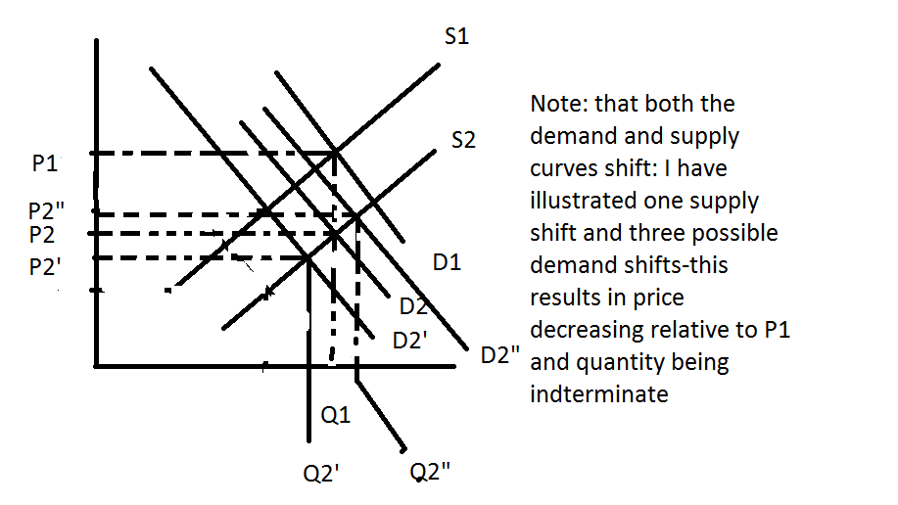
3. Suppose that there are two individuals in the market for chocolate bars, Mike and Annie. The following table provides data on the quantity of chocolate bars that they demand at different prices. However, some of the data from the table is missing and you have been asked to complete the missing values in the table.

Price per Chocolate Bar | Quantity Demanded of Chocolate Bars by Mike | Quantity Demanded of Chocolate Bars by Annie | Total Quantity Demanded of Chocolate Bars
$1 | 10 | 4
$2 | 8 | 2
$3 |  | 0 | 6
$4 | 4 |  | 4
$5 |  | 0 | 2

a. Complete the missing values in the table.

Answer:

Price per Chocolate Bar | Quantity Demanded of Chocolate Bars by Mike | Quantity Demanded of Chocolate Bars by Annie | Total Quantity Demanded of Chocolate Bars
$1 | 10 | 4 | 14
$2 | 8 | 2 | 10
$3 | 6 | 0 | 6
$4 | 4 | 0 | 4
$5 | 2 | 0 | 2

b. Given just the information in the table, who has the stronger tastes and preferences for chocolate bars? (Note: we are holding constant Mike and Annie’s incomes and just asking from the above information who likes chocolate more.) Explain your answer.

Answer:
From the completed table we can see that Mike continues to purchase chocolate once the price is at $4 or more while Annie stops purchasing the chocolate once it hits $3 per bar. We can also see that at every price Mike demands a greater quantity of chocolate than Annie. Mike therefore has the stronger tastes and preferences for chocolate bars.

c. Draw three graphs horizontally aligned with one another. In the first graph represent Mike’s demand curve for chocolate; in the second graph represent Annie’s demand curve for chocolate; and in the third graph represent the market demand curve for chocolate.

Answer:
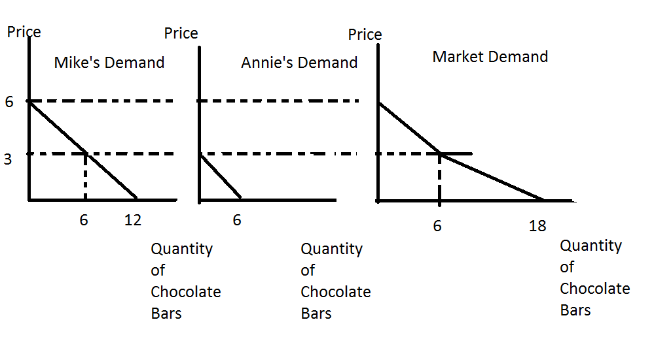

d. When chocolate bars cost $5 the quantity of chocolate bars that Annie demands is equal to zero. In your own words explain what it means for the quantity she demands to be equal to zero at this price. Provide an example of a good that you do not choose to purchase once its price hits a particular level: be specific in your example.

Answer:
When the price of chocolate bars is $5 per bar, the price is so high that Annie is not willing to demand any chocolate bars at this price. This is not unusual for any of us: there are many situations where we decide not to purchase an item once we know its price. For instance, I (Professor Kelly) have not chosen to buy a sports car because I am unwilling to pay the going price for a sports car given the transportation services that such a car would provide to me. For Yi, the sports car is a luxury good (it is a luxury good for her professor as well) and if Yi buys a sports car she will not have money to rent an apartment. The unaffordable opportunity cost of the sports car forces Yi to control her desire for the car. Answers here will obviously vary with each student.

e. In part (c) when you drew the market demand curve it should have had a “kink” point. Why is there a “kink” point in this market demand curve?

Answer:
Above $3 per bar Annie does not demand any chocolate bars. So, at prices above $3 the market demand curve just reflects Mike’s demand; and at prices, at $3 and lower the market demand reflects both Annie and Mike’s demand for the product.

Note: if all the consumers in a market had identical demand curves, then the market demand curve would not have a “kink”.

4. Suppose you are given the following table of information about the relationship between the price of pizza and the quantity demanded and the quantity supplied at these various prices.

Price per Pizza | Quantity of Pizza Demanded | Quantity of Pizza Supplied
$2 | 100 | 5
$4 | 85 | 8
$6 | 80 | 20
$8 | 60 | 35
$10 | 35 | 55
$12 | 18 | 75
$14 | 5 | 100

a. Given the above table, what can you predict about the equilibrium price in the market for pizzas?

Answer:
From the table we can see that when the price is $8 or less, the quantity demanded of pizza is greater than the quantity supplied of pizza, and when the price is $10 or more, the quantity demanded of pizza is smaller than the quantity supplied of pizza. Therefore the equilibrium price of pizza in this market will be greater than $8 but less than $10.

b. Given the above table, what can you predict about the equilibrium quantity in the market for pizzas?

Answer:
When the price of pizza is $8, the quantity demanded is 60 pizzas and the quantity supplied is 35 pizzas: we can infer from this that the equilibrium quantity must be between 35 and 60 pizzas. When the price of pizza is $10, the quantity demanded is 35 pizzas and the quantity supplied is 55 pizzas: we can infer from this that the equilibrium quantity must be between 35 and 55 pizzas. So, given both of these observations the conclusion is that the equilibrium quantity of pizza will fall within the smaller range of quantities: that is, between 35 and 55 pizzas.

c. Suppose that the government in a desire to promote healthy eating habits decides to institute a price floor of $10 per pizza. Describe the effect of this price floor on the market for pizza given the above information about the pizza market.

Answer:
When the government institutes the price floor of $10 per pizza, the government is effectively limiting how low the price of pizza can fall. This is an effective price floor since it is set above the equilibrium price in the market (see (a)). When the government artificially sets the price of pizza at $10 the quantity of pizza demanded is 35 pizzas while the quantity of pizza that suppliers are willing to supply at this price is 55 pizzas. Therefore there is excess supply, or a surplus, at this price floor. The “short side” of the market however will determine how many pizzas are actually bought: in this case, the “short side” of the market is the demand side since the quantity demanded at $10 is less than the quantity supplied at $10.

d. Instead of a price floor in the market for pizza, the government decides to implement a price ceiling in this market. What might be a possible reason for the government deciding to implement an effective price ceiling in this market?

Answer:
A price ceiling is a price set by the government that acts to limit how high the price can go. For a price ceiling to be effective the price ceiling must be set at a price that is less than the equilibrium price in the market. This implies that the price ceiling will create a situation of excess demand for the product since the implemented price is lower than the price where the quantity demanded is equal to the quantity supplied. The government institutes price ceilings as a way to lower the price some people pay for the good (the people lucky enough to be able to buy the good, will get the good at a lower price).

e. If the price ceiling in (d) is effective, describe its effect on the market for pizza.

Answer:
When a price ceiling is effective it creates a situation of excess demand for the good. A price ceiling to be effective must be set at a price that is lower than the equilibrium price in the market.

f. Economists are sometimes heard to say “the short side of the market determines how much of the good is sold”. What is the short side of the market when the government institutes an effective price ceiling? Explain your answer fully.

Answer:
An effective price ceiling creates excess demand for the product. That implies that the “short side” of the market is the supply side: at the implemented price ceiling price the quantity supplied is less than the quantity demanded. The amount of the good that is produced and consumed in the market will therefore be determined by the supply side of the market-that is, by the “short side” in this particular market.

6. In class we discussed the concepts of consumer surplus (CS) and producer surplus (PS). In the graph below we can see that the equilibrium price and quantity are given as P1 and Q1.
a. But, I am interested in trying to better understand this idea of surplus. So, I would like you to redraw the graph below in your homework answer and mark with a colored pencil the CS that occurs with the first unit (X1). With a different colored pencil I would like you to mark the PS that occurs with the first unit (X1). Then, carefully label with a key to your diagram these areas. Repeat this for X2, X3, and X4.

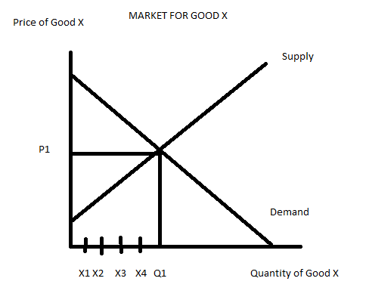
Answer:
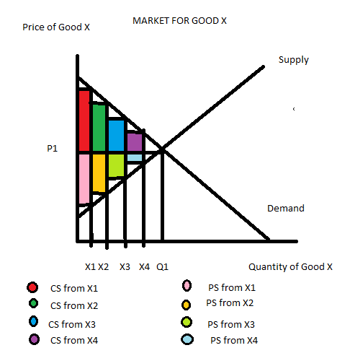

b. In your own words describe the meaning of CS for the consumer who consumes X1 units of the good.

Answer:
CS for the consumer who purchases and consumes the X1st unit of the good measures the difference between what the consumer would have paid and what the consumer actually had to pay. We can see what the consumer would have been willing to pay by going vertically up from the horizontal axis at X1 to the demand curve: the consumer would have been willing to pay P2 shown on the graph below. But, the consumer ends up paying the market price for the unit and thus receives additional value when consuming this good beyond what they would have been willing to pay. This additional value is equal to (P2 – P1)(X1) or the CS for the X1st unit.

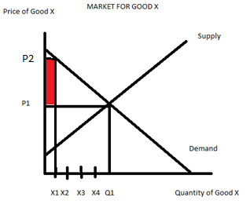
c. In your own words describe the meaning of PS for the producer who is willing to supply the X1st unit of the good.

Answer:
PS for the producer who produces and sells the X1st unit of the good measures the difference between what the producer is willing to accept as a price for the good and the price that the producer actually receives in the market place. We can see what the producer would have been willing to accept by going vertically up from the horizontal axis at X1 to the supply curve: the producer would have been willing to accept P3 shown on the graph below. But, the producer ends up receiving the market price for the unit and thus receives additional value when producing and selling this good beyond what they would have been willing to accept. This additional value is equal to (P1 – P3)(X1) or the PS for the X1st unit.

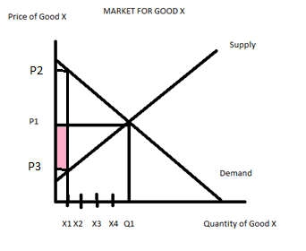

d. Redraw the graph and color in the entire area of CS assuming that consumers can consume any quantity that they are willing to buy (so, for instance a consumer could buy 1/1000th of X1 units). In the same graph color in the entire area of PS assuming that producers can sell any quantity. Label these two areas clearly.

Answer:
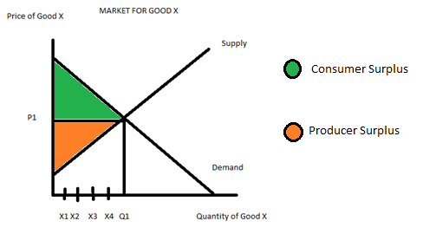

7. Suppose you have been given the task of deciding whether Madison Metro should raise the price of bus fares or lower the price of bus fares. Assume that the primary concern with fares has to do with generating sufficient revenue to cover the operating costs of the system; furthermore, assume that currently there is enough excess capacity (i.e., empty seats on each bus) that Madison Metro can transport additional riders without any additional cost.
a. What would be the primary argument for raising the price of bus fares?

Answer:
If Madison Metro raises the price of bus fares, Madison Metro will earn more revenue with every bus fare that is sold.

b. What would be the primary problem with raising the price of bus fares?

Answer:
Unless the demand for bus rides is perfectly inelastic, when Madison Metro raises the price of bus fares they will sell fewer bus fares. Revenue for Madison Metro will only increase with an increase in bus fares provided that the increase in revenue from higher bus fares offsets the decrease in revenue from selling fewer bus rides.

c. What would be the primary argument for lowering the price of bus fares?

Answer:
If Madison Metro lowers the price of bus fares, Madison Metro will be able to sell more bus rides.

d. What would be the primary problem with lowering the price of bus fares?

Answer:
When Madison Metro lowers the price of bus fares they will earn less revenue from every fare that they sell. Revenue for Madison Metro will only increase with a decrease in bus fares if Madison Metro sells enough additional bus fares to offset the decrease in revenue from selling bus rides at a lower price.

e. Suppose that Madison Metro currently is selling 100,000 bus fares a year at $1.00 per fare. Research suggests that if the fare were raised to $1.25 Madison Metro would experience a 10% decrease in ridership per year. Research also suggests that if Madison Metro decreases bus fares by 20%, then ridership would increase by 5% per year. Given this information, should Madison Metro raise fares, lower fares, or keep fares at their current level for next year? Explain your analysis fully.

Answer:
Let’s start by calculating Madison Metro revenue under the current pricing scenario: ($1.00)(100,000 rides per year) = $100,000 per year in revenue.
Now, let’s consider raising the price: the price would be increased to $1.25 and the ridership numbers would fall by 10%. 10% of 100,000 is 10,000: so, with a fare increase to $1.25, the number of riders sold per year will be 90,000. So, if Madison Metro increases the price of the bus fare to $1.25, then revenue for Madison Metro will be ($1.25)(90,000 rides per year) = $112,500. This is better than the revenue figure when bus fares are priced at $1.00 per ride.
Now, let’s consider lowering the price: the price would be decreased to $0.80 (a 20% decrease in the fare of $1.00) and the number of bus rides sold would increase to 105,000 (a 5% increase over the initial 100,000 rides per year). Revenue for Madison Metro if they decrease fares would be ($0.80)(105,000 rides per year) = $84,000.
Madison Metro given this information should increase fares to $1.25.

f. Given your work in (e), and the information you were given about the demand for bus fares, what would you conclude about the price elasticity of demand for bus rides in Madison when the price of a bus ride is $1.00?

Answer:
Our work in (e) tells us that total revenue increases when the price increases. This implies that demand is price inelastic since total revenue increases when price increases if the demand for the product is inelastic. Price inelasticity tells us that the percentage change in the quantity demanded in absolute value terms is less than the percentage change in the price of the good in absolute value terms.

8. Wheelan writes on page 36 of Chapter 2: “Any system that pays all teachers the same provides a strong incentive for the most talented among them to look for work elsewhere.” Write a brief paragraph explaining what Wheelan is saying in this paragraph and then think about a way to respond to this issue through public policy (a second paragraph).

Answer:
Wheelan is focusing on the importance of incentives and, in this case, the importance of financial incentives. If all teachers receive similar compensation based on years of experience and extent of education there is no way for someone of superior merit to distinguish themselves: this is apt to lead those with exceptional capabilities to seek work in some other area where their merit can be rewarded.

In a flexible labor market (where labor is free to move at will), occupational mobility should be expected. If the educational system does not pay higher wages to teachers with extraordinary talent then these teachers will choose to move their labor to jobs where they will be compensated. Several decades ago, female workers did not have as much freedom to choose occupations as they do today. Today, with less gender discrimination, people will tend to migrate to labor markets where their skills are valued.

Public policy on this is difficult: merit pay raises for teachers are potentially divisive, eroding moral, and creating a culture of competitiveness rather than cooperation among staff. In addition, merit pay poses the problem of how best to assess the teaching talents of staff: for example, classroom performance may not necessarily pose a good measure since it is conceivable that some groups of children have less capacity to learn, may be more difficult to teach, my come into the classroom with inferior preparation that reflects their experience in a different school system. Reliance on parental feedback is also problematic: parental agendas may be quite diverse and parents may not necessarily be in a position to objectively and correctly evaluate the performance of their child’s instructor. Reliance on administrative evaluation also has problems.

Some cultures elevate the position of teacher and make it very difficult to become a teacher. These cultures place a large emphasis on test scores and mastery of material (rather than mastery of education classes). Teachers in these cultures are paid high salaries reflective of what they could earn in other industries with their skill set. This is clearly a challenging problem for educational systems.

9. Wheelan in Chapter 2 writes about “creative destruction”. What does this term mean? Provide an example of creative destruction in your answer.
Answer:
“Creative destruction” is a term coined by Joseph Schumpeter about the way capitalism, or the market economy, destroys existent businesses while creating new businesses. For example, at one point in the early twentieth century transportation in the U.S. was dominated by railroads and often these railroads enjoyed economic advantages due to the monopolistic status. This meant that the railroad companies often enjoyed high levels of profitability. This profitability provided an incentive for someone to come up with a way to enter the market: the development of the internal combustion engine, the production of cars and trucks, and the spread of highways all worked to destroy the advantages that the railways had experienced.

Another example might be to consider the evolution of phone call service. When your instructor was in college all calls were made by landline and long distance calls were, for the most part, quite expensive. The phone companies enjoyed high levels of profitability and low levels of competition. However, over time this lack of competition and the high levels of profitability spurred others to innovate and find new ways to provide long distance service. Today we all have cell phones and we never stop in the midst of making our call to think “Maybe I better just write a letter; this call is not urgent and I’d rather not spend the money on the call.”

10. in Chapter 3 of Naked Economics Wheelan discusses the role of government in dealing with externalities. Provide and discuss two different ways to government can help when there is an externality.

Answer:
1) The government can regulate and/or ban the activity that produces the externality. This regulation or banning of the activity will reduce the amount of the externality.
2) The government can tax the externality-generating activity. This will reduce the externality generating behavior which is a good thing. The tax will also generate revenue for the government. The tax will also provide an incentive to innovate and this innovation will likely help society find a way to reduce the production of the externality.
3) Governments can work to define property rights clearly. Sometimes the problem of an externality can be solved once there are well defined and enforced property rights.

