Economics 100
Spring 2015
Answers to Homework #1
Due Thursday, February 5, 2015

Directions: The homework will be collected in a box before the lecture. Please place your name on top of the homework (legibly). Make sure you write your name as it appears on your ID so that you can receive the correct grade. Late homework will not be accepted so make plans ahead of time. Please show your work. Good luck!

Please realize that you are essentially creating “your brand” when you submit this homework. Do you want your homework to convey that you are competent, careful, and professional? Or, do you want to convey the image that you are careless, sloppy, and less than professional. For the rest of your life you will be creating your brand: please think about what you are saying about yourself when you do any work for someone else!

1. On the first day of class we were confronted with the issue of how to allocate a limited number of brownies. Recap that experience and in your description describe at least three different ways we could have allocated the scarce brownies among the members of our class. Then, provide a paragraph describing the impact of this experience on you: did you experience or learn something you had not thought about before, did the experience alter your thoughts on the complexity of allocating goods when there is scarcity? This paragraph should be well expressed and thoughtful.

Answer:
There are a variety of means to allocate scarce goods: 1) the market system which uses prices and the consumers willingness to pay to allocate the good to those willing to pay the most; 2) communal systems where the good is allocated equally among all the individuals in the group; 3) command systems where the powerful leader(s) get to make decisions about who gets what and are able to enforce this system due to their power; 4) “value-ladened” systems where someone or some group seeks to determine who has greatest need for the good or what is the most “just” distribution of the good.

The second paragraph will vary: here is my own paragraph about my experience of thinking about allocation and, especially, market allocation.

We live in a world of scarce resources: how best to allocate those scarce resources is a challenging problem. One way to allocate resources and the goods and services produced by these resources is via a market mechanism. The advantage of a market mechanism is that the goods and services will go to those who value them the most, provided these individuals can afford to bid for these goods and services. It is efficient to allocate these scarce items to those who value them at the greatest level, but it may prove high inequitable since those with little income or resources will not be able to acquire goods and services via this market mechanism. Alternative methods of allocation may prove more equitable but at a high cost with regard to efficiency. And, of course, this just reminds us of two basic economic principles: people face trade-offs and we live in a world with scarce resources.

2. Economists believe that “the cost of getting something is what you give up to get it”. Write a paragraph focusing on this general principle and how it applies to your decision to get an education. Are you aware of this principle or is this a new principle to apply to your decision to get an education? Be thoughtful in your discussion of this idea-no credit for a paragraph that is not analytical and well expressed.

Answer:
Lots of possibilities here! Here are two possible answers….

Going to college is an expensive proposition: I not only had to think about the tuition, books, and room and board expenses of attending a residential college, but I also needed to figure in the lost income I could have earned if I had elected to work instead of attending college as a full-time student. This lost, or foregone, income is a substantial amount: if I were able to earn $10 per hour and I gave up four years of working I would effectively be giving up approximately $80,000 worth of income as well as on-the-job experience during these four years of college. If I could command a higher hourly wage rate then this foregone income would be even greater. Going to college is an expensive proposition and I need to make sure that I am getting something out of these four years that justifies my making this choice.

I have never thought about the cost of going to college beyond the tuition, fees, and book expenses. It seems odd to need to think about the foregone income I could have earned, but now that we have discussed this in class it seems clear that this does need to be included. Once I included this foregone income into the cost of getting an education it made me more aware of the need for me to be pro-active with regard to getting a good education and one that will enhance my own self-knowledge and my own skill sets. I think this discussion has the potential to alter how I approach these four years at the University.

3. For each of the following statements determine whether the statement is a positive or a normative statement. Explain your answer.
a. Joe is working hard and by the end of the year his savings from his work should be sufficient to pay for a year of college tuition.
b. Susie is working hard and she ought to get more sleep than she is getting in order to function better in her day-to-day activities.
c. Mark is working hard and he ought to get straight A’s given his work effort.
d. Paul is working hard and this work effort seems to be paying off: he has been on the Dean’s List the last four semesters.

Answer:
a. Positive: at the end of the year you can verify or not that Joe has saved enough income to pay for a year of college tuition.
b. Normative: this is your opinion and this opinion cannot be verified.
c. Normative: this statement seems initially positive because at the end of the semester you can verify whether he got those straight A’s, but there is also a normative element to the statement. I am going with normative since it seems to me that the statement strongly suggests that work effort is all it takes to get those A’s and that is a value-ladened statement. Not everyone would agree that work effort is all that matters: for instance, would you agree to have brain surgery from a hard-working surgeon that has only a 10% success rate for the surgery you need?
d. Positive: the work effort can be verified by the student’s being on the Dean’s List.

4. Suppose you are given the following production possibility frontier (PPF) for the economy of Grantsville. Grantsville produces consumer goods (C) and capital goods (K) from its available resources.
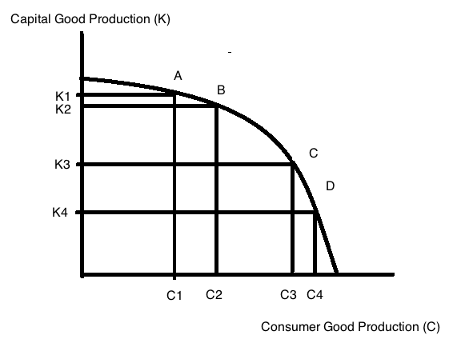

a. Given the above graph, what is the opportunity cost of moving from Point A to Point B? Make sure you identify the type of units that opportunity cost is measured in when you provide your answer.

b. Given the above graph, what is the opportunity cost of moving from Point C to Point A? Make sure you identify the type of units that opportunity cost is measured in when you provide your answer.

c. Given the above graph, does the Law of Increasing Opportunity Cost hold for capital goods? The Law of Increasing Opportunity Cost states that the opportunity cost of getting each additional unit of the good increases as you get more and more of that good. Explain your answer and provide a graph to illustrate this idea.

Answers:
a. The opportunity cost of going from Point A to Point B is measured by the number of capital goods you are giving up as you acquire more consumer goods: in this case you are giving up (K1 – K2) units of capital goods.

b. The opportunity cost of going from Point C to Point A is measured by the number of consumer goods you are giving up as you acquire more capital goods: in this case you are giving up (C3 – C1) units of consumer goods.

c. Yes, the Law of Increasing Opportunity Cost does hold for capital goods. Let’s amend the graph to show what the opportunity cost of an additional unit of capital looks like:
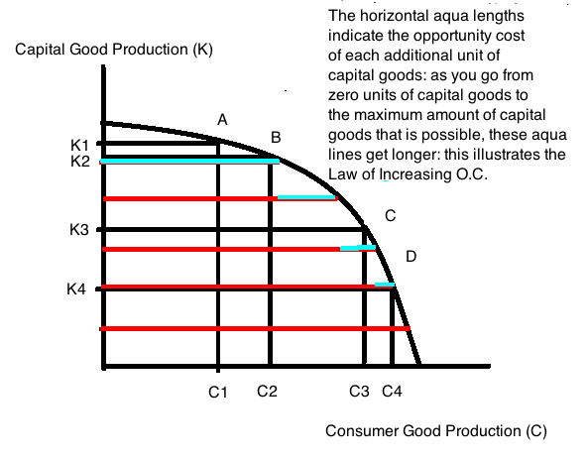
5. Janine is taking Econ 100 and Psych 202 this semester and has figured out that she has ten hours available each week to devote to the study of economics or psychology. The table below provides information about the amount of study time she allots to each subject and the anticipated final grade she will get in each subject given this allocation of study time.
Possible Study Combination | Number of Hours of Study for Economics | Number of Hours of Study for Psychology | Anticipated Final Grade in Economics | Anticipated Final Grade in Psychology
A | 10 | 0 | 98 | 50
B | 8 | 2 | 90 | 60
C | 6 | 4 | 78 | 75
D | 2 | 8 | 65 | 85
E | 0 | 10 | 50 | 90
a. In a graph plot out Janine’s production possibility frontier given the above information. Measure her Economics grade on the vertical axis and her Psychology grade on the horizontal axis. Instead of using (0, 0) as the origin, use (50, 50) as the point of intersection for the two axes: do this since even if she studies zero hours for Economics or Psychology she will get a grade of 50 in the classes: not a bad assumption for many classes where the professor expects a student to be able to get approximately 50% of the material by just coming to class and hearing the lectures. Mark combinations A, B, C, D, and E on your graph and then connect these five combinations to make a PPF for Janine’s production of these two goods (the grades in Economics and the Psychology). To make this a more interesting assignment: figure out how to draw the graph using some kind of computer program: for example, Excel (here you will need to enter the data and then convert to a graph), Paint, or Paintbrush (I tend to use Paint or Paintbrush if I am making “sketches” and Excel if I want a “too-scale” drawing). (By doing this with a computer program you will build your skill sets and can add “comfortable with graphic design programs to your resume.)

b. What is Janine’s opportunity cost of changing her study habits from 8 hours of Economics study a week to 2 hours of Economics study a week? Be sure to include some kind of unit of measurement for the answer you provide.

c. Given the above information, is there an optimal allocation of study time to these two subject areas? Explain your answer.

Answers:
a.
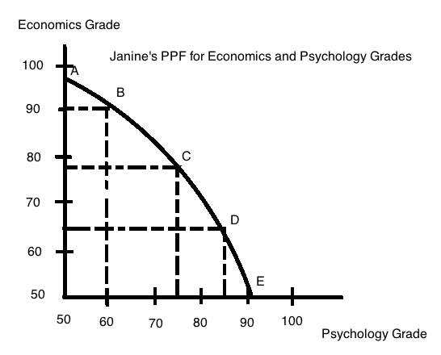
b. Opportunity cost is measured in terms of what you are giving up: in this case Janine by devoting fewer study hours to economics reduces her grade in economics from a 90 in the class to a 65 in the class: the opportunity cost of choosing this combination of study hours is a decrease of 25 points in her anticipated final grade in economics.

c. No there is no optimal choice of study time. The above combinations provide us with a set of efficient points: each combination tells us the anticipated maximum score in both subject areas that Janine can expect to get if she allocates her study time as given for that combination in the table. But, the table provides no guidance as to the optimal combination: Janine will need to think about her short-term as well as long-term goals in order to determine how best to allocate her scarce resource-study time-between these two subject areas. Clearly, if Janine anticipates pursuing a career direction more closely related to economics it is likely she will choose to devote more hours of study to economics. And, if she anticipates pursuing a career direction more closely related to psychology she will choose to devote more hours of study to psychology.

6. Consider two countries: Country X and Country Y. Both countries produce autos and shoes and the following table provides you with information about the maximum amount of autos and shoes that each country can produce if they only produce one of these goods. Both countries have linear production possibility frontiers in these two goods.
 | Maximum Amount of Autos that can be Produced in the given time period | Maximum Amount of Pairs of Shoes that can be Produced in the given time period
Country X | 20,000 | 50,000
Country Y | 10,000 | 20,000
a. Given the above table, which country has the absolute advantage in the production of autos?

b. Given the above table, which country has the absolute advantage in the production of shoes?

c. Draw two graphs: in the first graph represent Country X’s PPF measuring autos on the vertical axis and pairs of shoes on the horizontal axis; in the second graph represent Country Y’s PPF measuring autos on the vertical axis and pairs of shoes on the horizontal axis. Again, you might do this on a computer graphic program (see the last question for names of some of the readily available programs).

d. What is the opportunity cost of the following (in your answer provide units of measurement):
i. One pair of shoes for Country X?
ii. One pair of shoes for Country Y?
iii. One auto for Country X?
iv. One auto for Country Y?

e. Which country has the comparative advantage in the production of autos? Explain your answer. Which country has the comparative advantage in the production of shoes? Explain your answer.

f. Draw the joint PPF for these two countries in a single graph, measuring autos on the vertical axis and pairs of shoes on the horizontal axis. Label clearly the coordinates for any “kink points”.

g. What is the acceptable range of trading prices for 10,000 pairs of shoes? Provide a number line like the one presented in class to illustrate your answer. Include the directional arrows and the Country Perspective in your number line illustration.

h. What is the acceptable range of trading prices for 5,000 autos? Provide a number line like the one presented in class to illustrate your answer. Include the directional arrows and the Country Perspective in your number line illustration.

Answers:
a. Country X has the absolute advantage in the production of autos since Country X can absolutely produce more autos than can Country Y (20,000 autos versus 10,000 autos.

b. Country X has the absolute advantage in the production of shoes since Country X can absolutely produce more shoes than can Country Y (50,000 pairs of shoes versus 20,000 pairs of shoes).

c.

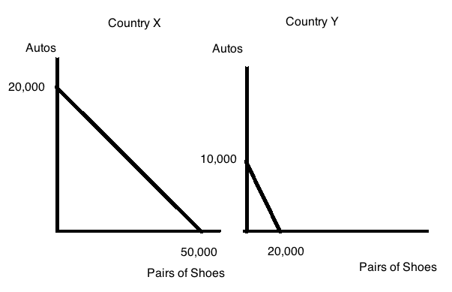

d.
i. The opportunity cost of one pair of shoes is 2/5 auto for Country X (note that this is the absolute value of the slope of the PPF for Country X)
ii. The opportunity cost of one pair of shoes is ½ auto for Country Y (note that this is the absolute value of the slope of the PPF for Country Y)

iii. The opportunity cost of one auto is 5/2 pairs of shoes for Country X (note that this is the absolute value of the reciprocal of the slope of the PPF for Country X)
iv. The opportunity cost of one auto is 2 pairs of shoes for Country Y (note that this is the absolute value of the reciprocal of the slope of the PPF for Country Y)

e. Country Y has the comparative advantage in the production of autos since Country Y’s opportunity cost of producing an auto is lower than Country X’s opportunity cost of producing an auto (2 pairs of shoes versus 2.5 pairs of shoes). Country X has the comparative advantage in the production of shoes since Country X’s opportunity cost of producing a pair of shoes is lower than Country Y’s opportunity cost of producing a pair of shoes (2/5 auto versus ½ auto).

f.
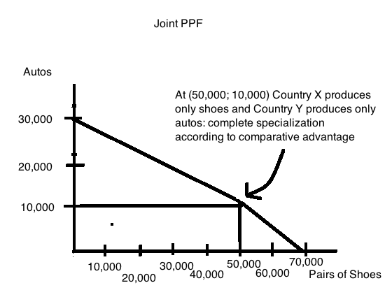
g. Here is the acceptable range of trading prices for 10,000 pairs of shoes: note that I started by making the number line for the trading prices for 1 pair of shoes and then just grossed this up by multiplying all the numbers by 10,000.

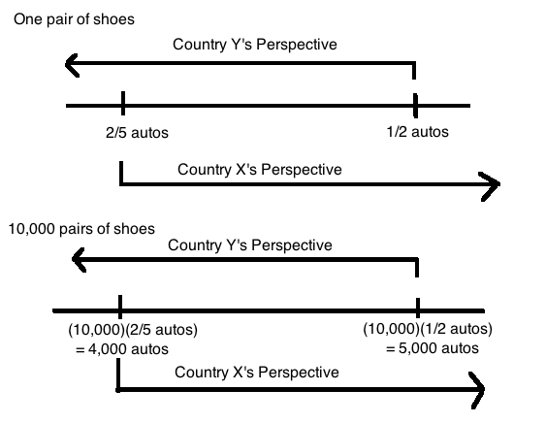
h. Here is the acceptable range of trading prices for 5,000 autos: note that I started by making the number line for the trading prices for 1 auto and then just grossed this up by multiplying all the numbers by 5000.

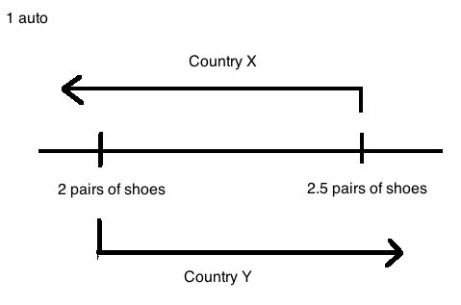
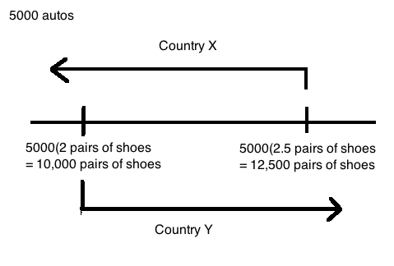
7. Wheelan writes that “the more generous a health care system is in the benefits it guarantees, the more it is going to cost” (page xxi). This is a positive statement that is supported by the data. It is early in your study of economics, but suppose you were the political leader in your society and had the difficulty of designing and implementing a health care system. How would you determine which procedures would be covered by the health care system and which procedures would not be covered by the health care system? Write a thoughtful answer here: no credit for this one for a glib answer (if you are not sure what “glib” is, look it up!).

Answer:
There is no one true answer here. This is a huge economic and philosophic issue. The economics of the issue are pretty straight forward: there are limited resources that can be devoted to health care and all resources devoted to health care are therefore not available for other uses. So, how many of our scarce resources do we wish to devote to health care and how will we choose what health care goods and services we wish to produce as a society?

One way of determining which procedures we will fund is to look at each procedure from a benefit and cost perspective: those procedures that generate more benefit than cost are certainly worth more consideration than procedures that generate more cost than benefit. To compare cost and benefit you are going to need to figure out a way to collect good data on procedures and their outcomes. This will not be an easy assignment, but data driven medicine is exactly about this concept: let’s collect data on different medical procedures so that we can make a more informed decision (this will only prove helpful if the data is reliable and decent-a huge problem!).

Another way to design this health care system is to take a strictly political approach: what position or positions is likely to generate greatest support for me as a political leader. What approach can I take to persuade people that I am looking after their “best interests” even if I may actually be looking after my own interests with greater intent? How do I manage and trade-off the various interest groups that are involved here: the medical community, the insurance companies, the consumers?

Philosophically the issue is more one of distributional dilemmas. Do poor people deserve medical treatment that is as good as the medical treatment received by wealthier, better-endowed individuals? If you say yes, then how does the society pay for these services? If you say no, how do you justify this position from a justice or equity position? Do older people deserve the same medical treatment as young people? After all, the old may be close to the end of their productive life, do they merit the same level of medical commitment as those whose working lives are still ahead of them? Clearly, living and working within a world with scarce resources generates some very difficult policy questions for all of us. How much of our scarce resources should be devoted to research and experimentation, particularly when there is little evidence yet available to guide a particular new area of research and experimentation.

8. On page 6, Wheelan writes “Economics starts with one very important assumption: Individuals act to make themselves as well off as possible.” Do you agree or disagree with this statement? Provide a short, concise but thoughtful answer to this question.

Answer:
So there are many answers you could write for this question. Here’s mine:

I’m an economist so I do tend to think that people “act to make themselves as well off as possible”. But, I would define “well off” pretty broadly: for example, I am pretty sure that I could have earned a far greater salary by working for some corporate entity: I have strong organizational skills, good people management skills, a high level of energy, a strong commitment to doing high quality work. But, I did not choose to go this route because this route, although it would have compensated me dearly financially, would have limited the time I could spend on pursuits that generate very high levels of satisfaction for me. For example, I would not have been able to devote as much time and attention to my children when they were growing up (would have hired a lot more help), would not have had the time to devote to interests that are enriching and delightful to me but not monetarily well compensated (so much for my sewing and art endeavors), and would not have had the time to devote to recreational pursuits (no great tennis serve, no long walks to keep in shape). My tastes and preferences tilt strongly to nurturing my children, pursuing creative activities, and maintaining my physical fitness. So, yes I believe that people “act to make themselves as well off as possible” but I readily admit that “well off” is a lot more than just monetary compensation. What do you think?

9. Wheelan in Chapter One of his book writes about a wide range of topics. Select a single topic or example that you found intriguing: write a brief paragraph identifying the example (you can quote directly from the text, but provide the specific page number and make sure you attribute the statement to Wheelan), and then discuss what you found interesting or unexpected about this example. Again, let me remind you that it is relatively easy for the reader to know when you have written in a hurried, thoughtless manner: so practice those writing skills as well as your critical thinking!

Answer:
Clearly there are a lot of possibilities here: I was struck this time through with Wheelan’s statement about there being too few sweatshops (page 24): I knew the arguments but I was impressed with how Wheelan worded them. He wrote concisely and to the point, yet the point was easy to see once he put it down on paper. Is it more likely that people take jobs in sweatshops because it is their best alternative or because they are dim-witted? Most of us, if we take the time to ponder this, will likely conclude that these individuals select these jobs because they have no better alternative. That thought may surprise readers who are just starting their “economic study” journey.

10. One last task for this homework: an important skill set worth developing is the ability to take reading notes on what you are reading. In contrast to highlighting text, taking reading notes encourages you to synthesize and compress the ideas you are reading into a short, but pithy version. Furthermore, deconstructing the underlying organization of the text may also prove insightful. So, in light of this: take the time to outline the key points and organizational structure of Chapter 2 of Wheelan. (Note: in the answer key I will be providing two outlines: a long version and a much shorter version. What was interesting to me is that I was not able to write the short version until I had done the long version (despite having read this chapter multiple times). I also included a short paragraph about my perception of Wheelan’s organizational structure within the paragraph.

Answer:
Your outline will likely prove shorter than mine, and I will admit that by the end of the chapter I was not quite as expansive as I was in the early part of the exercise. After I did the long outline I then created a shorter outline: the shorter outline is superior (I am giving you both) since it really synthesizes the chapter’s ideas in a more succinct, generalized manner. Do read both of them.

Also, one of the things I note when outlining Wheelan’s chapters (I have done this several times) is that his chapters have an overarching theme but then consist primarily of lots of examples to illustrate that theme. He likes to start his chapters with a eye opening story that “hooks” his reader and then he builds on this. His organizational structure I think is an unusual one and bears looking at just because it is a little different. In this chapter his theme is that incentives matter and then he knocks out a chapter that illustrates a huge variety of examples of where the incentives are not quite right and you end up with sub-optimal outcomes (black rhinos, fisheries, stock options for CEOs, fast food employees stealing from the till, etc.). By the end of the chapter Wheelan has exposed his reader to a really wide swath of ideas (free ridership, principal-agent, stock options, etc.) and a very broad view of the issue and its many manifestations. I hope that you will take the time to look at how he structures his writing of the chapter and not just the ideas: this may prove instructive to you!

Long outline of “Incentives Matter: Why you might be able to save your face by cutting off your nose (if you are a black rhinoceros)”

- Opening story: fate of the black rhinoceros-to save the black rhinoceros, change the incentives
  - Black rhinoceros horn very valuable: big incentive to kill them
  - Over harvesting (i.e., killing) of black rhinoceros: market forces do not work to protect the black rhinoceros
    - Most rhinoceros are communal rather than private property
    - Local communities view rhinoceros as trouble
    - Free ridership issue: people free ride on the efforts of others to protect the endangered specie
    - Role for government to protect the endangered resource: but governments in southern Africa are often too poor and/or too corrupt to effectively protect the species
  - Supply-side experiments to save the rhino: cut off their horns
    - Less incentive for hunters to kill the rhino since they have no horn
    - More incentive for hunters to kill the rhino so that they don’t waste time and resources tracking the same hornless rhino
    - More incentive to kill rhino: horn stump still valuable
    - More incentive to kill rhino: fewer rhinos make remaining rhinos more valuable
  - Demand-side policies to save the rhino
    - Limit consumption of products made from rhino
    - Create a legal market for rhino products: source of revenue for poor countries and a way to decrease market price for illegal products
  - Saving the black rhino is about economics as well as science
- Incentives matter: examples of Bill Gates, eastern European countries, North Korea, carbon emissions in US
  - Economist solution is to create markets and let price determine outcomes
  - Link pay to productivity (counterexample of US public school teacher compensation): higher pay will attract more productive individuals
  - “Law of Unintended Consequences”
    - Example where required infant seat usage in airplanes led to increased travel by car-a more dangerous mode of transportation
    - Mexico City reduction of car pollution effort in contrast to London peak pricing reduction of car pollution effort: raising prices reduces demand
- Examples of issues with incentives
  - Principal-agent problems: the owner employs an “agent” that may have incentive to engage in activities that are harmful to the owner or “principal”
    - Fast food employee stealing from owner
    - CEOs that do not always act in owners’ best interests: example of stock options, recent financial crisis
    - Firms need to reward “innovation, risk, insight, hard work” without creating incentives that encourage “employees to game the system”
    - Financial crisis of 2008
    - Example of real estate agent
  - Prisoner’s dilemma: self-interest leads to bad outcomes
  - Australian fisheries: creating private property to protect endangered species/to prevent overharvesting of common resource
- Wrapping it up
  - Incentives matter
  - Markets reward winners and “crush” losers: creative destruction (J. Schumpeter)
    - Theoretically we like the idea of the market
    - The reality-if you are a “loser” the market is less appealing
  - Tax policy impacts incentives
    - Difficult to transfer wealth from rich to poor through tax policy
    - Taxes provide incentives to reduce or stop the activity being taxed
  - Government benefit programs also affect incentives
    - Difficult to transfer wealth from rich to poor through government benefit programs
    - Welfare programs that aid unmarried unemployed women create incentives for women to not be married and/or not work
    - Unemployment benefits reduce the incentive to work
    - Social Security and Medicare-programs that benefit the elderly-may provide incentives to reduce private saving
  - Good taxes
    - “Broad, simple and fair”
    - Broad tax: small tax on large number of people-harder to evade
    - Simple tax: easy to administer and impose
    - Fair tax: two individuals in similar circumstances will pay the same amount
Short Outline of “Incentives Matter: Why you might be able to save your face by cutting off your nose (if you are a black rhinoceros)”

- Incentives matter and if you don’t get the incentives right you will have big problems
- Examples of where incentives are not right and the bad outcomes that arise from the failure to get the incentives right
  - Common resources: Black rhinoceros face extinction due to overharvesting; fishing industry
  - Bill Gates does not graduate from college since he can earn more by starting his personal computer company
  - Compensation system for public school teachers results in more productive individuals leaving this industry
  - Requirement to use infant car seats in air travel: leads to more expensive air travel trips for parents and encourages greater demand for car travel-a riskier form of travel
  - Pollution control: Mexico City experience (a policy failure) versus London experience (a policy success)
  - Principal-agent problems: when the best interest of the owner (the principal) are not the same as the best interest of the employee (the agent)
  - Tax policy: taxes create their own set of incentives that can either reward good behavior or bad behavior: moral of the story designing tax policy is challenging if you want it to generate optimal outcomes
  - Government benefit programs: create their own set of incentives that can either reward good behavior or bad behavior: see moral of the story for tax policy
- Two more general ideas to carry from the chapter
  - Creative destruction: Schumpeter-the market creates winners and also crushes losers
  - Best taxes should be simple, broad and fair

