Economics 100
Fall 2013
Answers to Homework #1
Due Tuesday, September 17, 2013

Directions: The homework will be collected in a box before the lecture. Please place your name, TA name and section number on top of the homework (legibly). Make sure you write your name as it appears on your ID so that you can receive the correct grade. Late homework will not be accepted so make plans ahead of time. Please show your work. Good luck!
Please realize that you are essentially creating “your brand” when you submit this homework. Do you want your homework to convey that you are competent, careful, professional? Or, do you want to convey the image that you are careless, sloppy, and less than professional. For the rest of your life you will be creating your brand: please think about what you are saying about yourself when you do any work for someone else!

1. In class there was a brief discussion of Greg Mankiw’s Ten General Principles of Economics. This question is based on those principles.

a. Principle #1 states that “People face tradeoffs.” Think about this statement and then express three different occasions within the first two weeks of class where you faced a tradeoff. Explain the situation and identify the tradeoff. How did you decide what to do in the situation?

Answer:

Answers here will vary with each student. For example, one tradeoff I am facing right now is that I can either go enjoy a cool lemonade on the porch and a light summer read or I can write this homework. If I choose the porch, then I am giving up getting this work done and will likely feel a “crunch” of too much work in a few weeks. If I choose the homework, then I am missing out on a perfectly lovely August afternoon on the porch! I will make my choice by considering the costs and benefits I derive from the two choices and hopefully, I will choose the one whose net benefit is greater.

b. Principle #4 states that “People respond to incentives.” Provide three examples of incentives you have faced and how you responded to those incentives.

Answer:
Again, answers here will vary with each student. One incentive I could mention is the homework policy in the class: turning in the homeworks on time and showing good effort is an easy way to get 10 out of the possible 100 points in the class. There is an incentive to do the homework and to do it well since it is an easy way to raise one’s grade. There is also an incentive to stay “on top of the course” and know the dates for homeworks and midterms: I am trying to make sure that each student has an incentive to be aware of those dates.

c. Let’s return to Principle #4: “People respond to incentives.” Now, fast forward fifteen years and imagine that you are a parent (it could happen!). Express three outcomes you would like your child to achieve and then determine what incentives you will provide to help them achieve this outcome. Be thoughtful about this: that is, be “intentional” about what incentives you are going to offer in order to reach your desired outcomes. For example, suppose one of my goals is to teach my child to take good care of their possessions: I might offer them the following incentive-“For items we both view as important for you to have, I am willing to contribute 40% of the cost of the item, but you (the child) will need to contribute the other 60%.” (This is actually about what we did when raising our children: after the first bicycle which we provided, we let the kids trade their bikes and then we provided about half of what the additional cost for the upgrade to a bigger bike was. Each of our kids ended up loving their bikes because they viewed them as something they had earned and each of them took really good care of their bikes. People respond to incentives.)

Answer:
Again answers will vary with each student. In the prompt I have already given an example from my own life.

2. Use the following figure of an economy’s production possibility curve to answer this set of questions. Assume this country has a fixed amount of resources, technology and time period in which they produce capital goods (plant and equipment that is produced this period in order to produce consumer goods next period) and consumer goods (goods that are produced and consumed this period).

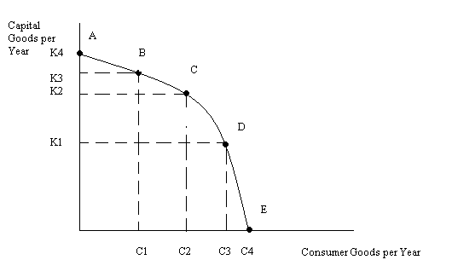
a. Given the above graph, what is the maximum amount of capital goods this economy could produce? Is it likely this economy will choose to produce this amount? Explain your answer.

Answer:
The maximum amount of capital goods this economy can produce given the PPF drawn is K4 units. The economy is unlikely to produce this level of capital goods however since this level of production does not provide any consumer goods: people need to eat, have clothing and shelter.

b. Given the above graph, what is the maximum amount of consumer goods this economy could produce? Is is likely this economy will choose to produce this amount? Explain your answer.

Answer:
The maximum amount of consumer goods this economy can produce given the PPF drawn is C4 units. The economy could produce this level of consumer goods, but the economy would not be replacing any capital goods that wear out (that depreciate) and that would imply that this economy would be reducing its potential production in future periods. This economy faces a tradeoff between current consumption and future consumption: choosing current consumption implies that you are reducing future consumption possibilities.

c. Suppose this economy is producing at point B in the above graph. What is the opportunity cost of this economy moving to point C? Remember that opportunity cost is measuring what you are giving up-in this case what does this economy give up when it moves from point B to point C? Make sure your answer provides units of measurement .

Answer:
The opportunity cost of this economy moving from point B to point C is measured by how many units of capital good production the economy is giving up. In this case, the economy gives up K3 – K2 units of capital good production.

d. Suppose this economy is producing at point D in the above graph. What is the opportunity cost of this economy moving to point C? Remember that opportunity cost is measuring what you are giving up-in this case what does this economy give up when it moves from Point D to point C? Make sure your answer provides units of measurement.
Answer:
The opportunity cost of this economy moving from point D to point C is measured by how many units of consumer good production the economy is giving up. In this case, the economy gives up C3 – C2 units of consumer good production.
e. What is the Law of Increasing Opportunity Cost? Does this PPF exhibit this law for both goods? Explain your answer.
Answer:
The Law of Increasing Opportunity Cost states that as more and more of one good is produced by an economy that the opportunity cost of producing this good increases. Moving from point A down the PPF to Point E we can see that increasing amounts of capital goods must be given up for each additional unit of consumer goods produced by this economy. Thus, moving from point A to point E we see the Law of Increasing Opportunity Cost is true. It is also true moving from point E towards point A: we can see that increasing amounts of consumer goods must be given up for each additional unit of capital goods produced by this economy.
3. Consider the following production possibility frontier of an economy that produces two goods, tents and bicycles:

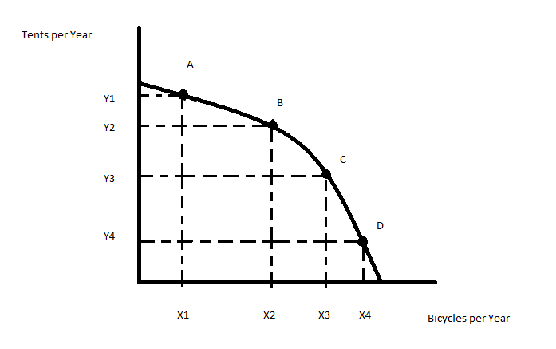

- On the above graph what is the opportunity cost of moving from point A to point B? In your answer be sure to identify the units of measurement for this cost.
- Given the above graph, suppose you are told that citizens in this economy want to produce at the point (X2, Y1). What would you tell these citizens given the above graph?
- Given the above graph, suppose the economy is currently producing at the point ((X2, Y3). What do you know with certainty about this economy given this information and the above graph?

Answers:

- The opportunity cost of moving from one point to another on a PPF is measured by what you must give up: in this example, moving from point A to point B you are giving up (Y1 – Y2) tents.
- The point (X2, Y1) lies beyond the PPF: this indicates that this economy given its resources, technology, and available time cannot produce this combination of tents and bicycles. This is an unobtainable or infeasible point. Citizens are asking for the impossible with this request.
- The point (X2, Y3) is inside the PPF: this indicates that this economy is not fully utilizing its resources, technology and/or time. This point is obtainable but inefficient: there is waste in this economy. We can refer to this waste as unemployment or underemployment.

- The opportunity cost of going to college includes the cost of tuition, the cost of the textbooks a college student will purchase, and the salary that they give up in order to go to college. The opportunity cost of going to college does not include the cost of the food the college student eats or the cost of his living arrangement. Why are these last two costs not included as part of the opportunity cost of going to school?
Answer:
The cost of room and board (the cost of the living arrangement and the cost of the food) for the college student is not included as part of the opportunity cost of going to school because whether or not the student is in school, the individual will face costs for their living arrangement and for the food they eat. Compare this to the cost of tuition: this cost is specific to acquiring the college degree: the student cannot get the college degree without making this expenditure and, if the student, decided to not go to college they could use their funds to consume something else.
5. Suppose that Bob and Sally produce bicycles and tents. The following graphs depict Bob and Sally’s production possibility frontiers for these two goods. Assume that Bob and Sally have identical amounts of resources, technology, and time in which to produce these two goods. Currently Bob is producing at point A on his PPF and Sally is producing at point B on her PPF. Bob and Sally both have linear PPFs.
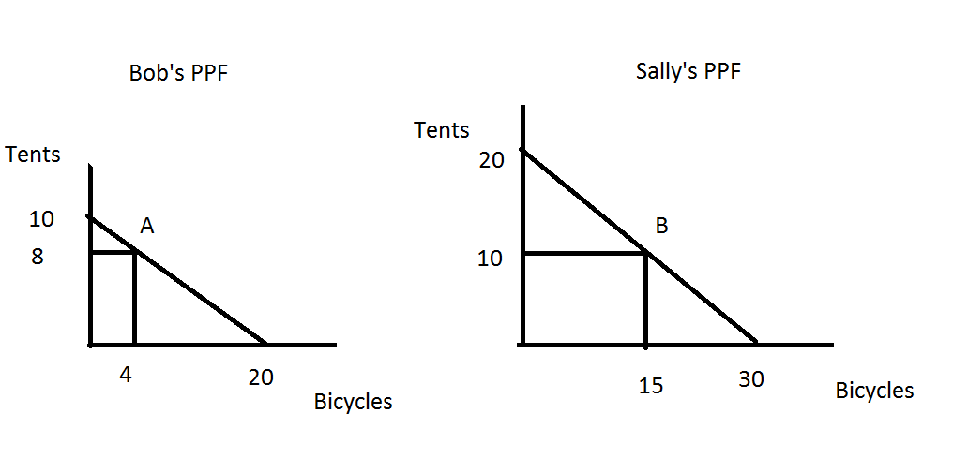
- Given the above graphs and given that Bob is producing at point A and Sally at point B fill in the following table providing the amount of tents (T) and bicycles (B) that are currently being produced.

 | Tents (T) | Bicycles (B)
Bob
Sally
Total Production

Answer:

 | Tents (T) | Bicycles (B)
Bob | 8 | 4
Sally | 10 | 15
Total Production | 18 | 19

- What is Bob’s opportunity cost of producing one additional bicycle given the above graph?

Answer:
The opportunity cost of producing one additional bicycle for Bob is ½ tent. To see this you might first calculate the slope of Bob’s PPF: slope = -10/20 or -1/2. This tells us that every time Bob increases the number of bicycles produced by one unit he decreases the number of tents he produces by ½ tent. Thus, the opportunity cost of getting an additional bicycle for Bob is measured as the ½ tent he must give up in order to get the additional bicycle.

- What is Sally’s opportunity cost of producing one additional bicycle given the above graph?

Answer:
The opportunity cost of producing one additional bicycle for Sally is 2/3 tent. To see this you might first calculate the slope of Sally’s PPF: slope = -20/30 or -2/3. This tells us that every time Sally increases the number of bicycles produced by one unit she decreases the number of tents she produces by 2/3 tent. Thus, the opportunity cost of getting an additional bicycle for Sally is measured as the 2/3 tent she must give up in order to get the additional bicycle.

- Given your answers in (b) and (c), who has the comparative advantage in the production of bicycles? Explain in your own words what this means.

Answer:
Bob has the comparative advantage in the production of bicycles since his opportunity cost of producing an additional bicycle is less than Sally’s opportunity cost of producing an additional bicycle. Comparative advantage is based on having individuals (or countries) specialize in producing those goods for which they have lower opportunity costs than do other individuals (or countries) and then trading with one another.

- Suppose that Bob decreases his production of tents by 2 units while Sally increases her production of tents by 2 units. Both Bob and Sally are assumed to still be producing at a point on their PPFs. Given these changes fill out the following table showing what their new level of production of these two goods will be.

 | Tents (T) | Bicycles (B)
Bob
Sally
Total Production

Answer:

 | Tents (T) | Bicycles (B)
Bob | 6 | 8
Sally | 12 | 12
Total Production | 18 | 20

- Use a number line to illustrate the range of acceptable prices for 1 bicycle that both Sally and Bob will agree to. Use a second number line to illustrate the range of acceptable prices for 10 tents that both Sally and Bob will agree to.

Answer:
We know that the opportunity cost of producing 1 bicycle is ½ tent for Bob and 2/3 tent for Sally. Hence, Bob will be willing to produce and trade 1 bicycle as long as he gets at least ½ tent or more for that bicycle; and Sally will be willing to trade for that bicycle provided she pays 2/3 tent or less for it. So, we can depict this as follows:
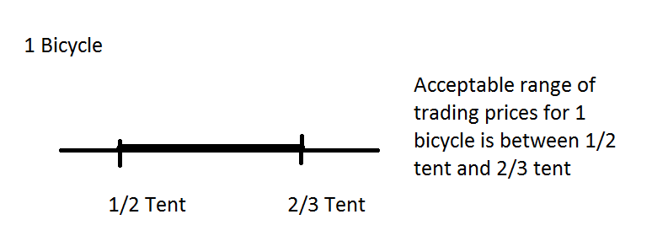
We know that the range of acceptable prices for 1 tent is between 3/2 bicycles (Sally’s opportunity cost of producing 1 tent) and 2 bicycles (Bob’s opportunity cost of producing 1 tent). So, the acceptable range of trading prices for 10 tents will fall between (10)(3/2 bicycles) and (10)(2 bicycles) or between 15 bicycles and 20 bicycles. The figure below illustrates this idea.
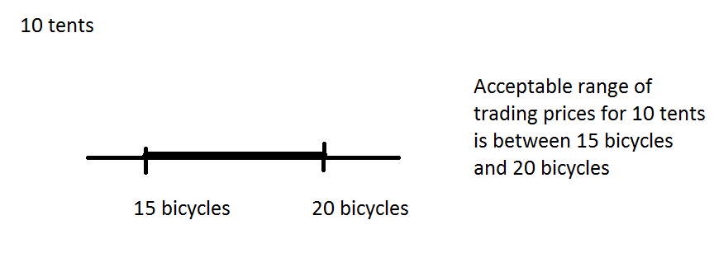
- Draw the joint PPF for Sally and Bob measuring tents on the y-axis and bicycles on the x-axis. Make sure you identify the y intercept, the x intercept, and the coordinates of the “kink” in the joint PPF. In drawing this joint PPF:
- Make sure that the y-intercept shows the total amount of tents that Sally and Bob can produce if they both produce only tents;
- Make sure the x-intercept shows the total amount of bicycles that Sally and Bob can produce if they both produce only bicycles;
- Make sure the “kink” point shows the total amount of bicycles and tents that Sally and Bob can produce if each of them fully specializes according to their comparative advantage.
Answer:
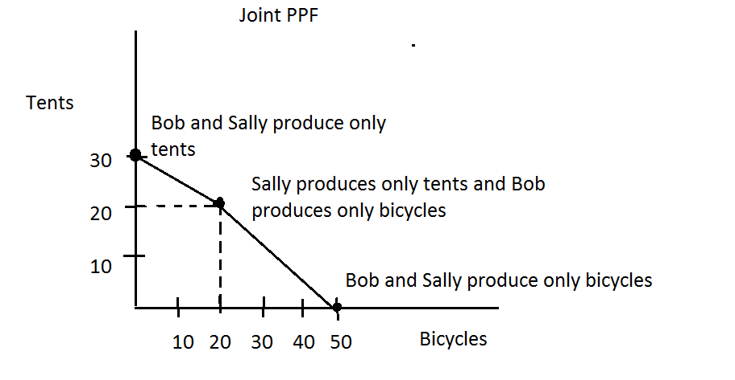

6. In the Foreward to Naked Economics Burton Malkiel makes a reference to economics as the “dismal science”. This term is attributed to Thomas Carlyle. Write a brief paragraph discussing why Carlyle referred to economics using this term. Make sure your paragraph convinces the reader that you have thought about this idea and that you have also read Malkiel’s commentary on it.

Answer:
Answers will vary here but the reader will be looking primarily for a thoughtful response that indicates both that the student has read the selected material and that the student is actively thinking about the ideas embedded in the written material.

7. In Chapter 1 of Naked Economics Wheelan writes “Is it fair for those of us who live comfortably to impose our preferences on individuals in the developing world.” Respond to this statement with a well-reasoned and thoughtful commentary: it does not matter what position you argue provided you make a logical, thoughtful response. Make sure you include at least one illustrative example in your answer.
Answer:
It is tempting to think that “my way is the best way and everyone should do things my way”. But, my way may fail to recognize very real issues that other people and other nations face. I may think that we should preserve rain forests for example and yet, if I happened to live in the rain forest and the only way I have to feed my family requires me to cut down the rain forest, then I might find myself cutting down the rain forest. One aspect of this quote is its ability to remind ourselves that our perspectives and beliefs are very much influenced by our situations. Among the affluent it is relatively easy to be worried about environmental issues; for the less affluent, these concerns may pale next to more pressing concerns.
Here is another example of a possible response:
The example I cite here is about food security and how food is produced within a country. Food security is a basic and critical requirement for each country and is affected by a complexity of factors, including unstable social and political environments that may be challenged by the issues of achieving sustainable economic growth, dealing with macroeconomic imbalances in trade, addressing inadequate education, and competing uses of natural resources. For both people living in the developed world and people living in the developing world, setting a stable social and political environment is a very real and very important issue. I suspect that all people have similar preferences for health, safety, shelter, and basic needs. The observed different behaviors between the developed world and the developing world are mainly due to the fact that those who live more comfortably have much less worries about social and political environments, fair trade, and education opportunities, so they can devote more of their resources to protecting their natural resources and the environment.
8. In Chapter 1 of Naked Economics identify a statement that caught your attention and made you think. Copy this statement and then write a brief, but illuminating paragraph, about why you chose this statement. Your response should convince the reader that you have read the material AND thought about the material.
Answer:
Answers here will clearly vary. But, let me give you an example of a statement that caught my attention and my response to the statement.
On page 8, Wheelan writes “Economists often argue that rich countries ought to pay poor countries to protect natural resources that have global value.” This statement caught my attention because it draws attention to the idea that a natural resource may have different value to a person of affluence than it does to a person of less affluence. The quote reminds us that environmental concern is a luxury good: it is easy to worry about environmental concerns if you do not have to worry about feeding yourself, having a job, securing safe and warm housing. We have a very clear example of this trade-off in many places in our world today: for example, China has experienced rapid economic growth (which provides more food, better housing, more jobs) over recent years but this growth has also produced high levels of environmental damage. China could pursue environmentally friendly policies but this would reduce its overall production of goods. Wheelan suggests if environmental concerns are of greater value to rich countries than to poor countries, then the rich countries should be willing to compensate poorer countries in order to convince the poorer countries to pursue environmentally friendly policies. Have you ever thought about this as a possibility?
Here’s another example of a response:
"[M]ost of us make decisions using intuition or rules of thumb, kind of like looking at the sky to determine if it will rain, rather than spending hours poring over weather forecasts ... these rules of thumb may lead us to do things that diminish our utility in the long run."
This quote points out the fact that people do not have perfect rationality and that there are many “rules of thumb” that we all use to help us make decisions. For example, one rule of thumb often cited is the need to “save for a rainy day”. This aphorism, or rule of thumb, encourages us to plan for the future by setting aside some of our current income. This is much like our carrying an umbrella when we head to class so that, should it rain, we are prepared for the shower. A similar logic underlies why we should purchase car insurance, health insurance, life insurance: yes, we have to give up current consumption when we do this (just like we have to carry that umbrella in our pack when it is not raining) but it enables us to be prepared for what we cannot fully predict or foresee in the future.
9. One skill set that I believe is incredibly valuable to have is the ability to summarize a long passage that you have read. To get this skill set however you do need to practice it! So, for this question I want you to outline the main points and supporting arguments that Wheelan uses in Chapter 1 of his text. Use standard outline form when you do this. (Guidance here: when I did the answer key I ended up with six major topics and a total of twenty-six separate entries in my outline. That is, my outline could easily fit on a single page of paper-and so should yours!)
Answer:
Again, your answer and mine will certainly not be the same on this-but here is my quick take on the assignment. Notice that I quoted some of Wheelan’s phrasing because it was succinct and captured the point. If this were a more formal setting I would make sure to tell the reader the exact page reference for the quote.

I. The market as a provider of goods and services
A. Aligning incentives so that individuals pursuing their own self-interest lead to improving standards of living
B. Huge numbers of transactions in the market lead to improving standards of living
C. Limited role of government in helping the market provide goods and services
D. The market is one way to provide goods and services: it is not perfect
II. “Individuals act to make themselves as well off as possible”: they maximize their utility
A. People have different preferences
B. There are tradeoffs between work and leisure
C. There is an opportunity cost to whatever we choose to do
D. People respond to incentives: when the price of something goes down, it becomes more attractive; when the price increases, it becomes less attractive
III. “Firms attempt to maximize profits”
A. Firms combine inputs to create outputs of greater value
B. The market helps “direct resources to their most productive use”
C. The importance of price as a way to guide resource use
D. Entry barriers make markets work less effectively but increase the level of profits that existent firms earn
IV. The importance of supply and demand: where firms and consumers meet
A. The market price
B. Price discrimination: a way to enhance firm profits
V. What if we are not rational? Behavioral economics
VI. Key phrases from the chapter
A. “The market is a powerful force for making our lives better”
B. “At the same time, the market is amoral”: remember, cockroaches and rats (and if you don’t remember them, go find the reference in the text)
C. “Our system uses prices to allocate scarce resources”
D. “Because we use price to allocate goods, most markets are self-correcting”
E. “If we fix prices in a market system, private firms will find some other way to compete”
F. “Every market transaction makes all parties better off”

