Econ 101 Name _________________________________
Summer 2014
Answers to Quiz #1

Please write all answers neatly and legibly.

1. Jason and Olivia both produce jam (J) and butter (B) and both of their production possibility frontiers are linear with respect to these two goods. If Jason uses 20% of his resources (his labor) for jam production and 80% of his resources (his labor) for butter production he can produce 5 units of jam and 20 units of butter. If Olivia uses 50% of her resources (her labor) for jam production and 50% of her resources (her labor) for butter production she can produce 10 units of jam and 20 units of butter. Assume that labor is the only resource needed by Jason or Olivia to produce jam or butter.

a. (2 points) Given the above information, write an equation for Jason’s production possibility frontier in slope intercept form where jam (J) is measured on the vertical axis and butter (B) is measured on the horizontal axis. For full credit provide an explanation for how you found your answer.

Answer:
From the given information we know that (B, J) = (25, 5) is on Jason’s PPF. We also know that at this point 20% of Jason’s resources are devoted to jam production. We can reason that if Jason devoted 40% of his resources to jam production he could double his jam production to 10 units; if he devoted 60% of his resources to jam production he could increase his jam production by another 5 units to 15 units; if he devoted 80% of his resources to jam production he could increase his jam production to 20 units; and if he devoted 100% of his resources to jam production he could increase his jam production to 25 units. So, the y-intercept of his PPF is 25. You can calculate the slope of his linear PPF by using two points (20, 5) and (0, 25): slope = -20/20 = -1. So the equation for Jason’s PPF is J = 25 – B.

b. (2 points) Given the above information, which person has the comparative advantage in the production of jam? Explain your answer.

Answer:
For Jason the opportunity cost of producing an additional unit of jam is one unit of butter. For Olivia you will first need to find her PPF: you know that (20, 10) is the midpoint of her PPF since she is devoting 50% of her resources to jam production and 50% of her resources to butter production. We can therefore reason that the points (0, 20) and (40, 0) lie on her PPF. We can write her PPF as J = 20 – (1/2)B. Using this equation we can note that the opportunity cost of Olivia producing an additional unit of jam is 2 units of butter. Jason has the comparative advantage in the production of butter since his opportunity cost of producing a unit of butter is less than Olivia’s opportunity cost of producing a unit of butter.

c. (2 points) In the space below draw the joint production possibility frontier for Jason and Olivia measuring jam (J) on the vertical axis and butter (B) on the horizontal axis. Make sure all intercepts, all “kink” points, and all axis are labeled.

Answer:
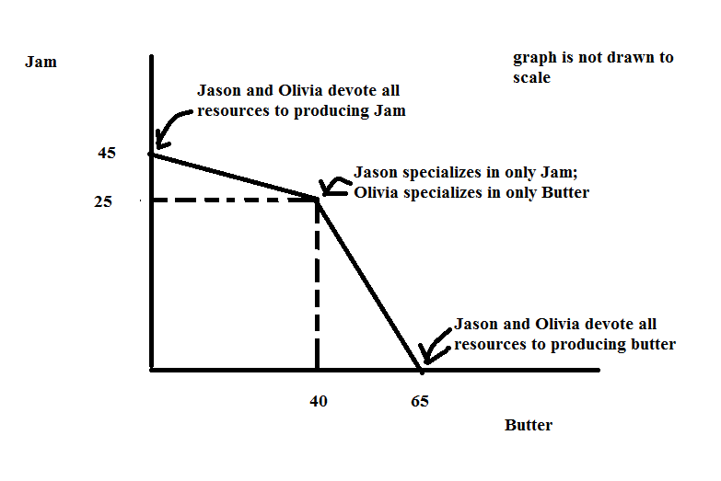

d. (2 points) If these two individuals decide to specialize according to comparative advantage and then trade with one another what will be the range of trading prices that 20 units of jam will trade between?

Answer:
1 unit of jam will trade between 1 unit of butter and 2 units of butter; so 20 units of jam will trade between 20 units of butter and 40 units of butter.

e. (2 points) Given the above information, if Jason uses only labor to produce butter and jam and Jason has a total of only 40 hours of labor available each week for butter and jam production, how many hours of labor does it take Jason to produce one unit of jam? Explain your answer.

Answer:
If Jason devotes all of his labor to producing jam, he can produce 25 units of jam. Since Jason has 40 hours of labor this implies that Jason can produce (25 units of jam)/(40 hours of labor) or .625 units of jam per hour of labor. Or, you could write this as 5/8 unit of jam per hour of labor.

