Economics 102 Name _____________________________
Summer 2013
07/10/13
Answers to Second Midterm

Version 1

DO NOT BEGIN WORKING UNTIL THE INSTRUCTOR TELLS YOU TO DO SO
READ THESE INSTRUCTIONS FIRST.

You have 75 minutes to complete the exam. The exam consists of 3 problems worth 10 points each and 20 multiple choice questions worth 3.5 points. Please accurately and completely provide your name on the exam booklet.

NO CELL PHONES, CALCULATORS, OR FORMULA SHEETS ARE ALLOWED.
PICK THE BEST ANSWER FOR EACH QUESTION.

- When you are finished, please get up quietly and bring your exam booklet to the place indicated by the instructors.

Multiple Choice _____________

Problems:
Problem 1 _____________

Problem 2 _____________

Problem 3 _____________

TOTAL _____________

I, __________________________________, agree to neither give nor receive any help on this exam from other students. Furthermore, I understand that use of a calculator on this exam is an academic misconduct violation.

Signed ____________________________________

I. Multiple Choice (20 questions worth 3.5 points each)

1. Wormwood currently does not include discouraged workers as part of the unemployed when it computes its unemployment rate. This decision not to include discouraged workers results in
a. The unemployment rate in Wormwood being higher than it would be if the discouraged workers were included.
b. The unemployment rate in Wormwood being lower than it would be if the discouraged workers were included.
c. No impact on the unemployment rate.
d. The employment rate in Wormwood being lower than it would be if the discouraged workers were included.

2. During the recent financial crisis and the subsequent persistence of long-term unemployment some analysts have argued that this long-term unemployment effectively reduces the level of human capital. Holding everything else constant, if this is true then
a. Real GDP for this economy has fallen relative to its initial level.
b. Nominal GDP for this economy has fallen relative to its initial level.
c. Labor productivity has fallen relative to its initial level.
d. Answers (a) and (c) are true statements.

3. Real GDP per capita in Eurolandia in 2013 is $20,000 while in Utopia real GDP per capita in 2013 is $15,000. Both countries are projected to have steady growth rates of real GDP per capita over the next 200 years: the growth rate in Eurolandia is projected to be 5% while the growth rate in Utopia is projected to be 10%. Given this information and the Rule of 70
a. By 2041 real GDP per capita in Utopia will be approximately three times greater than real GDP per capita in Eurolandia.
b. By 2027 real GDP per capita in Utopia will exceed real GDP per capita in Eurolandia.
c. In 2020 real GDP per capita in Utopia will be approximately equal to $30,000.
d. Given the above information, answers (a), (b) and (c) are true statements.
e. Given the above information, answers (a) and (c) are true statements.

4. You are given the following information about some transactions that occurred in 2012.
- Frances sells her home for $150,000 without using the services of a realtor. The home was built in 1980.
- Mary produces 10,000 T-shirts at her factory and sells $5000 worth of these T-shirts. Each T-shirt is priced at $5 per shirt.
- George retrieves a broken desk worth nothing from his neighbor’s trash pile. He refinishes the desk and then sells it for $300 to a friend. George does not report this transaction as part of his taxable income.
Given the above information, which of the following statements is true?
I. The sale of Frances’ house is not included in GDP for 2012.
II. Mary’s activities increase GDP in 2012 by $5000.
III. Refinishing and selling the desk is not included in 2012 GDP.
a. Statement I is correct.
b. Statement II is correct.
c. Statement III is correct.
d. Statements I, II and III are correct.
e. Statements I and III are correct.

5. Michael has three job offers for next year with the following salaries: 1) $80,000 in New York City; 2) $50,000 in Madison; and 3) $60,000 in St. Louis. Michael knows that the cost of living in New York is twice the cost of living in Madison and the cost of living in St. Louis is 75% of the cost of living in New York. Assume all three jobs are equivalent and Michael only cares about his real salary for the coming year. What do you recommend?
a. Michael should take the job in Madison.
b. Michael should take the job in New York.
c. Michael should take the job in St. Louis.
d. Michael should continue searching for a job.

6. Suppose real GDP in 2010 is $5 billion and in 2011 real GDP increases by 2%. Suppose population in 2010 is 1 million people and in 2011 population increases by 10,000 people. From this information you can conclude
a. Real GDP per capita was constant between 2010 and 2011.
b. Real GDP per capita increased between 2010 and 2011.
c. Real GDP per capita decreased between 2010 and 2011.
d. This economy is not growing fast enough to absorb the increase in population.

7. Suppose Mary knows that the current equilibrium wage rate is $10 per hour. Yet when Mary hires Joe she offers him $12 per hour. Mary is a rational person, knows the current equilibrium wage rate, and yet is still willing to pay Joe this wage. This situation might illustrate
a. An efficiency wage situation where Mary pays a wage in excess of the minimum wage in order to assure worker effort and worker loyalty.
b. An efficiency wage situation since Mary may be paying a wage in excess of the market equilibrium wage in order to assure worker effort and worker loyalty.
c. Cyclical unemployment since Mary’s actions will likely lead to many people not being able to get work at the wage rate she is offering Joe.
d. Given the above information, answers (b) and (c) are true answers.

8. Structural unemployment occurs when
a. The prevailing wage rate being paid is greater than the equilibrium wage rate in the labor market.
b. The economy is not producing at its full employment level of output.
c. An individual decides to return to the labor market but then the individual finds that it takes time to find a job that fits their skills and interests well.
d. The minimum wage imposed by the government is not effective.

9. Suppose technology improves in an economy. Holding everything else constant
a. Real GDP will increase in this economy.
b. Labor productivity will increase in this economy.
c. Capital productivity will increase in this economy.
d. Answers (a), (b), and (c) are all true statements.
e. Answers (a), (b) and (c) are all false statements.

10. Suppose the labor market is initially in equilibrium. If the demand for labor increases at every wage rate then holding everything else constant
a. Real GDP will increase, the equilibrium wage rate will increase, and labor productivity will fall.
b. Real GDP will increase, the equilibrium wage rate will increase, and labor productivity will increase.
c. Real GDP will decrease, the equilibrium wage rate will increase, and labor productivity will fall.
d. Real GDP will increase, the equilibrium wage rate will decrease, and labor productivity will fall.

11. Consider the following information about an economy in 2012:
- There are 150,000 people age 16 and older in this economy in 2012
- There are 40,000 people who are retired (they are all over 65 years old) in this economy in 2012
- There are 5,000 full-time students that are age 16 and older in this economy in 2012
- There are 80,000 people age 16 and older who are working for pay full-time in this economy in 2012 in jobs they really like
- There are 4,000 people age 16 and older who are working half-time in this economy in 2012 even though they would prefer to work full-time
- There are 4,000 people age 16 and older who are working half-time in this economy in 2012 in jobs for which they are over qualified
- There are 2,000 people age 16 and older who are working for pay full-time in this economy in 2012 in jobs they really dislike
- There are 5,000 people age 16 and older who are currently not working, are available for work but who have not made a job application in the past month
- There are 10,000 people age 16 and older who are currently not working, are available for work and are actively filling out job applications
Given the above information and holding everything else constant, the unemployment rate in this economy for 2012 is equal to
- 5%
- 10%
- 15%
- 20%
- The unemployment rate in this economy cannot be calculated given the above information.
.

Use the following information to answer the next THREE questions.

Suppose an economy’s aggregate production function is given by the equation:
Y = 10K^{1/2}L^{1/2}
where Y is real GDP, K is units of capital and L is units of labor. Furthermore suppose you know that the labor market in this economy can be described by the following demand and supply curves where W is the wage rate:
Demand for Labor: L = 200 – 10W
Supply of Labor: L = 10W
Assume capital is initially equal to 400 units in this economy.

12. Given the above information, full employment GDP for this economy is equal to
a. 2000
b. 200
c. 1000
d. 10,000

13. Suppose the amount of capital increases to 625 units. Holding everything else constant, labor productivity will increase to
a. 25 units of output per unit of labor.
b. 30 units of output per unit of labor.
c. 0.25 units of output per unit of labor.
d. 0.3 units of output per unit of labor.

14. Suppose capital is at its initial level. Now suppose the government imposes a minimum wage in this labor market equal to $17.50 per unit of labor. Given this information and holding everything else constant
a. Real GDP = 1000 units of output
b. Real GDP = 100 units of output
c. Real GDP = 500 units of output
d. Real GDP = 5000 units of output

15. Consider the following information about an economy in 2012:
- George a realtor sells 10 houses built between 1990 and 2009 for $1,000,000 and collects 10% of this amount as a commission on his efforts
- Harry runs a gambling operation where customers can place bets on the outcomes of different athletic events: he makes $50,000 in 2012 and does not report any of this income to government authorities
- Susie exchanges babysitting services with Stan: since they both provide services to each other they do not pay for these services: the value of these services is $30,000 for 2012
- Ace Car Manufacturing manufactures 4000 cars in 2012 and sells 3500 of these cars: the price of each car is $20,000
- Swift Tires manufactures 20,000 tires and provides Ace Car Manufacturing with 16,000 tires for the new cars; the rest of the tires are sold as replacement tires and each tire is sold for $100
GDP in 2012 in this economy given the above information would equal
a. $82,680,000
b. $80,500,000
c. $82,100,000
d. $82,600,000

16. Which of the following statements is true?
I. The construction of the CPI uses a fixed market basket.
II. In the base year the nominal value of a variable is equal to its real value.
III. If the CPI increases over time this implies that the real value of a variable must also increase.
a. Statements I, II and III are all true statements.
b. Statements I and II are true statements.
c. Statements I and III are true statements.
d. Statement I is a true statement.
e. Statement II is a true statement.

Use the following information to answer the next two questions.

Consider the following information about an economy.

Year | Nominal GDP | Real GDP | GDP Deflator with Year 1 as base year
1 | 200 | 200 | 100
2 | 300 |  | 125
3 | 350 |  | 140

17. Given the above information real GDP in year 3
a. Decreased relative to real GDP in year 2.
b. Decreased relative to real GDP in year 1.
c. Increased relative to real GDP in year 2.
d. Is equivalent to real GDP in year 2.

18. Given the above information the inflation rate from year 1 through year 3 based on the GDP deflator can be calculated as
a. 140%
b. 40%
c. 15%
d. 25%

19. Suppose an economy is currently producing a level of output that is smaller than this economy’s full employment level of output. Given this information
a. The economy’s unemployment rate is less than its natural rate of unemployment.
b. Cyclical unemployment is greater than the sum of frictional and structural unemployment.
c. Frictional and structural unemployment are greater than they would be if this economy was producing at its full employment level of output.
d. Cyclical unemployment is a positive number.

20. Suppose an economy finds that its cyclical unemployment rate is 4%. Given this information
a. Structural and frictional unemployment must be less than 4%.
b. Structural and frictional unemployment must be greater than 4%.
c. This economy is not producing at the full employment level of output.
d. There will be pressure for wages and prices to increase in this economy.

II. Problems (3 problems worth 10 points each)

1. Use the following information about production in a small economy to answer this set of questions. Assume that this economy only produces bikes, books, and tables from its available resources.

 | 2010 | 2011 | 2012
Price of a Bike | $500 | $500 | $600
Quantity of Bikes Produced | 20 | 25 | 30
Price of a Book | $10 | $15 | $10
Quantity of Books Produced | 10 | 20 | 20
Price of a Table | $100 | $80 | $100
Quantity of Tables Produced | 5 | 8 | 8

a. (3 points) Calculate the value of nominal GDP for 2010, 2011, and 2012 for the small economy described in the above table. Explicitly provide the formula you use to find nominal GDP and make sure your answer is clear, logical and easy to follow in its presentation. Summarize your final calculations in the table provided.

Year | Nominal GDP
2010
2011
2012

Answer:
Nominal GDP = ∑PiQi for I from 1 to 3 and where P (prices) are measured in the current year and Q (quantities) are measured in the current year
Nominal GDP for 2010 = ($500 per bike)(20 bikes) + ($10 per book)(10 books) + ($100 per table)(5 tables) = $10,600
Nominal GDP for 2011 = ($500 per bike)(25 bikes) + ($15 per book)(20 books) + ($80 per table)(8 tables) = $13,440
Nominal GDP for 2012 = ($600 per bike)(30 bikes) + ($10 per book)(20 books) + ($100 per table)(8 tables) = $19,000

Year | Nominal GDP
2010 | $10,600
2011 | $13,440
2012 | $19,000

b. (3 points) Using 2010 as your base year, calculate the value of real GDP for 2010, 2011, and 2012 for the small economy described in the above table. Explicitly provide any formula you use to find real GDP and make sure your answer is clear, logical and easy to follow in its presentation. Summarize your final calculations in the table provided.

Year | Real GDP
2010
2011
2012

Answer:
Answer:
Real GDP = ∑PiQi for I from 1 to 3 and where P (prices) are measured in the base year (2010) and Q (quantities) are measured in the current year
Real GDP for 2010 = ($500 per bike)(20 bikes) + ($10 per book)(10 books) + ($100 per table)(5 tables) = $10,600 = Nominal GDP in 2010 with the base year 2010
Real GDP for 2011 = ($500 per bike)(25 bikes) + ($10 per book)(20 books) + ($100 per table)(8 tables) = $13,500
Real GDP for 2012 = ($500 per bike)(30 bikes) + ($10 per book)(20 books) + ($100 per table)(8 tables) = $16,000

Year | Real GDP
2010 | $10,600
2011 | $13,500
2012 | $16,000

c. (1 point) Write an equation for the growth rate of nominal GDP from 2010 to 2012 using the answers you found in earlier steps in this problem. YOU DO NOT NEED TO SIMPLIFY THIS EQUATION.

Answer:
Growth rate in nominal GDP from 2010 to 2012 = [(19,000 – 10,600)/(10,600)](100%)

d. (1 point) Write an equation for the growth rate of real GDP from 2010 to 2012 using 2010 as the base year and the answers you found in earlier steps in this problem. YOU DO NOT NEED TO SIMPLIFY THIS EQUATION.

Answer:
Growth rate in real GDP from 2010 to 2012 = [(16,000 – 10,600)/(10,600)](100%)

e. (2 points) Compare your answers in (c) and (d). Are they the same? If your goal is measuring the percentage change in production, which of these measures is superior? And, why is this measure superior?

Answer:
They are not the same. The percentage change in real GDP is a superior measure of the percentage change in production since it considers only changes in GDP caused by changes in the quantities of goods and services produced whereas the percentage change in nominal GDP includes changes in prices as well as changes in quantities.

2. Use the following information describing aggregate production in an economy to answer this set of questions. (Note: the price of a table in 2012 is different in this problem from the price given in the first problem. There are no other changes in the table.)

 | 2010 | 2011 | 2012
Price of a Bike | $500 | $500 | $600
Quantity of Bikes Produced | 20 | 25 | 30
Price of a Book | $10 | $15 | $10
Quantity of Books Produced | 10 | 20 | 20
Price of a Table | $100 | $80 | $160
Quantity of Tables Produced | 5 | 8 | 8

For purposes of constructing the CPI for this economy the market basket is defined as 1 Bike, 4 Books, and 1 Table.

a. (3 points) What is the cost of the market basket in each of the three years? Please show your work neatly and completely for full credit. Summarize your calculations in the provided table.

Year | Cost of Market Basket
2010
2011
2012

Answer:
Cost of market basket in year n = (1 Bike)(Price of Bike in year n) + (4 Books)(Price of Book in year n) + (1 Table)(Price of Table in year n) =
Cost of market basket in 2010 = (1)(500) + (4)(10) + (1)(100) = $640
Cost of market basket in 2011 = (1)(500) + (4)(15) + (1)(80) = $640
Cost of market basket in 2012 = (1)(600) + (4)(10) + (1)(160) = $800

Year | Cost of Market Basket
2010 | $640
2011 | $640
2012 | $800

b. (3 points) Provide CPI index numbers on a 100 point scale for 2010, 2011, and 2012 using 2010 as your base year. Show how you found these index numbers to get full credit for your answer. In your answer provide any formula you use. Summarize your calculations in the provided table.

Year | CPI with base year 2010
2010
2011
2012

Answer:
CPI Index # = [(Cost of market basket in current year)/(Cost of market basket in base year)](100)
CPI Index # for 2010 = (640/640)(100) = 100
CPI Index # for 2011 = (640/640)(100) = 100
CPI Index # for 2012 = (800/640)(100) = 125

Year | CPI with base year 2010
2010 | 100
2011 | 100
2012 | 125

c. (2 points) Suppose the base year is changed to 2012. Provide the CPI index numbers for 2010, 2011, and 2012 on a 100 point scale using 2012 as your base year. Show all relevant formulas and calculations for full credit. Summarize your calculations in the provided table.

Year | CPI with base year 2012
2010
2011
2012

Answer:

CPI Index # = [(Cost of market basket in current year)/(Cost of market basket in base year)](100) or
CPI Index # with Base Year 2012 = [(CPI Index # for the current year using base year 2010)/(CPI Index # for the year 2012 using base year 2010)](100)
CPI Index # for 2010 using 2012 as the base year = (100/125)(100) = 80
CPI Index # for 2011 using 2012 as the base year = (100/125)(100) = 80
CPI Index # for 2012 using 2012 as the base year = (125/125)(100) = 100

Year | CPI with base year 2012
2010 | 80
2011 | 80
2012 | 100

d. (2 points) Calculate the rate of inflation from 2011 to 2012. Show any relevant formulas you use for this calculation to get full credit.

Answer:
Rate of inflation from 2011 to 2012 = [(CPI in 2012 – CPI in 2011)/(CPI in 2011)](100%)
Rate of inflation from 2011 to 2012 using 2010 as base year = [(125 – 100)/100](100%) = 25%
Rate of inflation from 2011 to 2012 using 2012 as base year = [(100 – 80)/80](100%) = 25%

3. Use the following graph of an economy’s aggregate production function to answer this set of questions.

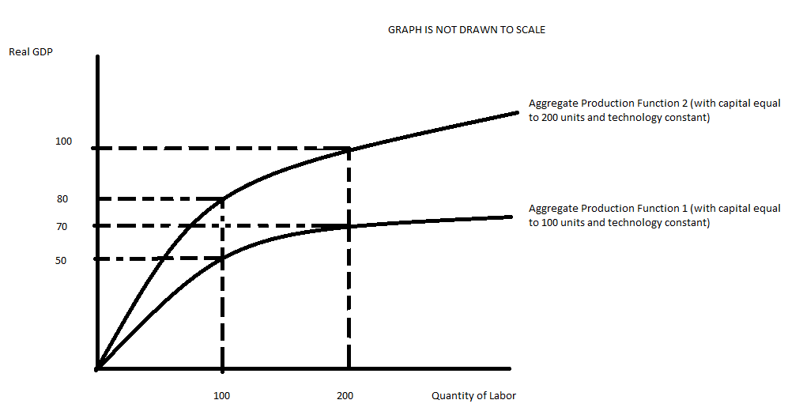

a. (2 points) Suppose this economy has 100 units of capital and 100 units of labor. Holding everything else constant, the value of labor productivity is __________________________. In your answer make sure you provide a numeric value as well as units of measurement for this value.

Answer:
Y/L = productivity = 50 units of output/100 units of labor = ½ unit of output per unit of labor

b. (2 points) Suppose this economy increases its level of capital to 200 units while maintaining labor usage at 100 units. Given this information and the above graph verbally explain what will happen to labor productivity.

Answer:
Labor productivity will increase since each unit of labor will have more capital to work with: output/labor will increase.

c. (2 points) Given the information in (b) calculate the new value of labor productivity: for full credit show any formula you use and provide a numeric value as well as the units of measurement for this value.

Answer:
Labor productivity = (real GDP)/(labor) = Y/L = 80/100 = 4/5 unit of output per unit of labor

d. (2 points) Given the information in (b) provide a graph in the space below illustrating the relationship between the level of capital (measure this on the x-axis) and the level of real GDP (measure this on the y-axis). Provide the coordinates for at least two points in this graph. Label your graph fully and completely for full credit. (Hint: Plot the curve of production function when the level of labor is 100)

Answer:
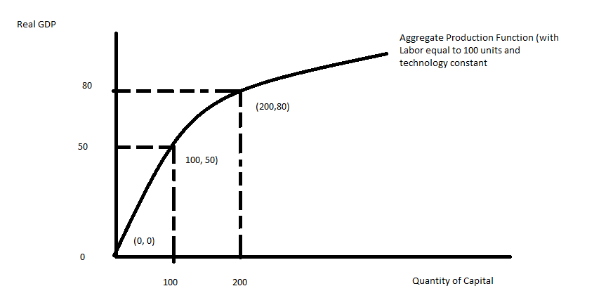
e. (2 points) Given the information in (b), verbally describe what happens to capital productivity.

Answer:
Capital productivity = Y/K
As we hire more units of capital with a given amount of labor we see real GDP increase. But, due to diminishing returns to capital we expect capital productivity to fall: real GDP increases at a slower rate than does capital, so real GDP/K declines.

