Economics 102 Name _____________________________
Fall 2015 TA Name __________________________
October 12, 2015 Discussion Section #_________________
First Midterm Student ID # _______________________

Version 1

DO NOT BEGIN WORKING UNTIL THE INSTRUCTOR TELLS YOU TO DO SO.
READ THESE INSTRUCTIONS FIRST.

You have 50 minutes to complete the exam, including filling in your scantron. The exam consists of 10 binary choice questions worth 2 points each and 19 multiple choice questions worth 4 points each. Please accurately and completely provide your name, ID number, discussion section number, version number, and TA name on the scantron sheet and the exam booklet. Writing all this information correctly is worth 4 points. Answer all questions on the scantron sheet with a #2 pencil. There are 20 printed pages in this exam, including this cover sheet. DO NOT PULL THE EXAM APART OR REMOVE THE STAPLE.

WARNING: NO COMMUNICATION OR CALCULATING DEVICES, OR FORMULA SHEETS ARE ALLOWED. NO CONSULTATION AND CONVERSATION WITH OTHERS ARE ALLOWED WHILE YOU ARE TAKING THE EXAM OR IN THE EXAM ROOM. ACADEMIC MISCONDUCT IS A SERIOUS OFFENSE AND PUNISHABLE TO THE FULLEST EXTENT.
PICK THE BEST ANSWER FOR EACH QUESTION.

How to fill in the scantron sheet and other information:
- Print your last name, first name, and middle initial in the spaces marked "Last Name," "First Name," and "MI." Fill in the corresponding bubbles below.
- Print your student ID number in the space marked "Identification Number." Fill in the bubbles.
- Write the number of the discussion section you’ve been attending under "Special Codes" spaces ABC, and fill in the bubbles. The discussion numbers can be found at the bottom of this page.
- Write the version number of your exam booklet under "Special Codes" space D, and fill in the bubble. The version number is at the top of this page.

- If there is an error on the exam or you do not understand something, make a note on your exam booklet and the issue will be addressed AFTER the examination is complete. No questions regarding the exam can be addressed while the exam is being administered.
- When you are finished, please get up quietly and bring your scantron sheet and this exam booklet to the place indicated by the instructors.

Gary Baker | Saerang Song | Sandra Spirovska | Wenqi Wu
372 Fri 11:00 AM  Van Hise 399 | 371 Thurs 3:30 PM  Van Hise 474 | 370 Thurs 2:25 PM  Van Hise 367 | 363 Thurs 3:30 PM  Ingraham 224
368 Fri 12:05 PM  Van Hise 486 | 362 Fri 8:50 AM  Social Sciences 5231 | 366 Fri 12:05 PM  Van Hise 491 | 367 Fri 8:50 AM  Social Sciences 6102
 | 369 Fri 1:20 PM  Van Hise 391 | 361 Fri 1:20 PM  Ingraham 223 | 365 Fri 11:00 AM  Van Hise 475
 |  | 360 Fri 2:25 PM  Ingraham 223 | 364 2:25 PM  Ingraham 224
I, , agree to neither give nor receive any help on this exam from others. I understand that the use of a calculator or communication device on this exam is academic misconduct. I also understand that providing answers to questions on this exam to other students is academic misconduct, as is taking or receiving answers to questions on this exam from other students. Thus, I will cover my answers and not expose my answers to other students. It is important to me to be a person of integrity and that means ALL ANSWERS on this exam are my answers. Any violation of these guidelines will result in a penalty of at least receiving a zero on this exam.

Signed

Binary Choice (worth 2 points each)

- Alice is in charge of the statistics bureau in the small nation of Wonderland, and part of her job is computing GDP for Wonderland. Until this year, Wonderland had a closed economy for widgets with a domestic price of $5 per widget. This year, however, Wonderland entered the international market for widgets, where the world price of widgets is $2. Given this information, what can Alice expect to happen to Wonderland’s nominal GDP this year relative to last year's nominal GDP in Wonderland? Assume production in all other markets is unaffected by this change.

  - Nominal GDP will decrease.
  - Nominal GDP will increase.

- 1,000,000 people live and work in Someland. Of these 1,000,000 people, half are citizens of Someland. Additionally, there are 10,000 citizens of Someland, who live and work overseas in Finland. All residents and citizens of Someland produce $20,000 of output per year per person. Given this information, what can we say about the relationship of Someland's GDP to Someland's GNP?

- Someland's GDP will be higher than Someland's GNP.
- Someland's GDP will be lower than Someland's GNP.

- “Investing in early childhood education will have positive effects on the child’s future income.” This is an example of a _____________ statement.

- Positive
- Normative
- If we want to find the market demand curve for a private good, should we vertically sum or horizontally sum the individual demand curves?

- Vertically sum
- Horizontally sum

- A researcher collects data on real GDP and the CPI for each US state for the year 2014. We say that she has collected _______________ data.

- Cross-sectional
- Time-series

- Suppose that a researcher at UW has shown that lettuce is healthier than previously believed, leading consumers to develop a stronger preference for lettuce. At the same time the drought in California has resulted in reductions in lettuce production. Holding everything else constant, we can conclude that:

- The equilibrium price of lettuce is indeterminate.
- The equilibrium quantity of lettuce is indeterminate.

- Suppose when operating efficiently, a furniture factory can produce 5 tables and 10 chairs, or it can produce 8 tables and 4 chairs. Assuming constant opportunity cost, is it feasible for the factory to produce 3 tables and 16 chairs?

      - Yes. This production combination is feasible.
      - No. This production combination is not feasible.

Use the following information for the next two (2) questions:

Robinson Crusoe works 8 hours a day. It takes him 2 hours to collect one coconut and 4 hours to catch a fish. His friend, Friday, works 12 hours a day. Friday needs 1.5 hours to collect a coconut and 2 hours to catch a fish. Assume that both Robinson Crusoe and Friday each have constant opportunity costs.

- Given the above information, who has the comparative advantage in catching fish?

      - Robinson Crusoe
      - Friday

- Suppose that Robinson Crusoe decides to work 12 hours a day as well. Now given this new information, who has the comparative advantage in collecting coconuts?

      - Robinson Crusoe
      - Friday

- Use the following graph to answer this question. The graph shows a joint PPF for Adam and Ben who both produce pencils and erasers.

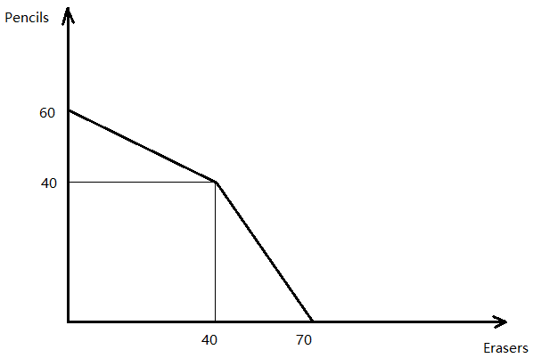
Suppose that when producing efficiently, Ben could at most produce 30 erasers. Given this information and the above graph, who has the comparative advantage in producing erasers?

- Adam
- Ben

Multiple Choice (worth 4 points each)

- McDonald’s and Burger King both make burgers (B) and Fries (F). Suppose they have the following PPFs:

McDonald’s PPF: B = - (1/4) F+3
Burger King's PPF: B = - (1/2) F +5

Now, consider the joint PPF for McDonald’s and Burger King. Which of the following combinations of burgers and fries is efficient if both firms work together?

      - 0 burgers and 20 packets of fries
      - 3 burgers and 10 packets of fries
      - 5 burgers and 10 packets of fries
      - 7 burgers and 4 packets of fries

- Both Casey and Dorothy produce erasers and pencils. It takes Casey 2 hours to make one eraser and 1 hour to make one pencil. It takes Dorothy 3 hours to make either one eraser or one pencil. Now, imagine that Casey and Dorothy engage in trade with one another. The acceptable range of trading prices for one pencil in terms of erasers is:

      - Between 2/3 eraser and 1 eraser.
      - Between 1 eraser and 2 erasers.
      - Between 1/2 eraser and 1 eraser.
      - Between 1/3 eraser and 2/3 eraser.

- Pentos and Westeros are two nations that produce swords and silk. Pentos and Westeros both have linear PPFs: at most, Pentos could produce a maximum of 300 swords or 600 pieces of silk annually; Westeros could produce a maximum of 2000 pieces of silk annually, but it keeps a secret and does not reveal the maximum number of swords it could produce.
As a spy from Pentos, you want to know the maximum number of swords Westeros can produce annually. You notice that when Pentos and Westeros engage in trade, the acceptable range of trading prices for one sword is between 4/3 pieces of silk and 2 pieces of silk.
Given this information, the maximum number of swords Westeros can produce in a year is:

      - 4000 swords.
      - 3000 swords.
      - 1500 swords.
      - 1000 swords.

- The supply and demand for inline skates are represented by the following equations where P is the price per pair of inline skates and Q is the quantity of pairs of inline skates.

Supply: P = (1/10)*Q^{S} + 60
Demand: P = 360 - (1/5)*Q^{D}

Given the above information and holding everything else constant, what is the equilibrium price?

      - $180 per pair of inline skates
      - $160 per pair of inline skates
      - $210 per pair of inline skates
      - $1000 per pair of inline skates

- Sarah’s monthly demand for coffee is P = 6 - 1/4*Q. She has trouble falling asleep, so she decides to cut back her intake by 4 coffee drinks at every possible price. Given this information and holding everything else constant, her new demand for coffee is:

      - P = 10 - (1/4)*Q
      - P = 7 - (3/10)*Q
      - P = 5 - (1/4)*Q
      - P = 2 - (1/4)*Q

- Kiril and Anna are the only consumers of mangoes in Slavia. Their demand curves are:
Kiril’s Demand: P = 5 – Q
Anna’s Demand: 3P = 9 – Q
Given the above information and holding everything else constant, which of the following equations represents the market demand for mangoes in Slavia?

      - Q = 8 – (4/7)P

      - Q = 5 – P for 3 ≤ P ≤ 5
Q = 14 – 4P for 0 ≤ P ≤ 3

      - P = Q – 5 for 3 ≤ P ≤ 5
P = (1/4)Q – (7/2) for 0 ≤ P ≤ 3

      - P = 5 – Q for 0 ≤ P ≤ 3
P = (7/2) – (1/4)Q for 3 ≤ P ≤ 5

- The following graph represents real GDP for the dictatorship of Gruyovia from 2007 to 2014 measured in billions of US dollars. What happened to real GDP from 2013 to 2014?

      - Real GDP decreased by 33.33%.
      - Real GDP increased by 33.33%.
      - Real GDP decreased by 25%.
      - Real GDP decreased by 20%.

- The following graphs represent the market demand for avocados in Wisconsin. One of these demand curves provides different information from the other three. Which graph provides different information?
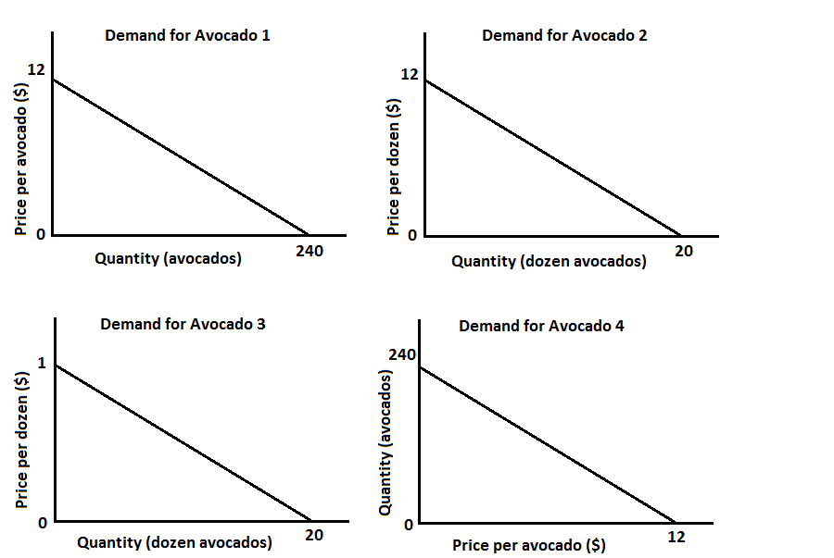

      - Demand for avocado 1
      - Demand for avocado 2
      - Demand for avocado 3
      - Demand for avocado 4

- The White Witch is the somewhat unscrupulous leader of Narnia. In order to convince people that her economic policies are working, she provides the following GDP data:

 | Real GDP… | …using Base Year
2012 | $1,000,000 | 1980
2013 | $1,100,000 | 1980
2014 | $9,000,000 | 2014

Being a well-educated citizen of Narnia, Tumnus realizes something is amiss with the data, because the base year would normally not change. Searching his data tables, he finds that the GDP deflator for 2014 using a base year of 1980 was 900 (the scale factor is 100). Given this information, which of the following statements is FALSE?

      - Nominal GDP in 2014 was $9,000,000.
      - When using the base year of 1980, real GDP decreased between 2013 and 2014.
      - Price levels decreased between 1980 and 2014.
      - When using the base year of 1980, Real GDP in 2012 equals Real GDP in 2014.

Use the following information for the next two (2) questions:

Pirate Island is a small economy with a domestic market for cutlasses (a type of sword) that can be described by the following equations where P is the price per cutlass and Q is the quantity of cutlasses:

Domestic Demand: P = 100 – Q

Domestic Supply: P = Q

You are also told that the world price of cutlasses is $10 per cutlass.

- George is the king of Pirate Island, a small economy. Perhaps not unsurprisingly for a Pirate King, George is rather corrupt, and wishes to enrich his friend Bob. To do this secretly, George decides to enact a quota limit in the cutlass market (under the pretense of protecting domestic suppliers) and grant the import license to Bob. If George wants Bob to earn $800, the import quota should be equal to:

      - 20 units
      - 40 units
      - 60 units
      - 80 units

- Unfortunately for George, the pirates of Pirate Island are surprisingly well-educated in economic matters and realize that this import quota enriches Bob at the cost of generating deadweight-loss. George doesn’t want to upset Bob, and thus doesn’t want to eliminate the import quota, but also fears an uprising by the unhappy pirate citizens. Thus, he decides to change the import quota so that there is zero deadweight loss. Which of the following import quotas has zero deadweight loss? An import quota of:

      - 0 units
      - 50 units
      - 60 units
      - 90 units

- Which of the following four options has an opposite effect on the demand for good X from the other three options? Assume that good X is a normal good.

      - an increase in the price of a substitute good in consumption
      - an increase in the price of a complement good in consumption
      - a decrease in income
      - a change in tastes against good X

- How do deadweight loss and government revenue change as the level of an import tariff increases, assuming the tariff is effective?

      - Both deadweight loss and government revenue increase as the size of the tariff increases.
      - Deadweight loss increases, while government revenue initially decreases and then increases as the size of the tariff increases.
      - Deadweight loss increases, while government revenue initially increases and then declines as the size of the tariff increases.
      - Government revenue increases, while deadweight loss initially increases and then declines as the size of the tariff increases.

- Suppose Alice, Bob, Charlie, and Sam can all produce coconuts and fish according to the following opportunity costs:

Alice: 10 coconuts per fish
Bob: 5 coconuts per fish
Charlie: 1/10 of a fish per coconut
Sam: 1/5 of a fish per coconut

If you were to graph the joint-PPF for these four individuals, how many "kink points" would the joint PPF have?

      - 1 kink point
      - 2 kink points
      - 3 kink points
      - 4 kink points

- England and Portugal are producers of woolen cloth (C) and wine (W). Assume that in a given year, England could produce the following combinations of cloth and wine when producing efficiently:

 | Units of Woolen Cloth | Units of Wine
Combination 1 | 10 | 10
Combination 2 | 20 | 0

Portugal, benefiting from a more pleasant climate, could produce the following combinations:
 | Units of Woolen Cloth | Units of Wine
Combination 1 | 10 | 20
Combination 2 | 5 | 30

Assume both countries have constant opportunity costs of production for these two goods.

The joint PPF curve for England and Portugal is of the following shape:

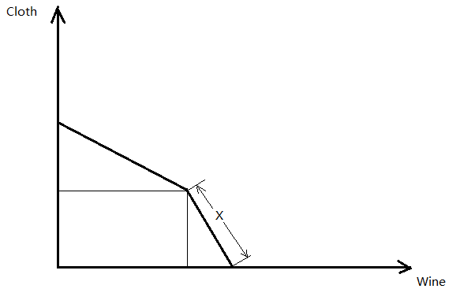

Given the above information, what is the function, or the equation, for the lower segment (labeled x in the graph) of the PPF? (Note: Wine is one the horizontal axis, and Cloth is on the vertical axis)

      - C = 60 - W
      - C = 40 - W
      - C = 60 - 2W
      - C = 40 - 2W

Use the following information for the next three (3) questions:
Suppose the market for lemons at the Capitol Square Farmer’s Market can be described by the following demand and supply equations where P is the price of a lemon and Q is the quantity of lemons.

Demand: Q = 10 - P
Supply: Q = 3P - 6

- Calculate the equilibrium price and quantity for this market.

      - P = $5 per lemon and Q = 5 lemons
      - P = $4 per lemon and Q = 6 lemons
      - P = $8 per lemon and Q = 2 lemons
      - P = $10 per lemon and Q = 7 lemons

- Calculate the producer surplus and consumer surplus in this market.

      - Producer surplus = $6 and Consumer surplus = $18
      - Producer surplus = $36 and Consumer surplus = $6
      - Producer surplus = $14 and Consumer surplus = $24
      - Producer surplus = $24 and Consumer surplus = $6

- Suppose the Madison City Council attempts to help farmers by setting a price floor of $7 per lemon in the market for lemons. What is the deadweight loss of such a policy?

      - $12
      - $6
      - $3
      - $9

- The US Census Bureau provides the following information on the share of household income held by each quintile of the income distribution in the years 1993, 2003, and 2013.

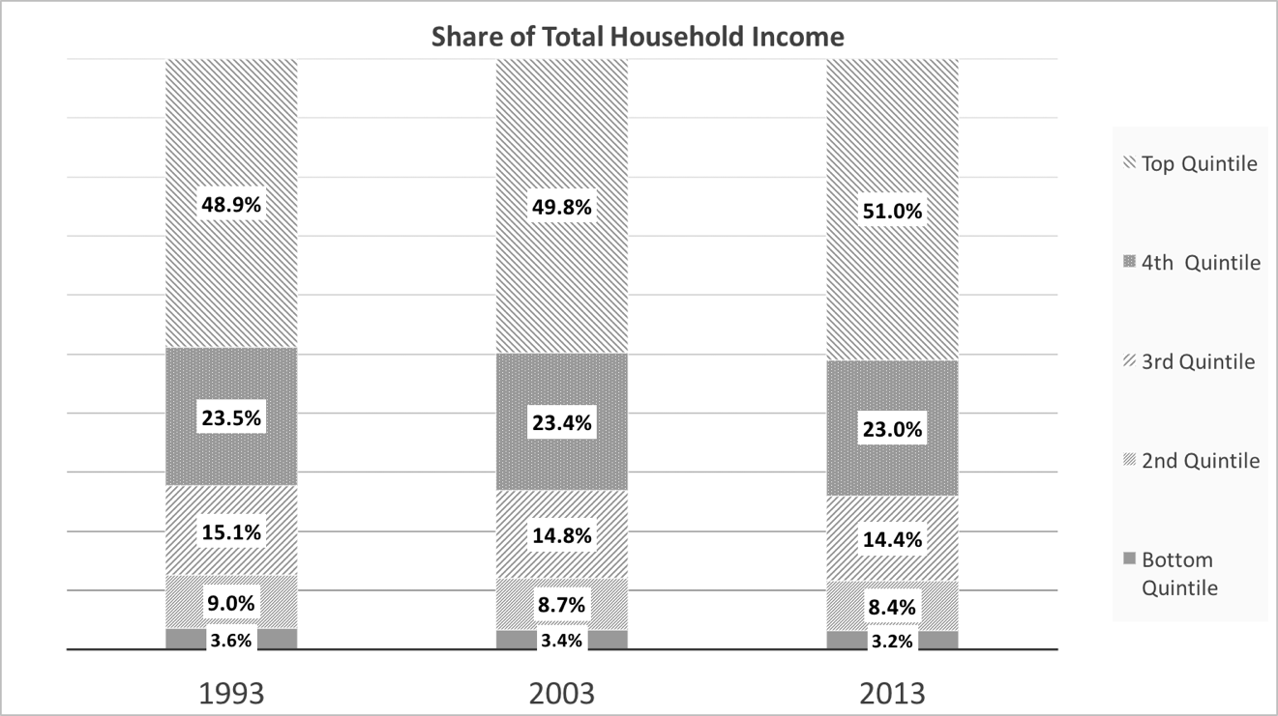

Which of the following statements about the income distribution is FALSE given the information in the graph above?

      - The share of total income held by the middle 3 quintiles increased between 1993 and 20013
      - Income has become less concentrated at the bottom of the distribution.
      - Income has become more concentrated at the top of the distribution.
      - The share of income held by the bottom two quintiles in 2003 was 12.1%.

END OF EXAM

Solutions

Binary Choice
- A
- A
- A
- B
- A
- B
- B
- B
- A
- A

Multiple Choice
- D
- C
- C
- B
- C
- B
- C
- B
- C
- B
- D
- A
- C
- A
- A
- B
- A
- B
- A

