Econ 102 Name _________________________________
Summer 2014
Answers to Quiz #3

Please write all answers neatly and legibly.

- (1 point) Maurice purchased 100 shares of IBM stock in 2014 with each share costing $120. He used the services of Lola, a stockbroker, to make this transaction. Lola collected 2% of the value of this transaction as her payment for this work. Jody, also in 2014, purchased an old beat up desk at a yard sale for $25 and then paid Dr. Furniture, a furniture repair shop, $200 to fully restore the desk. Given these transactions calculate the effect on GDP for 2014. Assume that Maurice, Lola, Jody, and Dr. Furniture all reside in the same economy. Explain your reasoning behind the figure you give for the impact of these transactions on GDP in 2014.

Answer:
The sale of shares of stock do not get counted in GDP since this transaction does not represent production during the given time period; the transaction merely represents a change in the ownership of this asset. However, Lola’s services as a stockbroker do get counted: so, to figure out her compensation (a measure of the dollar value of her services) we need to first calculate the value of the transaction (100 shares * $120 per share or $12,000) and then calculate what 2% of this transaction will equal ($12,000 * 0.02 = $240. So the contribution to GDP in 2014 from this stock transaction will be $240.

The purchase of the beat up desk does not get counted in GDP since the desk was produced in a prior period and counted in GDP for that prior period. In addition, the yard sale is not a legal market typically, so this transaction would also not get counted because of this. But, Dr. Furniture is providing a service that is values at $200 and this service is being rendered during 2014. So contribution to GDP in 2014 from this transaction is $200.

Total contribution to GDP for these transactions would be equal to $440.

- (2 points) The CPI in 2014 is 50% smaller than the CPI in 2013 in Bulavia. If Maria earns $40,000 in 2013, what must her nominal income be in 2014 in order for her purchasing power in 2014 to be equivalent to her purchasing power in 2013? Show how you found your answer for full credit.

Answer:
From the information you can fill in the following table:
Year | Nominal | CPI | Real
2013 | $40,000
2014
If you select 2013 as your base year, then you can fill in a few more entries in the table:

Year | Nominal | CPI | Real
2013 | $40,000 | 100 | $40,000
2014 |  |  | $40,000
You are also told that the CPI from 2013 to 2014 falls by 50%. So if the CPI for 2013 is 100, this implies that the CPI for 2014 must by 50.
Year | Nominal | CPI | Real
2013 | $40,000 | 100 | $40,000
2014 |  | 50 | $40,000

That leaves us with only one more cell to calculate: use the formula:
Real value = (nominal value)/(CPI) * (scale factor)
Thus, $40,000 = (Nominal Value)/(50) * (100)
Nominal Value = $20,000

- Novia has a population of 20,000 people who are 16 years old or older. 4,000 of these people are not employed and are currently available for work, looking for jobs, and submitting job applications. Another 4,000 people in Novia are currently not employed but are also not looking for work: 2,000 of these individuals are full-time students, 1,000 are parents at home with small children; and 1,000 are retired individuals who do not plan to work. The rest of this population that is at least 16 years old is currently working: 50% of these individuals are working part-time jobs and a fourth of the individuals with part-time jobs are actively seeking full-time jobs.

a. (1 point) Given this information, what is the number of employed people in Novia? Show how you found your answer.

Answer:
There are a total of 20,000 people in Novia that are at least 16 years old. 4,000 of these individuals are unemployed; another 4,000 are not in the labor force since they are not working and they are not seeking work. This gives us a total of 12,000 people that are employed. It does not matter whether you are working part-time or full-time: either individual will be counted as employed, even if the part-time workers would prefer full-time jobs.

b. (1 point) Given this information, what is the labor force equal to in Novia? Explain the number you provide.

Answer:
The labor force is equal to the number of employed plus the number of unemployed: in Novia, the number of unemployed is equal to 4,000 and the number of employed is equal to 12,000 for a total labor force of 16,000.

c. (1 point) Given this information, what is the unemployment rate in Novia? Show how you found your answer for full credit.

Answer:
The unemployment rate is equal to (number of unemployed)/(number of unemployed + number of employed) * (100%) = 4000/16,000 * 100% = 25%

d. (1 point) Suppose that instead of 2,000 full-time students, Novia has 1,000 full-time students and 1,000 discouraged workers. Everything else stays the same in the data you have been given. If Novia decides to view discouraged workers as unemployed workers, what will the new unemployment rate equal (round to the nearest whole percentage)? Show how you found your work.

Answer:
Using the new definition of unemployment, we would have the unemployment rate is equal to (the sum of the unemployed workers + the discouraged workers)/(the sum of the unemployed workers + discouraged workers + employed workers) * (100%) = (4,000 + 1,000)/(4,000 + 1,000 + 12,000) * (100%) = (5,000)/(17,000) * (100%) = (5/17) * 100% = 29%.

- Consider a country with an aggregate production function which exhibits diminishing marginal returns to both labor and capital. If the amount of capital increases in this economy holding constant the amount of labor and the amount of technology, what do you know about each of the following? Where requested draw a well labeled graph to illustrate the idea!

a. (1 point) The level of real GDP or output in this economy will __________________. The figure below illustrates this idea:

Answer:
Real GDP will increase. The graph below depicts the two aggregate production functions based on different amounts of capital.
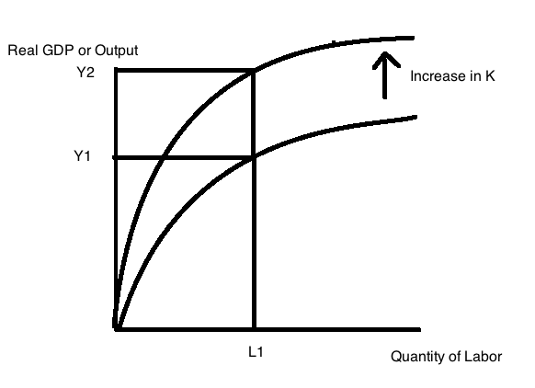
b. (1 point) Labor productivity will ____________________. The figure below illustrates this idea:

Answer:
Labor productivity will increase. The graph below depicts the two aggregate production functions based on different amounts of capital.
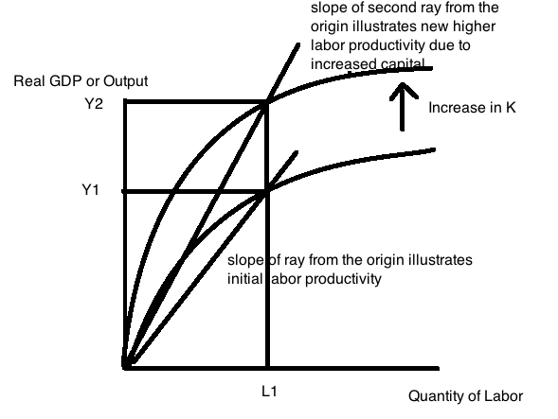
c. (1 point) Capital productivity will __________________. The figure below illustrates this idea:

Answer:
Capital productivity will decrease.
