Econ 102 Name _________________________________
Summer 2013
Answers to Quiz #1

Please write all answers neatly and legibly.

- Suppose that there are two countries, Nordia and Islandia, that both produce hotdogs and sweaters. Assume that both of these countries have linear production possibility frontiers for these two goods. If Nordia produces only hotdogs with its available resources it can produce 500 hotdogs and if Nordia produces only sweaters with its available resources it can produce 100 sweaters. If Islandia produces only hotdogs with its available resources it can produce 400 hotdogs and if Islandia produces only sweaters with its available resources it can produce 80 sweaters.
  - (1 points) What is the opportunity cost of producing two additional sweaters for Nordia?

Answer:
The opportunity cost of producing one additional sweater is 5 hotdogs, so the opportunity cost of producing two additional sweaters is 10 hotdogs.

  - (1 points) What is the opportunity cost of producing five additional hotdogs for Islandia?

Answer:
The opportunity cost of producing one additional hotdog is 1/5 sweater, so the opportunity cost of producing five additional hotdogs is 1 sweater.

  - (2 points) Which country has the comparative advantage in producing hotdogs? Explain your answer.

Answer:
Neither country has the comparative advantage since the opportunity cost of producing each good is the same for the two countries.

  - (4 points) Suppose these two countries decide to specialize according to comparative advantage and then trade with one another. In the space below draw the joint production possibility frontier for these two countries measuring hotdogs (D) on the vertical axis and sweaters (S) on the horizontal axis. Make sure you provide numeric labels for all intercepts as well as for any “kink” point on your production possibility frontier.

Answer:
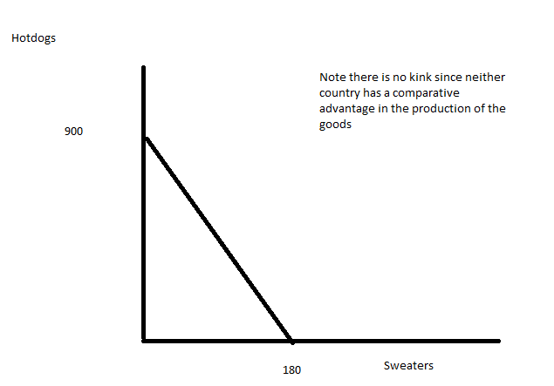

  - (2 points) What is the range of acceptable prices in terms of sweaters for 20 hotdogs?

Answer:
There is only one price for a sweater in terms of hotdogs in this example: one sweater is going to trade for 5 hotdogs from either country’s perspective. So the price will be four sweaters for 20 hotdogs.

