Economics 102
Spring 2014
Answers to Homework #5
Due May 7, 2014

Directions: The homework will be collected in a box before the lecture. Please place your name, TA name and section number on top of the homework (legibly). Make sure you write your name as it appears on your ID so that you can receive the correct grade. Please remember the section number for the section you are registered, because you will need that number when you submit exams and homework. Late homework will not be accepted so make plans ahead of time. Please show your work. Good luck!

Please remember to
- Staple your homework before submitting it.
- Do work that is at a professional level: you are creating your “brand” when you submit this homework!
- Not submit messy, illegible, sloppy work.

1. Use the Keynesian Model to answer this set of questions. Suppose that in the economy under consideration the consumption function can be written as C = 300 + .8(Y – T). Furthermore, you know that taxes are autonomous and equal to $50.
a. Draw a graph of the consumption function with respect to disposable income. Measure consumption spending on the vertical axis and disposable income on the horizontal axis. In your graph indicate the value of consumption spending when disposable income is equal to $0, $100, $200. $300, and $400.
b. Now, suppose that government spending is constant and equal to $200 at every level of disposable income. Alter your graph to show the C + G line.
c. Now, suppose that investment spending is constant and equal to $400 at every level of disposable income. Alter your graph to show the C + I + G line.
d. Now, suppose that (X – M) is constant and equal to $200 at every level of disposable income. Alter your graph to show the C + I + G + (X – M) line.
e. Suppose that (a) through (d) are all true for this economy and you also know that full employment output in this economy (Yfe) is equal to $5000. Given this information, what do you predict is happening to inventories if the full employment level of output is produced? Hint: to answer this question you will need to compare this full employment level of output with the level of aggregate expenditure at this level of output.
f. What is the equilibrium level of output for this economy?
g. Suppose that government spending is increased from its initial level to $300. Holding everything else constant, what will be the change in the equilibrium level of output given this spending change?
h. Suppose that government spending is decreased from its initial level by $100. Holding everything else constant, what will be the change in the equilibrium level of output given this spending change?

Answers:

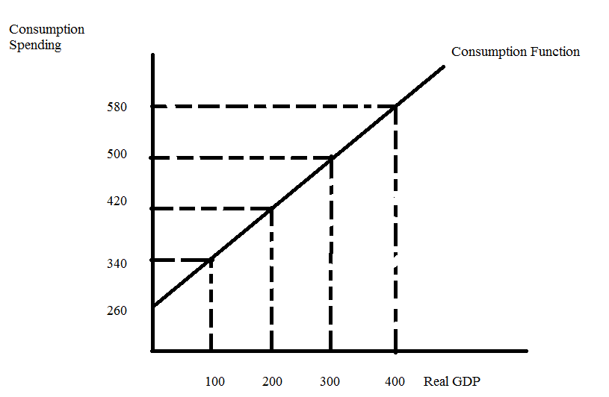
- , c., d.

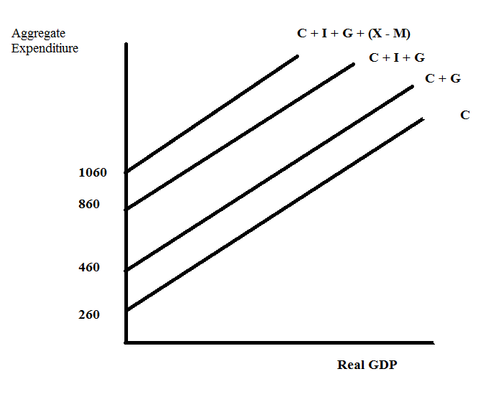
Note the y-intercept of the C+ G equation is 460; the y-intercept of the C + I + G equation is 860; and the y-intercept of the C + I + G + (X – M) equation is 1060.

e. To answer this question we first need to see what the equilibrium level of real GDP is for this economy. In equilibrium we know that Ye is equal to aggregate expenditure or
Y = AE
Y = C + I + G + (X – M)
Y = 300 + .8(Y – T) + 400 + 200 + 200
.2Y = 300 - .8(50) + 800
.2Y = 1100 - 40
.2Y = 1060
Ye = 5300
But, Yfe is equal to $5000: if this economy tries to produce at the full employment level the level of aggregate production ($5000) will be smaller than the level of aggregate expenditure (AE = 300 + .8(5000 – 50) + 400 + 200 + 200 or AE = 5060). Since production is smaller than aggregate expenditure at Y = 5000, we know that inventories will decrease and this will act as a signal to producers to increase their production toward the equilibrium level of output.

f. See the answer in (e).

g. You can answer this question in two ways: 1) use the multiplier or 2) plug in the new number and recalculate the equilibrium level of output.

- (change in real GDP) = [1/(1 – b)] * (change in government expenditure)
(change in real GDP) = [1/(1 - .8)] * (100)
(change in real GDP) = 5*100 = $500
So real GDP increases from $5300 to $5800
- Y’ = 300 + .8(Y’ – 50) + 400 + 300 + 200
.2Y’ = 1160
Y’ = $580
The change in real GDP = Y’- Y = $5800 - $5300 = $500

h. You can answer this question in two ways: 1) use the multiplier or 2) plug in the new number and recalculate the equilibrium level of output.

- (change in real GDP) = [1/(1 – b)] * (change in government expenditure)
(change in real GDP) = [1/(1 - .8)] * (-100)
(change in real GDP) = 5*(-100) = -$500
So real GDP decreases from $5300 to $4800
- Y’ = 300 + .8(Y’ – 50) + 400 + 300 + 200
.2Y’ = 960
Y’ = $4800
The change in real GDP = Y’- Y = $4800 - $5300 = -$500

2. This question is designed to give you some practice working with a consumption function, C = a + b(Y – T), where C is consumption spending, a is autonomous consumption, b is the marginal propensity to consume, Y is real GDP, and T is autonomous taxes. For this problem we will assume that the aggregate price level is fixed and unchanging.

Suppose you are given the following table where (Y – T) is disposable income and Sp is private savings:

Y | T | Y – T | C | Sp
0 | 80 |  | 340
100
200
300 |  |  |  | -345
400
500

a. Fill in the missing cells in the above table. Verbally describe how you found the values for the different cells.

b. Suppose in this economy government spending is equal to $400 and investment spending is equal to $100. Furthermore, assume this economy is a closed economy and therefore both exports and imports are equal to $0. What is the value of real GDP in this economy when the economy is in equilibrium? What is the value of consumption when the economy is in equilibrium? What is the value of private savings when this economy is in equilibrium?

c. Suppose you are told that full employment real GDP for this economy is 4000. Given your answer in (b) would you advocate that the government increase or decrease spending if this economy is to reach full employment real GDP using fiscal policy. Assume that only the level of government spending changes in making your policy prescription. What would be the necessary change in government spending to return this economy to full employment?

Answer:

a.
Y | T | Y – T | C | Sp
0 | 80 | -80 | 340 | -420
100 | 80 | 20 | 415 | -395
200 | 80 | 120 | 490 | -370
300 | 80 | 220 | 565 | -345
400 | 80 | 320 | 640 | -320
500 | 80 | 420 | 715 | -295

- The values for the column T are easy: since Taxes are autonomously given to us as $80 then we can fill in the rest of the column with 80
- Similarly, the column Y – T is easy: this is just disposable income and all we need do is subtract 80 from each real GDP (Y) figure in the first column
- The Sp figure for the first line is also relatively easy: recall Y = C + T + Sp is always a true statement when T is autonomous taxes (assuming away the issue of transfers here)
- When Y = 300 we can find C by using the relationship Y = C + T + Sp again. We have 300 = C + 80 – 345 or C = 565
- The rest of the table will require us to get either the Consumption Function of the Private Savings Function. Let’s go with the Consumption Function: C = a + b(Y – T). Recall that b = MPC = (the change in consumption)/(change in disposable income). From the table we can get (change in consumption) = (565 - 340) = 225 and the (change in disposable income) = (220 – (-80)) = 300. Thus, b = 225/300 = .75. Our consumption function can now be written as C = a + .75(Y – T), but we still need to find the value of a, the autonomous consumption. So, from the table we have a ((Y – T), C) set of coordinates: either (-80, 340) or (220, 565). Use either of these points and the consumption equation to find the value of a: e.g., 565 = a + .75(220) or a = 400. The consumption function with respect to disposable income can be written as C = 400 + .75(Y – T). Now that we have the consumption function written with respect to disposable income, we can write the private savings function as Sp = -400 + .25(Y – T). Use these equations and/or Y = C + T + Sp to fill in the rest of the table.

b. Y = C + I + G + (X – M) when the economy is in equilibrium. We know that
C = 400 + .75(Y – T)
T = 80
G = 400
I = 100
(X – M) = 0
So, Ye = 400 + .75(Ye – 100) + 100 + 400 + 0
Ye = 900 + .75(Ye – 80)
.25Ye =840
Ye = 3360
C = 400 + .75(3360 – 80)
C = 2860
Sp = -400 + .25(Y – T)
Sp = -400 + .25(3360 – 80)
Sp = 420
Check: Y = C + Sp + T or 3360 = 2860 + Sp + 80 or Sp = 420!

c. Since Ye is less than Yfe (3360 < 4000) this tells us that the government needs to increase its level of spending in order to stimulate the economy and return the economy to full employment. We can calculate the needed change in government spending by using the multiplier:
(Change in Y) = (multiplier)(change in government spending)
Multiplier = 1/(1- MPC) = 1/b in this simple example with autonomous taxes
Multiplier = 1/.25 = 4
(Change in Y) needed = 4000 – 3360 = 640
So, 640 = 4(change in government spending)
Change in government spending = 160.

Let’s verify that this will get us to Yfe. Instead of G being 400, we would now have G’ equal to 560. So,
Y = C + I + G
Y = 400 + .75(Y – T) + 100 + 560
.25Y = 1060 + .75(-80)
.25Y = 1000
Y = 4000!

3. Use the following graph and the Keynesian Model to answer this question. Assume that the aggregate price level is fixed in this problem.

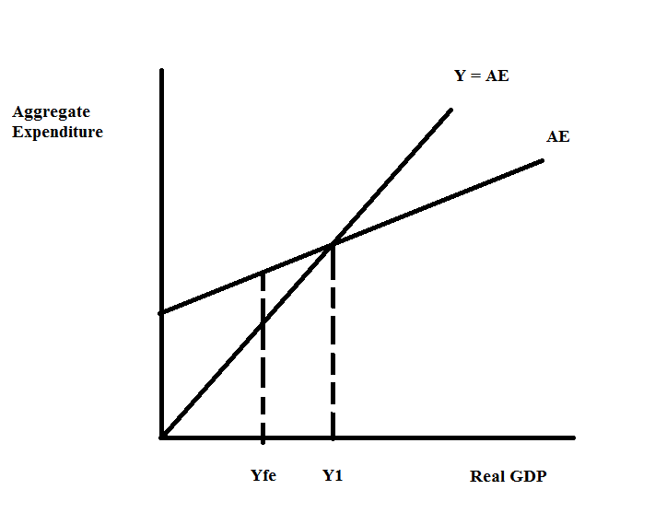
- Given the above graph, what is the equilibrium level of real GDP for this economy?
- When the economy is in equilibrium, what do you know about inventories in this economy?
- When this economy is in equilibrium, what do you know about the relationship between aggregate expenditure and aggregate production?
- At the equilibrium level of output in the above graph, what do you know about how this economy is performing?
- When this economy is in equilibrium, what do you know about the unemployment rate compared to the natural unemployment rate? What do you know about the cyclical unemployment rate in this economy?
- Suppose the government mandates that producers produce Yfe for one period. Assume there have been no monetary or fiscal policy changes to accompany this mandate. Describe the effect of this mandate on this economy given the above graph.
- Given the situation in the above graph, what policy (policies) do you advocate if the sole goal of the government is to restore this economy to full employment? Explain your reasoning.

Answers:
- The equilibrium level of real GDP in this economy is where the aggregate expenditure line intersects the 45 degree reference line. This occurs at a real GDP of Y1.
- At Y1, there are no unintended changes to inventories.
- At equilibrium, the level of aggregate expenditure is equal to the level of aggregate production.
- Since Y1 is greater than Yfe we know that this economy is in a boom.
- The unemployment rate is less than the natural unemployment rate since the level of aggregate production is less than the full employment level of aggregate production.
- At Yfe, aggregate expenditure is greater than production. That is, the level of demand for goods and services measured by aggregate expenditure is greater than the supply of goods and services as measured by real GDP. Since the aggregate price level is assumed to be constant, the deficiency in production will result in inventories decreasing and this unplanned decrease in inventories will cause producers to increase their level of production and the economy will move back towards Y1.
- The economy’s aggregate expenditure is too high to enable the economy to be at full employment. This over-heated spending can be rectified by enacting programs that will decrease aggregate expenditure. The government could decrease government expenditure or it could increase taxes so that households and businesses are left with less money they could spend in the economy. The government could also decrease the money supply so that interest rates rise and investment spending is contracted.

4. Use the AD-AS Model to answer this question. For each description assume that the AD-AS Model is initially in long-run equilibrium.
  - Suppose that the government in this economy has been at war for the last ten years. But, this year it stops all its defense operations. Holding everything else constant, what do you predict will happen to real GDP and the aggregate price level in the short run? Holding everything else constant, what do you predict will happen to real GDP and the aggregate price level in the long run? Explain your answer.
  - Suppose that the price of energy decreases in the economy due to the oil boom in North Dakota. Holding everything else constant, what do you predict will happen to real GDP and the aggregate price level in the short run? Holding everything else constant, what do you predict will happen to real GDP and the aggregate price level in the long run? Explain your answer.
  - Suppose that the government increases taxes and at the same time an announcement is made that a major new oilfield has been discovered in western Nebraska and this oilfield is anticipated to be so large that the country no long will need to import oil. Holding everything else constant, what do you predict will happen to real GDP and the aggregate price level in the short run? Holding everything else constant, what do you predict will happen to real GDP and the aggregate price level in the long run? Explain your answer.

Answers:
- When the country stops being at war this will cause the aggregate demand (AD) curve to shift to the left in the short run due to decreased government spending to finance the wars. In the short run then the aggregate level of real GDP will fall and the aggregate price level will decrease relative to their initial levels. Thus, the short run level of real GDP will be smaller than the full employment level of real GDP. In the long run the economy will return to full employment level of real GDP as the short run aggregate supply curve shifts to the right as nominal wages decrease. In the long run we can expect real GDP to return to its original level (the full employment level) while the aggregate price level will be lower than it was initially.
- The short run aggregate supply curve will shift to the right and this will result in the level of real GDP increasing relative to its initial level and the aggregate price level decreasing relative to its initial level. This implies then that the economy in the short run will be producing a level of real GDP that is greater than the full employment level of real GDP. In the long run nominal wages and prices will rise and the short run aggregate supply curve will shift left until real GDP returns to full employment real GDP. In the long run then we would expect real GDP and the aggregate price level to return to their original level.
- In the short run an increase taxes will shift the aggregate demand curve to the left since people will demand less at every aggregate price level. As taxes increase people’s disposable income will decrease and this will result in less consumption spending and therefore less aggregate demand at every price level holding everything else constant. The short run aggregate supply curve will also shift in the short run to the right since this new oilfield will increase the quantity of energy resources available to this economy and should therefore lead to lower resource prices. In the short run then we know with certainty that the aggregate price level will decrease but we do not know if the level of real GDP will increase, decrease or remain the same as the initial level since we do not know the magnitude of the two shifts. So, in the short run the aggregate price level decreases. Since real GDP is indeterminate in the short run it is much harder to analyze what happens in the long run: if short run real GDP is greater than full employment real GDP then nominal wages will rise and the SRAS curve will shift to the left to return this economy to long-run full employment; if the short run real GDP is less than full employment real GDP then nominal wages will decrease and the SRAS curve will shift to the right to return this economy to long-run full employment.

5. Suppose that an economy has one bank for the public’s financial transactions and a central bank authorized to manage the economy’s money supply. In this economy no one holds currency (i.e., there are no currency drains) and all purchases are made by writing checks (or using debit cards). Furthermore, First United never holds excess reserves after it makes full adjustment for any monetary policy. There are three people-Ringo, Paul and George-that live and work in this economy. The following t-accounts provide us with the initial situation in this economy.

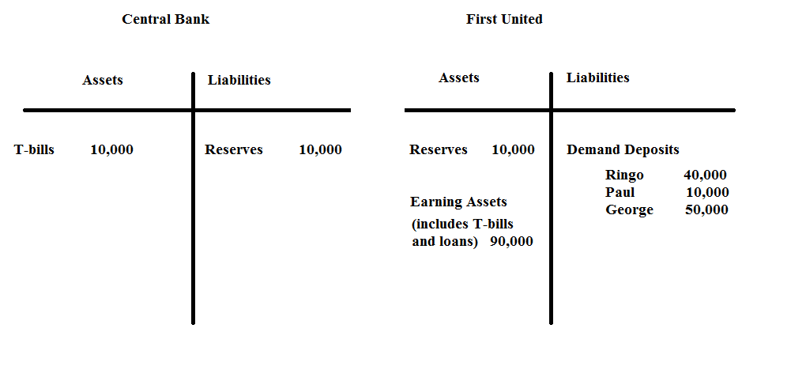
a. Given the above information, what is the required reserve ratio in this economy? Explain how you got your answer.

b. Given the above information, what is the money supply in this economy? Explain how you got your answer.

c. Suppose Ringo writes a check in order to purchase $5000 worth of camera equipment from George who owns and operates a camera store. Describe the impact of this purchase on First United’s demand deposits and reserves. Does this purchase affect the Central Bank’s t-account? If so, explain all the changes in this t-account.

d. For this question start with the initial t-accounts. Suppose the central bank decides to purchase $2000 worth of T-bills from First United. Show how this decision first impacts these t-accounts before any adjustment with regard to returning to the required reserve levels has been made (show the first round effects of this transaction and not the final full adjustment).

e. Given (d), right after the central bank purchases the T-bills does First United have insufficient or excess reserves? Quantify the level of these reserves relative to the required amount for the given amount of demand deposits.

f. Given (d), suppose Ringo, Paul and George approach First United and take out a series of loans such that at the end of this process First United has no excess reserves and the percentages of total demand deposits held by Ringo, Paul and George are the same as they were initially. Draw this final t-account. [Hint: this will be a t-account where First United has made full adjustment to the central bank’s purchase of $2000 worth of T-bills.] Show in your answer how you calculated the values in your t-account.

g. Given the transaction in (d), what is the change in the money supply? Provide two different ways (one of these methods should use the money multiplier) to get this change in the money supply.

Answers:
a. The required reserve ratio is 10% since there are $100,000 in demand deposits and $10,000 in reserves and we are told that First United does not hold excess reserves. Thus, Required Reserves = (RR)(Demand Deposits) where RR is the required reserve ratio. Or, 10,000 = (RR)(100,000) and RR = .1 or 10%.

b. The money supply is defined as the sum of currency plus demand deposits. In this economy there is no currency, so the money supply is therefore equal to the level of demand deposits. Thus, the money supply is equal to $100,000.

c. Ringo’s check will reduce his demand deposits by $5000, so his demand deposits will now equal $35,000. First United will need to honor her check and will do so by reducing its reserves by $5000. George will deposit Ringo’s check and this new deposit will increase George’s demand deposits by $5000 as well as the bank’s reserves by $5000. So, there is no change in the total amount of reserves and no change in the total amount of demand deposits. Here’s the new t-account for First United.
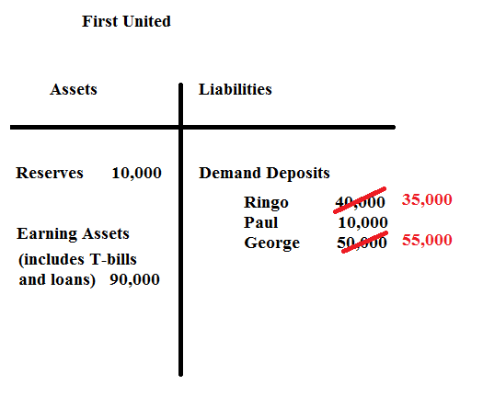
This transaction does not affect the Central Bank’s t-account.

d.
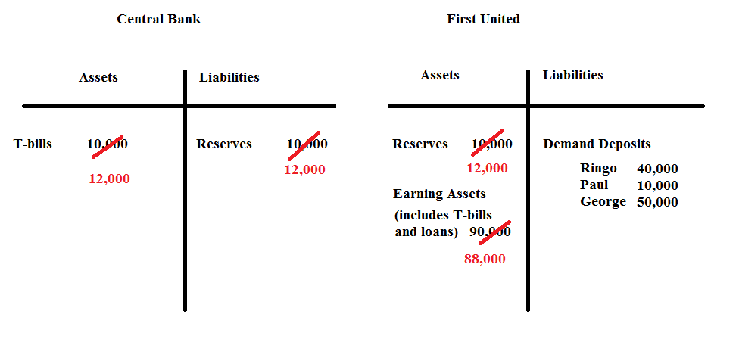

e. Right after the transaction First United has $100,000 in demand deposits and therefore requires $10,000 in required reserves. However, First United has $12,000 in reserves and therefore has excess reserves of $2000.

f. First United has a total of $12,000 in reserves and demand deposits of $100,000 after the central bank’s purchase of the T-bills. This means that First United has excess reserves of $2000 and these reserves will be lent out by First United in the first round of adjustments to this open market purchase. First United will find that these excess reserves of $2000 can support more than $2000 in loans however. One way to think about this is if First United has total reserves of $12,000, what is the amount of demand deposits it can support? Thus, Required Reserves = (RR)(Demand Deposits) and in this case 12,000 = .1(Demand Deposits) or Demand Deposits = $120,000. Thus, First United’s t-account after full adjustment to the central bank’s open market purchase will look like this:
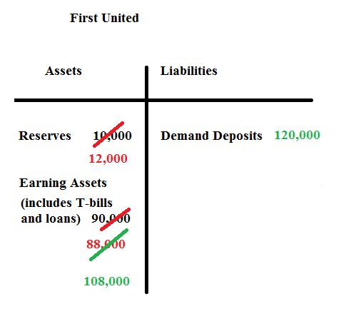
The question also asks you to figure out the level of demand deposits held by Ringo, Paul and George. Thus, Ringo’s Demand Deposits = (.4)(Demand Deposits) = .4(120,000) = $48,000; Paul’s Demand Deposits = (.1)(Demand Deposits) = .1(120,000) = $12,000; and George’s Demand Deposits = (.5)(Demand Deposits) = .5(120,000) = $60,000. The final t-account for First United looks like the following:
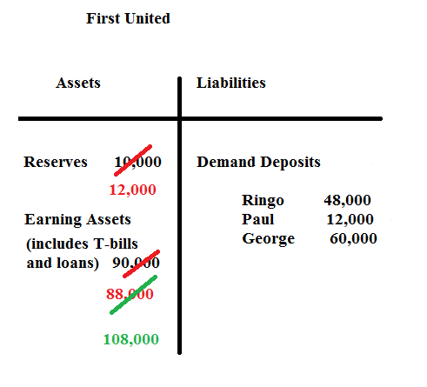

g. The money supply is defined as the sum of currency plus demand deposits. There is no currency in this economy and the demand deposits initially are $100,000 and at the end of the adjustment to the open market purchase the demand deposits are equal to $120,000: the change in the money supply is therefore equal to 120,000 – 100,000 or $20,000.

Alternatively, (the change in the money supply) = (money multiplier)(change in reserves). The money multiplier is equal to (1/rr) or in this case (1/.1) or 10. Thus, (the change in the money supply) = 10(change in reserves). Reserves increase by $2000. So, the change in the money supply = 10(2000) = $20,000.

6. Use the AD-AS Model to answer this set of questions. Suppose you are given the following information:
Long run aggregate supply (LRAS): Yfe = 3000
Short run aggregate supply (SRAS): Y = 1000P – 10,000
Aggregate demand (AD): Y = 20,000 – 1000P
where Y is real GDP and P is the aggregate price level.

a. Given the above information, find the short run equilibrium level of real GDP and the aggregate price level.

b. Draw a graph representing the SRAS curve, the AD curve, and the LRAS curve. Label the short run equilibrium.

c. Given your answers in (a) and (b), in this economy in the short run in a boom or a recession? Explain your answer.

d. In the long run, holding everything else constant, what do you predict will happen in this economy?

e. Given the above information, provide a numerical answer for the long run values of real GDP and the aggregate price level in this economy.

f. Given your answers in (d) and (e), provide an equation for the new SRAS curve.

g. At each aggregate price level, what was the decrease in real GDP given your new SRAS curve for (f)?

Answers:
a. In the short run the equilibrium occurs where the AD curve intersects the SRAS curve. Thus, 20,000 – 1000P = 1000P – 10,000 or P = 15. Ye = 20,000 – 1000(15) = 5,000.

b.
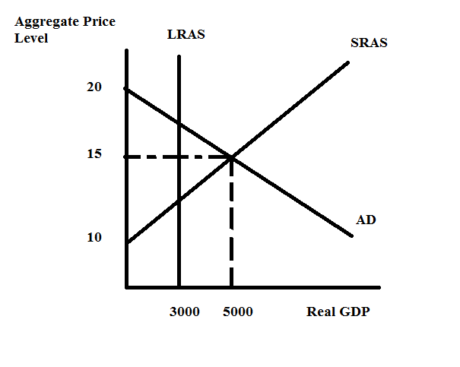
c. The economy in the short run produces where real GDP is equal to $5000. $5000 is greater than Yfe of $3000: this implies that this economy is operating in an economic boom since the level of real GDP is greater than the full employment level of real GDP.

d. The SRAS curve will shift to the left due to increases in nominal wages until real GDP returns to the full employment level of real GDP. The aggregate price level will increase to a level that is greater than the initial aggregate price level.

e. We know in the long run, that the equilibrium level of real GDP must equal the full employment level of real GDP. We also know that the full employment level of real GDP is $3000. The long run aggregate price level will be that aggregate price level where the LRAS curve intersects the AD curve since nothing has changed that would cause the AD curve to shift. Hence, we can find this aggregate price level by setting the AD curve equal to the LRAS curve. Thus, 20,000 – 1000P = 3000 or P = $17.

f. We know one point on the new SRAS curve and that point is (Y, P) = (3000, 17). We can rewrite the SRAS curve as P = 10 + .001Y (we are putting the curve in slope intercept form). The new SRAS curve will have the same slope as the initial SRAS but a different y-intercept. Thus, the new SRAS curve could be written as P = b + .001Y. Plugging in the point we know that does sit on this new SRAS curve we get: 17 = b + .001(3000) or b = 14. Thus the new SRAS curve can be written as P = 14 + .001Y or Y = 1000P – 14,000.

g. Initially when P = 15, Y = 5000. Now using the new SRAS curve, Y = 1000P – 14,000, and substituting P = 15 into this equation we get Y = 1000. So, when the aggregate price level is held constant at 15, we find that real GDP decreases by $4000. This decrease of $4000 would be true no matter what aggregate price level we considered.

7. You should definitely use a calculator on this problem and you will want to work neatly since you will need to look back at times for information you have already calculated. Suppose you are given the following information about an economy:

Required reserve ratio is 10%
Money Supply = Ms: Ms = 5,000
Money Demand = Md: Md = 10,000 – 1250r where r is the interest rate (for this problem we will assume that there are no expectations of inflation so that the nominal interest rate is the same as the real interest rate-this is a simplifying assumption that will make this rather-long problem less complex)(i.e., When the interest rate is 7%, it means r = 7.)
Investment Spending = I: I = 10,000 - 1000r
Aggregate Expenditure = AE: AE = C + I + G + (X – M)
Consumption Spending = C: C = 800 + .8(Y – T) -100P where P is the aggregate price level
Government Spending = G: G = 1000
Net Exports = (X – M): (X – M) = 400
Autonomous Taxes = T: T = 800
Aggregate Demand = AD: AD = AE = C + I + G + (X – M)
Long run Aggregate Supply = LRAS: LRAS = Yfe = 32,000
Short run Aggregate Supply = SRAS: Y = 4000P – 34,200

a. There is a lot of information given to you in this problem. There is information about the money market; information about aggregate expenditure; and information about the AD, LRAS and SRAS curves. Take a moment and look at this information carefully. Now, focus on the consumption function: what does consumption spending depend upon in this economy? What is the relationship between consumption spending and disposable income (e.g., is it a positive or negative relationship)? What is the relationship between consumption spending and the aggregate price level? Do both of these relationships seem plausible to you? Explain your reasoning.

b. Given the above information, what is the equilibrium interest rate in this economy? Explain how you found this interest rate.

c. Given the above information, what is the level of investment spending in this economy? Explain how you found this level of spending.

d. Given the above information, calculate an equation that expresses this economy’s aggregate demand for goods and services.

e. Given the above information and your work in (a) through (d), find the short run equilibrium level of real GDP (Y) and the short run aggregate price level (P). Then draw a graph illustrating this short run equilibrium. In your graph include the LRAS curve as well. Measure the aggregate price level on the vertical axis and real GDP on the horizontal axis.

f. Suppose the government sets a goal of using fiscal policy to reach the full employment level of output. If the government changes the level of government spending to reach this goal, how much will government spending need to change by holding everything else constant? After you compute the change in government spending, use this new level of spending to recalculate the equilibrium level of real GDP and see if your answer is correct. (Hint: the simple multiplier calculation will result in “too small” a level of stimulus since the aggregate price level will change when the AD curve shifts.) Show your work and your computations.

g. Suppose the government sets a goal of using fiscal policy to reach the full employment level of output. If the government changes the level of autonomous taxes to reach this goal, how much will the autonomous taxes need to change by holding everything else constant? After you compute the change in autonomous taxes, use this new level of taxes to recalculate the equilibrium level of real GDP and see if your answer is correct. (Hint: the simple multiplier calculation will result in “too small” a level of stimulus since the aggregate price level will change when the AD curve shifts.) Show your work and your computations.

h. Suppose the government, for political reasons, finds that fiscal policies are simply not possible to implement in this economy. But, the government is still determined to restore this economy to Yfe, perhaps because the government is concerned with the social instability that high levels of unemployment may create, or because the government is morally concerned about the impact of high unemployment on people in their society, or because….(fill in your own rationale).The government sets a goal of using monetary policy to reach the full employment level of output. Can the government reach this goal using only monetary policy? In your answer remember that it is not possible to have the nominal interest rate go below 0%. Holding everything else constant, what is the highest level of real GDP this economy can attain if the government engages in activist monetary policy? (Hint: you will definitely need your calculator on this one!) And, what will be the monetary policy that is implemented to reach this level of real GDP? In your answer to this last question be specific with the type of policy as well as providing a quantitative number for this policy.

i. Now, after doing (h), let’s enact monetary policy that will just get this economy to the full employment level of output holding everything else constant. This is a hard question, but if you make it through this analysis consider what you have learned over the course of the semester! Congratulations!

Answers:
a. Consumption spending depends upon disposable income (Y – T) and the aggregate price level. Consumption spending is positively related to disposable income: as disposable income increases, holding everything else constant, the level of consumption spending increases. Consumption spending is inversely related to the aggregate price level: as the aggregate price level increases, holding everything else constant, the level of consumption spending decreases. This reasoning seems plausible: an increase in disposable income suggests that individuals have greater command over goods and services and will decide to purchase more when their disposable incomes have risen. On the other hand, for a given level of nominal income, an increase in the aggregate price level means that consumers have less purchasing power and will therefore reduce their purchases of goods and services.

b. To find the equilibrium interest rate you need to find the interest rate that equates money supply to money demand. Hence,
5,000 = 10,000 – 1250r
r = 4 or 4%

c. We know that I = 10,000 - 1000r and we just calculated that r = 4%. So,
I = (10,000) – (1000)(4) = $6,000

d. We know that AD = AE and AE = C + I + G + (X – M). Hence,
Y (a convenient short hand for the level of output demanded) = AE
Y = C + I + G + (X – M)
Y = 800 + .8(Y – T) – 100P + I + G + (X – M)
Y = 800 + .8(Y – 800) – 100P + 6000 + 1000 + 400
Y = 8200 + .8(Y – 800) – 100P
.2Y = 7560 – 100P
Y = 37,800 – 500P
The equation for AD can be written as Y = 37,800 – 500P or rearranging and solving for P we have P = 75.6 – (1/500)Y.

e. To find the short run equilibrium we will want to see where the AD curve intersects the SRAS curve. Thus,
37,800 – 500P = 4000P – 34,200
4,500P = 72,000
Pe = 16
Ye = 37,800 – 500P = 37,800 – 500(16) = 29,800
Or, Ye = 4000P – 34,200 = 4000(16) – 34,200 = 29,800
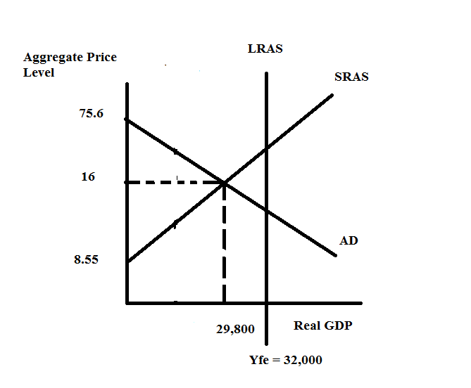

f. I started this answer by thinking-“this is easy, all I need to do is use the simple multiplier to figure out the needed level of government spending”. So, let’s try this out and see if it works. First, if we are currently producing at Ye = 29,800 and Yfe = 32,000 then we need a change in real GDP of 2,200. And, we know that the relationship between the multiplier, a change in autonomous spending, and real GDP can be written as:
(Change in real GDP) = (multiplier)(change in autonomous spending)
2200 = (1/(1-.8))(change in government spending)
Or, 2200 = 5(change in government spending)
Change in government spending = 440
So, let’s try this and see if it works:
Y’ = 800 + .8(Y’ – T) – 100P + 1440 + 6000 + 400
Y’ = 8640 + .8(Y’ – 800) – 100P
.2Y’ = 8000 – 100P
Y’ = 40,000 – 500P [This is our new AD’ curve: the increase in government spending will shift the AD curve to the right]
Now, let’s set the AD’ curve equal to the SRAS curve and see what the equilibrium level of real GDP is (we want this to be Yfe = 32,000). Thus,
40,000 – 500P = 4000P – 34,200
4500P = 74,200
P = 16.5 (rounding to the nearest tenth)
Y’ = 40,000 – 500(16.5) = 40,000 – 8250 = 31,750 ! An increase in government spending of $440 is not sufficient to get this economy to Yfe. Let’s see if I can draw an image that helps you see why this has failed.
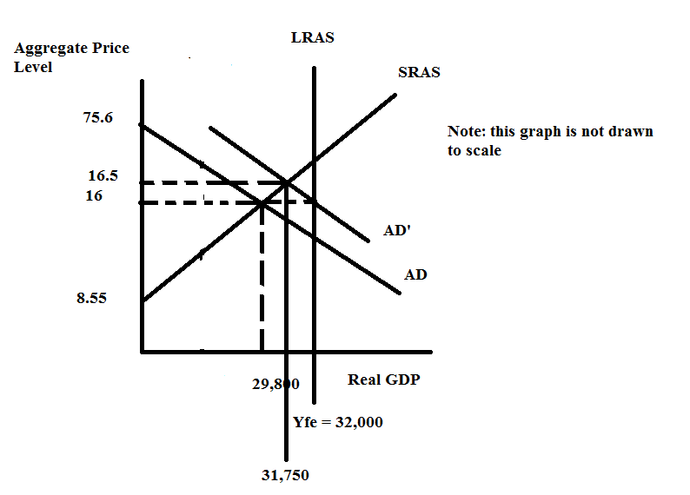
The simple multiplier holds the aggregate price level constant and shifts the AD curve to AD’ where AD’ intersects the LRAS curve at Yfe = 32,000. However, the SRAS curve is upward sloping, so when the AD curve shifts this causes a change in the aggregate price level and it results, in this case, in a smaller increase in government spending than the simple multiplier would have predicted. From the graph we can see that if we want to get to Yfe we will need a higher aggregate price level than 16.5 and a larger rightward shift of the AD curve than is generated by an increase of $440 in government spending. So, let’s try this again.

Looking at the graph let’s first find the aggregate price level where the SRAS and the LRAS intersect. Thus, 32,000 = 4000P – 34,200 or 66,200 = 4000P and P = 16.55. So, when the aggregate price level is equal to 16.55, then Yfe = SRAS curve. Use this aggregate price level to calculate what the change in real GDP needs to be in order for this economy to reach Yfe. Thus, when P = 16.55, the level of real GDP on the original AD curve is equal to Y = 37,800 – 500(16.55) = 37,800 – 8275 or Y = 29,525 and therefore if we want to shift AD to the right to get to Yfe, the change in real GDP must be 32,000 – 29,525 or 2475. Now, using these numbers, let’s repeat the simple multiplier process:

(Change in real GDP) = (multiplier)(change in government spending)
2475 = (1/(1-.8))(change in government spending)
2475 = 5(change in government spending)
495 = Change in government spending

Let’s try this and see if it works:
Y’ = 800 + .8(Y’ – T) – 100P + 6000 + 1495 + 400
Y’ = 8695 + .8(Y’ – 800) – 100P
.2Y’ = 8055 – 100P
Y’ = 40,275 – 500P [This is our new AD’ curve: the increase in government spending will shift the AD curve to the right]
Now, let’s set the AD’ curve equal to the SRAS curve and see what the equilibrium level of real GDP is (we want this to be Yfe = 32,000). Thus,
40,275 – 500P = 4000P – 34,200
4500P = 74,475
P = 16.55
Y’ = 40,275 – 500(16.55) = 40,275 – 8275 = 32,000 ! An increase in government spending of $495 will get this economy to Yfe.

g. Before reading this answer review the answer in (f) and make sure you understand how the upward sloping (e.g., the aggregate price level is no longer assumed to be constant as it was in the simple Keynesian model) SRAS complicates your work.

From (f) we know that the change in real GDP we need in order to reach Yfe is 2475. So,
(Change in real GDP) = (-b/(1 – b))(Change in autonomous taxes)
2475 = (-.8/.2)(Change in autonomous taxes)
-618.75 = Change in autonomous taxes (That is, taxes need to decrease by 618.75, so that means that the government will have taxes at 181.25 rather than taxing them at the original level of 800.)

Let’s try this and see if it works:
Y’ = 800 + .8(Y’ – (800 – 618.75)) – 100P + 1000 + 6000 + 400
Y’ = 8200 + .8Y’ - .8(181.25) – 100P
.2Y’ = 8055 – 100P
Y’ = 40,275 – 500P (This is our new AD’ curve that reflects the decrease in autonomous taxes of 618.75.)
Set this new AD’ curve equal to the SRAS curve and we have:
40,275 – 500P = 4000P – 34,200
74,475 = 4500P
P = 16.55
Y’ = 40,275 – 500P = 40,275 – 500(16.55) = 32,000
Or, Y’ = 4000P – 34,200 = 4000(16.55) – 34,200 = 32,000

h. The conduit for monetary policy in this model is the interest rate and its impact on the level of investment. So, let’s start with thinking about the maximum amount of investment spending that will occur in this economy. This maximum level of investment spending is that level associated with a nominal interest rate of 0%. So, I = 10,000 – 1000r and if r = 0 then we have:
I = 10,000.

But, what monetary policy will result in the interest rate equaling 0%? Monetary policy will shift the money supply curve: in this case we need the money supply curve to shift to the right-so the central bank will need to engage in open market purchases in order to expand the money supply. Money demand when r = 0% is equal to 10,000. So, since the initial money supply was 5,000 we will need the change in the money supply to be 5,000 (that is 10,000 – 5,000 = 5,000). So,

(Change in money supply) = (Money multiplier)(Change in reserves)
5,000 = (1/rr)(change in reserves)
5,000 = (1/.1)(change in reserves)
500 = change in reserves

So, if the government purchases $500 in t-bills this will increase the money supply to 5,000 and result in the interest rate being 0%. When the interest rate is 0% this will result in investment spending being equal to $10,000. So, given this policy and its impact, what happens to Ye?

Y = 800 + .8(Y – T) – 100P + 10,000 + 1000 + 400
Y = 12,200 + .8(Y – 800) – 100P
.2Y = 11,560 – 100P
Y = 57,800 – 500P ( This is our new AD curve that reflects the change in monetary policy and its resultant impact on investment spending.)
Use the SRAS curve and this new AD curve to find the new equilibrium aggregate price level and the new equilibrium real GDP. Thus,
57,800 - 500P = 4000P – 34,200
4500P = 92,000
P = 20.44 (rounded to the nearest hundredth)
Y = 57,800 – 500(20.44) = 57,800 – 10,220 = 47,580
Or, Y = 4000P – 34,200 = 4000(20.44) – 34,200 = 81,760 – 34,200 = 47,560

If the central bank reduces interest rates to 0% the central bank will overshoot the full employment level of output. In this case, monetary policy is strong enough to get the economy to full employment. You might find it interesting to try to figure out what the monetary policy is to actually get to full employment.

We know that the AD curve needs to be Y’ = 40,275 – 500P in order to intersect the SRAS curve at the full employment level of output. We can write this as
Y’ = 800 + .8(Y’ – T) – 100P + 1000 + I’ + 400 or
Y’ = 2200 + I’ + .8Y’ - .8(800) – 100P
Y’ = 1560 + I’ +.8Y’ -100P
.2Y’ = 1560 + I’ – 100P
Y’ = 5(1560 + I’) – 500P
And, we know that 5(1560 + I’) = 40,275
So, what does that imply about the value of I’ that is needed?
7800 + 5I’ = 40,275
32,475 = 5I’
I’ = 6495
Since I is initially 6000 that tells us we must increase investment by 495. So, go back to your investment function and plug in 6495 to see what interest rate the central bank needs to get for all of this to work. I = 10,000 – 1000r and I’ = 6495. Thus,
6495 = 10,000 – 1000r
3505 = 1000r
r = 3.505
What money supply does this imply we need?
Ms = Md
Ms = 10,000 – 1250r
We know that r needs to be 3.505, so Ms = 10,000 – 1250(3.505) = 10,000 – 4381.25 = 5618.75
Since the money supply is initially 5000, this implies that the central bank needs to expand the money supply by 618.75. Remember that the relationship between the money supply and reserves needs to be considered here:
(change in money supply) = (money multiplier)(change in reserves)
618.75 = (10)(change in reserves)
61.875 = change in reserves

So, to use monetary policy to reach full employment the central bank would need to purchase t-bills of $61.875. This would result in the money supply increasing by $618.75 which would result in the interest rate falling to 3.505%. This decrease in the interest rate would cause investment spending to increase and this would shift the AD curve to the right.

