Economics 101 Name _____________________________
Summer 2013 TA Name __________________________
06/17/13 Discussion Section #_________________
Answers to Second Midterm Student ID # _______________________

Version 1

DO NOT BEGIN WORKING UNTIL THE INSTRUCTOR TELLS YOU TO DO SO
READ THESE INSTRUCTIONS FIRST.

You have 75 minutes to complete the exam. The exam consists of 3 problems worth 10 points each, 10 binary choice worth 2 points and 20 multiple choice questions worth 2.5 points. Please accurately and completely provide your name, ID number, discussion section number, version number, and TA name on the scantron sheet and the exam booklet. Answer all questions on the scantron sheet with a #2 pencil

NO CELL PHONES, CALCULATORS, OR FORMULA SHEETS ARE ALLOWED.
PICK THE BEST ANSWER FOR EACH QUESTION.

How to fill in the scantron sheet and other information:
- Print your last name, first name, and middle initial in the spaces marked "Last Name," "First Name," and "MI." Fill in the corresponding bubbles below.
- Print your student ID number in the space marked "Identification Number." Fill in the bubbles.
- Write the number of the discussion section you’ve been attending under "Special Codes" spaces ABC, and fill in the bubbles. You can find the discussion numbers below on this page.
- Write the version number of your exam booklet under "Special Codes" space D, and fill in the bubble. The version number is on the top of this page.

- If there is an error on the exam or you do not understand something, make a note on your exam booklet and the issue will be addressed AFTER the examination is complete. No questions regarding the exam can be addressed while the exam is being administered.
- When you are finished, please get up quietly and bring your scantron sheet and this exam booklet to the place indicated by the instructors.

Binary Choice _____________

Multiple Choice _____________

Problems:
Problem 1 (10 points) _____________

Problem 2 (10 points) _____________

Problem 3 (10 points) _____________

TOTAL _____________

I, __________________________________, agree to neither give nor receive any help on this exam from other students. Furthermore, I understand that use of a calculator on this exam is an academic misconduct violation.

Signed ____________________________________

I. Binary Choice (10 questions worth 2 points each)

1. Over the same time period, suppose the nominal price of coffee increases by 20% while the CPI increases from 200 to 250. From this information we know that
a. The real price of coffee increased.
b. The real price of coffee decreased.

2. Jamie can purchase 10 cans of tuna (T) or 5 jars of peanut butter (PB) with her income. She knows that the price of tuna is $2 per can. Which of the following equations describes her budget line?
a. 2T = 10 – PB
b. 150T = 1500 – 300PB

3. Suppose that Marie’s marginal utility from consuming one more unit of bubble gum is 10 utils while her total utility from consuming one more unit of cake increases from 130 utils to 142 utils. Given this information and holding everything else constant, if the price of bubble gum is $1 per unit and the price of cake is $2 per util, then Marie should
a. Consume more bubble gum.
b. Consume less bubble gum.

4. The substitution effect measures
a. The change in the consumption of good X due to the change in the price of good X while holding the consumer’s utility level constant at the original level of satisfaction.
b. The change in the consumption of good X due to the change in the price of good X while holding constant the consumer’s level of income.

Use the graph below of Libby’s indifference curve map and budget lines for doughnuts and coffee to answer the next two questions.

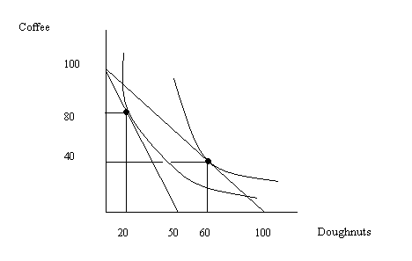
5. Given the above graph which of the following equations represents Libby’s demand for doughnuts?
a. P = 100 – 40Q
b. P = 2.5 – (1/40)Q

6. If Libby’s income is $500 and her budget line is C = 100 -2D where C is cups of coffee and D is doughnuts, then we can conclude that the price of doughnuts is
a. $10
b. $1

7. As output increases a firm finds that its marginal cost of producing an additional unit is rising. From this information we know that
a. The firm’s average total cost is also increasing as output increases.
b. The firm’s average total cost may be increasing or decreasing as output increases.

8. In a perfectly competitive industry, entry of firms will occur until
a. Each firm in the industry earns zero economic profits in the long run.
b. Marginal cost equals marginal revenue at each firm’s level of production.

9. In a perfectly competitive industry if each firm is identical then we can calculate the number of firms in the industry by
a. Multiplying the amount produced by each firm times the total production of the good.
b. Dividing the total amount produced in the market by the amount a representative firm produces.

10. An unregulated natural monopoly will
a. Produce the profit maximizing level of output and therefore there will be no deadweight loss associated with this production.
b. Produce where marginal revenue equals marginal cost.

II. Multiple Choice (20 questions worth 2.5 points each)

11. Jamie’s income in 2012 is $100,000 and his income in 2013 is $140,000. Jamie reads that the CPI for 2012 is 250 while the CPI for 2013 is projected to be 350. The CPI index numbers are based on base year 2005. Given this information, which of the following statements is true?
a. Prices in 2013 are in general projected to be 40% higher in 2013 than they were in 2012.
b. Jamie’s real income in 2012 is equivalent to Jamie’s real income in 2013.
c. If the CPI base year is changed to 2012 then the CPI for 2013 would have a value of 40.
d. All of the above answers are correct.
e. Answers (a) and (b) are both correct.

12. The price of an ice cream cone is $4 and the price of a hotdog is $5. Brian’s marginal utility from an ice cream cone is equal to 20 utils and his total utility from consuming the last hotdog he ate increased from 100 utils to 125 utils. From this information we can conclude that
a. Brian is currently allocating his income between these two goods optimally.
b. Brian should consume more hotdogs and fewer ice cream cones.
c. Brian should consume more ice cream cones and fewer hotdogs.
d. Brian’s income must be $100 and his maximum consumption of hotdogs is 4 hotdogs.

13. Suppose you are given the following information about the cost of the market basket used to compute the CPI:
Year | Cost of Market Basket
2010 | $250
2011 | $300
2012 | $400

Assume the CPI is calculated on a 100 point scale. If the base year for the CPI is 2012, then
a. The CPI for 2010 is equal to [(400 – 250)/(250)]*100.
b. The CPI for 2011 is equal to 75.
c. The CPI for 2012 is equal to [(400)/(100)]*100.
d. To calculate the CPI it is necessary to have more information.

14. Ellen operates a bicycle store where she sells new bikes and repairs broken bikes. She rents the building her business is housed in and her annual rent is $20,000. Each bike she sells costs her $400 from the wholesaler, but she can sell each bike for $700. She estimates that her labor cost is 1.5 hours of labor for every bike she sells and 2.0 hours of labor for every bike she repairs. She pays $10 per hour of labor she hires.
a. Given this information Ellen’s fixed costs include the rent she pays as well as the bikes she purchases from the wholesaler.
b. If Ellen repairs 100 bikes and sells 50 bikes then her variable costs will equal $2750 which is the cost of the labor she must hire in order to repair the bikes and sell the new bikes.
c. If Ellen repairs 100 bikes and sells 50 bikes then her variable costs will equal $22,750 which is the cost of the bikes from the wholesaler as well as the cost of the labor she must hire in order to repair the bikes and sell the new bikes.
d. If Ellen repairs 100 bikes and sells 50 bikes then her variable costs will equal $42,750 which is the cost of renting the building, the cost of the bikes from the wholesaler as well as the cost of the labor she must hire in order to repair the bikes and sell the new bikes.

15. Fixed costs
a. Do not change as the level of output changes for the firm in the short run.
b. Decrease as the level of output the firm produces increases in the short run.
c. Are those costs that are unaffected by changes in the level of production by the firm in the long run.
d. Are always less than variable costs as the level of output the firm produces increases in the short run.

16. George’s income increases from $100 to $500 while the price of hotdogs and the price of ice cream cones remain fixed. George finds that he initially maximizes his satisfaction when he consumes 50 hotdogs and 20 ice cream cones (assume this consumption bundle exhausts his income). George finds that his utility maximizing bundle when his income increases includes 200 hotdogs. Which of the following statements must be true?
a. Hotdogs are inferior goods given George’s tastes and preferences.
b. Ice cream cones are inferior goods given George’s tastes and preferences.
c. If George consumes 200 hotdogs then he will exhaust his income when he consumes 120 ice cream cones.
d. George’s demand curve for hotdogs must be a horizontal line given this information.

Use the following information to answer the next three questions.

Consider a perfectly competitive market that is initially in long run equilibrium.

17. Given that this market is in long run equilibrium then it must be the case that
a. Marginal cost is equal to average total cost for the representative firm.
b. Average total cost is at its minimum for the representative firm.
c. The representative firm is earning zero economic profits.
d. All of the above statements are true.
e. Answers (a) and (c) are both true.

18. Suppose that the price of a substitute good increases. Holding everything else constant and assuming this is a constant cost industry, which of the following statements is true?
a. In the short run this change in the price of a substitute good will not change the market price or the marginal revenue curve for the representative firm.
b. In the short run this change in the price of a substitute good will cause this representative firm to earn negative economic profits.
c. In the long run prices in this market will be unaffected by the change in the price of a substitute good.
d. There is not enough information in this question to analyze the impact on the short run or the long run in this market.

19. Suppose that this market is in its initial situation. Suppose that there is an increase in the number of people demanding this product. Holding everything else constant, which of the following statements is true?
I. In the short run the representative firms in this industry will earn positive economic profits.
II. In the long run there will be entry of firms into this industry.
III. In the long run each representative firm will produce a higher level of output than they did initially in order to serve the extra demand for the produce.
a. Statements I and III are both correct.
b. Statements I and II are both correct.
c. Statements II and III are both correct.
d. Statements I, II and III are all correct.
e. Statement I is correct.

Use the following table showing a perfectly competitive firm’s production and cost functions to answer the next question.

Labor | Capital | Output | Variable Cost | Fixed Cost | Total Cost | Average Variable Cost | Average Fixed Cost | Average Total Cost | Marginal Cost
0 | 25 | 0 | $0 |  |  | ---- | ---- | ---- | ----
1 | 25 | 10 | $5 |  |  |  |  |  | $.50 per unit
4 | 25 | 20 |  |  | $30 |  |  |  | 1.50
9 | 25 | 30 |  | $10 |  |  |  |  | 2.50
16 | 25 | 40 |  |  |  |  |  |  | 3.50

20. Which of the following statements is true given the above table?
a. The cost of fifteen units of labor is more than $80.
b. The cost of 10 units of capital is $6.00.
c. The average total cost of producing 10 units of output is the same as the average total cost of producing 20 units of output.
d. All of the above statements are true.

21. Suppose that you know that the income elasticity of demand for good X is equal to -2.5 and the cross price elasticity of demand of good X for good Y is equal to 1.25. From this information you conclude that
a. Good X is an inferior good and good X and good Y are substitutes.
b. Good X is an inferior good and good X and good Y are complements.
c. Good X is a normal good and good X and good Y are substitutes.
d. Good X is a normal good and good X and good Y are complements.

22. Madison Metro estimates that the demand for its bus services is given by the equation Q = 500,000 – 125,000P. Madison Metro is currently charging $1.50 per ride on its buses. Given this information and holding everything else constant, which of the following statements is true?
a. Madison Metro could increase its revenues by decreasing the price of each bus ticket.
b. Madison Metro’s current bus ticket price is less than it should be if Madison Metro wishes to maximize its costs.
c. If revenue maximization is Madison Metro’s primary goal then Madison Metro should charge $4.00 per bus ticket.
d. Madison Metro is currently earning $468,750 in revenues.

23. Suppose that the price of widgets increases from $1.00 per widget to $1.50. Furthermore, you know that the price elasticity of demand for widgets is equal to 2. From this information you can conclude that
a. The quantity of widgets demanded must have fallen by 200% when the price of widgets increased.
b. The quantity of widgets demanded must have fallen by 150% when the price of widgets increased.
c. The quantity of widgets demanded must have fallen by 100% when the price of widgets increased.
d. The quantity of widgets demanded must have risen by 100% when the price of widgets increased.

Use the information below to answer the next three questions.

Consider the market for bicycles in Monrovia. Currently the market can be described by the following equations where P is the price per bicycle and Q is the quantity of bicycles:
Market Demand Curve: Q = 20,000 – 20P
Market Supply Curve: Q = 20P - 4000

24. Which of the following statements is true given the above information?
I. When this market is in equilibrium, consumer surplus is equal to $1.6 million.
II. If a limit on the number of bicycles that can be sold in this market is set at 4000 bicycles by the government, then the difference between the price consumers will pay for a bike and the price suppliers must receive for the bike will be equal to $400 per bike.
III. If a limit on the number of bicycles that can be sold in this market is set at 4000 bicycles by the government, then the deadweight loss associated with this limit will be equal to $1.6 million.
- Statements I, II and III are all true statements.
- Statements I and III are true statements.
- Statements I and II are true statements.
- Statements II and III are true statements.

25. Suppose the government imposes an excise tax of $200 per bike on bicycle producers in this market. Given this excise tax and holding everything else constant, which of the following statements is true?
a. The excise tax results in consumers buying fewer bicycles than they would like to buy if there was no excise tax.
b. The excise tax results in producers selling fewer bicycles than they would like to sell if there was no excise tax.
c. The excise tax results in a redistribution of surplus from consumers and producers to the government.
d. Answers (a), (b) and (c) are all correct answers.
e. Answers (a) and (b) are correct answers.

26. Suppose the government imposes an excise tax of $200 per bike on bicycle producers in this market. Which of the following statements is true once this excise tax is imposed on this market?
a. The net price that bicycle producers receive when they sell bicycles will now be $700 per bicycle sold in this market.
b. The deadweight loss due to the imposition of this excise tax will be equal to $200,000.
c. Tax revenue from this tax will equal $1,600,000.
d. Total surplus in this market will increase with the implementation of this tax since the government will now be earning some tax revenue.

Use the following information to answer the next two questions.

The graph below is of monopolist: the graph illustrates the monopolist’s demand curve, its marginal revenue curve, and its cost curves.

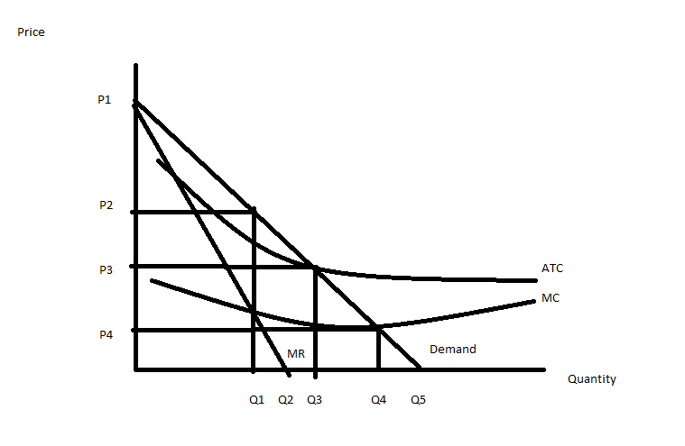
27. From the monopolist’s perspective, the best price and output combination if the goal of the firm is to profit maximize would be
a. P1 and Q3 since this is the highest price and the quantity associated with the midpoint of the demand curve (the point where revenue is maximized!).
b. P2 and Q4 since this combination has a relatively high price and a large quantity and it’s also the point where MC is minimized (surely a benefit to the firm!).
c. P3 and Q3 since this is where the price is equal to the average cost of production and it is also the point closest to the midpoint of the demand curve where revenue is maximized.
d. P2 and Q1 since this is where the addition to total revenue from selling one additional unit of the good is equal to the addition to total cost of producing one additional unit of the good.

28. Suppose this monopolist was regulated. This regulation might be justified because
a. There is only one firm serving this industry and if the firm acts as an unregulated monopolist it will restrict output and charge too high a price.
b. Over the relevant region of production the cost per unit of the good produced is falling and this implies that it is cheaper for a single firm to serve this market than it is to have multiple firms serving this market.
c. With regulation it is possible to get a price and output combination that is allocatively more efficient than what the market would produce.
d. Answers (a), (b) and (c) are all true answers.

Use the following information to answer the next two questions.

Charles initially has income of $100 that he spends on good X and good Y. Initially the price of good X is $4 per unit and the price of good Y is also $4 per unit. Charles finds that he maximizes his satisfaction when he consumes at point A where he has 15 units of good X and 10 units of good Y.

Then, suppose that the price of good X increases to $10 per unit. Given this change in the price of good X and holding everything else constant, Charles finds that he maximizes his satisfaction when he consumes the consumption bundle that includes 4 units of good X and 15 units of good Y.

If Charles had to face the new prices for good X and good Y, but had his income adjusted so that he had the same level of satisfaction as he had initially he would choose to consume the consumption bundle that includes 10 units of good X and 18 units of good Y.

29. Given the above information we can measure the substitution effect for Charles as being equal to
a. 11 units of good X.
b. 6 units of good X.
c. 5 units of good X.
d. 8 units of good X.

30. Given the above information we can conclude that the amount of income Charles would need to have in order to attain the same level of satisfaction as he had initially while paying the new prices for good X and good Y would be equal to
a. $72.
b. $100.
c. $112.
d. $172.

III. Problems (3 problems worth 10 points each)

1. Use the following information to answer this set of questions. Chris spends all of his income on salad (S) and fruit (F). The price of fruit is $1 per unit and the price of salad is $4 per salad. Chris can afford 100 salads if he only buys salad.

- (2 points) Given the above information what is the maximum amount of fruit that Chris can afford? In providing your answer show how you found this answer in a logical, easy to follow explanation.

Answer:
If Chris can afford a maximum of 100 salads and the price of salads is $4 per salad then this implies that his total income is $400. If his income is $400 and the price of fruit is $1 per unit, then he can afford to purchase 400 pieces of fruit.

- (2 points) In the space below draw Chris’s budget line and label it BL1. In your diagram measure salad (S) on the vertical axis and fruit (F) on the horizontal axis. Make sure you label the x-intercept as well as the y-intercept.

Answer:

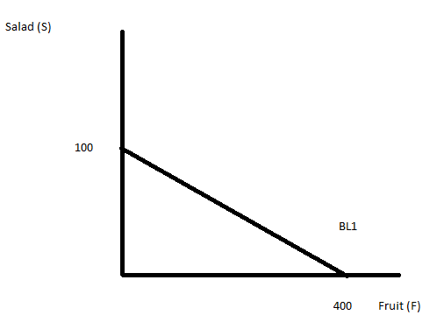

- (2 points) Given the above information, Chris chooses to consume 25 salads and 300 pieces of fruit (call this consumption bundle A). In your graph label this consumption bundle and make sure you identify the numeric values of both the y variable as well as the x variable.

Answer:
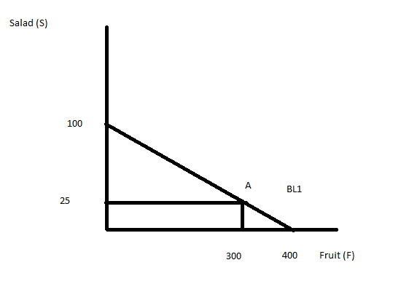
- (1 point) Suppose that the price of fruit increases to $2 per unit. Draw Chris’s new budget line, BL2, on the above graph and label all new intercepts for this budget line.

Answer:
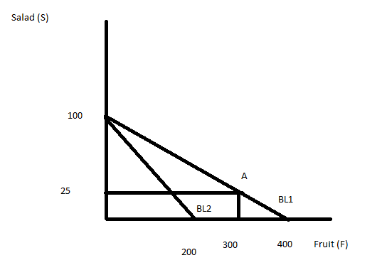
- (2 points) In the above graph draw a budget line, BL3, that is consistent with the new prices but allows Chris to achieve the same level of satisfaction as he did with BL1. In your graph include at least one indifference curve that illustrates this level of satisfaction.

Answer:
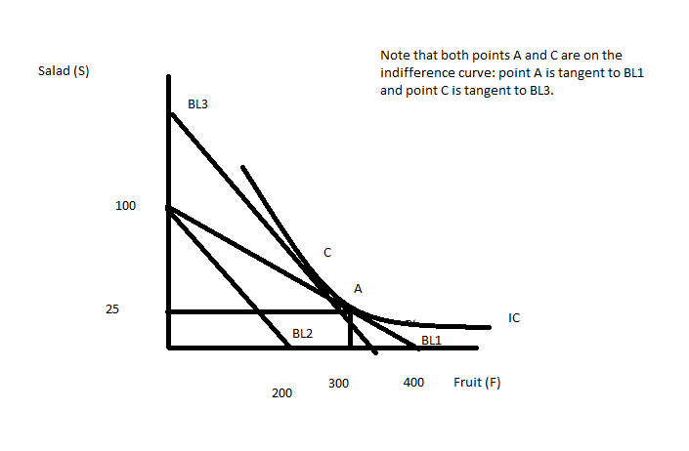
- (1 point) With regard to BL3, is the level of income implicit with this budget line greater than or less than the level of income implicit in BL2?

Answer:
The level of income implied for BL3 is greater than the level of income implied with BL2: both budget lines have the same slope and that implies that the ratio of the price of fruit to the price of salad has not changed but BL3 is further away from the origin. If two budget lines are parallel then the one further from the origin is based upon a higher level of income.

2. This question is about a perfectly competitive market.
a. (4 points) In the two graphs below depict long run equilibrium: in the left graph depict what long run equilibrium looks like for a representative firm in the perfectly competitive industry and in the right graph depict what long run equilibrium looks like in the market. In your graphs be sure to include market supply, market demand, MR, MC, ATC, the quantity the firm produces (q1), the quantity the market produces (Q1), the price the firm charges (P1), and the price the industry charges (P1). Be sure to label your graphs completely and carefully!!

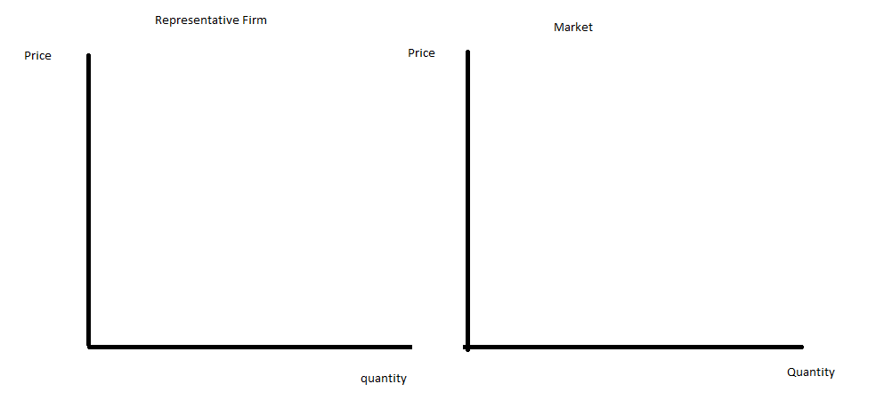
Answer:
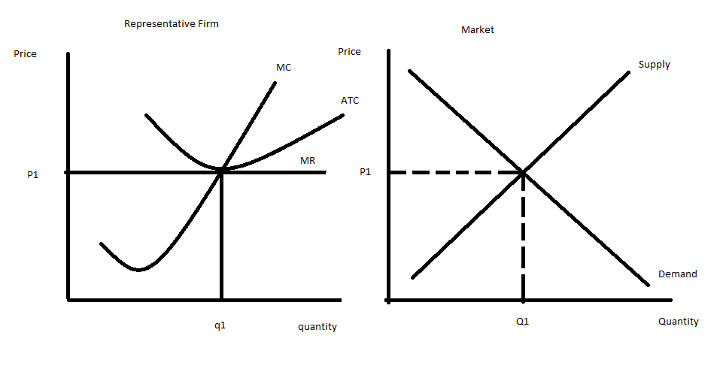
b. (4 points) In the two graphs below depict the same initial situation and then draw in what happens in the short-run if there is an increase in income and this good is an inferior good. Be sure to include market supply, market demand, MR, MC, ATC, the quantity the firm produces initially (q1), the quantity the firm produces in the short-run after this change (q2), the quantity the industry produces initially (Q1), the quantity the industry produces in the short-run after this change (Q2), the price the firm charges initially (P1), the price the firm charges in the short-run after this change (P2), the price the industry charges in the short-run after this change (P2), and the positive or negative economic profits the firm receives after this change. Be sure to label your graphs completely and carefully!! (If necessary for your answer assume that the market price is greater than or equal to the minimum point of the average variable cost curve.)

Answer:

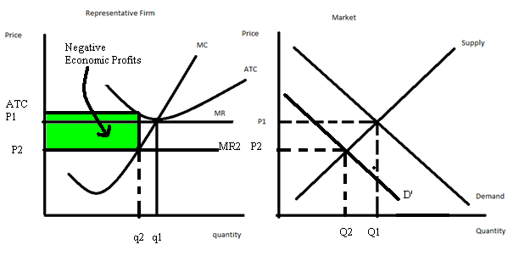
c. (2 points) Given the change described in (b) and holding everything else constant, what do you predict will happen to the following variables in the long run ?
i. In the long run, the quantity produced by the firm will ___not change_____________ relative to the initial level the firm produces.
ii. In the long run, the quantity produced by the industry will ___decrease________ relative to the initial market quantity.
iii. In the long run, the market price will ____not change___________ relative to the initial market price.

3. Use the following information about a monopolist to answer this next set of questions. Suppose there is a monopolist in a market where the market demand is given by the equation:
Market Demand: Q = 100 – (1/5)P
Furthermore you know that this monopolist’s marginal cost curve and its average total cost curve are given by the following equations:
MC = 150 + 4Q
ATC = 15 + 2Q + 10/Q

a. (2 points) In the graph below draw this firm’s MC curve, its MR curve, and the market demand curve. Provide numeric values for all intercepts. Label your graph carefully and completely.

Answer:

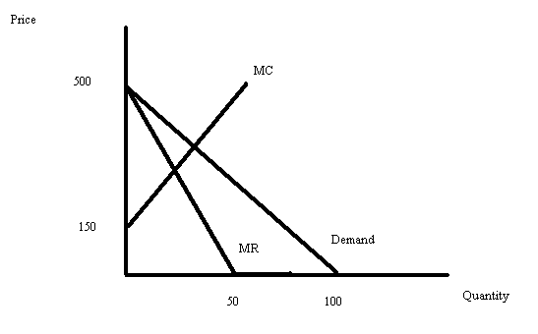
b. (2 points) Provide an equation for this firm’s MR curve in the space below.

Answer:
First you need to write the demand curve in slope intercept form: P = 400 – 5Q. Then, recall that the MR curve for a linear downward sloping demand curve has the same y-intercept as the demand curve and twice the slope. Hence, the MR curve can be written as MR = 500 – 10Q.

c. (2 points) Calculate the profit maximizing quantity and the profit maximizing price for this monopolist assuming that the monopolist only has one price for which it is willing to sell the good. In your answer be sure to identify your final answers clearly, but also provide a logical and easy to follow explanation of how you found these values.

Answer:
To find the profit maximizing quantity and price we need to equate MR to MC and find the quantity where these two curves intersect. Then we need to go to the demand curve to find the price associated with this quantity. Thus,
MR = MC
500 – 10Q = 150 + 4Q
350 = 14Q
Q = 25
P = 500 – 5Q
P = 500 – 5(25)
P = $375

d. (2 points) Calculate the value of this monopolist’s profits given the above information.

Answer:
Profit = TR – TC
Profit = (375)(25) – (15 + 2(25) + (10/25))(25)
Profit = $7740

Or, compare the price per unit ($375) to the average cost per unit ($65.40) to see that this monopolist earns a profit of $309.60 per unit it sells. Since the firm sells 25 units this means that its profit will be equal to ($309.60)(25) or $7740.

e. (2 points) In the graph below indicate the area that corresponds to the deadweight loss that occurs in this market because it is supplied by a monopolist rather than a perfectly competitive industry. In your answer be sure to identify all curves that you have drawn in the graph as well as the area that corresponds to the deadweight loss.

Answer:
