Economics 101
Spring 2021
Homework #4
Due 4/14/22

Production and Cost

1. Mike’s Widgets produces widgets and his production function for these widgets is given by the equation:

W = 2K^{.5}L^{.5}

where W is widgets, K is capital, and L is labor. Mike’s Widgets uses only capital and labor to produce the widgets. In the short run, Mike’s Widgets capital is equal to 4 units. Mike’s Widgets pays $10 per unit of capital and $20 per unit of labor. Use this information to answer this set of questions. Hint: you will find it helpful to use Excel to do this set of questions.

a. In the short run, what is the fixed cost associated with widget production?

b. For the short run, write an equation for Mike’s Widgets variable cost of widget production.

c. For the short run, write an equation for Mike’s Widgets total cost of production.

d. Complete the following table given the above information. All calculations should be rounded to two places past the decimal. (Hint: this is where you will want to start using Excel.)

L | K | W | MPL | VC | FC | TC | AVC | AFC | ATC | MC
0
1
4
9
16
25
36
49
64
81
100

2. Consider a production function for a firm:

Q = 2K^{1/2}L^{1/2}

where Q is output, K is capital, and L is labor. Suppose initially K is equal to 25 units and L is equal to 16 units. You also know that the price of K, Pk, is $10 per unit of K and the price of L, Pl, is $4 per unit of L.

a. Given the above information, what is the value of output?

b. What is the total cost of producing the output you calculated in (a)?

c. What is the average total cost of producing this level of output?

d. Suppose the amount of labor increases to 32 units and the amount of capital increases to 50 units. Given this information, what level of output can the firm now produce? (Hint: you can do this without a calculator – and, then you can check your answer with a calculator!)

e. Given the information in (d), what is the total cost for the firm of producing this level of output?

f. Given the information in (d) and (f), calculate the firm’s average total cost of producing this new level of output.

g. Given your answer to the above set of questions, what can you conclude about returns to scale for this firm?

3. Consider a production function for a firm:

Q = 2KL^{1/2}

where Q is output, K is capital, and L is labor. Suppose initially K is equal to 25 units and L is equal to 16 units. You also know that the price of K, Pk, is $10 per unit of K and the price of L, Pl, is $4 per unit of L.

a. Given the above information, what is the value of output?

b. What is the total cost of producing the output you calculated in (a)?

c. What is the average total cost of producing this level of output? Round your answer to the nearest hundredth.

d. Suppose the amount of labor increases to 32 units and the amount of capital increases to 50 units. Given this information, what level of output can the firm now produce? (Hint: you can do this without a calculator – and, then you can check your answer with a calculator!)

e. Given the information in (d), what is the total cost for the firm of producing this level of output?

f. Given the information in (d) and (f), calculate the firm’s average total cost of producing this new level of output.

g. Given your answer to the above set of questions, what can you conclude about returns to scale for this firm over the range of output you have considered?

Perfect Competition

4. Suppose a perfectly competitive firm has a total cost function that is equal to

TC = q² + 100q + 100

Furthermore, suppose you know that the firm’s marginal cost function is

MC = 2q + 100

From this information answer this set of questions.

a. At what quantity of output is average total cost minimized?

b. What is the value of marginal cost for the output you calculated in part (a)?

c. Suppose that the market demand curve in this market is given by the equation P = 240 – (12/10)Q where P is the price per unit and Q is the total amount of the good produced in the market. Suppose that this perfectly competitive industry is currently in long run equilibrium. How many firms are there in the industry?

d. Suppose that the good in this market is a normal good and that incomes increase. Furthermore suppose the change in income causes the quantity demanded in the market to change by 100 units at every price. Suppose the market supply curve is given by the equation P = (12/10)Q.

i. What will be the new short run price for the market?

ii. How many units of the good will a representative firm produce in the short run given this information?

iii. Calculate the short run profits for a representative firm.

iv. What do you predict will happen in the long run given your answer in part (iii)?

v. What will the long-run price be in this market?

vi. How many firms will there be in the industry in the long run once the market fully adjusts to this change in income?
5. Consider a perfectly competitive industry composed of ten identical firms. Suppose you are told that the representative firm has the following cost curves:

Total Cost: TC = 9 + 6q + q2
Marginal Cost: MC = 6 + 2q

Suppose you also know that the market demand curve is given by the following equation:

Market Demand: P = 20 – (1/2)Q

where Q represents market quantity and q represents firm quantity.
a. Given the above information write an equation for the market supply curve. Explain how you found this equation.

b. Given the market supply curve you found in (a), calculate the short run market equilibrium quantity and price in this market. How many units of output will the representative firm produce in the short run? Calculate the short-run profits for the representative firm. Explain your work.

c. Given your calculations in (b), will the representative firm produce in the short-run? Explain your answer.

d. Given your answer in (b), what do you predict will happen in the long-run in this industry?

e. Given no changes in the firm’s cost curves or the market demand curve, calculate the following and explain how you found your answers:

Long-run equilibrium market price = _________________________
Long-run equilibrium market quantity = _______________________
Level of production by the representative firm = ___________________
Approximate number of firms in industry in the long-run (this will not be a whole number) = _________________

Monopoly and Natural Monopoly

6. Consider a monopoly. Suppose you are told that the monopoly has the following cost curves:

Total Cost: TC = 9 + 6Q + Q2
Marginal Cost: MC = 6 + 2Q

Suppose you also know that the market demand curve is given by the following equation:

Market Demand: P = 18 – (1/2)Q
a. Given the above information, what is this monopolist’s equation for MR?

b. Determine the profit maximizing level of production for this monopolist as well as the price that will be charged for each unit of the good. Assume that this is a single price monopolist, i.e. the monopolist cannot engage in price discrimination. Explain how you found your answer.

c. Given the above information and your answer in (b) calculate the level of profit in the short-run for this monopolist. Explain how you found your answer.

d. Given your answer in (c), what do you predict will happen to this monopolist in the long-run?

e. Calculate the deadweight loss that results from this market being served by a monopolist. Show how you found your answer. Provide a graph that is well labeled to illustrate your answer.

7. Suppose Exxon Mobile purchased every gas company in the world and set their prices. Then, it would have a control of the gas market with no other competition. Thus, Exxon Mobile becomes a monopolist in providing gas. The market demand curve faced by Exxon Mobile is:

P = -Q + 40

and Exxon Mobile’s cost is given by the equation:

TC=Q² + 140

and the firm’s marginal cost is given by the equation:

MC=2Q

a. What is the equation for Exxon Mobile’s Marginal Revenue curve?

b. Draw the Demand Curve, Marginal Revenue Curve, Average Cost Curve and Marginal Cost Curve for this monopolist in a graph. Label your graph carefully and completely.

c. What is the monopolist’s profit-maximizing production quantity QM? What price will the monopolist charge P_{M}?

d. Compute the consumer surplus, producer surplus and profits for the monopolist.

Now, suppose there is a technological change for the monopolist, and its total cost is now given by TC = 20Q (no fixed cost), and its marginal cost is given by MC = 20.

e. What is the monopolist’s profit-maximizing production quantity Q_{M}? What price will the monopolist charge P_{M}? Show these values in a graph.

f. Suppose this market was a perfectly competitive market (i.e., the monopolist’s demand curve is still the market demand curve, but now there are many firms providing gas for the market). Given the market is perfectly competitive, what would be the equilibrium price (Ppc) and quantity (Qpc) in this competitive market?

g. Assume the technological change in the market is still true. What is the difference between the consumer surplus in the monopoly case and the consumer surplus in the perfect competition case?

h. What is the difference between the producer surplus in the monopoly case and the producer surplus in the perfect competition case?

i. What is the dead weight loss caused by the monopolist?

8. Suppose there is a market that provides electricity to a large metropolis. The graph below represents the market’s demand curve, the average total cost of providing electricity to the metropolis for a representative firm, and the marginal cost cure for the market.

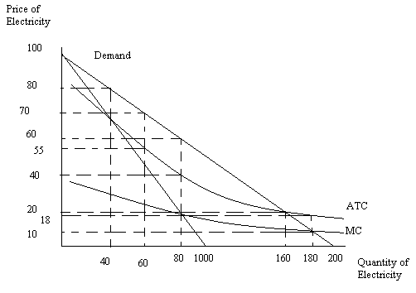

a. Suppose that we want this market to produce the socially optimal amount of the good. Furthermore, suppose we identify the socially optimal amount of the good as being that amount of the good where the price the consumer pays for the last unit of the good is exactly equal to the marginal cost of producing that last unit of the good. What is the socially optimal amount of the good?
b. Suppose that the socially optimal amount of the good identified in part (a) is produced. What is the cost of producing the good if the total amount is produced by a single firm?

c. Suppose that the socially optimal amount of the good identified in part (a) is produced. What is the total cost of producing this level of output if there are three equal size firms that divide up the market evenly and each produce 1/3 of the total amount provided.

d. Compare your answers in parts (b) and (c). Generalize your finding and why it is relevant.

9. Use the same graph that you used in problem 8 to answer this set of questions.

a. If this industry acts like a monopoly, what will be the equilibrium price and quantity in the market? What will be the level of profits?

b. Suppose this industry is regulated as a natural monopoly and the regulators set price so that the natural monopolist produces the socially optimal amount of output. What will be the price, quantity, and level of profits for the natural monopoly given this type of regulation? What must the natural monopoly receive from the government in order to be willing to produce the socially optimal amount of the good?

c. Suppose this industry is regulated as a natural monopoly and the regulators set price so that the natural monopolist breaks even. What will be the price, quantity, and level of profits for the natural monopolist given this type of regulation?

10. Consider a monopoly that produces widgets. Suppose you are told that the monopoly has the following cost curves where TC is total cost measured in dollars, Q is the quantity of widgets, and P is the price per widget in dollars:

Total Cost: TC = 25 + 6Q + Q2 Marginal Cost: MC = 6 + 2Q

Suppose you also know that the market demand curve is given by the following equation:
Market Demand: P = 50 – Q

- Given the above information, what is this monopolist’s equation for MR?
- Determine the profit maximizing level of production for this monopolist as well as the price that will be charged for each unit of the good. Assume that this is a single price monopolist, i.e. the monopolist cannot engage in price discrimination. Explain how you found your answer.

- Given the above information and your answer in (b) calculate the level of profit in the short- run for this monopolist. Explain how you found your answer.

- Given your answer in (c), what do you predict will happen to this monopolist in the long-run?

- Calculate the deadweight loss that results from this market being served by a monopolist. Show how you found your answer. Provide a graph that is well labeled to illustrate your answer.

11. Use the following graph of a natural monopolist to answer this next question. The graph depicts the market for a monopolist where LRATC is the long-run average total cost curve, MC is the marginal cost curve, and Demand is the market demand for the product.
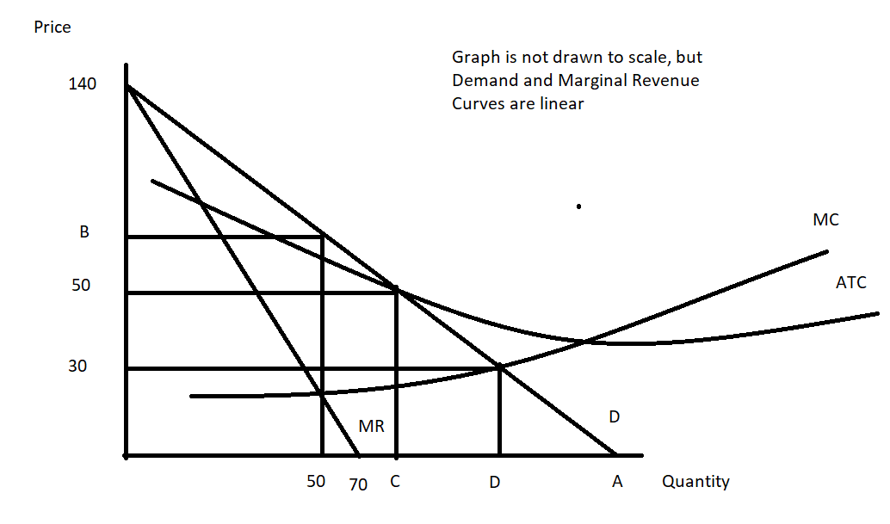

- Given the above information and the graph, write the equation for the market demand curve in slope intercept form. Explain how you found your answer. You will need to provide a numeric value for “A” in the above graph.

- Suppose that this monopolist is not regulated. Explain how this monopolist will determine its profit maximizing output and price. Assume that the monopolist is a single price monopolist. After explaining the process, identify the unregulated monopolist’s quantity and price.

- Will the monopolist described in (b) earn positive, negative, or zero economic profits? Explain your answer.

- Suppose that this monopolist is regulated with a MC pricing regulation. This insures that the monopolist produces the socially optimal amount of the good, but will require a subsidy for the producer since economic profits will be negative. From the graph and your prior work, identify (that is, provide a numeric value) the socially optimal amount of the good. Then amend the graph to show the amount of total subsidy this monopolist will need to receive if they are to produce the socially optimal amount of the good.

- Suppose that this monopolist is regulated with AC pricing regulation. This insures that the monopolist produces the level of output where its economic profit is equal to zero. From the graph and your prior work, identify (that is, provide a numeric value) of the quantity the monopolist will produce if it is regulated to produce that level of output where the monopolist breaks even. Amend the graph to provide this numeric value.

