Economics 101
Spring 2022
Homework #3
Due 3/31/2022

S&D: International Trade

1. Consider the market for space fuel on our planet Earth. Market demand and market supply curves for Earth residents are given by the following equations where P is the price per gallon of space fuel and Q is the quantity in millions of gallons of fuel:
Earth’s Market Demand: P = 80 - Q
Earth’s Market Supply: P = 20 + 2Q

a. Given the above information, find the equilibrium price and quantity in this market if the only producers and consumers are from Earth.

b. Calculate the value of consumer surplus and producer surplus. Show them on a well-labeled graph.

Suppose that humans now discover that we are not alone in the universe. This means that humans can now trade of the global interplanet market for space fuel and in this market the current price of one gallon of space fuel is $30.

c. Given the free trade in the interplanet market, find the quantity of space fuel that is sold by domestic producers and the quantity of space fuel that is imported from other planets. Calculate the new values of consumer surplus and producer surplus. Show them graphically in a well-labeled graph.

d. Suppose that leaders of the countries on Earth decide to protect domestic producers of space fuel by imposing a tariff of $20 on each gallon of imported space fuel. Find the quantity that is sold by domestic producers and the quantity that is imported from other planets given this tariff. Calculate the new values of consumer surplus and producer surplus with the tariff. Calculate the revenue the earth gets from the tariff, and the deadweight loss due to the implementation of this tariff. Show these areas in a well-labeled graph.
e. Suppose that due to the galactic energy crisis price of space fuel increases to $40 per gallon of space fuel. Earth leaders are still imposing the tariff of $20 per gallon of imported space fuel. Find the quantity that is sold by domestic producers and the quantity that is imported from other planets given this increase in the intergalactic price of space fuel and the tariff imposed by the earthlings. Calculate the new values of consumer surplus and producer surplus. Calculate the amount of tariff revenue the earth gets from implementing this tariff, and the deadweight loss due to the implementation of this tariff. Show all your results in a well-labeled graph.

f. Suppose that situation normalizes and the price for a gallon of space fuel returns to $30. During one of the Earth summits, the leader of country W suggests implementation of a per unit subsidy to domestic producers instead of a tariff that would result in the same value of producer surplus as in (d). What is the amount of this subsidy per gallon of space fuel? Calculate the total cost to Earth of this expenditures on this subsidy program.

2. Consider the market for chicken in Mexico. The domestic market demand and market supply curves are given by the following equations where P is the price in pesos per pound of chicken and Q is the quantity in millions of pounds of chicken:
Domestic Market Demand: P = 90 - 3Q
Domestic Market Supply: P = 10 + Q

a. Given the above information, find the equilibrium price and quantity in this market if this market is closed to international trade.

b. Calculate the value of consumer surplus and producer surplus. Show these areas in a well-labeled graph.

Suppose that now Mexico enters the international market of chicken, where a pound of chicken costs 15 pesos.

c. Given the free trade in the international market, find the quantity that is sold by domestic producers and the quantity that is imported or exported in the Mexican market for chicken. Calculate the new values of consumer surplus and producer surplus. Show them graphically.

d. Suppose that Mexican poultry farmers are unhappy with the results of opening this market to trade. They lobby for imposing an import quota equal to 8 million pounds of chicken. Find the market price, the quantity that is sold by domestic producers and the quantity that is imported given the implementation of this import quota. Calculate the new values of consumer surplus and producer surplus. Calculate the deadweight loss due to the implementation of this quota. Show them graphically.

e. Suppose that government does not like the idea of an import quota and decides to implement instead a tariff that results in the same producer surplus as an import quota of 8 million pounds of chicken. What is the amount of this tariff per pound? Find the quantity that is sold by domestic producers and the quantity that is imported when this proposed tariff is implemented. Calculate the new values of consumer surplus. Calculate tax revenue the government receives from implementing the tariff, and the deadweight loss due to the implementation of this tariff. Show these areas in a well-labeled graph.

f. Suppose that the government wants to receive the same amount of money that it receives from implementing the tariff in point (e) by selling the legal right to sell imported chicken to the foreigners who will import the chicken into Mexico. Suppose the Mexican government wants to sell the legal right to import chicken to 8 foreign producers. Suppose that the legal right allows each buyer of the legal right to sell 2 million pounds of foreign produced chicken in Mexico. Will foreign producers agree to buy this right?

Elasticity

3. Consider a demand curve given by the following equation where P is the price per unit and Q is the number of units of the good:

Demand: Q = 100 – (1/2)P

a. Suppose that the price this Goodis selling for initially is $180 per unit and then the price falls to $170 per unit. What is the price effect on total revenue of this change in price? What is the quantity effect on total revenue of this change in price? Explain your answer.

b. Given the information in (a), calculate the price elasticity of demand using the arc elasticity formula. Based on the value you found, is demand elastic or inelastic between these two prices?

c. Suppose that the price of the Goodis $80 per unit. Calculate the price elasticity of demand using the point elasticity formula. Show your work. Based on the value you found, is demand elastic or inelastic at this price?

4. Consider the following information: you know that the income elasticity for Tide, a laundry detergent, is 2 and that the cross price elasticity between Tide and All (another laundry detergent) is 1.5. Use this information to answer this set of questions.

a. Is Tide a normal or inferior good? Explain your answer.

b. Are Tide and All complements or substitutes? Explain your answer based on the information that is provided. Do NOT say that they must be substitutes since they are both laundry detergents.

c. Suppose that currently 200 units of Tide are being sold. You are told that in your community incomes rise by 20%. What will be the change in the number of units of Tide sold given this information and holding everything else constant? Show your work.

d. Suppose that currently 500 units of Tide are being sold. You are told that in your community the price of All decreases by 30%. What will be the change in the number of units of Tide sold given this information and holding everything else constant? Show your work.

5. Amy’s demand for cheesecakes is Q_{d} = 90 – 4P.
- At price P = 20, what is the price elasticity of demand? Hint: Use the point elasticity of demand formula to calculate this elasticity. ε_{p} = ___. Is it elastic or inelastic at price P = 20? ___ ___

b. Calculate the price elasticity as the price moves from P₀ = 20 to P₁ = 15 by using the mid-point price elasticity formula (hint: this is the same formula as the arc elasticity formula). ε_{p} = ___
c. Calculate the total revenue (TR) at P = 20 and P = 15 separately. When P = 20, TR = _____; when P = 15, TR = ____. Does the total revenue (TR) increase, decrease, or stay the same when the price decreases from P = 20 to P = 15? __ Use your calculation of the price elasticity of demand at these two different prices to explain the result in the change of total revenue.

d. At what price is the price elasticity of demand equal to 1? P = ___

e. Complete the table below based on Amy’s demand for cheesecakes which is Q_{d} = 90 – 4P.

P | Q_{d} | - ε_{p} | - TR (= P x Qd)
0 | 90 | 0 |  | 0
5
10
11.25
15
20
22.5

f. When the elasticity ε_{p} > 1: if the price increases, does the total revenue increase, decrease, or remain unchanged? When the elasticity ε_{p} < 1: if the price increases, does the total revenue increase, decrease, or remain unchanged? Explain your answer.

Consumer Theory

6. Use the graph below to answer the next TWO (2) questions.
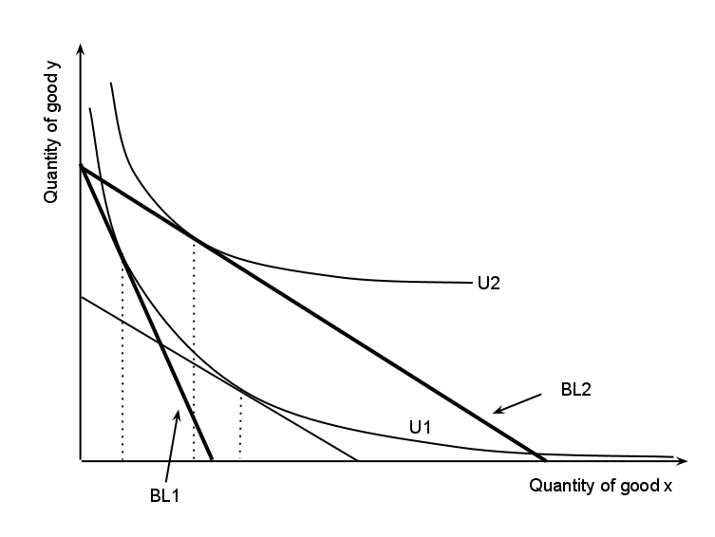

a. Suppose that BL1 is the initial budget line. Then, the budget line changes to budget line BL2. Explain what happened to cause this change in the budget line.

b. Suppose that BL1 is the initial budget line and that BL2 is the budget line after the price of Good X decreases. If we find the substitution effect given this information, we find that the consumption of Good X __(increases, decreases, or stays the same)___ due to the substitution effect. Explain your answer.

c. Given this diagram, is Good X or Good Y an inferior good? Explain your answer.

d. Given this diagram and the following question, select the right answer.

A price change has taken you from BL1 (budget line 1) to BL2 (budget line 2), which of the following is true:
- Your income and substitution effects for Good X are both positive.
- Your income and substitution effects for Good X are both negative.
- The income effect for Good X is positive, and the substitution effect for Good X is negative.
- The income effect for Good X is negative, and the substitution effect for Good X is positive.

7. Consider a consumer with the following information:

At the optimal consumption bundle this consumer consumes 3 boxes of apples and 3 boxes of oranges. If the Marginal Rate of Substitution of Apples for Oranges is 6 at the optimal consumption bundle (MRS_{AO} = 6), and the price of a box of Oranges is $1.80, what is the price of a box of Apples? Show how you found your answer.

8. Bob has $100 in income that he can spend on either Good X or Good Y. Good X costs $2 per unit while Good Y costs $4 per unit.

a. Given the above information, draw a graph of Bob’s budget line (call it BL1) and write an equation in slope-intercept form for Bob’s budget line measuring Good Y as the Goodon the vertical axis.

b. Given Bob’s income and the prices of these two goods and given Bob’s preferences he finds that he maximizes his satisfaction when he chooses to consume bundle A which consists of 30 units of Good X and 10 units of Good Y. Can Bob afford this bundle given his income and the prices of the two goods? Prove this mathematically. Does consumption of bundle A exhaust Bob’s available income?

c. Suppose that the price of Good X decreases to $1. Bob’s income and the price of Good Y stay constant. Bob now finds that he maximizes his satisfaction when he consumes consumption bundle B which consists of 56 units of Good X. Draw a graph that represents Bob’s BL1, his new budget line (BL2) and bundle A. Calculate how many units of Good Y Bob consumes when he consumes consumption bundle B (make sure you show how you found this answer). Mark bundle B in your graph.

d. Suppose that Bob was constrained to stay on his first indifference curve-the one that bundle A sits on- while paying the new price for Good X. We can construct this budget line 3 where Bob’s income has been compensated (in this case lowered) so that he can reach the indifference curve that bundle A is on, but he cannot reach a higher level of satisfaction. On budget line 3 Bob finds that he maximizes his satisfaction by consuming bundle C which consists of 36 units of Good X and 8 units of Good Y. Draw a graph that illustrates BL1, BL2, BL3, bundle A, bundle B, and bundle C. Sketch in indifference curve 1 and indifference curve 2 in your graph.

e. How much would Bob’s income have to be decreased by in order for him to have the same utility as he had initially but now face the lower price of Good X? You have all the necessary information at hand to calculate this decrease in income. Show how you found your answer.

f. What is the amount of the substitution effect for Good X given the above information? What is the amount of the income effect for Good X given the above information? Explain your answer.

9. Sabrina's utility from consuming cookies (C) and milk (M) is described by the following information:

Utility = 2CM
Marginal utility of cookies = MUc = 2M
Marginal utility of milk = MUm = 2C

Sabrina's income is initially equal to $100 and the price of cookies is $5 per unit and the price of milk is $10 per unit.

a. Given the above information, write an equation for Sabrina's budget line. Let's refer to this budget line as BL1. In your work, measure cookies on the horizontal axis and milk on the vertical axis.

b. Given the above information find the consumption bundle (C, M) that maximizes Sabrina's utility. Show all your work in finding this bundle and explain the steps you are taking to get to your answer.

c. Suppose that the price of cookies increases to $10 per unit. Given this information and holding everything else constant, what is Sabrina's new utility if she maximizes her utility? Show all your work in finding this answer and explain the steps you are taking to get to your answer.

d. The price of cookies is still $10 per unit. Identify the size of the income effect and the substitution effect for this individual when they move from BL1 to BL2. Explain all your work and how you arrived at your final answer.

