Econ 101
Spring 2022
Homework #1
Due:2/10/22

Math Review:

1. a. You are told that the initial relationship between X and Y can be described by the following equation where Y is the variable measured on the vertical axis and X is the variable measured on the horizontal axis:

Y = 150 – 3X

a. Suppose that for every X value the Y value increases by 50 units. Given this information and holding everything else constant, write the new equation for this relationship in slope-intercept form.

b. Return to the initial relationship between X and Y. Suppose you are now told that the quantity of X doubles at every value of Y, for all values of X greater than or equal to zero. This domain implies that we are only considering positive values of X. Given this information and holding everything else constant, write the new equation for this relationship in slope-intercept form for these positive values of X.

2. Imagine that you are studying how the number of rabbits and chipmunks evolved between 1950 and 2000 in Madison, Wisconsin. You have collected historical data and have summarized it in the following graph:

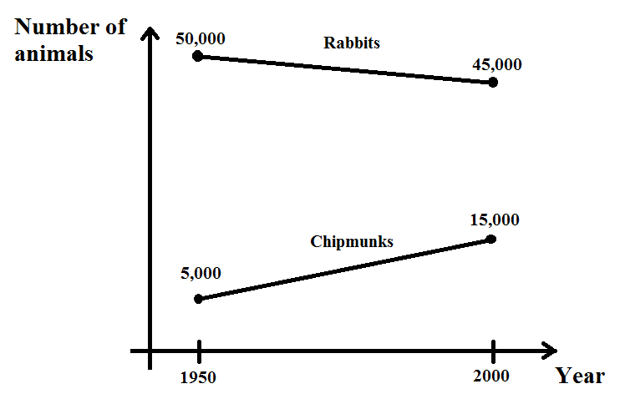

a) Find an expression for each species that helps you calculate the number of animals of each species between 1950 and 2000 as a function of the year. Use R as a symbol for rabbits, C as the symbol for chipmunks, and Y as the symbol for years. You will be finding two separate equations.

b) For which year was the population of rabbits approximately four times the population of chipmunks?

c) There is data that supports the hypothesis that the linear trends observed between 1950 and 2000 will continue in the future. By which year will both populations be approximately the same?

3. Consider the following equations of two straight lines

First Set of Equations: y = x/5 + 4 and 0.2y = 4 – x
Second Set of Equations: y = 7x + 1 and y = 7x + 2

Answer the following questions for each of the above 2 sets of equations. Start with the two equations given as the First Set of Equations and answer the next three questions; then, repeat for the two equations given in the Second Set of Equations.

a. What are the slopes, x-intercept and y-intercept of both lines for each set of equations?

b. For each set of equations, graph the two lines in a single graph measuring y on the vertical axis and x on the horizontal axis.

c. At which co-ordinate point (x, y) do the two straight lines intersect for each set of equations? [Hint: Be careful on this step when you are working with the equations given as the Second Set of Equations.]

Opportunity Costs and Production Possibility Frontiers:

4. Mary and Orson own farms on Central Wisconsin. Mary owns Farm 1 comprised of 20 acres of land, while Orson owns Farm 2 comprised of 30 acres of land. The type of soil in each farm is different. For each acre of land assigned to apple production, Mary harvests 5 apples per year while Orson harvests 8 apples per year. For each acre of land assigned to orange production, Mary harvests 10 oranges per year, while Orson harvests 9 oranges per year. Assume that Mary and Orson can produce either apples or oranges on any acre in any year.

a) Given the above information, what is the maximum amount of apples that Mary and Orson can harvest in a year? What is the maximum amount of oranges that Mary and Orson can harvest in a year?
b) Given the information above, what is Mary’s opportunity cost of harvesting one more apple? What is Orson’s opportunity cost of harvesting one additional apple? Who has the lowest opportunity cost of producing an additional apple?

c) Who has the absolute advantage in producing apples? Who has the absolute advantage in producing oranges?

d) Draw two separate graphs: on the first graph represent Mary's PPF and on the second represent Orson's PPF. In each graph, measure apples on the X-axis and oranges on the Y-axis.

e) Consider that Mary decides to sell all the land she owns to Orson. This sale doesn’t affect the previous levels of productivity of Mary’s farm. Draw the new PPF of Orson (“joint PPF”), considering that he now owns both farms. As before, graph in the X-axis the amount of apples and in the Y-axis the amount of oranges. Label clearly the coordinates for any “kink points”.

f) Orson has been hired to sell produce to Whole Foods Market. They have ordered Orson to harvest at least 100 apples and 350 oranges every year. Will Orson be able to satisfy this level of production?

g) (Challenging) Now consider that Orson can decide freely how many apples and oranges to harvest in both farms and that the sale price of apples and oranges is the same. If Orson wants to maximize the amount he earns, how many apples and oranges would he harvest? How would he divide the production of fruits between Farm 1 and Farm 2?

h) (Even more challenging) Return to the original setup where Orson owned only Farm 2. Draw the PPF of Orson if he now faces the following restriction: In order to start harvesting a particular type of fruit, he needs to install a special watering device that occupies 5 acres of land (no fruit will grow on the land devoted to this water device) and that is specific to the type of tree planted. In this sense, Orson could plant both types of trees at his farm, but then he would need to install two different watering devices (and he would lose 10 acres of land).

5. Annika and Bertrand are in two rival clubs baking brownies (B) and cupcakes (C) for a bake sale. They can each devote 9 hours a day to baking. Annika can bake 9 brownies every hour or 24 cupcakes every 1.5 hours. Bertrand can bake 16 brownies every hour or 12 cupcakes every hour.

- With brownies on the vertical axis and cupcakes on the horizontal axis, plot the production possibility frontiers for Annika and Bertrand on two separate graphs, and provide an equation for each of these graphs. Make sure your graphs are completely and clearly labeled.
- What is the opportunity cost of 1 cupcake for Annika and Bertrand, in terms of the number of brownies? What about the opportunity cost of 1 brownie in terms of the number of cupcakes?

- Who has the absolute advantage in the production of each good? Who has the comparative advantage in the production of each good?

- Suppose that Annika and Bertrand want to trade brownies and cupcakes before the bake sale. In terms of cupcakes, what is the range of possible trading prices for 1 brownie in terms of cupcakes? In terms of brownies, what is the range of possible trading prices for 1 cupcake?

- Plot and give an expression for the joint PPF of Annika and Bertrand.

6. Megan makes casseroles (C, where C is measured as dozens of casseroles) and pies (P). She has a total of forty hours each week that she can devote to the production of these two items. The following table provides you with information about Megan’s ability to produce these casseroles and pies.

Number of Hours Needed to Make a Dozen Casseroles | ½ Hour
Number of Hours Needed to Make a Pie | 1 Hour

a. Given the above information draw Megan’s production possibility frontier (PPF) for casseroles (measured in dozens) and pies per week. Measure Casseroles on the x axis and Pies of the y axis. In your graph label all intercepts.

b. Write an equation for Megan’s PPF in slope intercept form.

c. For each of the following coordinate pairs of (Dozens of Casseroles, Pies) determine whether the point sits on Megan’s PPF, lies beyond Megan’s PPF, or lies inside Megan’s PPF.

Coordinates for each point: (Dozens of Casseroles, Pies) | Where Point Lies with respect to Megan’s PPF
(60, 12)
(50, 14)
(48, 18)
(12, 37)
(20, 30)

d. In the table below provide the missing values based on the above information.

Coordinates for each point: (Casseroles, Pies) | Where Point Lies with respect to Megan’s PPF
(48, y) | Beyond the PPF
(15, z) | On the PPF
(4, w) | Inside the PPF
(a, 35) | On the PPF
(d, 19) | On the PPF

e. What is Megan’s opportunity cost of producing 1 pie? What is Megan’s opportunity cost of producing 10 pies? What is Megan’s opportunity cost of producing 6 dozen casseroles?

f. Suppose that Megan gets additional casserole pans and she now finds that she can make 2 dozen casseroles in ½ hour. Nothing else changes in this problem. What is Megan’s opportunity cost of producing one dozen casseroles now? What is Megan’s opportunity cost of producing one pie now?

Supply and Demand:

7. For each of the following scenarios describe whether the demand curve and/or the supply curve shifts as well as the direction of the shift(s). Assume that each market is initially in equilibrium and that each market adjusts to the scenario to find its new equilibrium.

Scenario | Which Curve(s) Shift? | What is the direction of the shift(s)? Describe the shift as a shift to the left or a shift to the right
In the market for new cars a hailstorm damages all the new cars in Iowa. The damage is so bad that none of these cars can be sold.
In the market for pizza researchers determine that pizza consumption is positively correlated with academic success.
In the market for cellphones a new phone is developed with a wider range of popular applications.
There is an economic boom and you are asked to evaluate the impact of this economic boom on the market for generic cereals.
The government decides to subsidize corn production. You are asked to evaluate the impact of this subsidy on the market for biofuels made from corn.

