Economics 101
Spring 2020
Homework #1
Due Thursday, 2/6/20

Directions: The homework will be collected in boxes marked with your TA name before the lecture. Please place your name, TA name and section number on top of the homework (legibly). Make sure you write your name as it appears on your ID so that you can receive the correct grade. Late homework will not be accepted so make plans ahead of time. Please show your work. Good luck!
Please realize that you are essentially creating “your brand” when you submit this homework. Do you want your homework to convey that you are competent, careful, professional? Or, do you want to convey the image that you are careless, sloppy, and less than professional. For the rest of your life you will be creating your brand: please think about what you are saying about yourself when you do any work for someone else!

1. a. Suppose you know that the two points (X, Y) = (12, 6) and (15, 2) sit on the same line. From this information write an equation for this line in slope-intercept form.

b. Suppose that you know that the slope of the line is 8 and that this line also contains the point (15, 25). What is the y-intercept for this line? Show your work.

c. You are given the following two equations:
Y = 2X + 100
Y = 76 – 10X
Find the solution (X, Y) for where these two equations intersect. Show your work.

d. Suppose that you know that the relationship between X and Y, where X is the variable measured on the horizontal axis, can be described by the following equation:
X = 30 – 2Y for all values of X ≥ 0
You are then told that for every Y value the X value has now increased by 5 units. Write the equation in slope-intercept form for this new line. Show your work. Hint: you might find it helpful to draw a "sketch" illustrating these two lines before you start doing your calculations.

e. Suppose that you know that the relationship between X and Y, where X is the variable measured on the horizontal axis, can be described by the following equation:
Y = 5 + 2X for all values of X ≥ 0
You are then told that for every X value the Y value has now decreased by 20 units. Write the equation in slope-intercept form for this new line. Show your work. Hint: you might find it helpful to draw a "sketch" illustrating these two lines before you start doing your calculations.

2. More math review:

a. Consider Sarah, a student in your Economics 101 class. Sarah wants to make sure she understands how her grade will be calculated in the class. She knows that there is something called a weighted final grade and it is the number associated with this weighted final grade that will determine Sarah’s relative position in the class. She estimates that she will need a weighted final grade of 82 to earn an AB in the class (this is her best guess since she does not know how well the rest of the class will perform in the class). In your answer round to the nearest whole number for that final exam grade: but, do not round until you get to the end of your calculations!

Using the syllabus as a guide (the weights for each assignment are given there), she calculates her weighted final grade based upon the following data:

Quiz scores (she takes all 10 quizzes and knows that her two lowest scores will not be included in her grade calculation) where each quiz is graded on a 100 point scale: 100, 70, 90, 60, 90, 90, 50, 70, 80, 80

Homework scores (she submits all five homeworks): she receives the maximum score of 2 points on each homework

Midterm One: 90 out of 100 points

Midterm Two: 70 out of 100 points

Final Exam: she wants to figure out what this score must be on a 100 point scale in order for her to have a weighted final grade of 82 for the class

Given the above information and holding everything else constant, what score must Sarah get on the final exam to have a weighted final grade of 82? Show your work.

b. Consider Sarah, the same student we just worked with in (a). Sarah, had great intentions with regard to her academic work when the semester started, but then stuff happened. Sarah didn’t feel well and she missed two quizzes due to not feeling well (students do get sick in the semester!). Sarah also had an opportunity to take a field trip with a student organization that she felt would be beneficial: this was not a required trip but when Sarah went on the trip it meant that she missed an additional quiz. Sarah also missed a fourth quiz due to her decision to have coffee with a friend one day rather than attend discussion section. Sarah also managed to turn in only three of the five homeworks. So, here is the information confronting Sarah now!

Quiz scores (she takes all 6 quizzes and knows that her two lowest scores will not be “dropped” and furthermore her quiz score is the average of eight quizzes!) where each quiz is graded on a 100 point scale: 100, 70, 60, 90, 90, 80

Homework scores (she submitted just three homeworks): she receives the maximum score of 2 points on each homework that she submitted

Midterm One: 90 out of 100 points

Midterm Two: 70 out of 100 points

Final Exam: she wants to figure out what this score must be on a 100 point scale in order for her to have a weighted final grade of 82 for the class

Given the above information and holding everything else constant, what score must Sarah get on the final exam to have a weighted final grade of 82? Show your work.

3. Consider the production possibility frontier that is given in the diagram. This PPF illustrates the production possibilities for Smallia, a country that produces just Cookies (C) and Pencils (P). Assume that this PPF is linear over each of the provided segments in the diagram (so the PPF is linear from point A to point B, from point B to point C, ….). Use this diagram and your calculations to answer this set of questions.

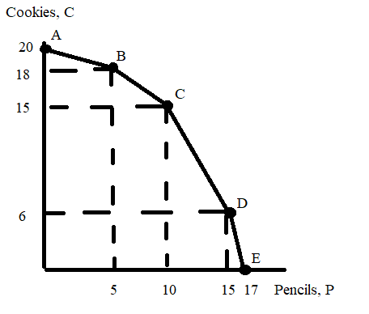

a. Smallia is currently producing in the linear segment between point A and point B. Suppose Smallia decides to produce ½ more pencil (assume they will still be producing between point A and point B). What is the opportunity cost of this decision is? Explain your answer.

b. Smallia is currently producing in the linear segment between point B and point C. For each of the following combinations determine if Smallia can produce this combination. For your answer you should identify whether the combination is on Smallia’s PPF, inside Smallia’s PPF, or beyond Smallia’s PPF.
i. Combination (P, C) = (6, 82/5)
ii. Combination (P, C) = (7, 91/5)
iii. Combination (P, C) = (42/5, 16)

c. Write an equation for the PPF between point C and point D. Show your work.

d. What is the opportunity cost of producing one more cookie if Smallia is currently producing 10 cookies?

4. The graph below depicts the production possibility frontier for a small economy that produces only buckets (B) and ladders (L). This PPF is linear between any two adjacent points on the PPF: e.g., the PPF is linear between points A and B, between points B and C, and between points C and D….
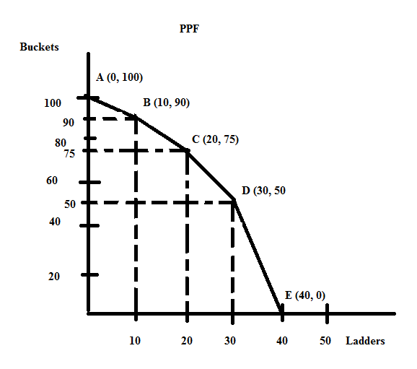

a. Suppose this economy is currently producing at point B. What is the opportunity cost of producing one additional bucket given this information? Explain your answer. Make sure your answer provides the units of measurement.

b. Suppose that this economy is currently producing at point B. What is the opportunity cost of producing one additional ladder given this information? Explain your answer. Make sure your answer provides the units of measurement.

c. Suppose this economy is currently producing at point C. What is the opportunity cost of producing one additional bucket given this information? Explain your answer. Make sure your answer provides the units of measurement.

d. Suppose this economy is currently producing at point C. What is the opportunity cost of producing one additional ladder given this information? Explain your answer. Make sure your answer provides the units of measurement.

e. Suppose this economy is currently producing at point D. What is the opportunity cost of producing one additional bucket given this information? Explain your answer. Make sure your answer provides the units of measurement.

f. Suppose this economy is currently producing at point D. What is the opportunity cost of producing one additional ladder given this information? Explain your answer. Make sure your answer provides the units of measurement.

g. Given the above PPF, write the equation(s) for each segment of the PPF. Identify the relevant range or domain for each equation. Show your work and how you found these equations.

5. Suppose that there are three countries that produce pretzels (P) and jam (J): Westfield, Southside, and Northmont. The maximum amount of pretzels and jam each country can produce if they only produce that one good is given in the table below. Use this information to answer this set of questions. Assume that each of the three countries have constant opportunity costs with respect to the production of pretzels and jam: that is, each country has a linear production possibility frontier.

Country | Maximum Amount of Pretzels Production Possible | Maximum Amount of Jam Production Possible
Westfield | 20 units of pretzels | 20 units of jam
Southside | 10 units of pretzels | 10 units of jam
Northmont | 10 units of pretzels | 20 units of jam

a. Given the above information, what is Northmont's opportunity cost of producing one more unit of pretzels?

b. Given the above information, what is Southside's opportunity cost of producing one more unit of jam?

c. Given the above information, rank these three countries in order of their comparative advantage in the production of pretzels. List the order from the country with the greatest comparative advantage to the country with the least comparative advantage.

d. Given the above information, rank these three countries in order of their comparative advantage in the production of jam. List the order from the country with the greatest comparative advantage to the country with the least comparative advantage.

e. Construct the joint PPF for these three countries if they specialize according to comparative advantage. For this joint PPF measure pretzels on the vertical axis and jam on the horizontal axis. After constructing this joint PPF, provide the coordinates of any intercept or "kink point" in your diagram. Then write the equation for each segment of the joint PPF and provide a range or domain for each segment.

f. Consider each of the production combinations given in the table below and decide whether this production combination is possible if these three countries specialize according to comparative advantage and then trade with one another. Enter your answer as a "Yes, this combination lies on the joint PPF", "Yes, this combination lies inside the joint PPF" or "No, this combination lies outside the joint PPF" in the provided column.

Combination | Amount of Units of Pretzels in Combination | Amount of Units of Jam in Combination | Is this Combination a Possible Production Combination for these Three Countries?
A | 36 | 9
B | 32 | 14
C | 20 | 38
D | 15 | 34
E | 2 | 48

6. Marcy and Eddie produce wagons (W) and dryers (D). The table below provides information about how many hours of labor they need individually to produce a wagon or a dryer. Assume that they only need labor to produce these two goods and assume that both Marcy and Eddie have linear PPFs.

 | Number of Hours of Labor Needed to Produce One Wagon | Number of Hours of Labor Needed to Produce One Dryer
Marcy | 3 hours of labor | 1 hour of labor
Eddie | 4 hours of labor | 6 hours of labor

a. Suppose that Marcy and Eddie each have 36 hours a week that they can devote to producing wagons and dryers. In two separate graphs draw Marcy's and Eddie's production possibility frontiers: label each graph clearly and completely. In your graphs, measure dryers on the vertical axis and wagons on the horizontal axis.

b. Given the above information, who has the comparative advantage in the production of dryers? Explain your answer.

c. Given the above information, who has the comparative advantage in the production of wagons? Explain your answer.

d. Given the above information, fill in the following table:

 | Opportunity Cost of Producing One More Wagon | Opportunity Cost of Producing One More Dryer
Marcy
Eddie

e. Based upon Marcy and Eddie each having 36 hours of labor available per week, construct the joint PPF for these two individuals if they decide to specialize and trade with one another. In your graph measure dryers on the vertical axis and wagons on the horizontal axis. Make sure that the coordinates of all kink points are identified.

f. Given the joint PPF you constructed in (c), write the equation(s) for each segment of this joint PPF. Make sure you identify either the relevant range or domain for any equation you provide.

g. Using the number line approach discussed in class show the range of acceptable trading prices for 5 wagons if Marcy and Eddie specialize according to comparative advantage and then trade with one another.

