Economics 101 Name ____________________________________________
Summer 2012
Answers to Quiz #2
6/5/12

Please answer all questions neatly and legibly. Your TA will not want to spend her time hunting for your answers or trying to decipher difficult handwriting.

1. (Five points) The graph below depicts the initial situation in the market for peanuts.

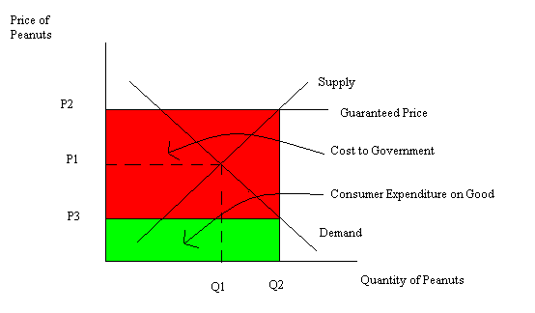
Suppose the legislature passes an agricultural price guarantee program for the peanut market where the government promises peanut farmers they will receive a price of P2 per unit of peanuts where P2 is greater than P1. The government will provide a subsidy per unit of peanuts to insure that the final price peanut farmers receive for their product totals P2. The peanut farmers are told to produce the quantity they wish to produce given this guaranteed price, then they are to sell it at whatever price they can (P3), and then the government will pay a subsidy of (P2 – P3) on each unit that has been produced. On the above graph:
a. Draw in a line representing the “Price Guarantee” and label this line accordingly. Also label P2 on your graph.
b. Indicate on your graph the total quantity of the peanuts, Q2, the farmers will produce given this program.
c. On your graph indicate the price that consumers will pay, P3, when they purchase these peanuts.
d. On your graph indicate the area that represents the direct expenditures on peanuts by consumers.
e. On your graph indicate the area that represents the cost to the government of this subsidy program.

2. (Five points) The domestic demand and supply curves for good X in a small closed economy are given below.
Domestic Demand: P = 100 – 2Q
Domestic Supply: P = 20 + 2Q
The world price for this good is $40. For each answer show your work to get full credit.

a. What is the value of consumer surplus (CS) in this closed economy?

Answer:
To find the value of CS you must first identify the equilibrium price and quantity in this market when the market is closed to trade. So 100 – 2Q = 20 + 2Q or 80 = 4Q. That is, Q = 20. When Q = 20, then P = 100 – 2(20) = $60 or P = 20 + 2(20) = $60. CS in this closed economy equals (1/2)($100 per unit - $60 per unit)(20 units) or $400. See first figure below.

b. What is the value of total surplus (TS) in this closed economy?

Answer:
The value of total surplus in this closed economy equals (1/2)($100 per unit - $20 per unit)(20 units) = $800. See first figure below.

c. This market opens to trade. How many units of good X will be imported or exported into this small open economy?

Answer:
The world price of the good is $40. When this economy opens this market to trade, the quantity demanded domestically at a price of $40 will equal 30 units and the quantity supplied domestically at a price of $40 will equal 10 units. The difference between the quantity demanded domestically and the quantity supplied domestically at $40 per unit will be the level of imports: in this case, imports equal 20 units. See second figure below.

d. What is the value of total surplus with trade (TStrade) for this small open economy?

Answer:
Total surplus for this economy in this market when it is open to trade will equal the sum of CS with trade plus PS with trade. CS with trade = (1/2)($100 per unit - $40 per unit)(30 units) = $900. PS with trade = (1/2)(($40 per unit - $20 per unit)(10 units) = $100. TS with trade is therefore equal to $900 + $100 or $1000. See second figure below.

e. Suppose a quota of 10 units is imposed by this economy’s government on this market. What will the price of good X be given this information?

Answer:
When a quota of 10 units is imposed by this economy’s government in this market we have that the quantity of the good supplied domestically plus the quota is equal to the quantity of the good demanded domestically. Thus, Qs + quota = Qd where Qs is the quantity supplied domestically and Qd is the quantity demanded domestically. We can rewrite the demand equation as Qd = 50 – (1/2)P and we can rewrite the supply equation as Qs = (1/2)P – 10. Using these two equations we can rewrite Qs + Quota = Qd as
(1/2)P – 10 + 10 = 50 – (1/2)P
(1/2)P = 50 – (1/2)P
P = 50
With a quota of 10 imported units, the price of the good in this small open economy with a quota will be $50 per unit.

