Econ 101 Name _________________________________
Summer 2013
Answers to Quiz #1

Please write all answers neatly and legibly.

1. Answer the following set of questions based on the following information. Country A and Country B produce bread and jam and they each have linear production possibility frontiers. If Country A produces only bread it can produce a maximum of 200 loaves per week and if Country A produces only jam it can produce a maximum of 100 jars of jam per week. If Country B produces only bread it can produce a maximum of 400 loaves per week and if Country B produces only jam it can produce a maximum of 120 jars of jam per week.
a. (2 points) Given the above information write an equation for Country A’s production possibility frontier in slope intercept form where bread (B) is measured on the vertical axis and jam (J) is measured on the horizontal axis.

Answer:
B = 200 – 2J

b. (2 points) Given the above information, which country has the comparative advantage in the production of jam? Explain your answer.

Answer:
For Country A the opportunity cost of producing 1 jar of jam is 2 loaves of bread and for Country B the opportunity cost of producing 1 jar of jam is 10/3 loaves of bread. Country A’s opportunity cost of producing jam is lower than Country B’s opportunity cost of producing jam. Country A has the comparative advantage in producing jam.

c. (2 points) In the space below draw the joint production possibility frontier for Country A and Country B measuring bread on the vertical axis and jam on the horizontal axis. Make sure all intercepts, all “kink” points, and all axis are labeled.

Answer:
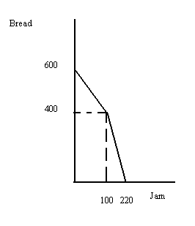

d. (2 points) If these two countries decide to specialize according to comparative advantage and then trade with one another what will be the range of trading prices that 100 loaves of bread will trade between?

Answer:
1 loaf of bread will trade between 3/10 jar of jam and ½ jar of jam. So, 100 loaves of bread will trade between 30 jars of jam and 50 jars of jam.

e. (2 points) Given the above information, if Country A uses only labor to produce bread and jam and Country A has a total of only 50 hours of labor available each week for bread and jam production, how many hours of labor does it take Country A to produce one loaf of bread?

Answer:
If all of Country A’s labor is devoted to producing bread, Country A can produce 200 loaves of bread. This implies that Country A can produce 4 loaves of bread with one hour of labor. Therefore Country A can produce 1 loaf of bread with 15 minutes of labor.

