Economics 101
Summer 2013
Answers to Homework #5
Due Wednesday, June 19, 2013

Directions: The homework will be collected in a box before the lecture. Please place your name, TA name and section number on top of the homework (legibly). Make sure you write your name as it appears on your ID so that you can receive the correct grade. Late homework will not be accepted so make plans ahead of time. Please show your work. Good luck!

Please realize that you are essentially creating “your brand” when you submit this homework. Do you want your homework to convey that you are competent, careful, professional? Or, do you want to convey the image that you are careless, sloppy, and less than professional. For the rest of your life you will be creating your brand: please think about what you are saying about yourself when you do any work for someone else!

1. Suppose there are two companies, Quality Products and Perfection Performed, in a market that compete with one another. Both firms are trying to decide independently of one another whether they should engage in an advertising campaign or not. If Quality Products advertises while Perfection Performed does not advertise, Quality Products will earn profits of $1000 while Perfection Performed will earn profits of $0. If Quality Products advertises and Perfection Performed also advertises, each firm will earn $500 in profits. The payoffs for advertising or not advertising for Perfection Performed are symmetric to those facing Quality Products. Finally you know that when both firms decide not to advertise they each earn $700 in profits. Use this information to complete the payoff matrix below.
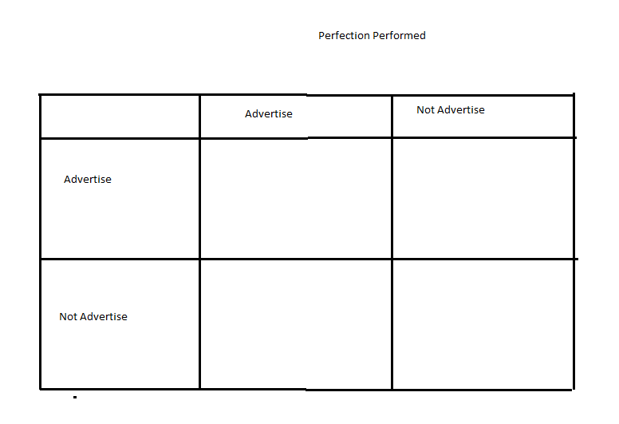
a. Complete the above matrix given the information provided in this question.
b. If Perfection Performed and Quality Products cooperate with one another, which choice of strategy for each firm will result in the greatest joint profits?
c. What is the dominant strategy for Quality Products?
d. What is the dominant strategy for Perfection Performed?
e. What do you predict will be the outcome of this “game” given the above information? What will the value of joint profits be given this predicted outcome?

Answer:
a.
b. If they cooperate with one another, the best outcome is for both firms to “Not Advertise” and their total joint profits will equal $1400.
c. The dominant strategy for Quality Products, no matter whether Perfection Performed advertises or not advertises, is to advertise.
d. The dominant strategy for Perfection Performed, no matter whether Quality Products advertises or not advertises, is to advertise.
e. Both firms will engage in their dominant strategy and they will both advertise. This will result in joint profits of $1000 which is less than what they could earn if they chose to cooperate with one another and not engage in advertising.
2. Consider the market for gasoline in the country of Good Will. The market for gasoline in this country is currently described by the following demand and supply equations:
Demand: Q = 50,000 – 5000P
Supply: Q = 20,000P
where P is the price per gallon of gasoline and Q is gallons of gasoline. Although the good citizens of Good Will are aware that consuming gasoline creates externality costs on their society the current gasoline market does not incorporate any of these externalities.
a. Describe at least four possible externality costs associated with the consumption of gasoline.
b. Given the externality costs you delineated in (a), where do you think the marginal social cost of gasoline curve is relative to the given supply curve? That is, are the two curves the same, is the marginal social cost of gasoline curve to the right of the market supply curve, or is the marginal social cost of gasoline curve to the left of the market supply curve?
c. Given the above information, what is the current market equilibrium quantity and price?
d. Suppose that the government analyzes the externality costs in this market and concludes that the market should ideally result in 20,000 gallons of gasoline being consumed if all the externalities associated with gasoline consumption were internalized in the market. Assuming the externality costs are per unit of usage of gasoline and are constant, what is the externality cost per gallon of gasoline consumed?
e. Suppose the government elects to impose a tax to internalize the externality. How big an excise tax would the government need to impose in order to address the externality that you measured in (d)?

Answer:
a. The answers will vary here, but here is at least a starting list of things you might have thought of: congestion costs, the over construction of highways and the resultant allocation of resources to highway construction rather than some other use, air pollution, particulate pollution, costs associated with health issues of those with respiratory illnesses, cost of military expenditures to secure low price gasoline, road rage, externality costs of accidents, etc.
b. The marginal social cost of gasoline includes many costs that are currently not included in the market supply curve. This implies that the marginal social cost of gasoline curve will be located to the left of the market supply curve.
c. To find the current equilibrium price and equilibrium quantity use the given demand and supply curves: thus, 50,000 – 5000P = 20,000P or P = $2 per gallon of gasoline. Q = 50,000 – 5000(2) = 40,000 gallons of gasoline.
d. If the market should ideally result in the consumption of 20,000 gallons of gasoline we can use this information to compute the externality cost per gallon of gasoline. Using the supply equation we find that producers are willing to supply 20,000 gallons of gasoline for a price of $1 per gallon. Using the demand equation we find that demanders are willing to demand 20,000 gallons of gasoline for a price of $6 per gallon. The externality cost per gallon of gasoline is therefore $5 per gallon.
e. If the government imposed an excise tax of $5 per gallon of gasoline this would cause the market supply curve to shift to the left by the amount of the externality cost per gallon of gasoline. The market with this tax would then provide the socially optimal amount of the good: 20,000 gallons of gasoline sold for a price of $6 per gallon.

3. Marty and Palmer are the only residents in their community. They are currently trying to decide how many streetlights should be installed in their community. Marty and Palmer both recognize that streetlights once they are installed are non-rival: that is, once the streetlight is installed and lit, everyone can enjoy consuming the benefits of the streetlight without affecting the level of consumption benefits available to other individuals in the community. They also recognize that streetlights are non-exclusive: that is, streetlights are apt to be under demanded as each individual in the community realizes that even if they do not pay for the streetlight they will still be able to enjoy consuming the benefits from the streetlight once it is installed and lit. Marty and Palmer have both decided to not free ride and take advantage of the non-exclusivity of the streetlight: they each are willing to fully reveal their willingness to pay for streetlights. Marty and Palmer’s demands for streetlights are given in the equations below where Q is the quantity of streetlights and P is the amount per streetlight they are willing to pay.
Marty’s Demand for Streetlights: P = 10 – (1/2)Q
Palmer’s Demand for Streetlights: P = 10 – Q
You also know that the MC of providing an additional streetlight is $4 per streetlight. Assume that this MC curve reflects the marginal social cost of providing streetlights.

a. In a diagram with the graphs vertically “stacked” on top of one another draw three graphs: in the top graph draw Marty’s demand curve, in the middle graph draw Palmer’s demand curve, and in the bottom graph draw the market demand curve for streetlights. Remember that these streetlights are public goods: this implies that you will need to vertically sum the individual demand curves to get the market demand curve. That is, select a quantity and ask how much Marty and Palmer will each pay to install this amount of streetlights-remember that the streetlights are non-rival so the critical thing here is that each of these individuals will contribute together for the purchase of this quantity of streetlights since they can both consume the benefits from this level of streetlights simultaneously.

b. In your graph draw in the MC curve for streetlights.

c. Mark the socially optimum amount of streetlights on your graph. Then determine how much Marty will pay per streetlight and how much Palmer will pay per streetlight.

Now, suppose that the MC of providing a streetlight increases and is now $8 per streetlight.

d. Given this new MC of providing a streetlight, what is the socially optimum amount of streetlights? How much will Marty pay per streetlight and how much will Palmer pay per streetlight?

Answer:

a. and b.

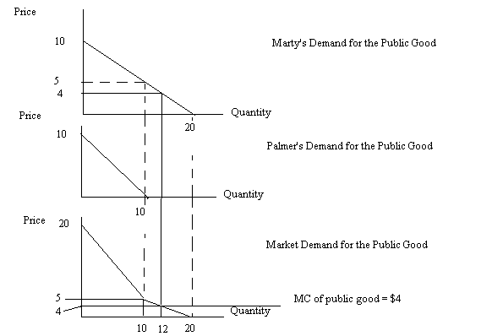
c. The socially optimum amount of streetlights is where the market demand curve intersects the MC curve. This occurs in the third graph at (Q, P) = (12, $4) so the optimal amount of streetlights for this community is 12 streetlights. The cost per streetlight is $4 and Marty will pay all of this. From Palmer’s perspective he is not willing to pay for so many streetlights: his demand for streetlights occurs for quantities less than or equal to 10 streetlights.

d. If the MC of streetlights increases to $8 this shifts the MC curve upward in the graphs. The optimal amount of streetlights will be where this new MC curve intersects the market demand curve. This will occur at a quantity of 8 streetlights. Marty will pay $6 per streetlight to get this quantity and Palmer will pay $2 per streetlight to get this quantity: together they will contribute $8 per streetlight.

To find this quantity you will need to know the equation for the market demand curve segment where the new MC intersects the demand curve. The equation for the market demand curve segment we are interested in is P = 20 – (3/2)Q. Set this demand curve equal to the MC curve to find the socially optimal amount of the good. Thus, 8 = 20 – (3/2)Q or Q = 8. Then use this quantity in Marty’s demand curve to find the amount she is willing to pay per streetlight when eight streetlights are provided. Use this quantity in Palmer’s demand curve to find the amount he is willing to pay per streetlight when eight streetlights are provided. Make sure that the sum of the amounts these two individuals are willing to pay is equal to the MC of providing a streetlight: if they are not equal, then you have made an error and you need to go back and revise your work.

