Economics 101
Spring 2020
Answers to Homework #5
Due April 30, 2020

Directions: Please take a photo of every page of your homework. Convert it into pdf file using websites outlines in the “Q&A” file. Go on Canvas “Homework 4 Submission” assignment and press “submit assignment” and upload your pdf files.

Please realize that you are essentially creating “your brand” when you submit this homework. Do you want your homework to convey that you are competent, careful, professional? Or, do you want to convey the image that you are careless, sloppy, and less than professional. For the rest of your life you will be creating your brand: please think about what you are saying about yourself when you do any work for someone else!

1. Consider a monopoly that produces widgets. Suppose you are told that the monopoly has the following cost curves where TC is total cost measured in dollars, Q is the quantity of widgets, and P is the price per widget in dollars:

Total Cost: TC = 18 + 5Q + (1/2)Q2 Marginal Cost: MC = 5 + Q

Suppose you also know that the market demand curve is given by the following equation:

Market Demand: P = 95 - Q

- Given the above information, what is this monopolist’s equation for MR?
- Determine the profit maximizing level of production for this monopolist as well as the price that will be charged for each unit of the good. Assume that this is a single price monopolist, i.e. the monopolist cannot engage in price discrimination. Explain how you found your answer.

- Given the above information and your answer in (b) calculate the level of profit in the short- run for this monopolist. Explain how you found your answer.

- Given your answer in (c), what do you predict will happen to this monopolist in the long-run?

- Calculate the deadweight loss that results from this market being served by a monopolist. Show how you found your answer. Provide a graph that is well labeled to illustrate your answer.

Answers:
- The monopolist’s MR curve has the same y-intercept as the firm’s demand curve and for a linear demand curve, has a slope that is twice the slope of the demand curve. The monopolist is the only firm in the market so the market demand curve is the monopolist’s demand curve. Thus, the monopolist’s MR curve can be written as MR = 95 – 2Q.

- The profit maximizing amount of output for the monopolist is that level of output where MR = MC. Thus,
95 – 2Q = 5 + Q
90 = 3Q
Q = 30 widgets
The price the monopolist will charge can be found by plugging in the profit maximizing quantity into the demand curve. Thus,
P = 95 – (30) = $65.00 per widget

- To find the monopolist’s profit we need to calculate the monopolist’s total revenue and its total cost:
TR = P*Q = ($65 per widget)(30 widgets) = $1950
TC = 18 + 5Q + (1/2)Q2 = 18 + 5(30) + (1/2)(30)(30) = 18 + 150 + 450 = $618
Profit for the monopolist = TR – TC = $1950 - $618 = $1332

- This monopolist will continue to earn positive economic profits in the long-run if there are effective barriers to entry that result in the monopoly continuing to operate as a monopoly and, therefore, be safe from competition.

- To find the deadweight loss we need to first figure out the socially optimal amount of the good: this would be the amount of output where the MC equals the demand curve since for the last unit of output we have the addition to total cost from producing this last unit is equal to the value the consumer places on consuming the last unit (the price they would be willing to pay). So, setting MC equal to the demand curve we have:
5 + Q = 95 – Q
2Q = 90
Q = 45 widgets
Q socially optimal = 45 widgets

We will also need to find the value of MC when Q = 30: so, MC = 5 + Q = 5 + (30) = $35.00

Deadweight Loss from the monopoly = (1/2)($65 per widget - $35 per widget)(45 widgets – 30 widgets)
Deadweight Loss from the monopoly = $225
The deadweight loss is shown in the graph below as red triangle.
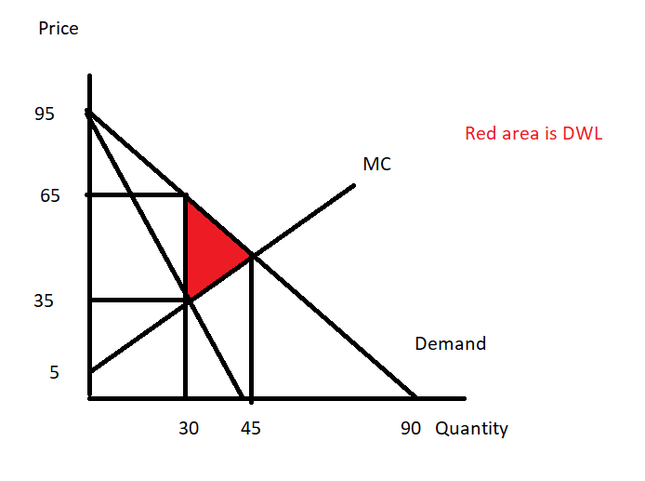

- Use the following graph of a natural monopolist to answer this next question. The graph depicts the market for a monopolist where ATC is the long-run average total cost curve, MC is the marginal cost curve, and Demand is the market demand for the product. You are also told that the reciprocal of the slope of the market demand curve is -500.

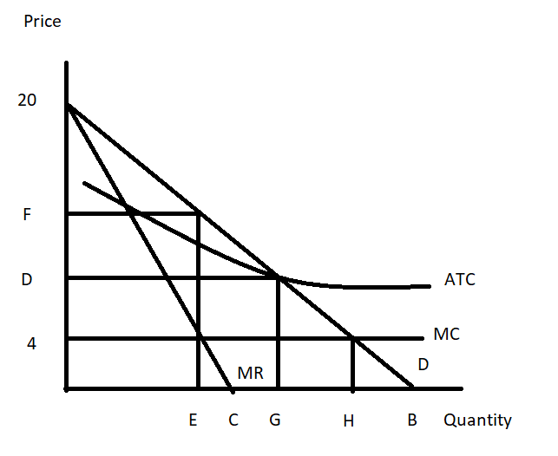

- Given the above information and the graph, write the equation for the market demand curve in slope intercept form. Explain how you found your answer. You will need to provide a numeric value for “B” in the above graph.

b) Suppose that this monopolist is not regulated. Explain how this monopolist will determine its profit maximizing output and price. Assume that the monopolist is a single price monopolist. After explaining the process, identify the value of E and F on the above graph.

c) Will the monopolist described in (b) earn positive, negative, or zero economic profits? Explain your answer. Calculate the monopolist’s Total revenue and then, on the graph indicate what the monopolist’s total costs are.

d) Suppose that this monopolist is regulated with a MC pricing regulation. This insures that the monopolist produces the socially optimal amount of the good, but will require a subsidy for the producer since economic profits will be negative. From the graph and your prior work, identify (that is, provide a numeric value) the socially optimal amount of the good. Then amend the graph to show the amount of total subsidy this monopolist will need to receive if they are to produce the socially optimal amount of the good.

e) Suppose that this monopolist is regulated with AC pricing regulation. This insures that the monopolist produces the level of output where its economic profit is equal to zero. You are also told that at this quantity the monopolist has total revenue equal to $42,000. From the graph and your prior work, identify (that is, provide a numeric value) of the price the monopolist will charge if it is regulated to produce that level of output where the monopolist breaks even. Amend the graph to provide this numeric value.

Answer:
- You are told that the reciprocal of the slope of the demand curve is -500: this implies that the slope of the demand curve is -1/500. You know from the provided figure that the y-intercept is 20 for the market demand curve so you need to figure out the x-intercept that will result in the slope of the line being - 1/500. Thus, (change in price)/(change in quantity) = - 1/500. Since change in price is equal to -20, this implies that change in quantity must be 10,000: so the value of “B” is 10,000.

Once we have the value for “B” and the slope of the line it is easy to write the equation for the market demand curve in slope intercept form: P = 20 – (1/500)Q.

- The unregulated single price monopolist will equate its MR curve to its MC curve and produce that quantity. It will go vertically up from this quantity to the demand curve to determine the price it will charge for the good. Thus,
20 – (1/250)Q = 4
16 = (1/250)Q
Q = 16(250) = 4000
If Q = 4000, then using the demand curve we get:
P = 20 – (1/500(4000) = 20 – 8 = $12 per unit
The value of “F” is $12 per unit

- The single price unregulated monopolist will earn positive economic profits since when it produces “E” amount of the good, the price it sells the good for (“F”) is greater than the average cost per unit of producing this level of output. Since the price exceeds the ATC at this level of output then the firm must be earning positive economic profit. Total revenue equals (12)(4000) = $48,000. The shaded area gives the firm’s TC when it is unregulated.
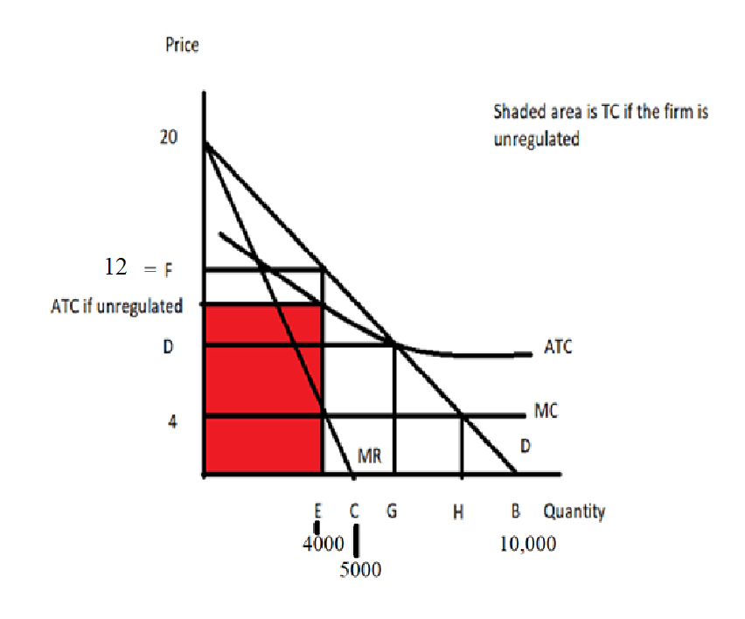

- The socially optimal amount of the good is that quantity where the demand curve intersects the MC curve. From the graph we can locate this point and see that we have the following: (Q, P)
= (H, 4). Let’s use the demand curve equation to solve for the value of “H”:
P = 20 – (1/500)Q but Q = H in this case, so P = 20 – (1/500)H
4 = 20 – (1/500)H
H = 8,000 units of output
Here’s the amended graph where the shaded area shows the total subsidy that the monopolist must receive if they are to produce the socially optimal amount of the good, “E”.
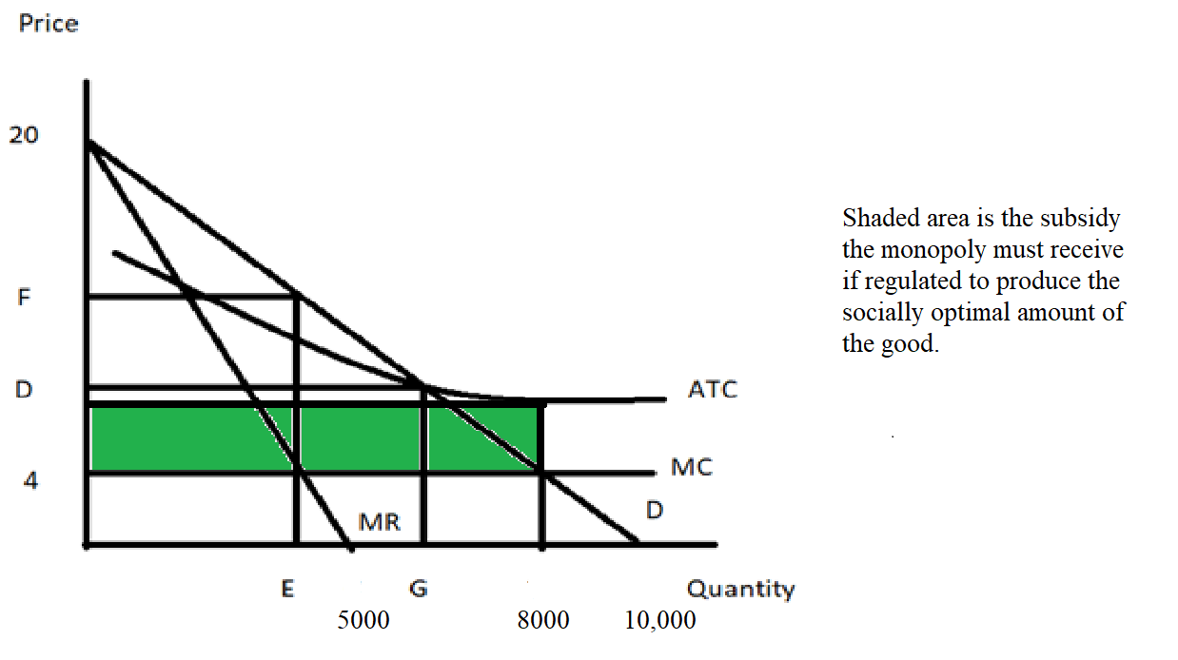

- If the monopolist is regulated by AC pricing regulation the monopolist will produce where P = ATC. We also know that total revenue is equal to $42,000 at this combination of (G, D) where the ATC curve intersects the demand curve. We know that the demand curve is given by the equation: P = 20 – (1/500)Q and we know that TR = PQ. Let’s use these two equations to find our solution:
42,000 = (20 – (1/500)Q)Q
42,000 = 20Q – (1/500)Q²
42,000 – 20Q + (1/500) Q² = 0
21,000,000 – 10,000Q + Q² = 0
(3000 – Q)(7000 – Q) = 0
Q = 3000 or Q = 7000
If Q = 3000, then P = $14 per unit which is outside the range for this point. So, this is not our answer!
If Q = 7000, then P = $6 per unit. (G, D) = (7000, $6).
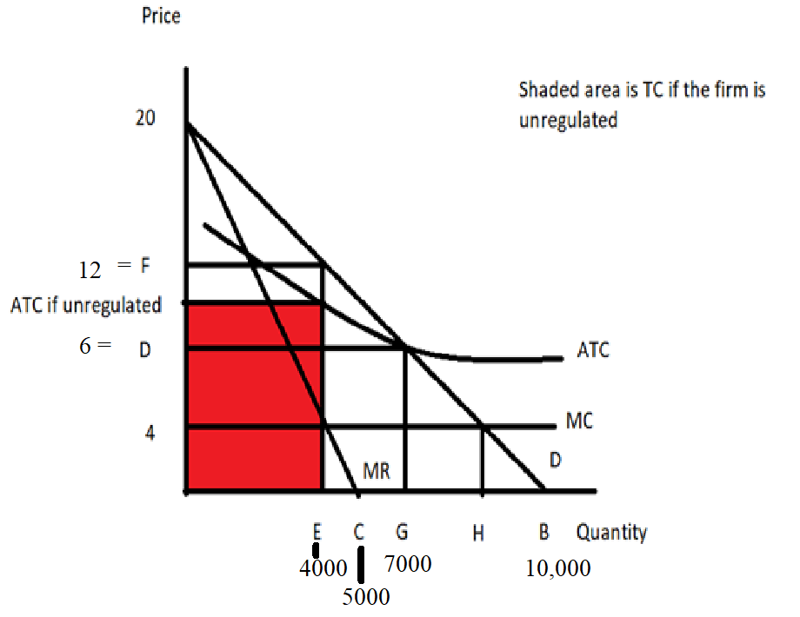

- Consider a market that is served by a single producer. This market has significant barriers to entry so the single producer has market power and is not likely to face any competition due to these barriers of entry. You are given the following information about this market:

Market Demand: Q = 600 – 40P
MC = 5
Fixed Cost for the Producer: FC = 4

- Given the above information, if this producer acts as a single price monopolist, calculate the following:

Profit maximizing quantity = Profit maximizing price = Level of profits =
Consumer Surplus = CS =
Producer Surplus (remember you will need to adjust this to take into account FC) = PS =

Deadweight Loss =

Show your work and provide a graph to illustrate your answer.

b) Suppose that this monopolist decides to practice second degree price discrimination. The monopolist decides that it will sell its first 100 units of the good produced for a price of $12.50 per unit, its next hundred units for a price of $10 per unit, and its next hundred units for a price of $7.50 per unit. Given this information and the initial information, calculate the following for the monopolist who practices this second degree price discrimination:

Total quantity produced by the second degree price discriminator = Prices charged by the second degree price discriminator = Level of profits for the second degree price discriminator =
Consumer Surplus in this case of second degree price discrimination = CS’ =

Producer Surplus (remember you will need to adjust this to take into account FC) in this
case of second degree price discrimination = PS’ = Deadweight Loss in this case of second degree price discrimination =

Show your work and provide a graph to illustrate your answer.

c) Compare your answers in (a) and (b). Does second degree price discrimination benefit consumers in this case? Explain your answer here and provide evidence to support your answer. Does second degree price discrimination benefit the producer? Explain your answer here and provide evidence to support your answer.

d) Suppose this monopolist practices first degree price discrimination in this market. Compute the following if this monopolist successfully implements first degree price discrimination.

Total amount of the good produced in the market = _____
PS” with perfect price discrimination = _______
CS” with perfect price discrimination = _______
Profit with perfect price discrimination = ______
DWL with perfect price discrimination = _______
Show your work and provide a graph to illustrate your answer.

Answer:

a) The firm if it acts as a single price monopolist will produce that quantity where MR = MC and then charge the price associated with this quantity from the demand curve. So, we need to find
MR first. Rewrite the demand curve in slope-intercept form: P = 15 – (1/40)Q. Recall that MR for the monopolist facing a linear demand curve shares the same y-intercept as the demand curve and has twice the slope of the demand curve. Thus, MR = 15 – (1/20)Q. Now, equate MR to MC:
15 – (1/20)Q = 5
10 = (1/20)Q
Q = 200 units
Go to the demand curve with this quantity to find the price the single price monopolist will charge:
P = 15 – (1/40)Q = 15 – (1/40)(200) = $10 per unit
Now, to calculate profit, we need TR and TC: Thus, TR = P*Q = 10(200) = $2000
TC = FC + VC = 4 + 5(200) = $1004
Profit for the single price monopolist = $2000 - $1004 = $996
CS = (1/2)($15 per unit - $10 per unit)(200 units) = $500
PS = ($10 per unit - $5 per unit)(200 units) = $1000
To calculate DWL we need to know the quantity which is socially optimal: to find this quantity locate where the MC intersects the demand curve and determine this quantity. Thus,
15 – (1/40)Q = 5 and
Qsocially optimal = 400 units.
DWL = (1/2)($10 per unit - $5 per unit)(400 units – 200 units) = $500

To summarize for the single price monopolist: Profit maximizing quantity = 200 units Profit maximizing price = $10 per unit Level of profits = $996
Consumer Surplus = CS = $500 Producer Surplus = PS = $1000 Deadweight Loss = $500
Here’s the graph to illustrate this outcome:
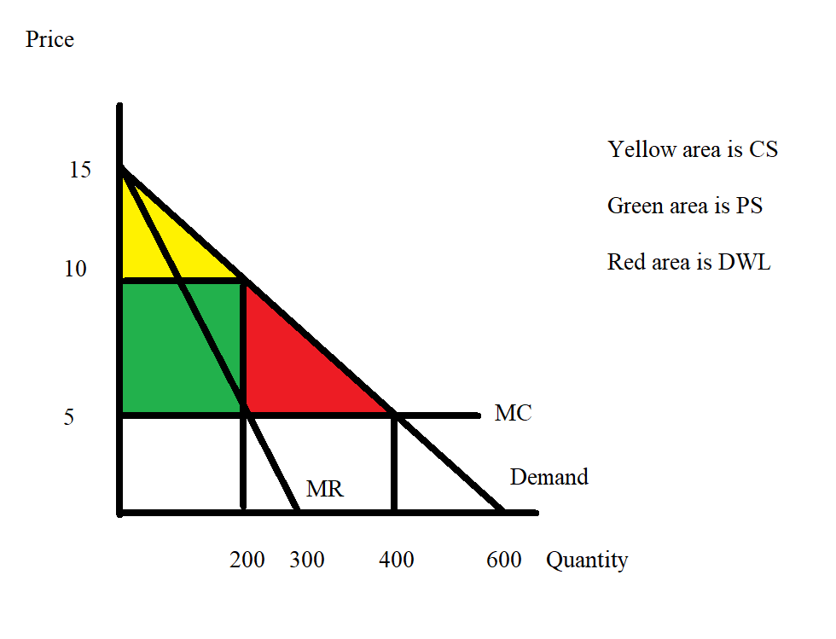

b) When this firm is a second degree price discriminator it chooses to produce 300 units in all. It will charge $12.50 per unit for the first 100 units sold, $10 per unit for the next 100 units, and $7.50 per unit for the last 100 units. To calculate the level of profits the firm earns when it practices second degree price discrimination we need to calculate its TR and its TC:
TR = P*Q = ($12.50 per unit)(100 units) + ($10 per unit)(100 units) + ($7.50 per unit)(100 units) = $1250 + $1000 + $750 = $3000
TC = FC + VC = $4 + ($5 per unit)(300 units) = $1504
Profits for this second degree price discriminator = $3000 - $1504 = $1496
CS’ = (1/2)($15 per unit - $12.50 per unit)(100 units) + (1/2)($12.50 per unit - $10 per unit)(200 units – 100 units) + (1/2)($10 per unit - $7.50 per unit)(300 units – 200 units) = $375
PS’ = ($12.50 per unit - $5 per unit)(100 units) + ($10 per unit - $5 per unit)(200 units – 100 units) + ($7.50 per unit - $5 per unit)(300 units – 200 units) = $1500
DWL’ = (1/2)($7.50 per unit - $5 per unit)(400 units – 300 units) = $125

To summarize our findings:
Total quantity produced by the second degree price discriminator = 300 units
Prices charged by the second degree price discriminator = $12.50 per unit for the first 100 units, $10 per unit for the next 100 units, and $7.50 per unit for the next hundred units
Level of profits for the second degree price discriminator = $1496
Consumer Surplus in this case of second degree price discrimination = CS’ = $375 Producer Surplus = PS’ = $1500
Deadweight Loss in this case of second degree price discrimination = $125 Here’s the graph to illustrate the second degree price discrimination case:
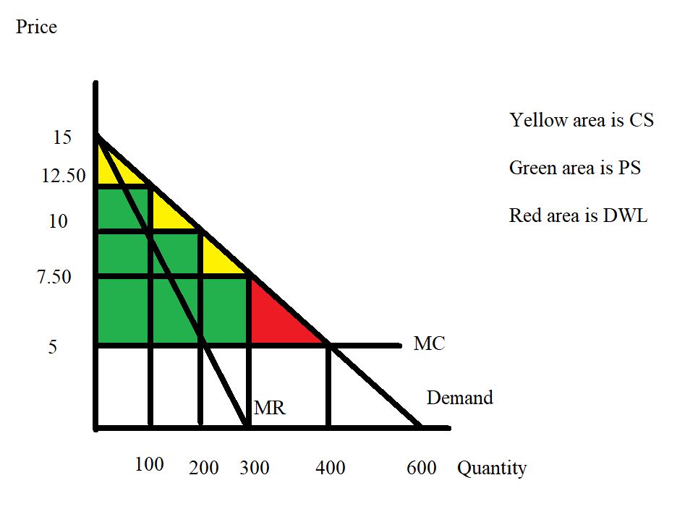

c) Second degree price discrimination does not benefit consumers since second degree price discrimination in this case is shrinking CS from $500 to $375. But, second degree price discrimination allows consumers to consume more units of the good: in this case, 300 units instead of 200 units. And, some of these units are cheaper-100 units are now selling for $7.50 per unit. We can also see that the area of DWL is shrinking from $500 to $125.

Second degree price discrimination benefits the producer: they sell more of the good and their total profit goes up from $996 to $1496. We can also see that PS increases from $1000 to
$1500.

d) When the firm practices perfect price discrimination it charges a different price for every unit it sells. This results in the market demand curve also being the firm’s marginal revenue curve. To find the quantity the firm will produce we still set MR = MC but this time the MR is the firm’s demand curve. Thus,
MR = MC
15 – (1/40)Q = 5
Qsocially optimal = 400 = the amount that the perfect price discriminator will produce. This is the socially optimal amount of the good because the MC of producing the last unit is equal to the price the consumer pays for this last unit: that is, the cost to society of producing this last unit equals the value to the consumer of consuming this last unit.
CS” = 0 since the producer captures all of the consumer surplus when they practice perfect price discrimination
PS” = (1/2)($15 per unit - $5 per unit)(400 units) = $2000
TR = (1/2)($15 per unit - $5 per unit)(400 units) + ($5 per unit)(400 units) = $4000
TC = FC + VC = 4 + ($5 per unit)(400 units) = $2004
Profit for the perfect price discriminator = $4000 - $2004 = $1996
DWL” = 0 since the firm is now producing the socially optimal amount of the good

To summarize our findings:
Total amount of the good produced in the market = 400 units PS” with perfect price discrimination = $2000
CS” with perfect price discrimination = $0
Profit for firm with perfect price discrimination = $1996
DWL with perfect price discrimination = $0
Here’s the graph:

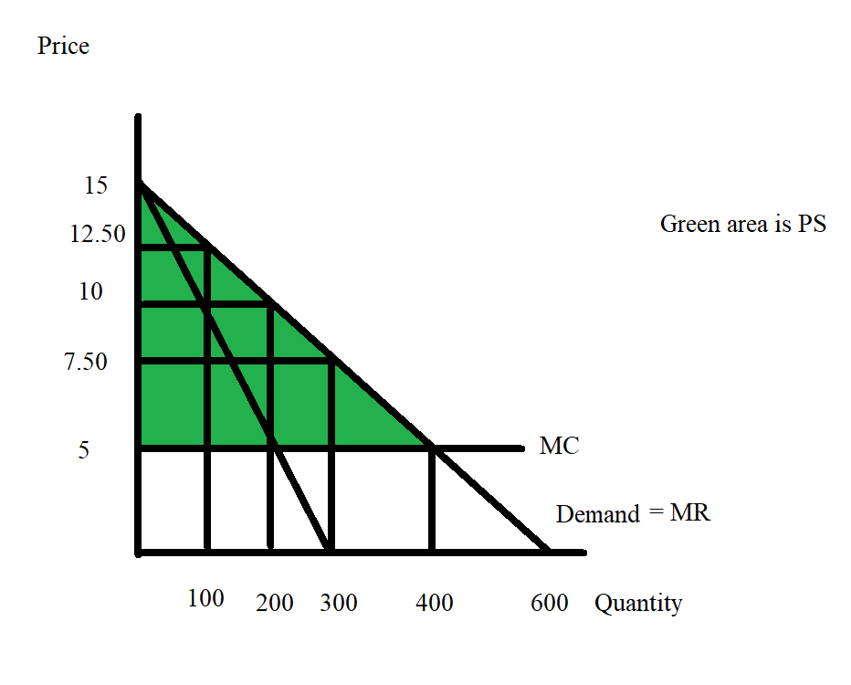
- Marcia is a supplier of dry cleaning services in her small town. She operates the only dry cleaning service and therefore has significant market power. She knows that she has two types of clients: business clients who come in regularly to have their clothing cleaned and non-business clients who have occasional garments to clean. She knows the following information where Q is the quantity of dry cleaning units and P is the price per unit of dry cleaning:

Demand for dry cleaning services from business clients: Q = 20 – (1/2)P
Demand for dry cleaning services from non-business clients: Q = 30 - P
MC of providing dry cleaning services: MC = 4
Fixed Costs of providing dry cleaning services: FC = 10

Suppose that Marcia decides to treat her dry cleaning business as two separate monopolies: one providing dry cleaning services to business clients and one providing dry cleaning services to non-business clients. She can readily identify the status of each of her clients since she has been in business in this small town for a long, long time and she knows her customers well.

- Given that Marcia is going to treat these two types of customers as separate entities, what will be the profit maximizing price and quantity of the good for each type of customer? And, what will total profits be equal to? Show how you found your answers to this set of questions clearly and logically! Provide a set of graphs to illustrate your answer.

- Now, suppose Marcia would like to verify that this two pricing scheme idea in (a) actually results in her earning greater profits than if she were to simply follow a single pricing monopoly model. So, find the market demand curve. Then determine the profit maximizing quantity and price if Marcia treats this market as a single market with one price for dry cleaning. What happens to the level of profits Marcia earns under this pricing decision? Provide numeric values for all your work and clearly and logically explain how you found your answers. Also, provide a graph to illustrate your answer.

Answers:
a) Marcia has decided to treat this pricing and production decision as two separate monopolies: so she needs to find the MR curves for each sub-market and then equate MR to MC to identify the profit maximizing quantity for each market. She will then take these quantities and use the respective demand curve to find the profit maximizing price for each market. Once she has the price and quantity for each sub-market she can calculate the total profit she will earn by treating this market as two separate monopolies. So, let’s go through this process:

Business Client Market Analysis:
Demand for this market: Q = 20 – (1/2)P or P = 40 – 2Q MR for this market: MR = 40 – 4Q
MC for this market: MC = 4 Set MR = MC: 40 – 4Q = 4
Q for business client market = 9 units of dry cleaning
Use this quantity in the demand curve to find the profit maximizing price for this sub-market: P = 40 – 2(9) = $22 = price for a unit of dry cleaning for the business clients

Non-Business Client Market Analysis:
Demand for this market: P = 30 – Q
MR for this market: MR = 30 – 2Q
MC for this market: MC = 4
Set MR = MC: 30 – 2Q = 4
Q for non-business client market = 13 units

Use this quantity in the demand curve to find the profit maximizing price for this sub-market:
P = 30 – 13 = $17 = price for a unit of dry cleaning for the non-business clients

TR from business customers = ($22 per unit of dry cleaning)(9 units of dry cleaning) = $198
TR from non-business customers = ($17 per unit of dry cleaning)(13 units of dry cleaning) = $221
Total TR from the two market = $198 + $221 = $410
TC from production of 22 units of dry cleaning = VC + FC = ($4 per unit)(22 untis) + 10 = $98
Profits from this pricing scheme = $419 - $98 = $321

Here’s the set of graphs:
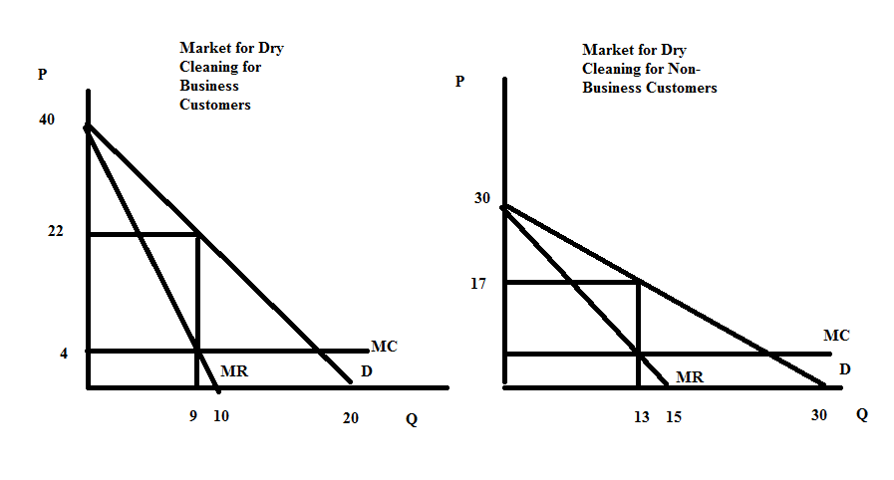

b) First profits from the pricing scheme in part (a) = $419 - $98 = $321

Now, let's consider if this market is treated as a single price monopolist. We will need the market demand curve. Here's the picture of this market demand curve:
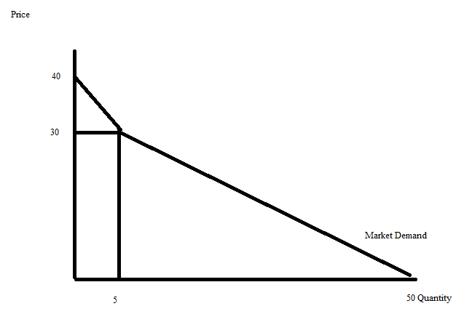

We can write the equations for the two segments of the market demand curve as: Top segment: P = 40 – 2Q for quantities less than or equal to 5
Lower segment: P = (100/3) – (2/3)Q for quantities greater than or equal to 5

The MR curves for these two segments are:
Top segment: MR = 40 – 4Q for quantities less than or equal to 5 Lower segment: MR = (100/3) – (4/3)Q for quantities greater than or equal to 5
But, which MR to use? Let's try both and decide which gives us greater profits! Using the top segment:
MR =MC 40 –4Q=4
4Q = 36
Q = 9 units of dry cleaning….but this quantity is beyond the domain of this segment of the market demand curve

Using the lower segment: MR=MC
(100/3) – (4/3)Q = 4
100 – 4Q = 12
4Q = 88
Q = 22 units of dry cleaning
P = (100/3) – (2/3)Q = (100/3) – (2/3)(22) = $18.67 per unit of dry cleaning
TR = ($18.67 per unit of dry cleaning)(22 units of dry cleaning) = $410.74
TC = ($4 per unit of dry cleaning)(22 units of dry cleaning) + 10 = $98 Profit with this output and price combination = 410.74 – 98.00 = $312.74

Comparison of the profits from the pricing scheme in (a) versus that in (c) reveals that charging different prices to business customers and non-business customers results in greater profits: $321 in profits versus $312.74. Price discrimination does pay off!

Here's a graph to illustrate this second possibility:
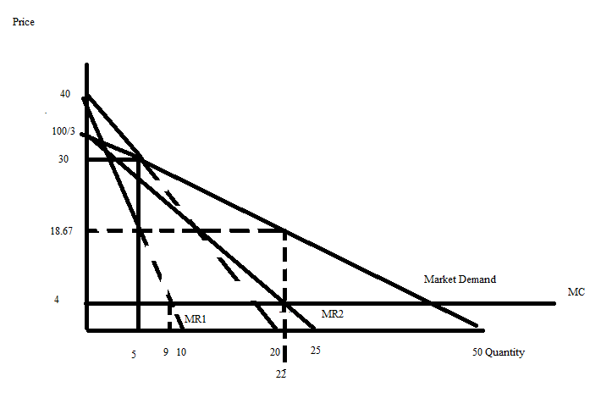
5. Suppose Mary and Peter are running for an elected position and are busy Jeanniepaigning against one another. Two issues are being debated in this election: free college education and comprehensive public healthcare for everyone. Mary realizes that both of these programs are expensive and she advocates for a need based approach for both financing college education as well as universal health care. If Peter elects to not address these two issues in his Jeanniepaign, Mary’s election team estimates that she will get 52% of the vote if she adheres to her program to provide these goods based upon financial need and 47% of the vote if she decides to instead not provide these two goods. If Peter adopts a program of universal healthcare as well as universal college education, then Mary’s Jeanniepaign team estimates that she will earn 49% of the vote if she does not provide these two goods and 50% of the vote if she decides to provide these goods based upon financial need. Over at Peter’s Jeanniepaign headquarters his team finds that no matter what stance he takes on this issue he will get 49% of the vote irrespective of the stance that Mary takes. Understand that there is some rounding going on with these projected percentages: they may sum to just a bit more than 100% of the vote!

a) Given the above information fill in the following payoff matrix. In each cell put Mary’s vote percentage first, followed by Peter’s vote percentage.
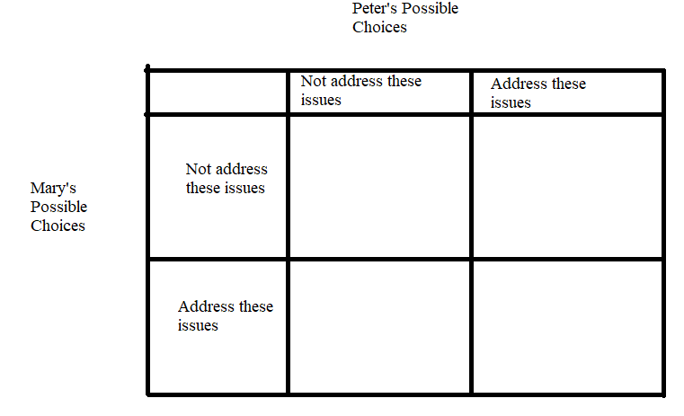
b) Examine the payoff matrix you created in (a). Does Mary have a dominant strategy? Explain your answer.

c) Examine the payoff matrix you created in (a). Does Peter have a dominant strategy? Explain your answer.

d) Suppose Mary follows her dominant strategy, can you predict what Peter will do given the above information? Explain your answer.

e) You plan to watch Mary and Peter debate each other this weekend. Describe the debate you anticipate seeing. What do you think the two candidates platforms will be at the debate?

Answers:
a)
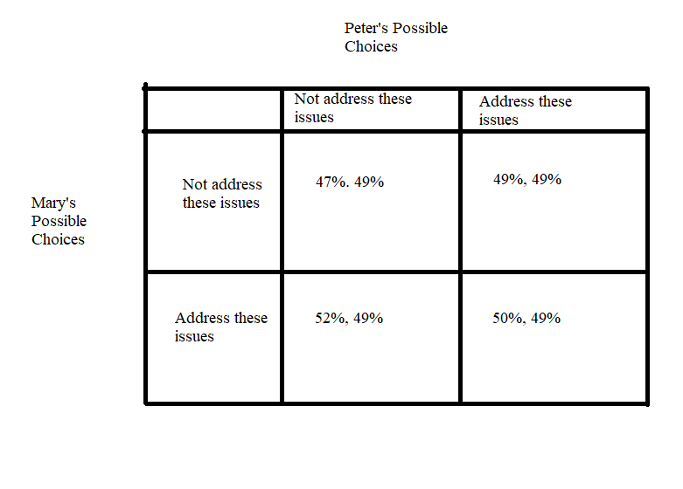
b) Mary's dominant strategy is to adopt an “Address these issues” strategy. To see this think about Mary looking at this table as two separate columns: a column where Peter plays "Not Address" and a column where Peter plays "Address". If Peter plays "Not Address", then Mary will win 52% of the votes with an “Address these issues” strategy and only 47% of the vote with a “Not address these issues” strategy. If Peter plays "Address", then Mary will win 50% of the votes with an “Address these issues” strategy and only 49% of the vote with a “Not address these issues” strategy. Mary has a better outcome no matter what strategy Peter adopts if Mary adopts the "Address these issues" strategy.

c) Peter's does not have a dominant strategy in this game. His outcome is the same no matter what strategy he pursues.

d) If Mary follows her dominant strategy of “Address these issues” then the payoff matrix shows us that Peter has a payoff of 49% of the vote. Peter will likely look at the spread between the two candidates depending upon the stances they take. If Peter recognizes that Mary is certainly going to pursue “Address these issues” then it is likely that he will pursue “Address these issues” since the spread is smaller between the two candidates when he selects this strategy given Mary’s dominant strategy.

e) At the debate you can anticipate lots of loud voices, aggressive rebuttals, and incendiary words: should make for an exciting evening although it may not be the best path to reaching consensus and negotiating the political landscape.

6. Consider two firms in an industry consisting solely of these two firms. Giant Industries and Mega Products produce identical products. Both firms are trying to decide whether they want to offer coupons or not offer coupons. They know that when they offer coupons the other firm is hurt by this policy since they are selling identical products.

Giant Industries knows that if Mega Products offers coupons then Giant Industries will earn a profit of $60,000 for the year if it also offers coupons and a profit of $70,000 for the year if it does not offer coupons. Giant Industries knows that if Mega Products does not offer coupons then Giant Industries will earn a profit of $75,000 for the year if it offers coupons and a profit of $80,000 for the year if it does not offer coupons.

Mega Products knows that if Giant Industries offers coupons then Mega Products will earn a profit of $48,000 for the year if it also offers coupons and a profit of $50,000 for the year if it does not offer coupons. Mega Products knows that if Giant Industries does not offer coupons then Mega Products will earn a profit of $60,000 for the year if it offers coupons and a profit of $64,000 for the year if it does not offer coupons.

a) Given the above information, construct a payoff matrix for this situation. Put Giant Industries on the left hand side of the payoff matrix and Mega Products on the top of the matrix. Make sure your payoff matrix identifies the strategies that each firm faces as well as the payoff from each combination of strategies.

b) Identify if these two firms have the dominant strategies and, if so, what these dominant strategies are. Explain your answer.

c) Given the above information, can you predict what these two firms will do? Explain your answer.

Answers:

a)
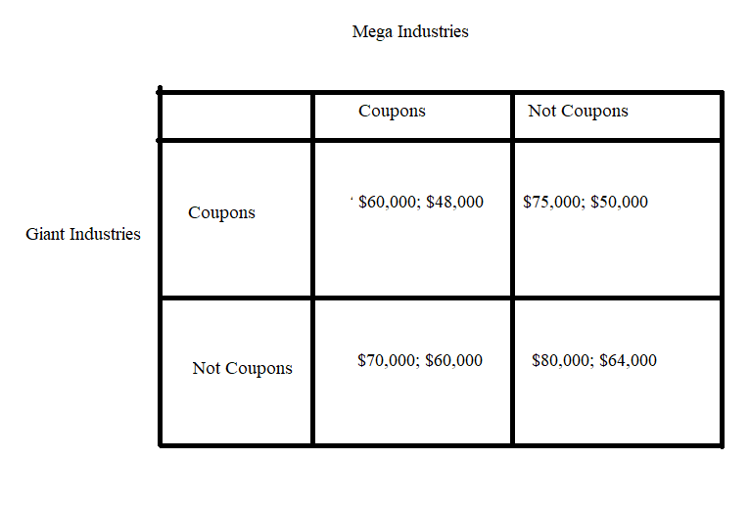

b) Giant Industries has a dominant strategy of “Not Coupons”: no matter what Mega Products does, Giant Industries is better off with a “Not Coupons” strategy. Mega Products has a dominant strategy of “Not Coupons”: no matter what Giant Industries does, Mega Products is better off with a “Not Coupons” strategy.

c) Both firms will pursue their dominant strategies and both firms will therefore not offer coupons.

7. Suppose there are two firms in a market and these two firms agree to form a cartel and divide up the market evenly. The two firms know the following:

Market Demand for the Product: P = 2000 – 2Q
Marginal Cost of producing the good: MC = 400
Fixed Cost of production: FC = 0

a) What is the profit maximizing quantity and price for the cartel? Explain your answer and provide a graph of this market to illustrate your answer.

b) What are the industry profits given your answer in (a)? Show your work.

c) What is the level of production for each firm if both firms adhere to the cartel agreement? What are the profits for each firm? Explain your answer.

d) Suppose one of the firms decides to cheat on the cartel agreement and sell the product for $1100 per unit. How many units can this firm sell at this price and what will be its profits when it follows this pricing strategy? Assume that the other firm does not drop its price and consumers know all prices, so the other firm sells zero units.

e) Suppose that one of the firms drops its price as described in (d), but now the other firm matches this price decrease. If the two firms continue to split the market evenly, what will the profit for each firm equal now that both firms are selling the good for $1100 per unit? Explain your answer.

f) Make a payoff matrix for these two firms with each firm having a choice of charging the profit maximizing price (see (a)) or the “cheating on cartel” price of $1100. Put Firm A on the left hand side of the payoff matrix and Firm B at the top of the matrix.

g) Does each firm have a dominant strategy? Explain your answer.

h) What do you predict will be the outcome of this game? Explain your answer.

i) If you apply the above logic many times to successively lower prices (e.g. $1050, $1000, …), what will the price eventually be?

Answers:
a) The cartel will maximize its total profits by producing that quantity where MR = MC and then pricing this quantity off the market demand curve. So, we first need to find the MR curve for the cartel: MR = 2000 – 4Q. We can get this equation by remembering that for a downward sloping linear demand curve the MR curve shares the same y-intercept and has twice the slope as the demand curve. Then, set MR equal to MC:
2000 – 4Q = 400
4Q = 1600
Q = 400 units
So the cartel should produce a total of 400 units: one firm will produce 200 units and the other firm will produce another 200 units since they have agreed to split the market. To find the profit maximizing price, plug this quantity into the demand curve:
P = 2000 – 2Q
P = 2000 – 2(400) = $1200 per unit

Here’s a graph to illustrate this answer:
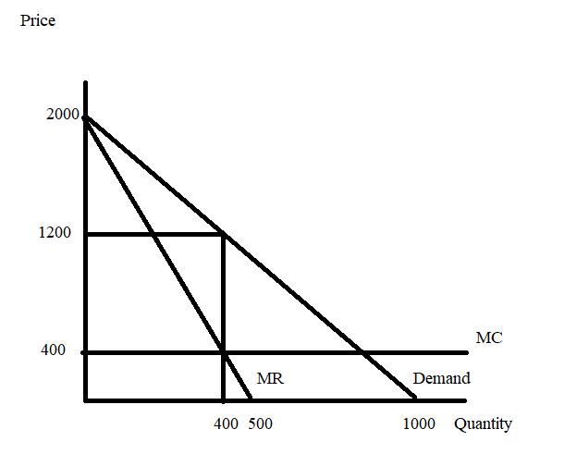
b) Profits = TR – TC
TR = P*Q = ($1200 per unit)(400 units) = $480,000
TC = ATC*Q = MC*Q since there are no FC
TC = ($400 per unit)(400 units) = $160,000
Profits = $320,000

c) Each firm will produce half of the total amount produced: so each firm will produce 200 units of the good. Since each firm is selling 200 units at a price of $1200 per unit, each firm will earn profits of $160,000 (TR for each firm is $240,000 and TC for each firm is $80,000) or half of the total profits earned by the cartel.

d) If the price is $1100 per unit, then 450 units of the good will be demanded (use the demand curve and the price of $1100 per unit to find this quantity). So, the cheating firm will be the only firm selling in this market: it will sell 450 units at a price of $1100 per unit. The cheating firm’s profit will therefore be equal to ($1100 per unit)(450 units) – ($400 per unit)(450 units) = $315,000.

e) If both firms drop their price to $1100 per unit and split the market, then each firm will sell 225 units (half of the total of 450 units demanded at this price). Each firm will earn profit equal to ($1100 per unit)(225 units) – ($400 per unit)(225 units) = $157,500 (or half of the $315,000).

f)
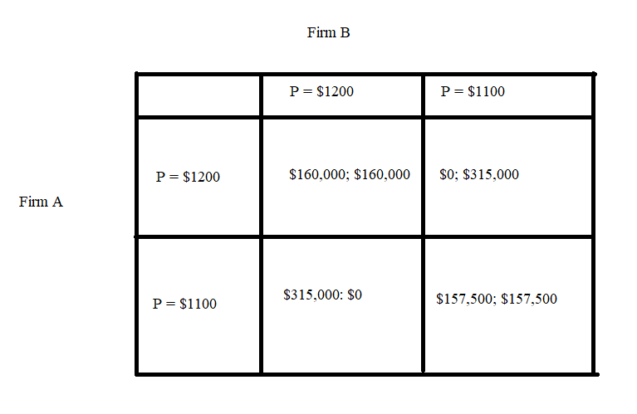
g) Yes, each firm has a dominant strategy of cheating on the cartel price and charging $1100 per unit.

We can see this from Firm A’s perspective by looking at the payoff matrix as two columns: if Firm B holds to a price of $1200, Firm A will earn more profit by charging a price of $1100 ($315,000 versus $160,000); if Firm B goes to a price of $1100, Firm A will earn more profit by charging a price of $1100 ($0 versus $157,500). No matter what Firm B does, Firm A is better off charging a price of $1100.

We can see this from Firm B’s perspective by looking at the payoff matrix as two rows: if Firm A holds to a price of $1200, Firm B will earn more profit by charging a price of $1100 ($315,000 versus $160,000); if Firm A goes to a price of $1100, Firm B will earn more profit by charging a price of $1100 ($0 versus $157,500). No matter what Firm A does, Firm B is better off charging a price of $1100.

h) Firm A and Firm B will both pursue their dominant strategies and charge a price of $1100. They will make $157,500 in profit at each firm which is less than they would make if they would cooperate and adhere to the cartel agreement.

i) The same logic works for any price: if both firms charge a price above zero, charging a positive price below the current price dominates charging the current price, regardless of what the other firm does. If we apply this logic many times we see that the price must approach the marginal cost! This is known as the “Bertrand paradox”: if firms are competing by choosing prices, even two firms are sufficient to drive price down to marginal cost. You can learn more about this if you take a later course in Industrial Organization.

8. Tom, Kem, and Jeannie live in the same community (they are the only residents) and they are debating installing some lighthouses. Thankfully each of these individuals is willing to reveal their preferences and demand for lighthouses, but the community is still trying to decide how many lighthouses they should buy. Here is the relevant information that they have gathered:

Tom’s demand for lighthouses: Q = 20 – 4P
Kem’s demand for lighthouses: Q = 40 – 4P
Jeannie’s demand for lighthouses: Q = 10 – P
Marginal social cost of a lighthouse: MSC = $16

a) Given the above information draw an illustration of these three demand curves plus the market demand curve for lighthouses. In your illustration provide four different graphs that are vertically stacked with the market demand curve the bottom graph in the stack. Make sure all your graphs are clearly and completely labeled. Describe verbally how you found the market demand curve.

b) Write the equation(s) for the market demand curve and provide a range or domain for any segments of the demand curve. Show how you found these equations.

c) What is the socially optimal amount of lighthouses for this community? Explain how you found your answer. How much will Tom pay per lighthouse? How much will Kem pay per lighthouse? How much will Jeannie pay per lighthouse?

Answers:
a)
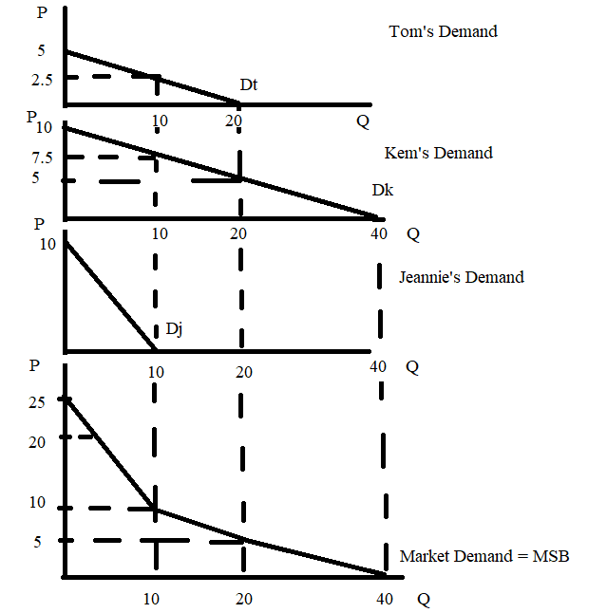
To find the market demand curve, we need to hold the quantity constant and then add the prices each of these individuals are willing to pay for this quantity of the good. We do this because the lighthouses are non-rival goods: that is, one person’s use of the lighthouse does not diminish another person’s ability to also consume this lighthouse. Thus, when the quantity is 10 units, Tom is willing to pay $2.50 per lighthouse, Kem is willing to pay $7.50 per lighthouse, and Jeannie is willing to pay $0 per lighthouse: this implies that the point (Q, P) = (10, 10) is on the market demand curve. We can repeat this process for Q = 0, Q = 20 and Q = 40 to get the different end points and kink points of the market demand curve.

b) The market demand curve has three linear segments so we need three equations. For prices greater than or equal to $10 the market demand curve is P = 25 – (3/2)Q. The domain for this equation is 0 ≤ Q ≤ 10 and the range for this equation is 10 ≤ P ≤ 25.

For prices less than or equal to $10 and greater than or equal to $5 we need to do a bit more work. First, the slope of this middle segment is equal to rise/run = (-1/2). Then, we know that the points (Q, P) = (10, 10) and (20, 5) sit on this middle segment. So, use the slope-intercept form and go to work!
y = mx + b
P = (-1/2)Q + b
10 = (-1/2)(10) + b
b = 15
So, the market demand equation for the middle segment is P = 15 – (1/2)Q. The domain for this equation is 10 ≤ Q ≤ 20 and the range for this equation is 5 ≤ P ≤ 10.

For prices less than or equal to $5 and greater than or equal to $0 we need to do a bit more work. First, the slope of this lowest segment is equal to rise/run = (-1/4). Then, we know that the points (Q, P) = (20, 5) and (40, 0) sit on this lowest segment. So, use the slope-intercept form and go to work!
y = mx + b
P = (-1/4)Q + b
0 = (-1/4)(40) + b
b = 10
So, the market demand equation for the lowest segment is P = 10 – (1/4)Q. The domain for this equation is 20 ≤ Q ≤ 40 and the range for this equation is 50 ≤ P ≤ 5.

c) To find the socially optimal amount of lighthouses we need to equate the marginal social benefit curve (the market demand curve) to the marginal social cost curve. We know that MSC is given as MSC = 16. We need to use the equation for the upper segment of the market demand curve for our MSB: MSB = 25 – (3/2)Q. Thus,
16 = 25 – (3/2)Q where Q is the socially optimal quantity of lighthouses
9 = (3/2)Q
Q = 6 lighthouses = socially optimal quantity of lighthouses

Using Tom’s demand curve: Q = 20 – 4P
6 = 20 – 4P
4P = 14
P = $3.50 per lighthouse is the amount that Tom will pay per lighthouse.

Using Kem’s demand curve: Q = 40 – 4P
6 = 40 – 4P
4P = 34
P = $8.50 per lighthouse is the amount that Kem will pay per lighthouse.

Using Jeannie’s demand curve: Q = 10 – P
6 = 10 – P
P = $4 per lighthouse is the amount that Jeannie will pay per lighthouse.

Lest you be concerned about this: notice that Tom, Kem, and Jeannie's contribution per lighthouse sums to $16 which is the MSC of providing an additional lighthouse. So, we will be able to collect enough money to pay for the lighthouses and all three individuals will enjoy having the socially optimal amount of lighthouses in their community.

9. Consider the market for college education in the economy of Statesville. The market demand curve for a year of college education is given by P = 80,000 – 2Q where P is the price per year of college and Q is the quantity of students attending college per year. This market demand curve expresses the marginal private benefit of going to college but does not include the social benefits derived from this education. The market supply curve for a year of college education is given by P = 2000 + 2Q. This market supply curve expresses the marginal social cost of going to college. The social benefit of going to college for a year is equal to $10,000 per year per student, in addition to the private benefit that goes to the student directly.

a) Given the above description is there a negative or positive externality in this market? Explain your answer.

b) Given the above description, is this a consumption or a production externality? Explain your answer.

c) What quantity of students will attend college this year and what price will they pay given the above information? Show your work.

d) Suppose that the described externality is internalized in this market. Write the new equations we will need in order to find the socially optimal amount of college education to provide this year. Explain how you got these equations.

e) What is the socially optimal amount of college education to provide this year given the above information? What is the “right” (the one that corresponds to the socially optimal amount of the good) price for a year of college? Explain your answer.

f) What is the deadweight loss that occurs when the externality is not internalized in this market? Show your work.

Answers:

a) This is a positive externality since the economy derives extra social benefits from the education of its students.

b) This is a consumption externality. We know this because the market supply curve is the MSC of producing this good while the market demand curve is the marginal private benefit (MPB) rather than the marginal social benefit (MSB) of consuming the good.

c) We can find the market solution by equating the market supply curve to the market demand curve: thus,
2000 + 2Q = 80,000 – 2Q
4Q = 78,000
Q = 19,500 college students this year will be the market outcome
P = 2000 + 2Q = 2000 + 2(19,500) = $41,000 per college student or
P = 80,000 – 2Q = 80,000 – 2(19,500) = $41,000 per college student

d) The market supply curve does not change since this curve expresses the MSC of providing the good: Market supply curve = marginal social cost = MSC = 2000 + 2Q.

The market demand curve expresses only the marginal private benefits from consuming a college education for the year. We need to add in the social benefit which is $10,000 per student per year. So, the new marginal social benefit curve (MSB) will be P = 90,000 – 2Q (the MSB curve is effectively shifting up from the MPB by $10,000 per student).

e) Using these two equations from (d) we get:
2000 + 2Q = 90,000 – 2Q where Q is the socially optimal amount of the good
4Q = 88,000
Q = 22,000 college students per year is the socially optimal amount of the good
Note: the market, left alone, under produces this good since the market fails to take into account the social benefits derived from the consumption of this good.

P = 2000 + 2Q = 2000 + 2(22,000) = $46.000 or
P = 90,000 – 2Q = 90,000 – 2(22,000) = $46,000

f) When Q = 19,500 college students, the MSB is $51,000.
DWL = (1/2)($51,000 per student per year - $41,000 per student per year)(22,000 students per year – 19,500 students per year) = $12,500,000 = $12.5 million

