Economics 101
Summer 2013
Answers to Homework #3
Due Tuesday, June 11, 2013

Directions: The homework will be collected in a box before the lecture. Please place your name, TA name and section number on top of the homework (legibly). Make sure you write your name as it appears on your ID so that you can receive the correct grade. Late homework will not be accepted so make plans ahead of time. Please show your work. Good luck!

Please realize that you are essentially creating “your brand” when you submit this homework. Do you want your homework to convey that you are competent, careful, professional? Or, do you want to convey the image that you are careless, sloppy, and less than professional. For the rest of your life you will be creating your brand: please think about what you are saying about yourself when you do any work for someone else!

- This problem consists of two separate problems using the price elasticity of demand concept.
  - Suppose that you know that the market demand curve for a product is given by the equation P = 100 – 2Q. Furthermore you know that initially 40 units are demanded in this market when it is in equilibrium. Then, some event causes the equilibrium to change so that only 35 units are demanded in this market. From this information you are asked to calculate the price elasticity of demand using the arc elasticity concept. Finally you are asked to identify whether demand is elastic, unit elastic, or inelastic when quantity changes from 40 units to 35 units.
  - Suppose you know that the price elasticity of demand for good X has a value of 2. Suppose that the price in the market is initially $10 and the quantity demanded is 100 units. If price in this market decreases by 10%, what will be the percentage change in the quantity demanded given the above information?
Answer:
- To answer this question you will want to find the price associated with the quantity demanded of 40 units: P = 100 – 2Q = 100 – 2(40) = $20 per unit. You will also want to find the price associated with the quantity demanded of 35 units: P = 100 – 2Q = 100 – 2(35) = $30. Now, we have a (Q1, P1) and a (Q2, P2) that we can use in our arc elasticity formula for price elasticity of demand.
Price elasticity of demand = │[(Q2 – Q1)/Q2 + Q1)]/[(P2 – P1)/(P2 + P1)] │
Price elasticity of demand = │[(35 – 40)/(35 + 40)]/[(30 – 20)/(30 + 20)]
Price elasticity of demand = 1/3 and since this value is less than one we can conclude that the demand curve is inelastic between
- From the information we know that the price elasticity of demand =2; we also know that the price elasticity of demand = the absolute value of [(% change in the quantity demanded of good X)/(% change in the price of good X)]. Thus, 2 = the absolute value of [(the % change in the quantity demanded of good X)/-10%]. Or, the % change in the quantity demanded of good X is 20%. The quantity demanded of good X will increase by 20% (the quantity demanded will now be 120 units) since the price of the good is inversely related to the quantity demanded of the good.

- Suppose the market demand and supply of widgets is given by the following equations:
Market Demand for Widgets: P = 100- Q
Market Supply of Widgets: P = 3Q + 20
where P is the price per unit and Q is the quantity demanded.

  - What is the equilibrium price and equilibrium quantity of widgets?
  - Describe what happened to the supply curve due to this change in production costs. What is the equation for the new supply curve?
Suppose that production costs increase in the market for widgets such that at every quantity the cost has now increased by $20.
  - Given the change in production costs described above, calculate the new equilibrium price and equilibrium quantity in the market for widgets.
  - Intuitively what do you think happened to total expenditure in this market given the increase in production costs? Explain your answer.
  - Calculate total expenditure in the market for widgets initially and total expenditure in the market for widgets after the increase in production costs.
  - Does your answer in (e) support or confirm your answer in (d)?
  - Calculate the value of the price elasticity of demand between these two points of equilibrium using the arc elasticity of demand formula.
Answer:
- 100 – Q = 3Q + 20
4Q = 80
Qe = 20
Pe = 100 – 20 = $80 per unit
- The new supply curve will shift to the left but be parallel to the initial supply curve: the two curves will have the same slope. Thus, the new supply curve will be P = b’ + 3Q. We also know that the supply curve has shifted vertically up by 20 units since costs have risen at each quantity by $20. Thus, the new y-intercept of the supply curve will be equal to the initial y-intercept plus 20: the new supply curve will be P = 40 + 3Q.
- 3Q = 40 = 100 – Q
4Q = 60
Qe’ = 15
Pe’ = 100 – 15 = $85 per unit
- Total expenditure should decrease since the price is increasing in the elastic region of the demand curve. We know we are in the elastic region of the demand curve for any price greater than $50 since (50, $50) is the midpoint of the demand curve.
- Total expenditure initially = ($80 per unit)(20 units) = $1600
Total expenditure after change in production costs = ($85 per unit)(15 units) = $1275
- Yes, provided in (d) you predicted that total expenditure would fall.
- Price Elasticity of Demand = │{[(Q2 – Q1)/(Q2 + Q1)]/[(P2 – P1)/(P2 + P1)]}│
Price Elasticity of Demand = {[(15 – 20)/35]/[(85 – 80)/165]} = [(1/7)/(5/165)] ≈ 4.7

- Suppose the market for doughnuts has five consumers and each consumer’s demand for doughnuts can be described by the equation Pd = 5 – Qd where Pd is the price per doughnut and Qd is the quantity of doughnuts demanded.
  - What is the market demand curve for doughnuts?

Suppose the market demand and market supply curves for coffee are given by the following equations where Pc is the price per cup of coffee and Qc is the quantity of cups of coffee:
Market Demand for Coffee: Pc = 5 – (1/20)Qc
Market Supply of Coffe: Pc = 1 + (1/60)Qc

  - Suppose you know that the price of doughnuts is fixed at $1 per doughnut. How many doughnuts will be demanded in the market given this information?
  - What is the equilibrium price and equilibrium of coffee given the above information?

Suppose the quantity of coffee supplied at every price decreases by 20 units. Furthermore you are told that the cross-price elasticity of doughnuts for coffee has a value of -1.0.

  - What is the new supply equation for coffee given the above information?
  - Calculate the new equilibrium price and quantity in the coffee market.
  - Using the simple percentage change formula (the standard mathematical definition of percentage change), what is the percentage change in the price of coffee given your answers in (c) and (e)?
  - Using the simple percentage change formula (the standard mathematical definition of percentage change), what is the percentage change in the quantity demanded of coffee given your answer in (c) and (e)?
  - Calculate the price elasticity of demand for coffee using two different methods: a) use the simple percentage change formula to get an estimate of the price elasticity of demand; and b) use the arc elasticity formula to get a numerical value of the price elasticity of demand.
  - Given your values in (g), is demand for coffee inelastic or elastic over this range of prices? Explain your answer.
  - Calculate the percentage change in the quantity of doughnuts demanded given this change in the supply of coffee. What will be the new quantity demanded of doughnuts?

Answer:
- Pd = 5 – (1/5)Qd
To see this think about drawing one consumer’s demand curve and then from that graph think about what the y-intercept and the x-intercept would be if there were five consumers with identical individual demand curves.
- P = 5 – (1/5)Qd
1 = 5 – (1/5)Qd
Qd = 20 doughnuts
- 5 – (1/20)Qc = 1 + (1/60)Qc
4 = (1/20)Qc + (1/60)Qc
4 = (1/15)Qc
Qc = 60
Pc = 1 + (1/60)(60) = $2 per cup of coffee
- The supply curve will have the same slope but a different y-intercept than the original supply curve. The new supply equation will be Pc = b + (1/60)Qc. You need a point on the new supply curve so that you can use the coordinates of this point to find the new supply curve’s y-intercept. So, originally when Pc = $2 per cup, 60 units were supplied; now when Pc = $2 per cup, only 40 units are supplied-we can therefore use the coordinates (40, $2) in our equation in order to find the y-intercept. Thus, 2 = b + (1/60)(40) or b = 4/3. The new supply equation is Pc = 4/3 + (1/60)Qc.
- 4/3 + (1/60)Qc = 5 – (1/20)Qc
(1/60 + 1/20)Qc = 5 – 4/3
(1/15)Qc = 11/3
Qc = 55 cups of coffee
Pc = 5 – (1/20)Qc = 5 – (1/20)(55) = $2.25 per cup of coffee
- Percentage change in the price of coffee = [(2.25 – 2)/2](100%) = 12.5%
- Percentage change in the quantity demanded of coffee = [(55 – 60)/60](100%) = -8.3%

  - Price elasticity of demand for coffee = │(% change in the quantity demanded of coffee)/(% change in the price of coffee)│ = 8.3%/12.5% = .664
  - Price elasticity of demand for coffee = │{[(Q2 – Q1)/(Q2 + Q1)]/[(P2 – P1)/(P2 + P1)]}│= (5/115)/(.25/4.25) ≈.74
- Demand is inelastic since the absolute value of the price elasticity of demand is less than one.
- Cross-price elasticity of doughnuts for coffee = ( % change in quantity demanded of doughnuts)/(% change in the price of coffee)
-1.0 = (% change in quantity demanded of doughnuts)/12.5%
-12.5% = % change in the quantity demanded of doughnuts
Quantity of doughnuts initially = 20 doughnuts
Quantity of doughnuts now = (1 - .125)(20 doughnuts) = 17.5 doughnuts

- Suppose you are told that the price elasticity of demand for soft drinks is 2.0; the cross price elasticity of demand of soft drinks for iced tea is 1.5; the cross price elasticity of demand of soft drinks for popcorn is -2.0; and the income elasticity of demand for soft drinks is 1.2. Use this information to answer the following question.
  - Describe verbally the relationship between soft drinks and popcorn. In your statement describe how you know these two goods have this relationship.
  - Describe verbally the relationship between soft drinks and iced tea. In your statement describe how you know these two goods have this relationship.
  - Are soft drinks a normal or an inferior good given the above information? Explain your answer fully.
Answer:
- Soft drinks and popcorn are complements since the cross-price elasticity of demand between these two goods is negative. The negative sign tells us that when the price of popcorn increases this price increase results in a decrease in the quantity of soft drinks demanded. Two goods are complements if an increase (decrease) in the price of one results in a decrease (increase) in the quantity demanded of the other.
- Soft drinks and iced tea are substitutes since the cross-price elasticity of demand between these two goods is positive. The positive sign tells us that when the price of iced tea increases this price increase results in an increase in the quantity of soft drinks demanded. Two goods are substitutes if an increase (decrease) in the price of one results in an increase (decrease) in the quantity demanded of the other.
- Soft drinks are a normal good in this example since the income elasticity of demand is a positive number. When the price of soft drinks increases (decreases) this price increase results in an increase (decrease) in the quantity demanded of soft drinks. A good is a normal good if the quantity demanded of the good increases when income increases.

- In Xenia the typical consumer purchases 10 pounds of potatoes, 2 pounds of coffee, and 5 bags of apples. Use this market basket and the following data for this question. (Hint: you will want to use a calculator or Excel for this question.)
Year | Price of Potatoes Per Pound | Price of Coffee Per Pound | Price of a Bag of Apples | Cost of Market Basket
1 | $1 | $2 | X | $34
2 | $1 | Y | $3 | $27
3 | $2 | $2 | $4 | Z
4 | $3 | $3 | A | $61

  - Fill in the missing cells in the above table.
  - Given the above data construct the CPI index for Xenia using year 1 as your base year and a 100 point scale. Carry out calculations to two places past the decimal. Show how you got these values and then enter your answers in the following table. (Hint: you will want to use a calculator on this problem.)
Year | CPI with base year year 1

  - Now, recalculate the CPI using year 4 as your base year. Put your new CPI index numbers in the following table.
Year | CPI with base year year 4

  - Joe lives and works in Xenia. He knows his nominal income per year over these four years and wants to calculate his real income. He asks you to help him out. Here is the data he provides you with for your analysis.

Year | Nominal Income
1 | $50,000
2 | $50,000
3 | $56,000
4 | $60,000

He asks you to calculate his real income in year 1 dollars and his real income in year 4 dollars. He wants you to put your findings in the following table and also explain how you calculated his real income.
Year | Nominal Income | CPI: BY year 1 | Real Income (BY: Year 1) | CPI: BY year 4 | Real Income (BY: Year 4)
1 | $50,000
2 | $50,000
3 | $56,000
4 | $60,000

  - Consulting your answer in (d), calculate the ratio of real income in year 1 to real income in year 4 using year 1 as the base year. Then calculate the ratio of real income in year 1 to real income in year 4 using year 4 as the base year. Compare your answers.
  - Calculate the general rate of inflation per year for Xenia based on the CPI. Enter your findings in the table below.
Year | Rate of Inflation
1 | ----
2
3
4

  - What does it mean if, when you calculate the annual rate of inflation, yet get a negative rate of inflation? Is a negative rate of inflation a good or bad outcome? Explain your answer fully.
  - Given your analysis has Joe’s nominal income kept up with the general rate of change in prices in Xenia over these four years? Explain your answer. If your answer is no, then calculate what his nominal income would need to equal in year 4 for his purchasing power in year 4 to be equal to his purchasing power in year 1.
Answer:
- Cost of market basket in year 1 = (10)(1) + (2)(2) + (5)X = 34, this implies that X = $4
Cost of market basket in year 2 = (10)(1) + (2)Y + (5)(3) = 27, this implies that Y = $1
Cost of market basket in year 3 = (10)(2) + (2)(2) + (5)(4) = z, this implies that Z = $44
Cost of market basket in year 4 = (10)(3) + (2)(3) + (5)A, this implies that A = $5
Year | Price of Potatoes Per Pound | Price of Coffee Per Pound | Price of a Bag of Apples | Cost of Market Basket
1 | $1 | $2 | $4 | $34
2 | $1 | $1 | $3 | $27
3 | $2 | $2 | $4 | $44
4 | $3 | $3 | $5 | $61

- To find the CPI for year n, use the following formula:
CPI year n = [(Cost of market basket in year n)/(Cost of market basket in base year)]*(scale factor)
Year | CPI with base year year 1
1 | 100
2 | 79.41
3 | 129.41
4 | 179.41

- There are two equivalent ways to do this calculation:
Year | CPI with base year year 4
1 | (100/179.41)(100) = 55.74 or (34/61)(100) = 55.74
2 | (79.41/179.41)(100) = 44.26 or (27/61)(100) = 44.26
3 | (129.41/179.41)(100) = 72.13 or (44/61)(100) = 72.13
4 | (179.41/179.41)(100) = 100 or (61/61)(100) = 100

Year | Nominal Income | CPI: BY year 1 | Real Income (BY: Year 1) | CPI: BY year 4 | Real Income (BY: Year 4)
1 | $50,000 | 100 | $50,000 | 55.74 | $89,702
2 | $50,000 | 79.41 | $62,964 | 44.26 | $112,969
3 | $56,000 | 129.41 | $43,272 | 72.13 | $77,638
4 | $60,000 | 179.41 | $33,443 | 100 | $60,000

To find these answers use the formula:
Real income = [(Nominal Income)/(Inflation index)]*(Scale Factor)
Where the inflation index is the relevant CPI and the scale factor equals 100 since the CPI is measured on a 100 point scale in this example.
- With the base year Year 1:
(Real income in year 1)/(Real income in year 4) = $50,000/$33,443 = 1.5
With the base year Year 4:
(Real income in year 1)/(Real income in year 4) = $89,702/$60,000 = 1.5
The two ratios are the same: the choice of base year does not affect the ratio of real prices.
- Inflation rate = [(CPI current year – CPI previous year)/(CPI previous year)](100%)
Year | Rate of Inflation
1 | ----
2 | -20.59%
3 | 62.96%
4 | 38.64%

- This tells you that the general price level is falling: that is, there is deflation in the overall economy. A negative rate of inflation may be good or bad depending upon your situation: for example, if you lend money to someone and fix the payment in nominal terms and then there is deflation, you will receive the same nominal amount of money but this money will have greater purchasing power. You will be better off while the individual who borrowed the money from you and is now paying it back will be worse off.
- No, Joe’s nominal income has not kept up with the rate of inflation over these four years: we can see that by comparing his real income in year 1 ($50,000) to his real income in year 4 ($33,443) using year 1 as our base year. Joe’s nominal income has less purchasing power in year 4 than in year 1.

For Joe to have the same purchasing power in year 4 as in year 1 he would need to have real income of $50,000 in both years. So,
Real income = [(Nominal income)/(Inflation index)](scale factor)
50,000 = (Nominal income/179.41)(100)
Nominal income = $89,705

To maintain the same purchasing power between year 1 and year 4, Joe’s nominal income must increase from $50,000 in year 1 to $89,705 in year 4.

- In this problem the goal is to practice drawing budget lines from a given set of information and then to be able to generalize what you have learned from the exercise. Each question is independent of the rest of the questions.
  - Mary has income of $120 and she spends all of this income on either shoes (price of a pair of shoes is $40) or shirts (price of a shirt is $10). Draw Mary’s budget line, BL1, on a graph with shoes on the horizontal axis and shirts on the vertical axis. Write an equation for Mary’s BL1. Then, suppose that Mary’s income doubles: on your graph draw Mary’s BL2 based on this information. Write an equation for Mary’s BL2. In words describe any similarity between BL1 and BL2: explain why this similarity exists.
  - Susan has $150 to spend on sandwiches (S) and milk (M). The price of sandwiches is $5 per sandwich and the price of milk is $2 per carton. Given this information draw Susan’s budget line, BL1, on a graph with sandwiches on the horizontal axis and milk on the vertical axis. Suppose the price of sandwiches increases to $10 while everything else is held constant. Draw this new budget line, BL2, on your graph. Explain in words the effect of a change in the price of sandwiches on this budget line. Write equations for both BL1 and BL2.
  - You are given the following graph of Jorge’s budget lines, BL1 and BL2. You know that Jorge’s income is $500 per day and that he spends all of his income on either airplane tickets (T) or food (F). From the graph, calculate the price of food as well as the price of an airplane ticket for BL1. Then, calculate the price of food as well as the price of an airplane ticket for BL2.
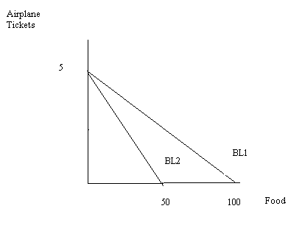

Answers:
a. BL1: Y = 12 – 4X
BL2: Y = 24 – 4X
The two budget lines have the same slope: the slope of the budget line is (-Px/Py) and since neither the price of shoes (Px) or the price of shirts (Py) have changed, the ratio of these two prices is unchanged. The two budget lines are parallel and this represents a change in income.
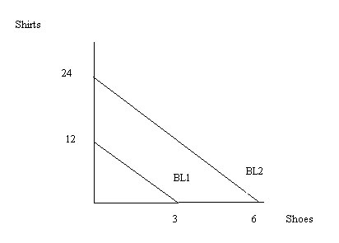
b. When sandwiches get more expensive this results in the budget line pivoting in along the horizontal axis: for a given amount of income, an increase in the price of sandwiches implies that the person cannot consume as many sandwiches as they could initially. BL2 pivots in toward the origin.
BL1: M = 75 – 2.5S
BL2: M = 75 – 5S
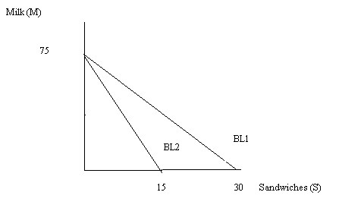
c. BL1: 500 = PtT + PfF
500 = PtT assuming that F = 0
500 = 5Pt
Pt = $100 per ticket
500 = PfF assuming that T = 0
Pf = $5 per unit of food
BL2: 500 = Pt’T + Pf’F
Since the y-intercept has not changed we know that Pt = Pt’ = $100 per ticket. To find Pf’, we know 500 = Pf’F and F = 50 when T = 0. So, Pf’ = $10 per unit of food

- Suppose you are told that Mary’s utility function is given by the equation U = 2XY where U is the level of utility measured in utils and X and Y refer to good X and good Y respectively. You are also told that the marginal utility of good X can be expressed as MUx = 2Y; and the marginal utility of good Y can be expressed as MUy = 2X.
  - In a graph draw three indifference curves illustrating Mary’s utility from consuming different bundles of X and Y: draw an IC1 representing utility of 20 (U = 20); and IC2 representing utility of 40; and an IC3 representing utility of 80. Make sure for each IC you identify at least three distinct points that lie on that IC. You will find it helpful to complete a table like the following for each IC. (In the table I have provided one possible solution and proposed two other numbers to try.)
U = 2XY = 20
X | Y
1 | 10
2 | ?
? | 5

  - Suppose you are told that Mary maximizes her utility at 40 utils when she selects 5 units of good X and 4 units of good Y when the price of good X is $4/unit of good X and the price of good Y is $5/unit of good Y. Prove that Mary is maximizing her utility given the information provided. Verbally as well as mathematically identify what must be true for Mary to be maximizing her utility.
  - Given the above information, calculate Mary’s income. Show how you found your answer.
  - Draw a graph illustrating Mary’s IC and her budget line as well as her utility maximizing bundle given the above information.

Answer:
a. Here are some possible (X, Y) combinations that yield utility of 20, 40, and 80 based on U = 2XY.
U = 2XY = 20  X Y | U = 2XY = 40  X Y | U = 2XY = 80  X Y
1 10 | 1 20 | 1 40
2 5 | 2 10 | 2 20
4 2.5 | 4 5 | 10 4
5 2 | 10 2 | 20 2
10 1 | 20 1 | 40 1

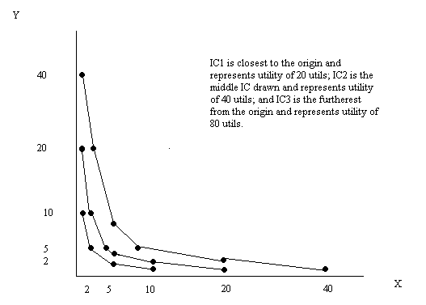
b. In order to maximize utility it must be the case that the addition to total utility from good X of spending one more dollar on good X must be equal to the addition to total utility from good Y of spending one more dollar on good Y. If this condition is not met, than the individual could rearrange their spending and increase their total utility. Mathematically this implies that (MYx/Px) = (MUy/Py). We can rearrange this equation to (MUx/MUy) = (Px/Py). Or, in absolute value terms, the slope of the budget line (-Px/Py) is equal to the slope of the indifference curve (MUx/MUy) when the individual maximizes his utility. This is our definition of the utility maximization rule for a consumer.
So, now let’s look at plugging in the information we’ve been given:
MUx = 2Y
MUy = 2X
Px = $4/unit of good X
Py = $5/unit of good Y
So, 2Y/2X = 4/5 or Y = (4/5)X
But, we also know that the combination (X, Y) = (5, 4) maximizes Mary’s utility. So,
4 = (4/5)(5) is a true statement.

c. I = PxX + PyY
I = ($4/unit of good X)(5 units of good X) + ($5/unit of good Y)(4 units of good Y)
I = $40

d.
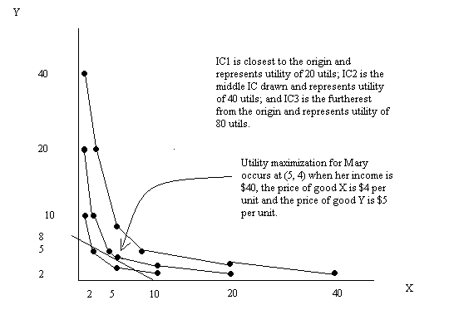
- Use the graph below to answer this question.
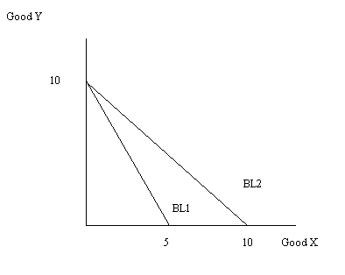
You are told that Wei’s income is $100 and he spends all of this income on either good X or good Y. BL1 is his initial budget line.
a. Given BL1 and the above information, what is the price of good X and the price of good Y?
b. The graph also depicts Wei’s BL2. What is a likely explanation for why Wei’s budget line changed from BL1 to BL2? Be specific in your answer.
c. Suppose you are told that Wei consumes 3 units of good X and 4 units of good Y when he maximizes his utility subject to his income and the prices of good X and good Y he faces with BL1. When Wei’s budget line is BL2, he maximizes his utility by consuming 8 units of good X. Given this information, how many units of good Y does he consume if he faces BL2 and he is maximizing his utility?
d. If we constrain Wei to have the same utility as he had when he faced BL1, but assume he is now facing the new prices of BL2, will this new BL (in class this was “BL3”) relative to BL2 reflect an increase or a decrease in income? Explain your answer.
e. Suppose you are told that on BL3 Wei maximizes his utility when he consumes the bundle (X, Y) = (5, 2). From the given information calculate Wei’s income and substitution effect. (Hint: you may find it helpful to draw a graph before answering this question.)
f. Given the above information, what is Wei’s adjusted income for BL3?

Answer:
a. If Wei spends all of his income on good X, he can afford 5 units. So, Income/(5 units) = $100/(5 units of good X) = $20 per unit of good X. The price of good X is $20 per unit of good X. Similarly, if Wei spends all of his income on good Y he can afford 10 units: so Income/(10 units of good Y) = $100/(10 units of good Y) = $10 per unit of good Y. The price of good Y is $10 per unit of good Y.
b. BL1 and BL2 have different slopes but the same y-intercept. This implies that the price of good X has changed while income and the price of good Y have remained constant. The price of good X has decreased since Wei can now afford more of good X: the price of good X is now $10 per unit of good X.
c. We can write the equation for Wei’s BL2 as Y = 10 – X. If X = 8 units, then Wei must be consuming Y = 10 – 8 = 2 units of good Y.
d. When the price of good X decreases Wei’s budget line changes from BL1 to BL2: although Wei’s nominal income has not changed his real purchasing power has increased when the price of good X decreases. Thus, when we construct BL3 this must reflect a decrease in Wei’s income (an imagined decrease) from that represented in BL2.
e. The substitution effect is 2 units of good X and the income effect is 3 units of good X. The graph below illustrates this.
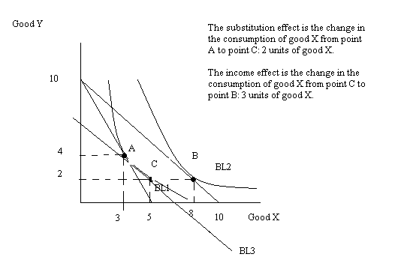
f. On BL3 we know the price of good X is $10 and the price of good Y is $10. Wei maximizes his utility by consuming the bundle (X, Y) = (5, 2) and we can calculate that he would need income = ($10 per unit of good X)(5 units of good X) + ($10 per unit of good Y)(2 units of good Y) = $70.

- Mario’s Widgets produces widgets and his production function for these widgets is given by the equation:
W = 2K^{.5}L^{.5}
where W is widgets, K is capital, and L is labor. Mario’s Widgets uses only capital and labor to produce the widgets. In the short run, Mario’s Widgets capital is equal to 4 units. Mario’s Widgets pays $10 per unit of capital and $20 per unit of labor. Use this information to answer this set of questions. Hint: you will find it helpful to use Excel to do this set of questions.
a. In the short run, what is the fixed cost associated with widget production?
b. For the short run, write an equation for Mario’s Widgets variable cost of widget production.
c. For the short run, write an equation for Mario’s Widgets total cost of production.
d. Complete the following table given the above information. All calculations should be rounded to two places past the decimal. (Hint: this is where you will want to start using Excel.)
L | K | W | MPL | VC | FC | TC | AVC | AFC | ATC | MC
0
1
4
9
16
25
36
49
64
81
100

Answer:
a. FC = PkK = ($10 per unit of K)(4 units of K) = $40
b. VC = PlL = ($20 per unit of L)(units of L) = 20L
c. TC = FC + VC = 40 + 20L
d.
L | K | W | MPL | VC | FC | TC | AVC | AFC | ATC | MC
0 | 4 | 0 |  | 0 | 40 | 40
1 | 4 | 4 | 4.00 | 20 | 40 | 60 | 5 | 10.00 | 15.00 | 5
4 | 4 | 8 | 1.33 | 80 | 40 | 120 | 10 | 5.00 | 15.00 | 15
9 | 4 | 12 | 0.80 | 180 | 40 | 220 | 15 | 3.33 | 18.33 | 25
16 | 4 | 16 | 0.57 | 320 | 40 | 360 | 20 | 2.50 | 22.50 | 35
25 | 4 | 20 | 0.44 | 500 | 40 | 540 | 25 | 2.00 | 27.00 | 45
36 | 4 | 24 | 0.36 | 720 | 40 | 760 | 30 | 1.67 | 31.67 | 55
49 | 4 | 28 | 0.31 | 980 | 40 | 1020 | 35 | 1.43 | 36.43 | 65
64 | 4 | 32 | 0.27 | 1280 | 40 | 1320 | 40 | 1.25 | 41.25 | 75
81 | 4 | 36 | 0.24 | 1620 | 40 | 1660 | 45 | 1.11 | 46.11 | 85
100 | 4 | 40 | 0.21 | 2000 | 40 | 2040 | 50 | 1.00 | 51.00 | 95

10. Consider a production function for a firm:
Q = 2K^{1/2}L^{1/2}
where Q is output, K is capital, and L is labor. Suppose initially K is equal to 25 units and L is equal to 16 units. You also know that the price of K, Pk, is $10 per unit of K and the price of L, Pl, is $4 per unit of L.
a. Given the above information, what is the value of output?
b. What is the total cost of producing the output you calculated in (a)?
c. What is the average total cost of producing this level of output?
d. Suppose the amount of labor increases to 32 units and the amount of capital increases to 50 units. Given this information, what level of output can the firm now produce? (Hint: you can do this without a calculator – and, then you can check your answer with a calculator!)
e. Given the information in (d), what is the total cost for the firm of producing this level of output?
f. Given the information in (d) and (f), calculate the firm’s average total cost of producing this new level of output.
g. Given your answer to the above set of questions, what can you conclude about returns to scale for this firm?

Answer:
a. Q = 2K^{1/2}L^{1/2}
Q = 2(25)^{1/2}(16)^{1/2}
Q = (2)(5)(4)
Q = 40 units of output
b. TC = PlL + PkK
TC = ($4 per unit of L)(16 units of L) + ($10 per unit of K)(25 units of K)
TC = $314
c. ATC = TC/Q
ATC = $314/(40 units of output)
ATC = $7.85 per unit of output
d. Q’ = 2K^{1/2}L^{1/2}
Q’ = 2(50)^{1/2}(32)^{1/2}
Q’ = 2(2)^{1/2}(25)^{1/2} (2)^{1/2}(16)^{1/2}
Q’ = 2(2)(5)(4)
Q’ = 80 units of output
e. TC’ = PlL + PkK
TC’ = ($4 per unit of L)(32 units of L) + ($10 per unit of K)(50 units of K)
TC’ = $128 + $500
TC’ = $628
f. ATC’ = TC’/Q’
ATC’ = $628/(80 units of output)
ATC’ = $7.85 per unit of output
g. When the amount of labor and capital is increased proportionately (in this example these inputs were doubled) output doubles, total cost doubles, and average total cost remains constant. This implies this firm has constant returns to scale.

11. Consider a production function for a firm:
Q = 2KL^{1/2}
where Q is output, K is capital, and L is labor. Suppose initially K is equal to 25 units and L is equal to 16 units. You also know that the price of K, Pk, is $10 per unit of K and the price of L, Pl, is $4 per unit of L.
a. Given the above information, what is the value of output?
b. What is the total cost of producing the output you calculated in (a)?
c. What is the average total cost of producing this level of output? Round your answer to the nearest hundredth.
d. Suppose the amount of labor increases to 32 units and the amount of capital increases to 50 units. Given this information, what level of output can the firm now produce? (Hint: you can do this without a calculator – and, then you can check your answer with a calculator!)
e. Given the information in (d), what is the total cost for the firm of producing this level of output?
f. Given the information in (d) and (f), calculate the firm’s average total cost of producing this new level of output.
g. Given your answer to the above set of questions, what can you conclude about returns to scale for this firm over the range of output you have considered?

Answer:
a. Q = 2KL^{1/2}
Q = 2(25)(16)^{1/2}
Q = 50(4)
Q = 200 units of output
b. TC = PlL + PkK
TC = ($4 per unit of L)(16 units of L) + ($10 per unit of K)(25 units of K)
TC = $314
c. ATC = TC/Q
ATC = $314/(200 units of output)
ATC = $1.57 per unit of output
d. Q’ = 2KL^{1/2}
Q’ = 2(50)(32)^{1/2}
Q’ = 100(4)(2)^{1/2}
Q’ = 100(4)(1.42)
Q’ = 568 units of output
e. TC’ = PlL + PkK
TC’ = ($4 per unit of L)(32 units of L) + ($10 per unit of K)(50 units of K)
TC’ = $628
f. ATC’ = TC’/Q’
ATC’ = $628/(568 units of output)
ATC’ = $1.11 per unit of output
g. When the amount of L and K is increased proportionately (in this example, these inputs were doubled) output increased by more than double (it increased by a factor greater than 2), total cost doubled (it increased by a factor of 2), and average total cost declined. This implies that as output expanded from 200 units to 568 units, the firm’s cost per unit declined: this firm has increasing returns to scale over this range of output.

