Economics 101
Spring 2020
Answers to Homework #3
Due 3/12/20

Directions: The homework will be collected in a box before the lecture. Please place your name, TA name and section number on top of the homework (legibly). Make sure you write your name as it appears on your ID so that you can receive the correct grade. Late homework will not be accepted so make plans ahead of time. Please show your work. Good luck!
Please realize that you are essentially creating “your brand” when you submit this homework. Do you want your homework to convey that you are competent, careful, professional? Or, do you want to convey the image that you are careless, sloppy, and less than professional. For the rest of your life you will be creating your brand: please think about what you are saying about yourself when you do any work for someone else!

1. Consider a small economy whose market for pies is described by the following demand and supply equations where P is the price per pie and Q is the quantity of pies:

Domestic Demand: P = 80 – (1/20)Q
Domestic Supply: P = 20 + (1/80)Q

Suppose this economy opens the pie market to trade and that the world price is $22 per pie.

a) Given this information and assuming that this domestic economy opens its pie market to trade, find the number of imports, the number of exports, the value of consumer surplus with trade (CStrade), the value of producers surplus with trade (PStrade), and the value of total surplus with trade (TStrade). Explain how you found your answers.

Suppose a tariff of $4.00 per pie is imposed on this good by the domestic economy’s government.

b) Given this tariff, find the values of the following items. Show how you found your answers.

Number of imports with tariff = _________________
Number of exports with tariff = ________________
Government tariff revenue = ____________________
CStariff = _____________________
PStariff = ___________________
DWL with tariff = ____________________

c) From the perspective of this domestic economy analyze the impact of this tariff. Who benefits from the tariff and how do they benefit? Who loses from the imposition of the tariff and what is their loss?

Answers:
a) The world price is $22 per pie and we can use this price to find the quantity demanded and the quantity supplied. Thus:
22 = 80 – (1/20)Qd
(1/20)Qd = 58
Qd = 1160 pies
22 = 20 + (1/80)Qs
(1/80)Qs = 2
Qs = 160 pies
Imports = Qd = Qs
Imports = 1160 – 160 = 1000 pies
Since the Qd is greater than the Qs, we know that this economy will import pies. Therefore, the number of exports is equal to 0 pies in this market.

CStrade = (1/2)($80 per pie - $22 per pie)(1160 pies) = $33,640
PStrade = (1/2)($22 per pie - $20 per pie)(160 pies) = $160
TStrade = CStrade + PStrade = $33,640 + $160 = $33,800

b) Number of imports with tariff = 400 pies
Number of exports with tariff = 0 pies
Government tariff revenue = $2400
CStariff = $29,160
PStariff = $1440
DWL with tariff = $800

To find the number of imports with tariffs: plug the tariff price of $26 per pie into the domestic demand curve and then into the domestic supply curve to determine the quantity demanded domestically with the tariff and the quantity supplied domestically with the tariff. Thus, 26 = 80 – (1/20)(Qd with tariff) and Qd with tariff = 1080 pies. And, 26 = 20 + (1/80)(Qs with tariff) and Qs with tariff = 480 pies. The number of imports with the tariff will equal (Qd with tariff) – (Qs with tariff) = 600 pies.

There will be no exports with the tariff since the price with the tariff will still be lower than the closed economy price. This country will continue to import the good after it imposes the tariff.

Government tariff revenue = (Tariff per pie)(Number of Imports)
Government tariff revenue = ($4 per pie)(600 pies)
Government tariff revenue = $2400

CStariff = (1/2)($80 per pie - $26 per pie)(1080 pies) = $29,160

PStariff = (1/2)($26 per pie - $20 per pie)(480 pies) = $1440

DWL with tariff = (1/2)($26 per pie - $22 per pie)(480 pies – 160 pies) + (1/2)($26 per pie - $22 per pie)(1160 pies – 1080 pies) = $800

c) Imposition of the tariff benefits domestic producers since the tariff enables them to sell the good at a higher price than the world price while also enabling domestic producers to sell more of the product than they would if this were just an open economy. Producer surplus increases with the tariff relative to producer surplus in the open economy.

Imposition of the tariff hurts domestic consumers. They get less of the good (1080 pies rather than 1160 pies) and they pay more per pie ($26 per pie versus $22 per pie). Consumer surplus decreases with the tariff relative to consumer surplus in the open economy.

2. Consider a small economy whose market for printers is described by the following demand and supply equations where P is the price per printer and Q is the quantity of printers:

Domestic Demand: P = 200 - 10Q
Domestic Supply: P = 20 + 10Q

The world price is $60 for a printer.

a) Suppose this is initially a closed economy. Find the equilibrium price and equilibrium quantity of printers in this closed economy.

b) Now, suppose this economy opens its printer market to trade. What will be the price of a printer given this decision? Calculate the number of printers produced by domestic producers, the number of printers demanded by domestic consumers, the number of imported printers into this economy, and the number of exported printers from this economy. Show how you found your answers.

Suppose the government in this small domestic economy imposes an import quota of 6 printers in this market once it is open to trade.

c) Given this import quota and the provided information, find the values for the following (make sure you explain how you got your answer!). Hint: you might find it helpful to draw a graph to guide your work.
Price with the import quota = ___________________
Quantity of Printers demanded domestically with the import quota = _________________
Quantity of Printers supplied domestically with the import quota = _________________
DWL due to the imposition of the import quota = __________________________
License Holder Revenue with the imposition of the import quota = _________________

Answers:
a) To find the equilibrium price and equilibrium quantity in the closed economy set the demand equation equal to the supply equation: thus,
200 – 10Q = 20 + 10Q
20Q = 180
Q = 9 printers
P = 200 – 10(9) = $110 per printer
Or, P = 20 + 10(9) = $110 per printer

b) The price of printers in the domestic economy will equal the world price of $60 per printer once this economy opens its printer market to trade.

Domestic producers will produce 4 printers at this price: 60 = 20 + 10Qs or Qs, the quantity supplied domestically, is equal to 4 printers.

Domestic consumers will consume 14 printers at this price: 60 = 200 – 10Qd or Qd, the quantity demanded domestically, is equal to 14 printers.

The number of printers imported into this domestic economy will equal Qd – Qs or 10 printers.

There will be no printers exported from this domestic economy because the world price is less than the closed economy price of a printer for this domestic economy.

c) Here are the answers followed by an explanation of how to find these answers.
Price with the import quota = $80 per printer
Quantity of Printers demanded domestically with the import quota = 12 printers
Quantity of Printers supplied domestically with the import quota = 6 printers
DWL due to the imposition of the import quota = $40
License Holder Revenue with the imposition of the import quota = $120

To find these answers I find it helpful to start with a graph that illustrates the domestic demand curve, the domestic supply curve, the world price, and the import quota:
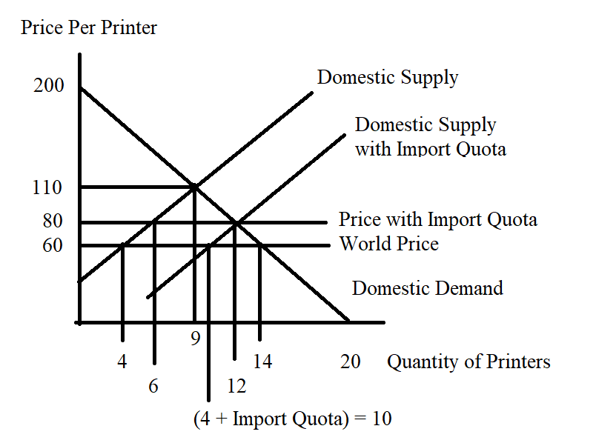
Now, we need to add in the import quota to the graph. I am going to provide two methods to use when analyzing the impact of an effective import quota: you should review both of these methods and then determine which method is easier for you to understand and implement.

Method One:
We know the effect of the quota is to shift the Supply curve in this market to the right by the amount of the quota: the new supply curve will have the same slope as the original supply curve but it will have a different y-intercept. Thus, the new supply curve with the import quota will be P = b + 10Q where “b” is the new y-intercept. We can find the value of “b” by substituting in one point that we know sits on this new supply curve: (10, 60) or (15, 110) are two points that we can easily see from the above graph as points that would sit on this new supply curve. Let’s use (10, 60): 60 = b + 10(10) or b = -40. The new supply curve that includes the import quota is therefore P = 10Q – 40.

Combine this new supply curve with the demand curve to find the price with the quota, the total quantity provided in the market and the total quantity domestically demanded in the market (these will be the same amount), the quantity domestically supplied in the market, the license holder revenue, and the deadweight loss. So, 10Q – 40 = 200 – 10Q and solving for Q we get Q = 12 printers = the quantity demanded domestically. We can find the price with the quota by using this quantity in the demand equation: Pquota = 200 – 10(Q) or Pquota = 200 – 10(12) = $80 per printer. To get the quantity supplied domestically we can use the Pquota and the original supply equation: 80 = 20 + 10(Qs) or Qs = the quantity supplied domestically = 6 printers. DWL = (1/2)($80 per printer - $60 per printer)(6 printers – 4 printers) + (1/2)($80 per printer - $60 per printer)(14 printers – 12 printers) = $40. License Holder Revenue = ($80 per printer - $60 per printer)(6 printers) = $120. The graph below illustrates these ideas.
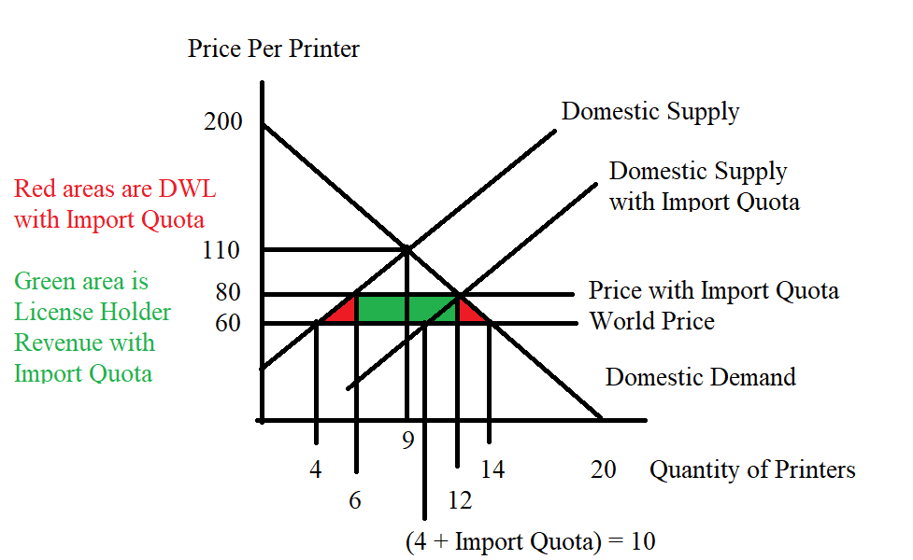

Method Two:
With an import quota, the market equates the quantity supplied domestically plus the import quota amount to the quantity demanded domestically: or, symbolically
Qs + import quota = Qd
We can replace Qs with (1/10)P – 2 from the original supply curve (just solve this supply curve for Qs); we can replace Qd with 20 – (1/10)P from the domestic demand curve; and we can replace the import quota with 6 printers since this is the amount of the import quota. Thus,
(1/10)P – 2 + 6 = 20 – (1/10)P
(2/10)P = 16
P with the quota = $80 per printer
Qs = the quantity supplied domestically with the import quota = (1/10)(80) – 2 = 6 printers
Qd = the quantity demanded domestically with the import quota = 20 - (1/10)(80) = 12 printers
Note that the difference between Qd and Qs is 6 printers or the amount of the import quota.

The calculations of CS with the quota, PS with the quota, license holder revenue, and DWL are the same as discussed under Method One.

3. It is Thanksgiving and once again Uncle Stu and Rooster have gotten into a heated argument (this happens every year!). Rooster's son just got hired in an entry-level management position where he will earn $28,000 during his first year of employment. Uncle Stu is long retired, but he is busy reminiscing about the “good old days” and he insists that life was much tougher for him when he was starting out. In fact, he states that his first job paid him only $2000 a year. Uncle Stu got this job in 1950 while Rooster's son got his job in 2018 (the 2019 data weren’t available last Thanksgiving).

a. Rooster argues that Uncle Stu is making a serious error in his argument. Write an explanation about what you think Uncle Stu’s error is.

Rooster goes to the computer and finds the Bureau of Labor Statistics site that provides him with the Consumer Price Index for 1950, 2018, and for the base year 1982-1984 (this reflects the use of a "chain-weighted index" method). The CPI index numbers we are using here are for the Average Annual CPI for all Urban Consumers based on a U.S. City Average.

Year | CPI with base year 1982-1984
1950 | 24.1
1982-1984 | 100.00
2014 | 251.107

b. Given the above data, what scale is the CPI measured on?

c. Compute the following table’s missing values using 1982-1984 as the base year. Make sure you show the work you did to get the missing values. Round your answer to the nearest whole number.

 | Nominal Value | Real Value using 1982-1984 as Base Year
Uncle Stu’s Salary
Rooster’s Son's Salary

d) Compute the following table’s missing values using 2018 as the base year. Make sure you show the work you did to get the missing values. Round your answer to the nearest whole number.

 | Nominal Value | Real Value using 2018 as Base Year
Uncle Stu’s Salary
Rooster’s Son's Salary

e) Uncle Stu contends that Rooster’s son's salary is 14 times greater than his starting salary was. Thus, Uncle Stu concludes that Rooster's son has it much easier than Uncle Stu did when he was first starting out. Analyze this argument and provide some clarity for these two relatives! (If you need to in your answer, round any calculations to two places past the decimal.)

Answer:
a) Uncle Stu’s error is that he is comparing a 1950 dollar to a 2018 dollar: dollars do not maintain constant purchasing power over time so basically Uncle Stu is comparing salaries that are measured in units that do not have the same value over time. Uncle Stu needs to convert these nominal salaries into real salaries if he wants to compare salaries from two different points in time.

b) The CPI is measured on a 100 point scale: we can see this since the base year CPI is given as 100.

c)
 | Nominal Value | Real Value using 1982-1984 as Base Year
Uncle Stu’s Salary | $2000 | 2000(100)/24.1 = $8298.75
Rooster’s Son's Salary | $28,000 | 28000(100)/251.107 = $11,150.63

d)

 | Nominal Value | Real Value using 2018 as Base Year
Uncle Stu’s Salary | $2000 | (2000*100)/((24.1*100)/(251.107)) = $20,838.76
Rooster’s Son's Salary | $28,000 | [28000(100)]/[(251.107)(100)/(251.107)] = $28,000

e) Uncle Stu gets his number by comparing the ratio of Rooster’s son's nominal salary to his own nominal salary:

Nominal salary ratio = (28,000)/(2000) = 14

But, this is essentially comparing apples and oranges since the two salaries are measured using nominal dollars. So, let’s compare the real salary ratio (note it will not matter which year you use as base year in this calculation):

Real salary ratio using 1982-1984 as the base year = Rooster’s son's real salary/Uncle Stu’s real salary
Real salary ratio using 19882-1984 as the base year = $11,150.63/$8298.75 = 1.34365

Real salary ratio using 2018 as the base year = Rooster’s real salary/Uncle Stu’s real salary
Real salary ratio using 2018 as the base year = $28,000/$20,838.76 = 1.34365

Uncle Stu overstates the difference in their two salaries: Rooster's son is earning more than Uncle Stu and thus has it “easier” if we only look at real purchasing power (he might have job stresses and uncertainties that Uncle Stu never faced-but, we are not valuing these items here), but he is earning 1.34 times more in terms of real purchasing power than Uncle Stu did in his entry job and not 14 times more.

4. Consider the following demand curve for computers where P is the price per computer and Q is the quantity of computers.

Demand: Q = 6000 – 3P

a) Fill in the following table using the above information.

P | Q | Total Revenue = TR
$0
120
180
200
250
450
600
800

b) In your own words describe what happens to total revenue if the price of this good goes from $900 to $1200. In your answer make sure you include references to the price and quantity effects.

c) What is the maximum total revenue that could be earned given this demand curve and holding everything else constant? Assume that the supplier is free to set any price they want and their goal is to set their price to maximize their total revenue. Note: this price may not be in the table you just filled in!

Answer:
a)
P | Q | Total Revenue = TR
$0 | 6000 | $0
120 | 5640 | $676,800
180 | 5460 | $982,800
200 | 5400 | $1,080,000
250 | 5250 | $1,312,500
450 | 4650 | $2,092,500
600 | 4200 | $2,520,000
800 | 3600 | $2,880000

b) In this example, when the price is $900, the quantity demanded is 3300 computers and the total revenue is $2,970,000; when the price rises to $1200, the quantity demanded is 2400 computers and the total revenue is $2,880,000. When price increases fewer units will be demanded and this quantity effect will cause total revenue to fall instead of selling 3300 computers only 2400 computers are demanded and therefore (900)($900) or $810,000 in total revenue is lost due to the quantity effect. But, the price effect causes total revenue to increase: the good is selling for $300 more and there are 2400 computers demanded at this higher price-this implies that the price effect is an increase in total revenue of (2400)($300) or $720,000. Combining these two effects we see that total revenue decreases by $720,000 - $810,000 or -$90,000.

c) Total revenue will be maximized at the midpoint of this market demand curve. This will occur at a price of $1000 and a quantity of 3000 computers for an amount of total revenue equal to $3,000,000.

5. Consider the following market demand and market supply curves for staplers where P is the price per stapler and Q is the quantity of staplers.

Demand: P = 22 – (1/100)Q
Supply: P = 4 + (1/200)Q

a) Given the above information find the equilibrium price and quantity in this market. Show your work.

b) Calculate the point elasticity of demand at equilibrium. Provide the general formula and show your calculations. Is demand elastic or inelastic? Explain your answer. Given this answer, will producers enhance their total revenue by increasing or by decreasing the price they charge for staplers?

c) Calculate the point elasticity of supply at equilibrium. Provide the general formula and show your calculations. Is supply elastic or inelastic? Explain your answer.

d) Suppose the price increases by $2.00. Using the arc elasticity formula calculate the price elasticity of demand between the initial equilibrium and this new point on the demand curve. Provide the general formula and show your work. Is demand inelastic or elastic? Explain your answer. Assume that this price increase is due to a shift in supply and that there is only a movement along the original demand curve.

Answer:
a) Set demand equal to supply: thus,
22 – (1/100)Q = 4 + (1/200)Q
18 = (3/200)Q
Q = 1200 staplers
P = 22 – (1/100)Q = 22 – (1/100)(1200) = $10.00 per staplers
Or, P = 4 + (1/200)Q = 4 + (1/200)(1200) = $10.00 per staplers

b) Point elasticity of demand = (-1/slope)(P/Q) = (1/(1/100))(10/1200) = 5/6
Since the value of point elasticity of demand is less than one, we can conclude that demand is inelastic at the equilibrium point. We can also see that total revenue will increase if producers raise the price of staplers since demand is inelastic.

c) Point elasticity of supply = (1/slope)(P/Q) = (1/(1/200))(10/1200) = 5/3
Since the value of point elasticity of supply is greater than one, we can conclude that supply is elastic at the equilibrium point.

d) When the price of staplers is $12 per stapler, the quantity demanded is equal to 1000 staplers. We can use these two points on the demand curve (Q, P) = (1200, 10) and (1000, 12) and the formula for arc elasticity of demand to make this calculation. Here is the formula:
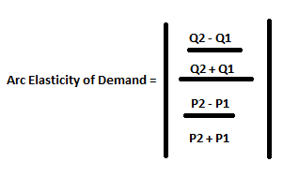
Arc elasticity of demand = │[(1000 - 1200)/(1000 + 1200)]/[(12 - 10)/(12 + 10)]│
Arc elasticity of demand = [(200)/(2200)]/[(2)/(22)] = (1/11)/(1/11) = 1
Since the measure of demand elasticity is equal to one, we can conclude that demand is unit elastic over this range. Note: we are moving symmetrically about the midpoint of the demand curve and that is why we are getting this result.

6. a. You are told that the income elasticity of demand for bicycles is equal to 7. What does this mean if incomes in an economy decrease by 2%?

b. You are told that the cross price elasticity of demand for bicycles and bike helmets is -1.5. What does this mean if the price of a bike helmet increases by 8%?

c. You are told that the cross price elasticity of demand for bicycles and bus fares is equal to 1.5. What does this mean if the price of a bus fare decreases by 20%?

Answer:
a. Income elasticity is equal to the percentage change in the quantity demanded divided by the percentage change in income. So, 7 = (percentage change in the quantity demanded)/(-2%) implies that the percentage change in the quantity demanded is -14%. Thus, when incomes decrease by 2%, the quantity of bicycles demanded decrease by 14%. This would be bad news if you were in the business of selling bicycles! Since income decreased and the quantity of bicycles demanded decreased, this tells us that bicycles are a normal good.

b. The cross price elasticity of demand is the percentage change in the quantity demanded of good X divided by the percentage change in the price of good Y. So, -1.5 = (percentage change in the quantity demanded of bicycles)/(8%) implies that the percentage change in the quantity demanded of bicycles was -12%. Thus, when the price of bike helmets increases by 8%, then the quantity of bicycles demanded decreases by -12%. These two goods are complements.

c, The cross price elasticity of demand is the percentage change in the quantity demanded of good X divided by the percentage change in the price of good Y. So, 1.5 = (percentage change in the quantity demanded of bicycles)/(-20%) implies that the percentage change in the quantity demanded of bicycles was -30%. Thus, when the price of bus fares decreases by 20%, then the quantity of bicycles demanded decreases by 30%. These two goods are substitutes.

7. Sam has $200 in income that he can spend on either good X or good Y. Good X costs $2 per unit while good Y costs $4 per unit.

a) Given the above information, draw a graph of Sam’s budget line (call it BL1) and write an equation in slope-intercept form for Sam’s budget line measuring good Y as the good on the vertical axis.

b) Given Sam’s income and the prices of these two goods and given Sam’s preferences he finds that he maximizes his satisfaction when he chooses to consume bundle A which consists of 60 units of good X and 20 units of good Y. Can Sam afford this bundle given his income and the prices of the two goods? Prove this mathematically. Does consumption of bundle A exhaust Sam’s available income?

c) Suppose that the price of good X increases to $4. Sam’s income and the price of good Y stay constant. Sam now finds that he maximizes his satisfaction when he consumes consumption bundle B which consists of 28 units of good X. Draw a graph that represents Sam’s BL1, his new budget line (BL2), bundle A and bundle B. Calculate how many units of good Y Sam consumes when he consumes consumption bundle B (make sure you show how you found this answer). Mark bundle B in your graph.

d) Suppose that Sam was constrained to stay on his first indifference curve-the one that bundle A sits on- while paying the new price for good X. We can construct this budget line 3 where Sam’s income has been compensated (in this case increased) so that he can reach the indifference curve that bundle A is on. On budget line 3 Sam finds that he maximizes his satisfaction by consuming bundle C which consists of 40 units of good x and 30 units of good Y. Draw a graph that illustrates BL1, BL2, BL3, bundle A, bundle B, and bundle C. Sketch in indifference curve 1 and indifference curve 2 in your graph.

e) How much would Sam’s income have to be increased by in order for him to have the same utility as he had initially while now facing the higher price for good X? You have all the necessary information at hand to calculate this increase in income. Show how you found your answer.

f) What is the amount of the substitution effect for good X given the above information? What is the amount of the income effect for good X given the above information? Explain your answer.

Answer:
a)
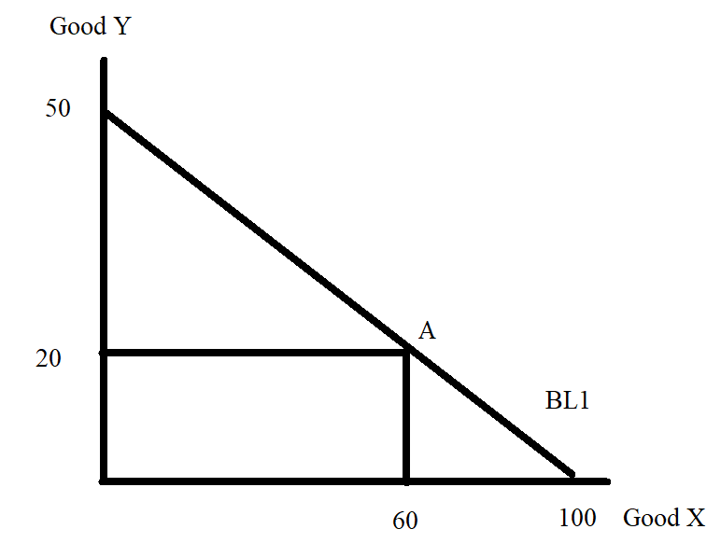
Y = 50 – (1/2)X

b) Bundle A consists of (X, Y) = (60, 40). We know that the price of good X is $2 per unit and the price of good Y is $4 per unit. 60 units of good X will cost $120 and 20 units of good Y will cost $80, for a total cost of $200. Since Sam's income is $200, he can afford this consumption bundle and his income will be exhausted (completely used up) when he purchases this bundle.

We know that the budget line for the two goods X and Y can be expressed as:
Income = (Price of good X)(Quantity of good X) + (Price of good Y)(Quantity of good Y)
$200 = ($2 per unit of good X)(60 units of good X) + ($4 per unit of good Y)(20 units of good Y)
200 = 120 + 80
This is a true statement: that tells us that the consumption bundle A sits on Sam's budget line 1.

c)
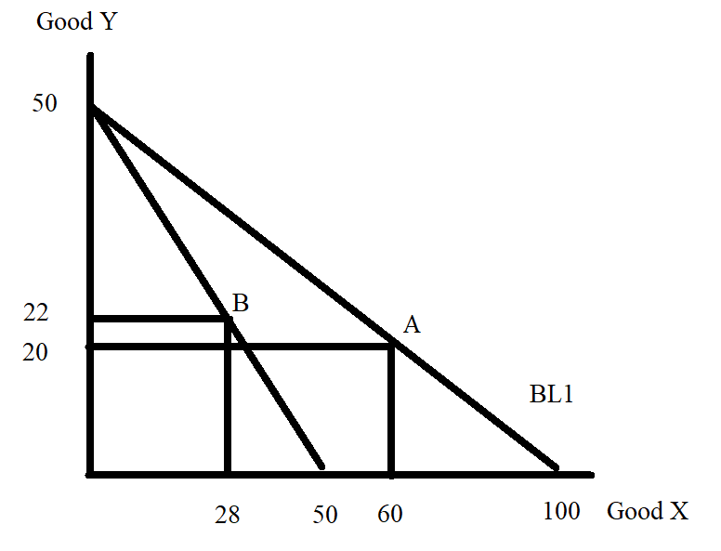
For BL2: Income = (New Price of good X)(Quantity of good X) + (Price of good Y)(Quantity of good Y)
200 = ($4 per unit of good X)(28 units of good X) + ($4 per unit of good Y)(Quantity of good Y)
200 = 112 – 4Y' where Y' is the Quantity of good Y
88 = 4Y'
Y' = 22

d)
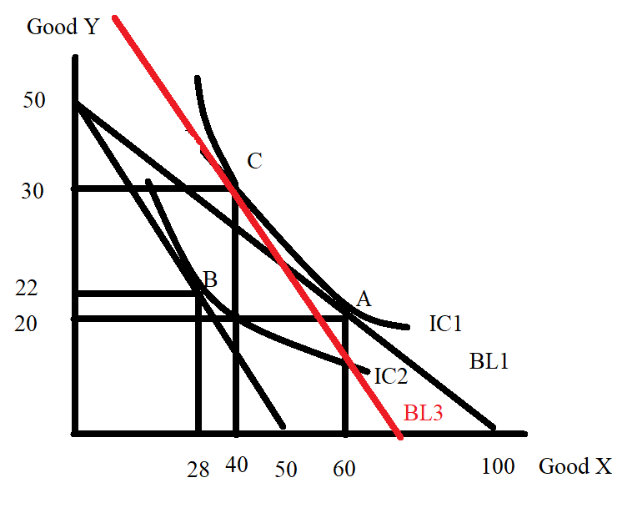
This is not a beautifully "drafted" image, but it gives the "flavor" of what is happening. Point A is just tangent to BL1 and lies on IC1. Point C is tangent to BL3 (new prices and compensated income) and lies on IC1 (same satisfaction as Sam gets at Point A). Point B is just tangent to BL2 (new prices and original income) and lies on IC2.

e) At Bundle C we know that Sam consumes 40 units of good X at a price of $4 per unit of good X and 30 units of good Y at a price of $4 per unit of good Y. We can therefore calculate the income Sam must have in order to consume this bundle:
Income' = ($4 per unit of good X)(40 units of good X) + ($4 per unit of good Y)(30 units of good Y)
Income' = 160 + 120 = $280
Sam needs a total of $280 in order to consume bundle C. If we were to compensate Sam so that when facing the new prices he had the same satisfaction or utility he got from Bundle A we would need to increase his income by $80 from $200 to $280.

f) The substitution effect can be measured as the change in good X as Sam moves from Bundle A to Bundle C: the substitution effect is therefore a decrease of 20 units (60 units of good X – 40 units of good X = 20 units of good X). Sam consumes 20 units less of good X due to the change in the relative price of good X.

The income effect can be measured as the change in good X as Sam moves from Bundle C to Bundle B: the income effect is therefore a decrease of 12 units (40 units of good X – 28 units of good X = 12 units of good X). Sam consumes 12 units less of good X due to the reduction in his purchasing power that occurs when the price of good X increases.

8. Consider a small, closed economy whose market for pies is described by the following demand and supply equations where P is the price per pie and Q is the quantity of pies:

Domestic Demand: P = 40 – (1/20)Q
Domestic Supply: P = (1/80)Q

a) Assume this market is a closed market. Find the equilibrium price, equilibrium quantity, the value of consumer surplus (CS), and the value of producer surplus (PS). Show your work.

Suppose this economy opens the pie market to trade and that the world price is $12 per pie.

b) Verbally explain whether this small economy will import or export pies given this information.

c) Now, provide a numerical value for your answer in (b). Make sure you show how you found your answer.

d) Suppose this market is still open to trade. Calculate the value of CS in the domestic economy when this market is open to trade (CStrade) and the value of PS in the domestic economy when this market is open to trade (PStrade).

e) Economists state that “trade is beneficial but has distributional consequences”. Explain this statement using your calculations in this problem as proof to support this statement.

Answers:

a) To find the equilibrium price and equilibrium quantity set the demand curve equal to the supply curve: thus, 40 – (1/20)Q = (1/80)Q
80(40) – 4Q = Q
5Q = 80(40)
Q = 640 pies
P = 40 – (1/20)Q
P = 40 – (1/20)(640) = $8 per pie
Or, P = (1/80)Q
P = (1/80)(640) = $8 per pie
CS = (1/2)($40 per pie - $8 per pie)(640 pies) = $10,240
PS = (1/2)($8 per pie - $0 per pie)(640 pies)
PS = $2560

b) Since the closed domestic economy price of a pie is less than the world price of a pie we can conclude that this small economy will export pies if this market is open to trade. Domestic producers who have been selling pies for $8 per pie will be quite happy to export pies to the world market where they can sell the pies for $12 per pie.

c) If t4e world price is $12 per pie, then putting this price into the demand equation we get the following:
12 = 40 – (1/20)(Qd)
Qd = 560 pies
That is, at the world price of $12 per pie, domestic demand for pies is equal to 560 pies.
Putting this price into the supply equation we get the following:
12 = (1/80)(Qs)
Qs = 960 pies
That is, at the world price of $12 per pie, domestic supply of pies is equal to 960 pies.
Exports = Qs – Qd or
Exports = 960 pies – 560 pies = 400 pies

d) CStrade = (1/2)($40 per pie - $12 per pie)(560 pies) = $7840
PStrade = (1/2)($12 per pie - $0 per pie)(960 pies) = $5760

e) In the closed economy CS + PS = total surplus or TS. In the closed economy the TS is equal to $12,800. In the open economy TStrade is equal to CStrade + PStrade or $13,600. Clearly TS increases with trade: thus trade is beneficial. But, we can also see that there are winners and losers with this trade. CS in the closed economy is greater than CS in the open economy: domestic consumers will find that opening this market to trade results in their being worse off since they now must pay more for each pie and they end up consuming fewer pies. PS in the closed economy is smaller than PS in the open economy: domestic producers will find that opening this market to trade results in their being better off since they now receive a higher price per pie and they also sell more pies.

9. Consider the market for clocks where the market demand and market supply curves are given by the equations below where P is the price per clock and Q is the quantity of clocks:

Market Demand: P = 500 – 10Q
Market Supply: P = 100 + (10/3)Q

a) Given the above information, find the equilibrium price and quantity in this market. Then calculate the value of consumer surplus (CS) and producer surplus (PS).

b) Draw a graph illustrating this market and in your graph identify the equilibrium price, equilibrium quantity, all intercepts, the area that is CS and the area that is PS.

Suppose that the government in this economy decides to impose an excise tax of $80 per clock on producers of clocks.

c) Given this excise tax, write an equation that represents the supply curve in this market now that producers have this new additional cost.

d) Given this excise tax, find the new price consumers will pay for a clock in this market, the new price producers will receive for a clock in this market once they have met their legal obligation to the government to remit the excise tax, and the new equilibrium quantity of clocks that will be sold in this market.

e) Given this excise tax, calculate the value of consumer surplus with the tax (CSt), producer surplus with the tax (PSt), tax revenue the government receives from implementing the tax, consumer tax incidence (CTI), producer tax incidence (PTI), and the deadweight loss (DWL) due to the implementation of this excise tax.

f) Draw a graph illustrating this market and this excise tax. In your graph identify the price consumers pay for a clock now that the tax has been implemented, the price producers receive once they have paid the government the excise tax, the area of CSt, the area of PSt, the area of CTI, the area of PTI, and the area of DWL.

g) Suppose that the government decides it wants to implement an excise tax in this market so that consumption of clocks falls to 18 units. Calculate the size of the excise tax that would be needed (assume that there is no initial excise tax) for the government to accomplish this goal. Show how you found your answer.

h) As the size of the excise tax increases, what happens to the area of DWL? Provide a verbal explanation and assume that the demand curve is downward sloping and the supply curve is upward sloping.

i) As the size of the excise tax increases, what happens to the level of tax revenue? This is a thought experiment-so provide a verbal explanation rather than a numeric answer. You might think about in this example what the tax revenue is when the excise tax is $0 per clock and what the tax revenue is when the excise tax is $400 per clock. Then, think about what must occur at excise taxes that are set between these two extremes.

Answers:
a) To find the equilibrium price and equilibrium quantity we set the demand equation equal to the supply equation: thus,
500 – 10Q = 100 + (10/3)Q
400 = 10Q + (10/3)Q
3(400) = 30Q + 10Q
3(400) = 40Q
30 clocks = Q
P = 500 – 10Q = 500 – 10(30) = $200 per clock
Or, P = 100 + (10/3)(10) = $200 per clock
CS = (1/2)($500 per clock - $200 per clock)(30 clocks)
CS = $4500
PS = (1/2)($200 per clock - $100 per clock)(30 clocks)
PS = $1500

b)
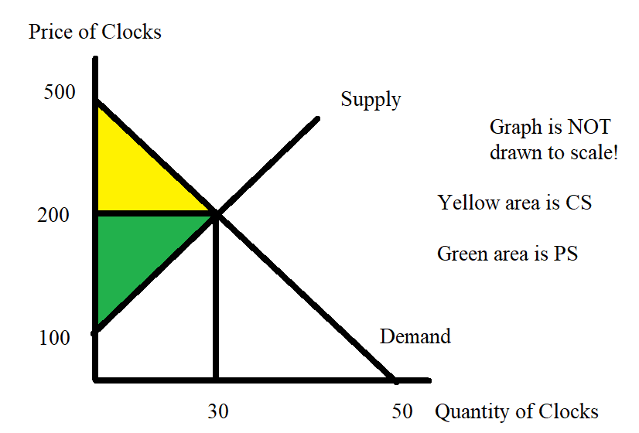

c) The new supply curve that includes the excise tax will shift to the left of the original supply curve. The y-intercept of this new supply curve will be equal to the amount of the original y-intercept from the first supply curve plus the amount of the excise tax per unit: thus, the new supply curve with the excise tax will have y-intercept of 180. The new supply curve will be parallel to the original supply curve (same slopes) and thus can be written as Pt = 180 + (10/3)Qt where Pt is the price with the excise tax and Qt is the quantity of the good with the excise tax.

d) To find the new equilibrium quantity in the market for clocks with the excise tax we need to equate the demand curve to the new market supply curve: thus,
500 – 10Qt = 180 + (10/3)Qt
320 = (10/3)Qt + 10Qt
3(320) = 10Qt + 30Qt
960 = 40Qt
Qt = 24 clocks
Pt = 500 – 10(Qt) = 500 – 10(24) = 500 – 240 = $260 per clock
Pnet = Price producers receive once they pay the excise tax to the government = Pt – excise tax per unit = $260 - $80 = $180 per clock. You can also get this number by substituting the quantity into the supply curve before adjusting for the tax.

e) CSt = (1/2)($500 per clock - $260 per clock)(24 clocks)
CSt = $2880
PSt = (1/2)($180 per clock - $100 per clock)(24 clocks)
PSt = $960
Tax Revenue = ($80 per clock)(24 clocks)
Tax Revenue = $1920
CTI = (Pt – P)(Qt)
CTI = ($260 per clock - $200 per clock)(24 clocks)
CTI = $1440
PTI = (P – Pnet)(Qt)
PTI = ($200 per clock - $180 per clock)(24 clocks)
PTI = $480
DWL = (1/2)(Pt – Pnet)(Q – Qt)
DWL = (1/2)(Tax per unit)(Q – Qt)
DWL = (1/2)($80 per clock)(30 clocks –24 clocks)
DWL = $240

f)
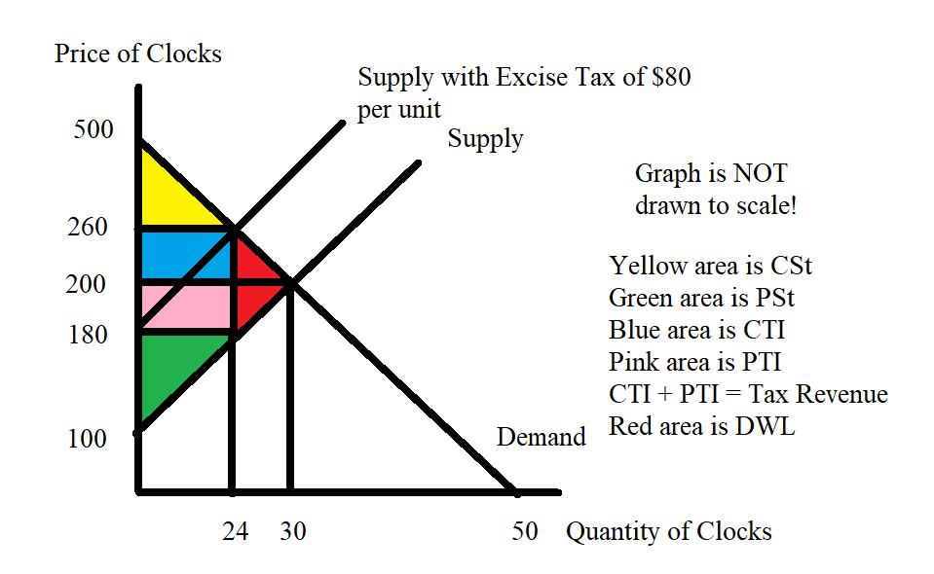
g) The government wants Qt to equal 18 units. Suppliers are willing to supply this quantity at a price of:
P = 100 + (10/3)Qt
P = 100 + (10/3)(18)
P = 100 + 60 = $160
Demanders are willing to consume this quantity at a price of:
P = 500 – 10(Qt)
P = 500 – 10(18)
P = $320
To figure out the excise tax we need to set the excise tax per unit = (price demanders are willing to pay for Qt) – (price suppliers must get to supply Qt) or Excise Tax per unit = $320 per clock - $160 per clock = $160 per clock.

h) Holding everything else constant, the larger the excise tax the larger the DWL. A larger excise tax will have two impacts on DWL: the first impact is that the larger excise tax amount enters into the calculation of the DWL and this larger numeric value of the excise tax will result in a larger amount of DWL due to the impact of the excise tax on the level of prices in this market. But there is also a quantity effect where a larger excise tax results in a larger change in the amount of the good consumed for a given market with a downward sloping demand curve and an upward sloping supply curve.

i) When the excise tax is set at $0 per clock, the tax revenue the government receives is $0. When the excise tax is set at $400 per clock in this example, the tax revenue the government receives is $0 since at this level of excise tax consumers will purchase 0 clocks. Yet, we know that an excise tax has the capacity to generate tax revenue, so it must be the case that tax revenue rises as the excise tax increases, then at some point tax revenue decreases as the excise tax continues to increase. In our example, we see that an excise tax of $80 per unit results in tax revenue of $1920 while an excise tax of $160 per unit results in tax revenue of $2880. (An excise tax of $300 per unit will result in tax revenue of $2250, for one more data point in our analysis.)

