Economics 101
Summer 2014
Answers to Homework #1
Due Thursday, May 29, 2014

Directions: The homework will be collected in a box before the lecture. Please place your name, TA name and section number on top of the homework (legibly). Make sure you write your name as it appears on your ID so that you can receive the correct grade. Late homework will not be accepted so make plans ahead of time. Please show your work. Good luck!
Please realize that you are essentially creating “your brand” when you submit this homework. Do you want your homework to convey that you are competent, careful, professional? Or, do you want to convey the image that you are careless, sloppy, and less than professional. For the rest of your life you will be creating your brand: please think about what you are saying about yourself when you do any work for someone else!

1. Here are a couple of math review problems for you to work through.
a. Suppose you are given the two points (X, Y) = (10, 15) and (12, 20) and are told that these two points sit on a straight line. Write an equation in slope-intercept form for this line and then identify the y-intercept, the x-intercept, and the slope of this line. Also, write the equation in x-intercept form.

Answer:
The general slope intercept form for the line is y = mx + b where m is the slope of the line and b is the y-intercept. Let’s start by finding the slope of the line:
m = slope = ∆Y/∆X = (15 – 20)/(10 – 12) = (-5)/(-2) = 2.5
Thus, y = 2.5X + b
To find b: use one of the given points in this equation: thus, (X, Y) = (10, 15) yields
15 = (2.5)(10) + b or b = -10
The equation in slope-intercept form is Y = 2.5X – 10 where the slope is 2.5 and the y-intercept is -10
The equation in x-intercept form is X = 1/(2.5) Y + 4 where the reciprocal of the slope is (1/2.5) = .4 and the x-intercept is 4.

b. Now, suppose that you are given two new points that sit to the right of the line described in (a) and you are told that at every y-value the x-value is now 3 units higher than the initial x-value. Given the two points described in (a), what are the coordinates (X, Y) for these two new points?

Answer:
(X, Y) = (x initial + 3, y initial)
So, the two new points are (13, 15) and (15, 20)

c. Given the information in (a) and (b) write the equation for the second line in slope-intercept form and the equation for the second line in x-intercept form. Is one of these equations easier to find than the other? Explain your answer.

Answer:
The general slope intercept form for the line is y = mx + b where m is the slope of the line and b is the y-intercept. Let’s start by finding the slope of the line:
m = slope = ∆Y/∆X = (15 – 20)/(13 – 15) = (-5)/(-2) = 2.5 (the slope does not change since the two lines are parallel to one another)
Thus, y = 2.5X + b
To find b: use one of the points you found in (b) in this equation: thus, (X, Y) = (13, 15) yields
15 = (2.5)(13) + b or b = -17.5
The equation in slope-intercept form is Y = 2.5X – 17.5 where the slope is 2.5 and the y-intercept is -10.
The equation in x-intercept form is X = 1/(2.5) Y + 7 where the reciprocal of the slope is (1/2.5) = .4 and the x-intercept is 7. In this example, the x-intercept form of the equation is easier to write if you realize that the new line has shifted horizontally over by 3 units which implies that the new x-intercept of the line is now equal to the initial x-intercept plus 3 units or 4 + 3 = 7. Think about this a bit: you might find it a handy idea later in the class!!

d. Now, suppose that you are given two new points on a third line that sit to the right of the line described in (a) and you are told that at every x-value the y-value is now 3 units lower than the initial y-value. Given the two points described in (a), what are the coordinates (X, Y) for these two new points?

Answer:
(X, Y) = (x initial, y initial - 3)
So, the two new points are (10, 12) and (12, 17)

e. Suppose you are given the following graph.

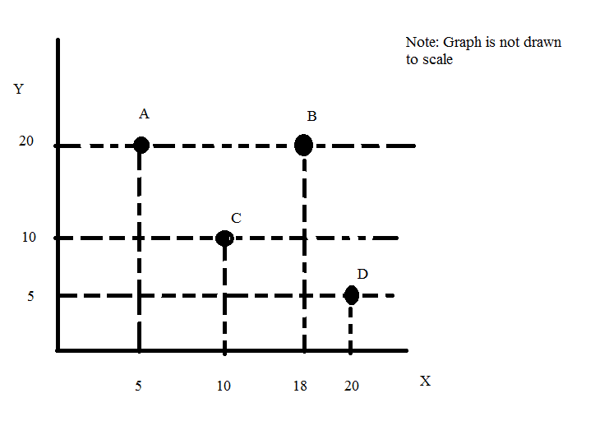
i. Is it possible that points A, C and D all sit on the same straight line? Provide an explanation to support your answer.

Answer:
No, if you were to construct a measure of slope between points A and C you would get that the slope is equal to (20 – 10)/(5 – 10) or -2. If you were to construct a measure of slope between points C and D you would get that the slope is equal to (10 – 5)/(10 – 20) or (-1/2). For a straight line we know that the slope of the line will be constant between any two points on that line: hence, these three points cannot all lie on the same straight line.

ii. Write an equation for a straight line that contains points A and D in y-intercept form.

Answer:
The coordinates of points A and D are given as (5, 20) and (20, 5) respectively. From this we can get the slope of the straight line that contains these two points as (20 – 5)/(5- 10) = -1. We can then write the equation for the straight line as Y = -1X + b and use one of the points we have to solve for b: 20 = (-1)(5) + b or b = 25. The equation in slope intercept form for the straight line that contains points A and B can be written as Y = 25 – X.

iii. Write an equation for a straight line that contains points C and B in y-intercept form.

Answer:
The coordinates of points C and B are given as (10, 10) and (18, 20) respectively. From this we can get the slope of the straight line that contains these two points as (10 – 20)/(10 – 18) = -10/-8 or 1.25. We can then write the equation for the straight line as Y = 1.25X + b and use one of the points we have to solve for b: 10 = 1.25(10) + b or b = -2.5. The equation in slope intercept form for the straight line that contains points C and B can be written as Y = 1.25X – 2.5.

iv. What is the y-intercept of a straight line that contains points B and D? Show your work. Hint: the numbers get ugly, so just give a close approximation.

Answer:
The coordinates of points B and D are given as (18, 20) and (20, 5) respectively. From this we can get the slope of the straight line that contains these two points as (20 – 5)/(18 – 5) = 15/13. We can then write the equation for the straight line as Y = (15/13)X + b and use one of the points we have to solve for b: 5 = (15/13)(20) + b or b= [5 – (15/13)(20)]. The question asks for the y-intercept and that is b: the actual value of b is -235/13 and an approximation for b would be about -18.

2. Suppose you are comparing prices while shopping online. You look at two websites: on both websites the list price for the product you want to buy is the same. On website A the product is offered at a 20% discount but you are told you will need to pay a $5 flat shipping fee and this shipping fee cannot be discounted. On website B the product is offered at the list price, but with free shipping.
a. At what price, are these two offers identical? Show how you found your answer.

Answer:
To solve this problem you will need to do some math:
Suppose X is the list price of the product.
You want to find where the following is equal:
Price of the product (including shipping) at website A = Price of the product (including shipping) at website B
Price of the product (including shipping) at website A = .8(X) + 5
Price of the product (including shipping) at website B = X
Set these two equations equal to one another and solve for X:
.8X + 5 = X
.2X = 5
X = $25
When the list price of the good is $25, the total price for the good including shipping is equivalent at the two websites.

b. Is there ever a situation where you should choose to purchase this product from website A? Explain your reasoning.

Answer:
Yes, if the list price is at least $25 or more, then it would be better to buy the product from website A. For example, if the list price was $32 this would be the analysis:
Discounted price at website A plus shipping cost: (.8)(32) + 5 = 25.6 + 5 = $31.50
Price at website B plus shipping cost: $32
Total price paid at website A is less than total price paid at website B provided that the list price is $25 or more.

c. Is there ever a situation where you should choose to purchase this product from website B? Explain your reasoning.

Answer:
Yes, if the list price is less than $25, then it would be better to buy the product from website B. For example, if the list price was $12 this would be the analysis:
Discounted price at website A plus shipping cost: (.8)(12) + 5 = 9.6 + 5 = $14.60
Price at website B plus shipping cost: $12
Total price paid at website B is less than total price paid at website A provided that the list price is less than $25.

3. Suppose the PPF for Smallia is given by the equation Y = 4M – (1/2)X where Y is the number of machines that are produced during the current time period, X is the number of units of consumer goods that are produced (and consumed) during the current time period, and M is the number of machines that Smallia has at the beginning of the time period. All of the X good that is produced in a given period of time is consumed in that same period of time, while all of the Y good that is produced in a given period of time is then available in subsequent periods of time and therefore the level of M in the next time period changes as the level of Y production in this time period changes. Assume that once machines are produced, that they last forever. Currently at the beginning of this time period Smallia has one machine.

a. Given the above information, construct the PPF for Smallia in this time period measuring Y, the number of machines produced this period, on the y-axis and X, the number of units of consumer goods that are produced this period, on the x-axis. To find this PPF you will want to use the provided equation and the initial amount of M.

Answer:
The equation for the PPF is Y = 4M – (1/2)X and you also know that M is equal to 1 initially. So, Y = 4 – (1/2)X. We can graph this equation of Smallia’s PPF as follows:
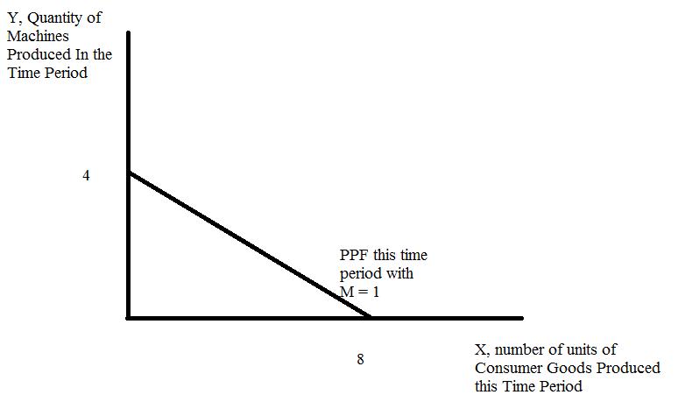

b. Suppose that this year (the initial period of time) Smallia decides to produce and consume 6 units of consumer goods. Given this information, how many machines will Smallia be able to produce this year if they are efficient? At the end of this year how many machines will Smallia have? Show how you found your answer.

Answer:
From (a) we know that Smallia’s PPF is given as Y = 4 – (1/2)X for this year. If Smallia produces 6 units of consumer goods this year then this implies that Smallia will be able to produce 1 unit of Y this year. At the end of the year Smallia will therefore have a total of 2 machines: the machine they had initially and the new machine produced this year.

c. Given your answer in (b), draw a new graph that illustrates Smallia’s PPF for this year and for next year given that this year Smallia has decided to produce 6 units of consumer goods.

Answer:
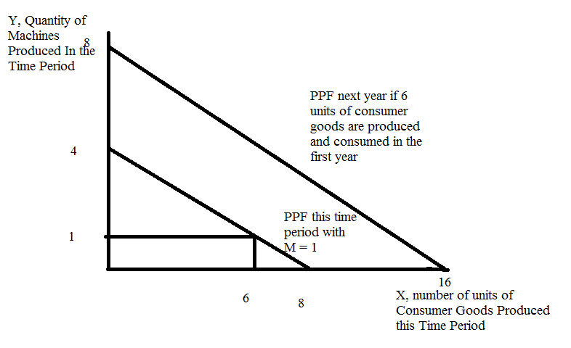

d. Suppose that instead of producing and consuming 6 units of consumer goods this year, Smallia could decide to produce and consume 5 units of consumer goods this year. Construct a graph that illustrates the initial PPF, the PPF for next year if Smallia consumes 6 units of consumer goods this year, and the PPF for next year if Smallia consumes 5 units of consumer goods this year. How does their consumption decision impact their future consumption decisions?

Answer:
If Smallia produces and consumes five units of consumer goods this year, Smallia will be able to produce 1.5 machines this year. To see this go back to the PPF for this year: Y = 4 – (1/2)X and consider what happens to Y production if X production is given as 5 units. When X = 5, Y = 1.5 units. So, when Smallia produces and consumes 5 units of consumer goods this year, it can produce 1.5 machines this year. At the end of the year Smallia will therefore have 2.5 machines: it will have the machine it had initially plus the additional 1.5 machines it produced this year.

With 2.5 machines available the PPF for Smallia for next year can be written as Y = 4(2.5) – (1/2)X or Y = 10 – (1/2)X. This is in contrast to the PPF for next year if Smallia produces and consumes 6 units of consumer goods this year: Y = 4(2) – (1/2)X or Y = 8 – (1/2)X.

Let’s graph these two possibilities:
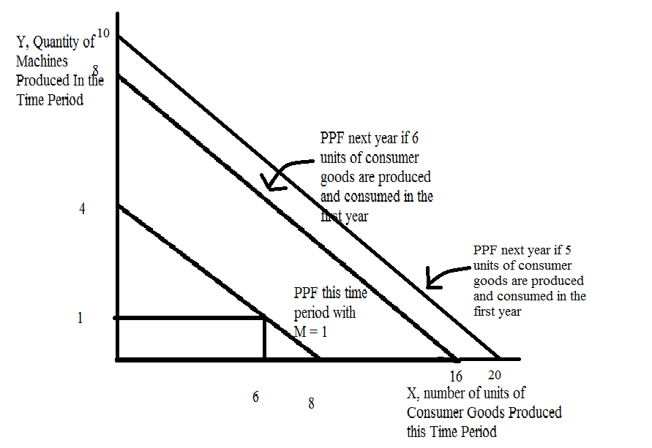

When we compare the two possible PPFs for next year we see that Smallia’s decision to consume more consumer goods in the first year results in a smaller shift in the PPF for next year: when Smallia chooses higher current consumption it results in an impact on their future production possibilities.

4. Consider two countries, East and West. Both of these countries produce cars and food and both of these countries have linear production possibility frontiers. You are told that the countries have the same level of labor resources and that labor is the only input used in producing these goods. You are also provided with the following table:

 | Units of Labor needed to Produce 1 Car | Units of Labor needed to Produce 1 unit of Food
East | 2 units of labor | 1 unit of labor
West | 3 units of labor | 4 units of labor

a. Suppose that East and West both possess 60 units of labor. Construct their production possibility frontiers given this information. Provide a separate graph for each country and measure units of food on the x-axis and cars on the y-axis. Label your graphs carefully and completely. In your graphs provide the numeric values for each intercept.

Answer:
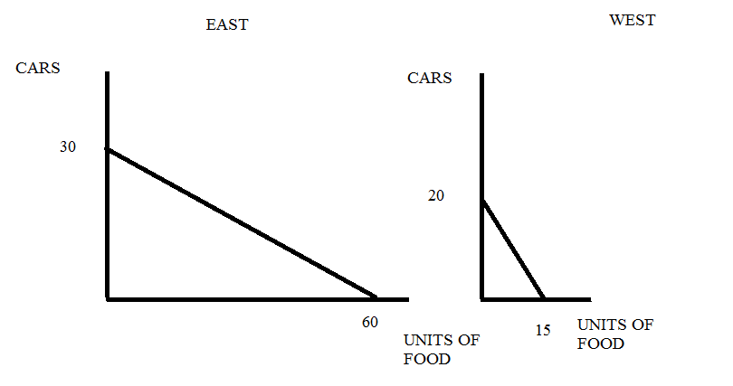

b. What would happen to East’s PPF if the amount of labor East had increased to 90 units? Describe verbally the effect of this change on East’s PPF.

Answer:
If East had 90 units of labor, its PPF would shift out from its initial position in (a). If East only produced cars it would now be able to produce 45 cars (the new y-intercept). If East only produced foods it would now be able to produce 90 units of food (the new x-intercept).

c. Suppose that East and West both have 60 units of labor available but that East has recently discovered a new technology that allows East to produce twice as many cars from its available labor. This technology does not impact East’s ability to produce food. Draw a graph illustrating East’s new PPF given this technological change.

Answer:
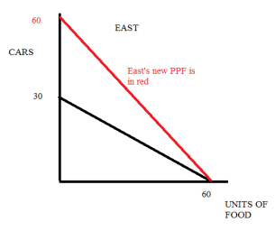

d. Given the scenario described in (a), who has the comparative advantage in producing cars? Explain your answer.

Answer:
West has the comparative advantage in the production of cars since the opportunity cost of producing 1 car for West ( ¾ unit of food) is less than the opportunity cost of producing 1 car for East (2 units of food).

e. Given the scenario described in (a), what is the range of trading prices measured in cars for 10 units of food?

Answer:
The opportunity cost of producing one unit of food for East is ½ car and the opportunity cost of producing one unit of food for West is 4/3 cars. Thus, 1 unit of food will trade between ½ car and 4/3 cars; or, 10 units of food will trade between 5 cars and 13 1/3 cars. The number line below depicts this:
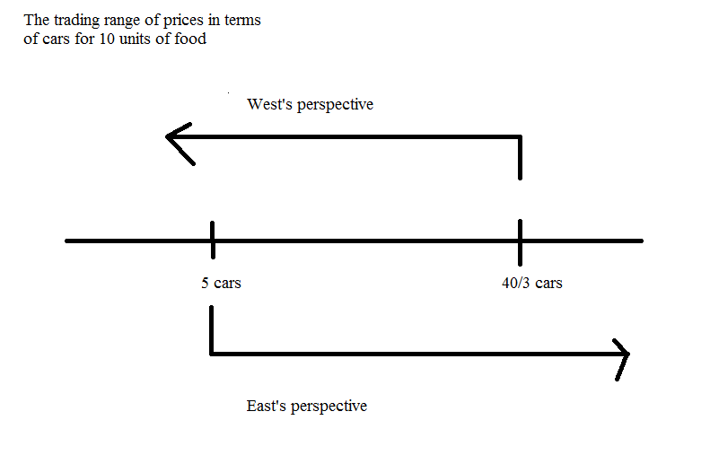

f. Given the scenario described in (a), draw the joint PPF for East and West measuring cars on the vertical axis and units of food on the horizontal axis. Provide numeric values for all intercepts and all kink points.

Answer:
