Economics 101
Spring 2020
Answers to Homework #1
Due Thursday, 2/6/20

Directions: The homework will be collected in boxes marked with your TA name before the lecture. Please place your name, TA name and section number on top of the homework (legibly). Make sure you write your name as it appears on your ID so that you can receive the correct grade. Late homework will not be accepted so make plans ahead of time. Please show your work. Good luck!
Please realize that you are essentially creating “your brand” when you submit this homework. Do you want your homework to convey that you are competent, careful, professional? Or, do you want to convey the image that you are careless, sloppy, and less than professional. For the rest of your life you will be creating your brand: please think about what you are saying about yourself when you do any work for someone else!

1. a. Suppose you know that the two points (X, Y) = (12, 6) and (15, 2) sit on the same line. From this information write an equation for this line in slope-intercept form.

b. Suppose that you know that the slope of the line is 8 and that this line also contains the point (15, 25). What is the y-intercept for this line? Show your work.

c. You are given the following two equations:
Y = 2X + 100
Y = 76 – 10X
Find the solution (X, Y) for where these two equations intersect. Show your work.

d. Suppose that you know that the relationship between X and Y, where X is the variable measured on the horizontal axis, can be described by the following equation:
X = 30 – 2Y for all values of X ≥ 0
You are then told that for every Y value the X value has now increased by 5 units. Write the equation in slope-intercept form for this new line. Show your work. Hint: you might find it helpful to draw a "sketch" illustrating these two lines before you start doing your calculations.

e. Suppose that you know that the relationship between X and Y, where X is the variable measured on the horizontal axis, can be described by the following equation:
Y = 5 + 2X for all values of X ≥ 0
You are then told that for every X value the Y value has now decreased by 20 units. Write the equation in slope-intercept form for this new line. Show your work. Hint: you might find it helpful to draw a "sketch" illustrating these two lines before you start doing your calculations.

Answer:

a. To write the equation start by finding the slope of the line: slope = (change in Y)/(change in X) = (6 – 2)/(12 – 15) = -4/3. Then, use the general form of the slope-intercept equation and this slope value to find the y-intercept:
Y = mX + b where m = slope and b = y-intercept
Y = -X + b
Substitute one of the given points into this equation to find the value of the y-intercept, b:
6 = (-4/3)(12) + b
b = 22
Equation for the line containing these two points: Y = 22 – (4/3)X
b. Since we know the slope of the line, we can write the equation for this line as:
Y = 8X + b
We are asked to find the value of the y-intercept, or b, in this equation. To do this, we can substitute into the equation the given point and solve for b:
25 = 8(15) + b
b = -95
The y-intercept for this line described by the provided information is -95 and the coordinates for this y-intercept are (0, -95).

c. To find the solution set the two equations equal to one another:
2X + 100 = 76 – 10X
12X = -24
X = -2
Then, use this X value in either equation to solve for Y:
Y = 2(-2) + 100 = 96
Or, Y = 76 – 10(-2) = 96
(X, Y) = (-2, 96)

d. I find it helpful to visualize what is happening to this line by drawing a sketch. Here is my sketch with the red line the original equation and the blue line indicating the new equation. Note that the two lines are parallel and therefore they have the same slope. But, the x-intercept for the new line will now be 5 units greater than the original x-intercept.

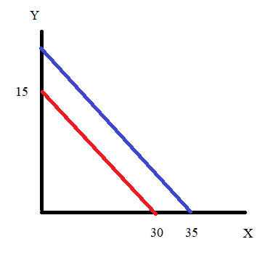

With my sketch it is easy to see that the X-intercept has increased by 5 units from 30 to 35: so, if the equation is in X-intercept form I simply need to change the X-intercept:
X = 35 – 2Y
But, I am asked to write the equation in Y-intercept form so I will rearrange the equation:
2Y = 35 – X
Y = 17.5 – (1/2)X

e. I find it helpful to visualize what is happening to this line by drawing a sketch. Here is my sketch with the red line the original equation and the blue line indicating the new equation. Note the two lines are parallel and hence, have the same slope. The y-intercept of the new line is 20 units less than the y-intercept of the original line.

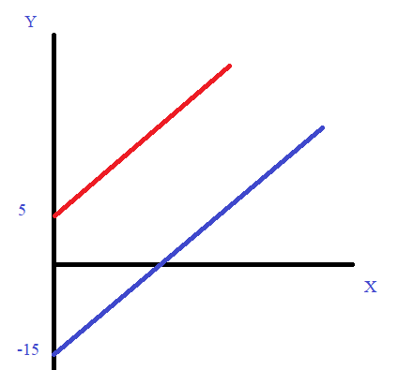

With my sketch it is easy to see that the Y-intercept has decreased by 20 units from 5 to = - 15: so, if the equation is in Y-intercept form I simply need to change the Y-intercept:
Y = -15 + 2X
Or, I might write it as
Y = 2X – 15 so that the negative sign before the 15 does not get visually lost!

2. More math review:

a. Consider Sarah, a student in your Economics 101 class. Sarah wants to make sure she understands how her grade will be calculated in the class. She knows that there is something called a weighted final grade and it is the number associated with this weighted final grade that will determine Sarah’s relative position in the class. She estimates that she will need a weighted final grade of 82 to earn an AB in the class (this is her best guess since she does not know how well the rest of the class will perform in the class). In your answer round to the nearest whole number for that final exam grade: but, do not round until you get to the end of your calculations!

Using the syllabus as a guide (the weights for each assignment are given there), she calculates her weighted final grade based upon the following data:

Quiz scores (she takes all 10 quizzes and knows that her two lowest scores will not be included in her grade calculation) where each quiz is graded on a 100 point scale: 100, 70, 90, 60, 90, 90, 50, 70, 80, 80

Homework scores (she submits all five homeworks): she receives the maximum score of 2 points on each homework

Midterm One: 90 out of 100 points

Midterm Two: 70 out of 100 points

Final Exam: she wants to figure out what this score must be on a 100 point scale in order for her to have a weighted final grade of 82 for the class

Given the above information and holding everything else constant, what score must Sarah get on the final exam to have a weighted final grade of 82? Show your work.

b. Consider Sarah, the same student we just worked with in (a). Sarah, had great intentions with regard to her academic work when the semester started, but then stuff happened. Sarah didn’t feel well and she missed two quizzes due to not feeling well (students do get sick in the semester!). Sarah also had an opportunity to take a field trip with a student organization that she felt would be beneficial: this was not a required trip but when Sarah went on the trip it meant that she missed an additional quiz. Sarah also missed a fourth quiz due to her decision to have coffee with a friend one day rather than attend discussion section. Sarah also managed to turn in only three of the five homeworks. So, here is the information confronting Sarah now!

Quiz scores (she takes all 6 quizzes and knows that her two lowest scores will not be “dropped” and furthermore her quiz score is the average of eight quizzes!) where each quiz is graded on a 100 point scale: 100, 70, 60, 90, 90, 80

Homework scores (she submitted just three homeworks): she receives the maximum score of 2 points on each homework that she submitted

Midterm One: 90 out of 100 points

Midterm Two: 70 out of 100 points

Final Exam: she wants to figure out what this score must be on a 100 point scale in order for her to have a weighted final grade of 82 for the class

Given the above information and holding everything else constant, what score must Sarah get on the final exam to have a weighted final grade of 82? Show your work.

Answer:

a. From the syllabus we know that quizzes are 10% of your grade, Midterm One is 22% of your grade, Midterm Two is 22% of your grade, the Final Exam is 36% of your grade, and the homeworks are 10% of your grade.
Sarah starts by first determining which quiz scores get counted. She needs to “drop” her two lowest scores on the quizzes: this leaves her with 100, 70, 90, 90, 90, 70, 80, 80. She needs to compute the her average quiz score based on these eight quizzes: (sum of scores)/(number of quizzes) = average quiz score on a 100 point scale. Average quiz score = 670/8 = 83.75. Now, she needs to convert this to a 10 point scale: 83.75 on a 100-point scale is equivalent to 8.375 on a 10-point scale.

Now, she can go to the general formula for her weighted final grade:

Weighted final grade = (10% of average quiz score based on top 8 quizzes) + .22(Midterm One Exam Score on a 100-point scale) + .22(Midterm Two Exam Score on a 100-point scale) + .36(Final Exam Score on a100-point scale) + Sum of Homework Scores

82 = 8.375 + .22(90) + .22(70) + .36x + 10 where “x” is the final exam score needed in order to have a weighted final grade of 82.

82 = 8.375 + 19.8 + 15.40 + .36x + 10
82 = 53.575 + .36x
.36x = 28.425
x = 78.9 or approximately 79 on the final exam

b. From the syllabus we know that quizzes are 10% of your grade, Midterm One is 22% of your grade, Midterm Two is 22% of your grade, the Final Exam is 36% of your grade, and the homeworks are 10% of your grade.

Sarah starts by first determining which quiz scores get counted. All of her quiz scores get counted since she only took six quizzes: 100, 70, 60, 90, 90, 80. She needs to compute the her average quiz score based upon eight quizzes even though she only took these six quizzes: (sum of scores)/(number of required quizzes) = average quiz score on a 100 point scale. Average quiz score = 490/8 = 61.25. Now, she needs to convert this to a 10 point scale: 61.25 on a 100-point scale is equivalent to 6.125 on a 10-point scale.

Now, she can go to the general formula for her weighted final grade:

Weighted final grade = (10% of average quiz score based on top 8 quizzes) + .22(Midterm One Exam Score on a 100-point scale) + .22(Midterm Two Exam Score on a 100-point scale) + .36(Final Exam Score on a100-point scale) + Sum of Homework Scores

82 = 6.125+ .22(90) + .22(70) + .36x + 6 where “x” is the final exam score needed in order to have a weighted final grade of 82.

82 = 6.125 + 19.8 + 15.40 + .36x + 6
82 = 47.325 + .36x
.36x = 34.675
x = 96.3 or approximately 96 on the final exam
.4(Score for Sue) = 41
Score for Sue = 102.5
If the final exam has only 100 points, then it is impossible for Sue to earn an "A; in the class. Sue should have done her homework!

3. Consider the production possibility frontier that is given in the diagram. This PPF illustrates the production possibilities for Smallia, a country that produces just Cookies (C) and Pencils (P). Assume that this PPF is linear over each of the provided segments in the diagram (so the PPF is linear from point A to point B, from point B to point C, ….). Use this diagram and your calculations to answer this set of questions.

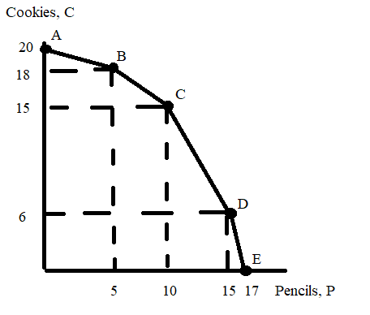

a. Smallia is currently producing in the linear segment between point A and point B. Suppose Smallia decides to produce ½ more pencil (assume they will still be producing between point A and point B). What is the opportunity cost of this decision is? Explain your answer.

b. Smallia is currently producing in the linear segment between point B and point C. For each of the following combinations determine if Smallia can produce this combination. For your answer you should identify whether the combination is on Smallia’s PPF, inside Smallia’s PPF, or beyond Smallia’s PPF.
i. Combination (P, C) = (6, 82/5)
ii. Combination (P, C) = (7, 91/5)
iii. Combination (P, C) = (42/5, 16)

c. Write an equation for the PPF between point C and point D. Show your work.

d. What is the opportunity cost of producing one more cookie if Smallia is currently producing 10 cookies?

Answer:

a. The slope of the PPF segment between point A and point B is -2/5. This means that the opportunity cost of producing an additional pencil can be measured as 2/5 of a cookie. So, if Smallia decides to increase their pencil production by ½ pencil then it must give up 2/10 of a cookie. The opportunity cost is 2/10 of a cookie.

b.
i. Combination (P, C) = (6, 82/5) is inside the PPF. To see this, first write an equation for the PPF for the segment between point B and point C. C = mP + b. You know that the slope of this segment is m = -3/5. You also have two known points on this segment: (P, C) = (5, 18) and (10, 15). Use one of these points to solve for “b”. Thus,
C = mP + b
C = (-3/5)P + b
15 = (-3/5)(10) + b
b = 21
C = 21 – (3/5)P

If P = 6, then:
C = 21 – (3/5)(6) = 105/5 – 18/5 = 87/5
Thus, (P, C) = (6, 87/5) is on the PPF and therefore (P, C) = (6, 82/5) must lie inside the PPF.

ii. Combination (P, C) = (7, 91/5) is outside the PPF. To see this, use the equation you found in (i):
C = 21 – (3/5)P

If P = 7, then:
C = 21 – (3/5)(7) = 105/5 – 21/5 = 84/5
Thus, (P, C) = (7, 84/5) is on the PPF and therefore (P, C) = (7, 91/5) must lie outside the PPF.

iii. Combination (P, C) = (42/5, 16) is outside the PPF. To see this, use the equation you found in (i):
C = 21 – (3/5)P

If P = 42/5, then:
C = 21 – (3/5)(42/5) = 105/5 – 126/25 = 525/25 – 126/25 = 399/25 = 15.96
Thus, (P, C) = (42/5, 15.96) is on the PPF and therefore (P, C) = (42/5, 16) must lie outside the PPF.

c. The slope of the PPF segment between point C and point D is -9/5. Use one of your known points to find the value of “b”. The known points are (P, C) = (10, 15) and (15, 6). Thus,
C = b – (9/5)P
15 = b – (9/5)(10)
15 + 18 = b
b = 33
C =33 – (9/5)P

d. The opportunity cost of producing one more cookie is Smallia is currently producing cookies is measured by the number of pencils Smallia must give up in order to produce that additional cookie. The opportunity cost of one more cookie when Smallia is currently producing 10 cookies is measured as 5/9 of a pencil.

4. The graph below depicts the production possibility frontier for a small economy that produces only buckets (B) and ladders (L). This PPF is linear between any two adjacent points on the PPF: e.g., the PPF is linear between points A and B, between points B and C, and between points C and D….
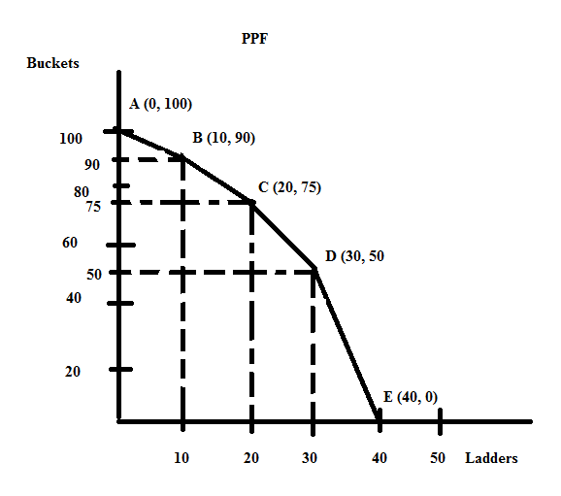

a. Suppose this economy is currently producing at point B. What is the opportunity cost of producing one additional bucket given this information? Explain your answer. Make sure your answer provides the units of measurement.

b. Suppose that this economy is currently producing at point B. What is the opportunity cost of producing one additional ladder given this information? Explain your answer. Make sure your answer provides the units of measurement.

c. Suppose this economy is currently producing at point C. What is the opportunity cost of producing one additional bucket given this information? Explain your answer. Make sure your answer provides the units of measurement.

d. Suppose this economy is currently producing at point C. What is the opportunity cost of producing one additional ladder given this information? Explain your answer. Make sure your answer provides the units of measurement.

e. Suppose this economy is currently producing at point D. What is the opportunity cost of producing one additional bucket given this information? Explain your answer. Make sure your answer provides the units of measurement.

f. Suppose this economy is currently producing at point D. What is the opportunity cost of producing one additional ladder given this information? Explain your answer. Make sure your answer provides the units of measurement.

g. Given the above PPF, write the equation(s) for each segment of the PPF. Identify the relevant range or domain for each equation. Show your work and how you found these equations.

Answers:

a. If this economy is initially at point B and wants to produce an additional bucket, then the economy is moving along the PPF from point B toward point A. To find the opportunity cost of an additional bucket we would need to find the reciprocal of the slope of the segment of the PPF between points A and B. The slope of this segment is -1, so the reciprocal of the slope of this segment is also -1. The opportunity cost of an additional bucket if this economy is at point B is therefore 1 ladder.

Alternatively, you could write the equation for the PPF between points A and B:
B = 100 – L and then plug in B' = 91. When you do this, you find that L' = 9. Instead of having 10 ladders you now only have nine ladders: the opportunity cost of producing that additional bucket (going from 90 buckets to 91 buckets) is measured by what you gave up...in this case, this economy gives up 1 ladder.

b. If this economy is initially at point B and wants to produce an additional ladder, then the economy is moving along the PPF from point B toward point C. To find the opportunity cost of an additional ladder we would need to find the slope of this segment of the PPF between points B and C. The slope of this segment is -3/2: the opportunity cost of an additional ladder if this economy is at point B is therefore 3/2 buckets.

Alternatively, you could write the equation for the PPF between points B and C: this takes a bit more work. So, here are the steps:
y = mx + b is the general form of an equation for a straight line
B = (-3/2)L + b
Then, use one of the known points that lies on this segment to find the value of the y-intercept, b: we know that (L, B) = (10, 90) and (20, 75) both are on this segment.
90 = (-3/2)(10) + b
b = 105
B = 105 – (3/2)L and then plug in L' = 11. When you do this, you find that B' = 88.5. Instead of having 90 buckets you now only have 88.5 buckets: the opportunity cost of producing that additional ladder (going from 10 ladders to 11 ladders) is measured by what you gave up...in this case, this economy gives up 1.5 buckets.

c. If this economy is initially at point C and wants to produce an additional bucket, then the economy is moving along the PPF from point C toward point B. To find the opportunity cost of an additional bucket we would need to find the reciprocal of the slope of the segment of the PPF between points B and C. The slope of this segment is -3/2, so the reciprocal of the slope of this segment is -2/3. The opportunity cost of an additional bucket if this economy is at point C is therefore 2/3 ladder.

Alternatively, you could write the equation for the PPF between points B and C: this takes a bit more work. So, here are the steps:
y = mx + b is the general form of an equation for a straight line
B = (-3/2)L + b
Then, use one of the known points that lies on this segment to find the value of the y-intercept, b: we know that (L, B) = (10, 90) and (20, 75) both are on this segment.
90 = (-3/2)(10) + b
b = 105
B = 105 – (3/2)L and then plug in B' = 76. When you do this, you find that L' = 19.3. Instead of having 20 ladders you now only have 19.3 ladders: the opportunity cost of producing that additional bucket (going from 75 buckets to 76 buckets) is measured by what you gave up...in this case, this economy gives up 2/3 ladder.

d. If this economy is initially at point C and wants to produce an additional ladder, then the economy is moving along the PPF from point C toward point D. To find the opportunity cost of an additional ladder we would need to find the slope of this segment of the PPF between points C and D. The slope of this segment is -5/2: the opportunity cost of an additional ladder if this economy is at point C is therefore 5/2 buckets.

Alternatively, you could write the equation for the PPF between points C and D: this takes a bit more work. So, here are the steps:
y = mx + b is the general form of an equation for a straight line
B = (-5/2)L + b
Then, use one of the known points that lies on this segment to find the value of the y-intercept, b: we know that (L, B) = (30, 50) and (20, 75) both are on this segment.
50 = (-5/2)(30) + b
b = 125
B = 125 – (5/2)L and then plug in L' = 21. Instead of having 75 buckets you now only have 72.5 buckets: the opportunity cost of producing that additional ladder (going from 20 ladders to 21 ladders) is measured by what you gave up...in this case, this economy gives up 2.5 buckets.

e. If this economy is initially at point D and wants to produce an additional bucket, then the economy is moving along the PPF from point D toward point C. To find the opportunity cost of an additional bucket we would need to find the reciprocal of the slope of the segment of the PPF between points C and D. The slope of this segment is -5/2, so the reciprocal of the slope of this segment is -2/5. The opportunity cost of an additional bucket if this economy is at point D is therefore 2/5 ladder.

Alternatively, you could write the equation for the PPF between points C and D: this takes a bit more work. So, here are the steps:
y = mx + b is the general form of an equation for a straight line
B = (-5/2)L + b
Then, use one of the known points that lies on this segment to find the value of the y-intercept, b: we know that (L, B) = (30, 50) and (20, 75) both are on this segment.
50 = (-5/2)(30) + b
b = 125
B = 125 – (5/2)L and then plug in B' = 51. When you do this, you find that L' = 29.6. Instead of having 30 ladders you now only have 29.6 ladders: the opportunity cost of producing that additional bucket (going from 75 buckets to 76 buckets) is measured by what you gave up...in this case, this economy gives up .4 or 2/5 ladder.

f. If this economy is initially at point D and wants to produce an additional ladder, then the economy is moving along the PPF from point D toward point E. To find the opportunity cost of an additional ladder we would need to find the slope of this segment of the PPF between points D and E. The slope of this segment is -5: the opportunity cost of an additional ladder if this economy is at point D is therefore 5 buckets.

Alternatively, you could write the equation for the PPF between points D and E: this takes a bit more work. So, here are the steps:
y = mx + b is the general form of an equation for a straight line
B = (-5)L + b
Then, use on of the known points that lies on this segment to find the value of the y-intercept, b: we know that (L, B) = (30, 50) and (40, 0) both are on this segment.
0 = (-5)(40) + b
b = 200
B = 200 – 5L and then plug is L' = 31. When you do this, you find that B' = 45. Instead of having 50 buckets you now only have 45 buckets: the opportunity cost of producing that additional ladder (going from 30 ladders to 31 ladders) is measured by what you gave up…in this case, this economy gives up 5 buckets.

g.
For the segment between points A and B: B = 100 – L
This equation holds from 90 ≤ B ≤ 100 or for 0 ≤ L ≤ 10.

For the segment between points B and C: B = 105 – (3/2)L
This equation holds from 75 ≤ B ≤ 90 or for 10 ≤ L ≤ 20.

For the segment between points C and D: B = 125 – (5/2)L
This equation holds from 50 ≤ B ≤ 75 or for 20 ≤ L ≤ 30.

For the segment between points D and E: B = 200 – 5L
This equation holds from 0 ≤ B ≤ 50 or for 30 ≤ L ≤ 40.

5. Suppose that there are three countries that produce pretzels (P) and jam (J): Westfield, Southside, and Northmont. The maximum amount of pretzels and jam each country can produce if they only produce that one good is given in the table below. Use this information to answer this set of questions. Assume that each of the three countries have constant opportunity costs with respect to the production of pretzels and jam: that is, each country has a linear production possibility frontier.

Country | Maximum Amount of Pretzels Production Possible | Maximum Amount of Jam Production Possible
Westfield | 20 units of pretzels | 20 units of jam
Southside | 10 units of pretzels | 10 units of jam
Northmont | 10 units of pretzels | 20 units of jam

a. Given the above information, what is Northmont's opportunity cost of producing one more unit of pretzels?

b. Given the above information, what is Southside's opportunity cost of producing one more unit of jam?

c. Given the above information, rank these three countries in order of their comparative advantage in the production of pretzels. List the order from the country with the greatest comparative advantage to the country with the least comparative advantage.

d. Given the above information, rank these three countries in order of their comparative advantage in the production of jam. List the order from the country with the greatest comparative advantage to the country with the least comparative advantage.

e. Construct the joint PPF for these three countries if they specialize according to comparative advantage. For this joint PPF measure pretzels on the vertical axis and jam on the horizontal axis. After constructing this joint PPF, provide the coordinates of any intercept or "kink point" in your diagram. Then write the equation for each segment of the joint PPF and provide a range or domain for each segment.

f. Consider each of the production combinations given in the table below and decide whether this production combination is possible if these three countries specialize according to comparative advantage and then trade with one another. Enter your answer as a "Yes, this combination lies on the joint PPF", "Yes, this combination lies inside the joint PPF" or "No, this combination lies outside the joint PPF" in the provided column.

Combination | Amount of Units of Pretzels in Combination | Amount of Units of Jam in Combination | Is this Combination a Possible Production Combination for these Three Countries?
A | 36 | 9
B | 32 | 14
C | 20 | 38
D | 15 | 34
E | 2 | 48

Answers:

a. Northmont's opportunity cost of producing one more unit of pretzels is 2 units of jam.

b. Southside's opportunity cost of producing one more unit of jam is one unit of pretzels.

c. Southside and Westfield have the same opportunity cost for producing pretzels and they have a comparative advantage over Northmont who has comparative advantage in producing jam.

To see this ordering, first write the opportunity cost of producing one unit of pretzels for each of these countries: you may find it helpful to draw a sketch of each country's PPF and then use the slope measure to guide these opportunity cost measures. For example, if you measure pretzels on the vertical axis and jam on the horizontal axis, then the PPF for Westfield has a slope of -1: this tells us that the opportunity cost of one more unit of the good on the X axis (jam) is 1 unit of the good on the Y axis (pretzels). We can use the reciprocal of the slope (-1) to find the opportunity cost of one more unit of the good measured on the Y axis: in this case, this means that the opportunity cost of one more unit of pretzels is 1 unit of jam.

Using this method: the opportunity cost of producing one more unit of pretzels for Westfield is 1 unit of jam, for Southside is 1 unit of jam, and for Northmont is 2 units of jam. Southside and Westfield have the lowest opportunity cost and therefore the comparative advantage in the production of pretzels.

d. Northmont has the comparative advantage, followed by Westfield and Southside that have the same opportunity cost for the production of a unit of jam.
To see this ordering, first write the opportunity cost of producing one unit of jam for each of these countries: you may find it helpful to draw a sketch of each country's PPF and then use the slope measure to guide these opportunity cost measures. For example, if you measure pretzels on the vertical axis and jam on the horizontal axis, then the PPF for Westfield has a slope of -1: this tells us that the opportunity cost of one more unit of the good on the X axis (jam) is 1 unit of the good on the Y axis (pretzels). We can use the reciprocal of the slope (-1) to find the opportunity cost of one more unit of the good measured on the Y axis: in this case, this means that the opportunity cost of one more unit of pretzels is 1 unit of jam.

Using this method: the opportunity cost of producing one more unit of jam for Westfield is 1 unit of pretzels, for Southside is 1 unit of pretzels, and for Northmont is 1/2 unit of pretzels. Northmont has the lowest opportunity cost and therefore the comparative advantage in the production of jam.

e. Here is the joint PPF.
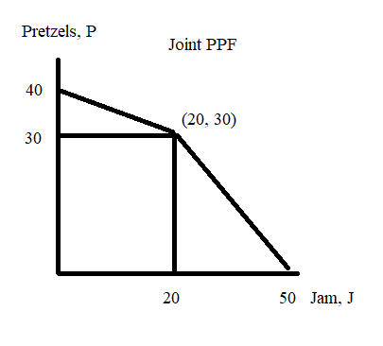

And, now for the equations:
For 0 ≤ J ≤ 20, P = 40 – (1/2)J

For 20 ≤ J ≤ 50, P = 50 – (1)J
To see this start with your basic y-intercept form for the equation: Y = mX + b
Then, replace Y and X with the relevant variables:
P = mJ + b
Then, calculate the slope of this segment: m = slope = -30/30 = -1 and plug this slope value into the equation:
P = b – (1)J
Then use one of the points that you know is on the joint PPF in this segment to solve for b: (J, P) = (20, 30) or (50, 0) are known points. Thus,
30 = b – (1)(20)
50 = b
The equation for this segment is thus, P = 50 – (1)J

f. For this question you will find it helpful to use the equations you found in (e). For example, for (J, P) = (9, 36) you will need to use the first equation: P = 40 – (1/2)J since 9 units of jam lies in the domain of 0 ≤ J ≤ 20. In this equation, if J = 9 units, then the point on the joint PPF associated with 9 units of jam would provide 35.5 units of pretzels. Thus, the point (J, P) = (9, 36) lies outside the possible production frontier.

Repeat this process for each combination using the appropriate equation for the segment of the PPF you are considering.

Here are the final answers:

Combination | Amount of Units of Pretzels in Combination | Amount of Units of Jam in Combination | Is this Combination a Possible Production Combination for these Three Countries?
A | 36 | 9 | Not possible since the point lies outside the PPF
B | 32 | 14 | Possible since this point lies inside the PPF
C | 20 | 38 | Not possible since the point lies outside the PPF
D | 15 | 34 | Possible since this point lies inside the PPF
E | 2 | 48 | Possible since this point lies on the joint PPF

6. Marcy and Eddie produce wagons (W) and dryers (D). The table below provides information about how many hours of labor they need individually to produce a wagon or a dryer. Assume that they only need labor to produce these two goods and assume that both Marcy and Eddie have linear PPFs.

 | Number of Hours of Labor Needed to Produce One Wagon | Number of Hours of Labor Needed to Produce One Dryer
Marcy | 3 hours of labor | 1 hour of labor
Eddie | 4 hours of labor | 6 hours of labor

a. Suppose that Marcy and Eddie each have 36 hours a week that they can devote to producing wagons and dryers. In two separate graphs draw Marcy's and Eddie's production possibility frontiers: label each graph clearly and completely. In your graphs, measure dryers on the vertical axis and wagons on the horizontal axis.

b. Given the above information, who has the comparative advantage in the production of dryers? Explain your answer.

c. Given the above information, who has the comparative advantage in the production of wagons? Explain your answer.

d. Given the above information, fill in the following table:
 | Opportunity Cost of Producing One More Wagon | Opportunity Cost of Producing One More Dryer
Marcy
Eddie

e. Based upon Marcy and Eddie each having 36 hours of labor available per week, construct the joint PPF for these two individuals if they decide to specialize and trade with one another. In your graph measure dryers on the vertical axis and wagons on the horizontal axis. Make sure that the coordinates of all kink points are identified.

f. Given the joint PPF you constructed in (c), write the equation(s) for each segment of this joint PPF. Make sure you identify either the relevant range or domain for any equation you provide.

g. Using the number line approach discussed in class show the range of acceptable trading prices for 5 wagons if Marcy and Eddie specialize according to comparative advantage and then trade with one another.

Answers:
a.
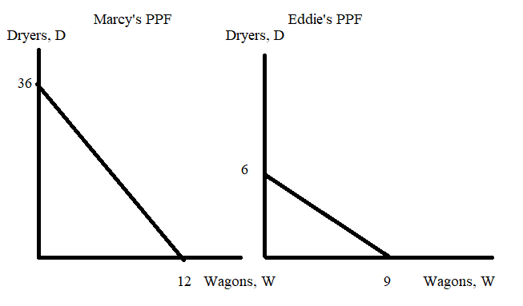
b. Marcy has the comparative advantage in the production of dryers: Marcy's opportunity cost of producing an additional dryer is 1/3 wagon while Eddie's opportunity cost of producing an additional dryer is 3/2 wagon.

c. Eddie has the comparative advantage in the production of wagons. Eddie's opportunity cost of producing an additional wagon is 2/3 dryer while Marcy's opportunity cost of producing an additional wagon is 3 dryers.

d.
 | Opportunity Cost of Producing One More Wagon | Opportunity Cost of Producing One More Dryer
Marcy | 3 dryers | 1/3 wagon
Eddie | 2/3 dryer | 3/2 wagons

e.
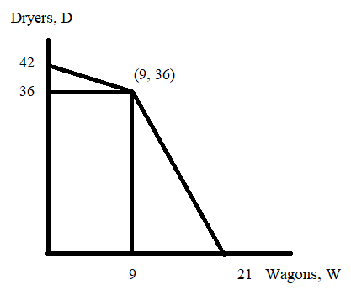
f. The top segment of the joint PPF can be written as:
D = 42 – (2/3)W for the 0 ≤ W ≤ 9
The bottom segment of the joint PPF takes a bit more work:
y = mx + b
D = (-3)W + b
We know that the points (W, D) = (9, 36) and (21, 0) sit on this part of the PPF. So, use one of these points to solve for the value of b, the y-intercept for the equation.
0 = (-3)(21) + b
b = 63
The equation for this lower segment of the joint PPF can be written as:
D = 63 – 3W for 9 ≤ W ≤ 21

g.
Let's start by drawing this sketch showing the acceptable range of trading prices in terms of dryers for 1 wagon and then we can "gross this up" for five wagons.
