Economics 101
Fall 2014
Answers to Homework #2
Due 10/2/14
Directions: The homework will be collected in a box before the lecture. Please place your name, TA name and section number on top of the homework (legibly). Make sure you write your name as it appears on your ID so that you can receive the correct grade. Late homework will not be accepted so make plans ahead of time. Please show your work. Good luck!
Please realize that you are essentially creating “your brand” when you submit this homework. Do you want your homework to convey that you are competent, careful, professional? Or, do you want to convey the image that you are careless, sloppy, and less than professional? For the rest of your life you will be creating your brand: please think about what you are saying about yourself when you do any work for someone else!

1. AT&T, T-mobile and Verizon all want to purchase some iPhone6 phones from Apple and hold these phones in stock so that they can promote their new contract with the iphone6 incorporated as an important element. Their respective demand curves for iPhone6 phones are as follows where Qa is the quantity of iPhone6 phones demanded by AT & T, Qt is the quantity of iPhone6 phones demanded by T-mobile, Qv is the quantity of iPhone6 phones demanded by Verizon, and P is the price per iPhone6 phone:
AT&T: Qa = 30 - P
T-mobile: Qt = 20 - 0.5P
Verizon: Qv = 40 - 2P
- Draw the three individual demand curves in separate graphs measuring the quantity (Q) of iPhone6 phones on the horizontal axis and the price (P) on the vertical axis.

Answer:
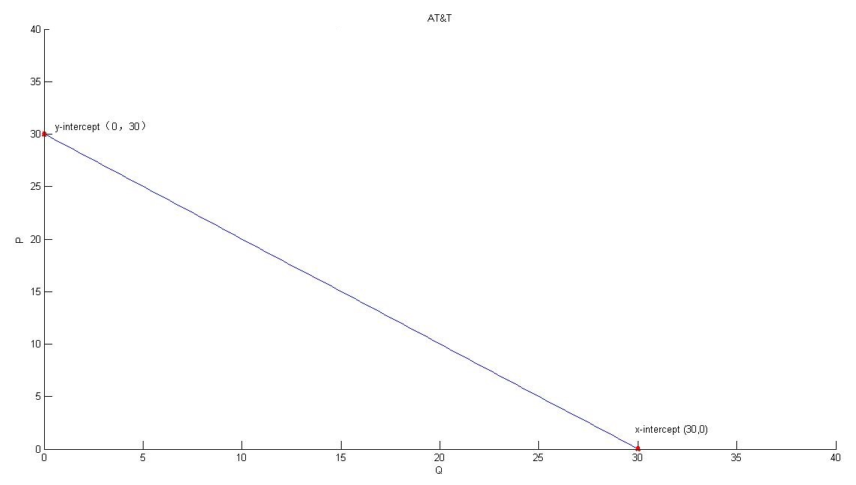
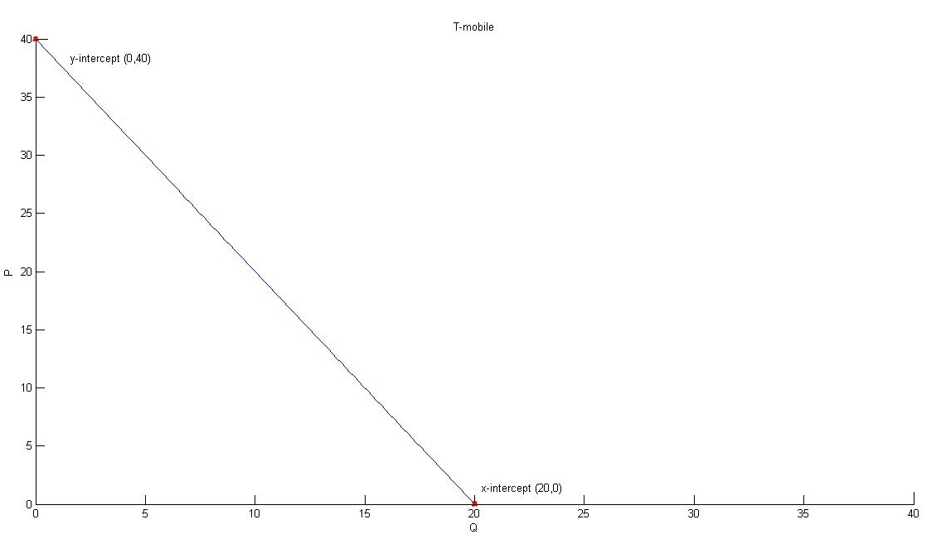
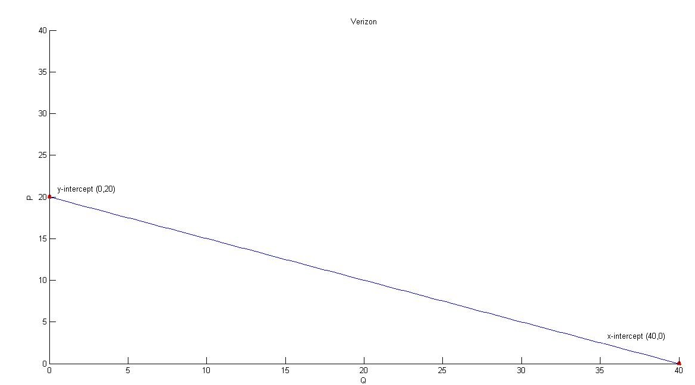
- In a new graph find the market demand curve for iPhone6 phones assuming that the only demanders of these phones are AT&T, T-mobile and Verizon. After you draw the graph find the slope of each linear segment of the demand curve, the coordinates of each “kink point”, and the equation for each linear segment of the market demand curve. Make sure you identify the range of prices for each linear segment of the market demand curve.

Answer:

To find the market demand curve we need to horizontally sum the three demand curves. We will do this by holding price constant and then summing the quantity demanded at that price. If the price is $40 per iPhone6 phone, then there is no demand for the phone: hence, the point (Q, P) = (0, 40) is one point on the market demand curve. If the price is $30 per phone, then T-mobile will demand 5 phones and the other two companies will demand 0 phones: hence, the point (Q, P) = (5, $30) is another point on the market demand curve. Between a price of $30 and $40, then the market demand curve is just T-mobile’s demand curve, or Qmarket = 20 – 0.5P for P greater than or equal to $30.

If the price is $20 per phone, then T-mobile will demand 10 phones and AT&T will demand 10 phones for a total demand of 20 phones at this price. Thus, the point (20, 20) is another point on the market demand curve. Connecting the points (5, 30) and (20, 20) with a linear segment we can write the market demand curve for prices between $20 and $30 as Qmarket = 50 – (3/2)P.

If the price is $0 (this is a nonsense price, but a useful one for finding the last segment of the market demand curve) then AT&T will demand 30 phones, T-mobile will demand 20 phones, and Verizon will demand 40 phones for a total demand of 90 phones. Thus, the point (0, 90) sits on the market demand curve. Connecting the points (20, 20) and (0, 90) with a linear segment we can write the market demand curve for prices between $0 and $20 as Qmarket = 90 – (7/2)P.

In summary:
For prices greater than or equal to $30, the market demand can be written as:
Qmarket = 20 – 0.5P or
P = 40 – 2Q and thus, the slope of the market demand curve in this segment of the demand curve is (-2).
For prices greater than or equal to $20 and less than or equal to $30, the market demand can be written as:
Qmarket = 50-(3/2)P or
P = (100/3) – (2/3)Q and thus, the slope of this segment of the market demand curve is (-2/3).
For prices less than or equal to $20, the market demand can be written as:
Qmarket = 90 – (7/2)P or
P = (180/7) – (2/7)Q
The coordinates for the two “kink points” are (Q, P) = (5, 30) and (20, 20).
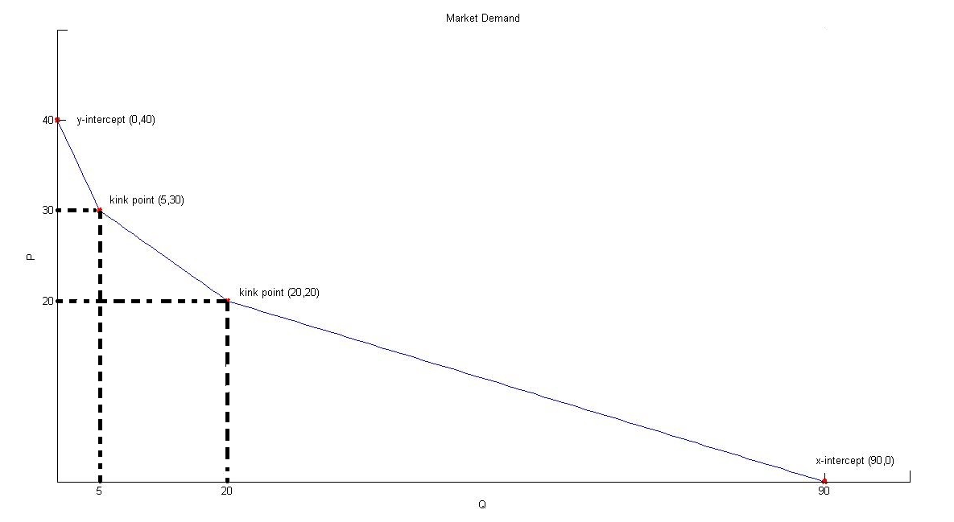

2. Suppose we are still working with the iPhone6 market described in problem 1. On the supply side in this market suppose Apple, the manufacturer or provider of these phones, outsources their production of the iPhone6 phones to two firms, Firm A and Firm B. These firms’ supply curves are given below where Qa is the quantity of iPhone6 phones supplied by Firm A, Qb is the quantity of iPhone6 phones supplied by Firm B, and P is the price per iPhone6 phone:
Firm A: Qa = P - 15
Firm B: Qb = 0.5P - 5

- Draw each firm’s supply curves in separate graphs and then construct the market supply curve in a new graph assuming that Firm A and Firm B are the only firms that are authorized to produce iPhones. Measure P on the vertical axis and Q on the horizontal axis for each graph. In the market supply curve identify the coordinates (Q, P) for any “kink points”.

Answer:
When prices are less than or equal to $15 per phone, only Firm B is willing to supply phones. So, the market supply curve for prices less than or equal to $15 per phone is given by the equation Qmarket = (1/2)P – 5, or in slope-intercept form P = 2Qmarket + 10.

When prices are greater than or equal to $15 per phone, both Firm A and Firm B are willing to supply phones. So, the market supply curve for prices greater than or equal to $15 per phone is given by the equation Qmarket = (3/2)P – 20, or in slope-intercept form P = (2/3)Qmarket + (40/3).

When you draw the market supply curve the y-intercept of the first segment will be at $10. The coordinates of the “kink point” will be (Q, P) = (2.5, 15).
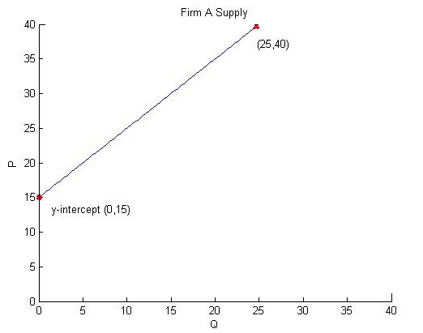
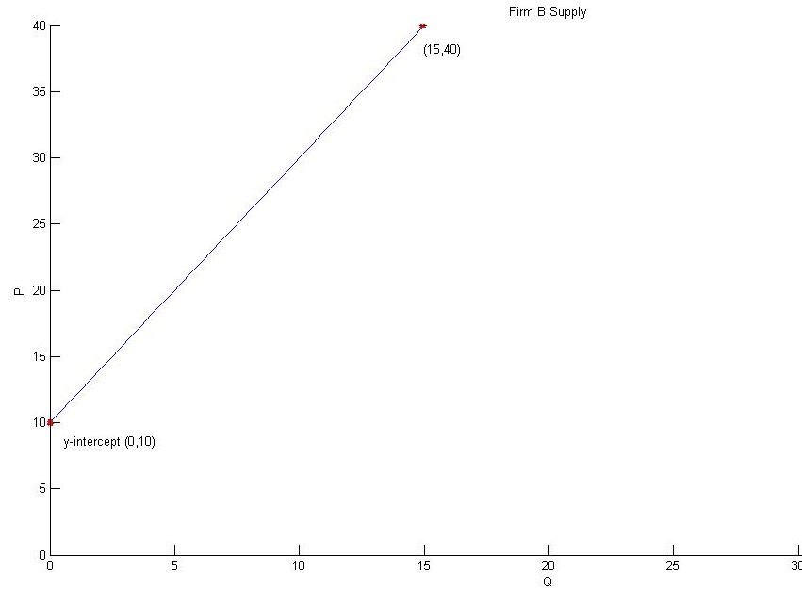

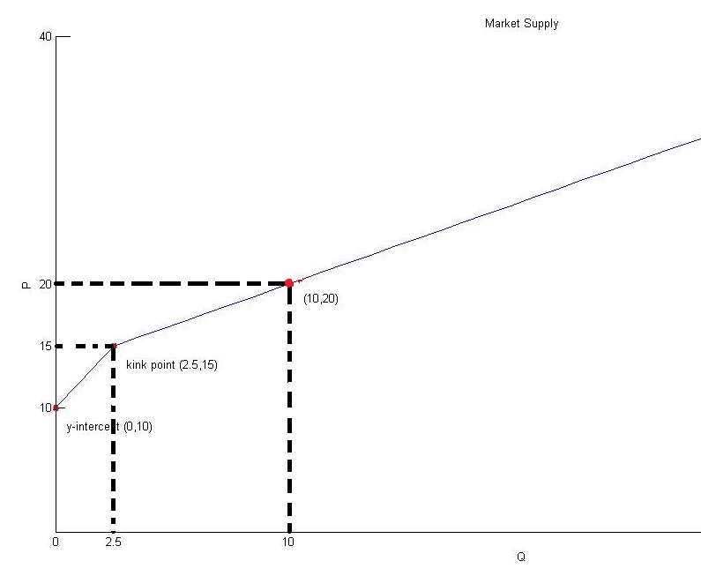
- Based on the market demand curve in question 1, what is equilibrium price and quantity in this market? Explain how you found your answer and how you decided which segments of the demand curve and the supply curve were the relevant segments to consider.

Answer:
The first challenge in finding the equilibrium here is identifying which segment of the market demand curve is needed and which segment of the market supply curve is needed. From our work in (2a) we know that the “kink point” of the supply curve occurs at (2.5, 15). This “kink point” clearly is beneath all the segments of the demand curve. So, let’s consider a quantity of phones that is greater than 2.5 and see if we can by logic figure out the relevant equations to use. If Q = 20, then we know that we are using the market supply curve P (2/3)Qmarket + (40/3) since the Q is greater than 2.5 units. And, when Q = 20, we can easily figure out that suppliers must receive a price of $(80/3) in order to be willing to supply this quantity of phones. From our market demand curve we know that when Q = 20, the market price demanders are willing to pay is $20 (it’s one of our “kink points”). This tells us that we need to use the following market demand and market supply curves to find the equilibrium:
Market Demand Curve: P = (100/3) – (2/3)Qmarket
Market Supply Curve: P = (2/3)Qmarket + (40/3)

Using these two equations we get:
(100/3) – (2/3)Qmarket = (2/3)Qmarket + (40/3)
(60/3) = (4/3)Qmarket
15 = Qmarket
Using this quantity and either the market demand curve or the market supply curve we get:
P = (100/3) – (2/3)(15) = (70/3) = $23.33
P = (2/3)(15) + (40/3) = (70/3) = $23.33

- Suppose Apple provides better technology to both Firm A and Firm B and this better technology reduces the cost of producing the iPhone6 phones. Given this information and holding everything else constant, make a prediction about how this new technology will affect the equilibrium price and quantity in this market.

Answer:
The new technology will shift the market supply curve to the right. Since the market demand curve does not move, we can conclude that the equilibrium price per iPhone6 phone will decrease while the equilibrium quantity of iPhone6 phones will increase.

3. Use the framework of the supply and demand model to answer these questions. Assume that each market described is initially in equilibrium and then evaluate what happens to the market given the provided scenario. In answering this set of questions you will find it helpful to sketch the market and what is happening to the market: our answer key will provide graphs for each scenario and we highly suggest that you draw the graphs as well in your answers!

- Consider the case of B. Wayne who is the most popular video blogger on YouTube. B Wayne receives a payment for every video he supplies to YouTube and his supply curve for these videos is upward sloping. The CEOs would like B. Wayne to supply a greater number of videos to YouTube. What kind of change in demand would result in B. Wayne supplying a greater number of videos? And, why would this change produce this result?

Answer:
If the CEOs could offer a better payment for every video, then B. Wayne would be willing to supply more videos given his upward sloping supply curve. The way to achieve this outcome is to shift the demand curve for these videos to the right. So any policy they could implement that would result in a greater quantity demanded at every given price would help them reach their goal of getting Wayne B. to provide more videos. The graph below illustrates this answer.

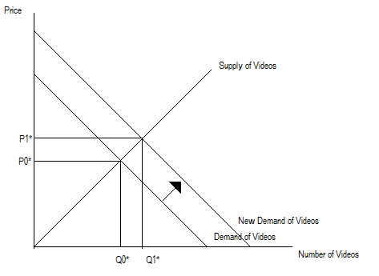

- P. Parker works at a local newspaper where he uses a special film to take nice photographs that are newspaper worthy (this requires that he use a better camera than his iPhone6). Since the release of the iPhone6, everyone but P. Parker are taking photos with their cellphones. How should this change affect the price of the special film that P. Parker uses? Provide a complete answer using your own words.

Answer:
Given the above information we can assume that fewer people are consuming the special film and this will cause the demand curve for this special film to shift to the left. This implies that the special firm will be sold at a lower price and there will be a smaller amount of the special film sold. P. Parker will pay less than he did initially. The graph below illustrates this answer.

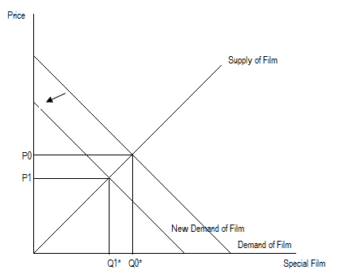

- T. Stark is a scientist that provides special weapons to some countries. T. Stark also enjoys skydiving and he would like to spend as much time as possible skydiving while still meeting the production needs for these weapons. He must decide on how many weapons to produce two years in advance of producing these weapons. He knows that Israel and Palestine plan to sign a peace agreement during this two year time period (and it will be an agreement that both countries respect). He also expects that next month the price of plutonium (a necessary input into his weapons) will be cheaper. Given this information, should T. Stark increase or decrease his production of these weapons? Should T. Stark expect a higher equilibrium price in the future?

Answer:
You should first note that the peace treatment will generate less demand for weapons: this means that T. Stark should anticipate that the demand curve for his weapons will shift to the left. We also know that the plutonium is an input used in the production of weapons and when the price of plutonium falls this means that he will be willing to produce a greater quantity of weapons at every price. That is, the decrease in the price of plutonium will shift the supply curve of weapons to the right. Since both curves are shifting we can anticipate that one of the variables we are trying to predict will be indeterminate: in this case, we can expect the new equilibrium price to be lower than the initial equilibrium price, but the new equilibrium quantity may be equal to, greater than, or less than the initial equilibrium quantity. The graph below illustrates this answer.

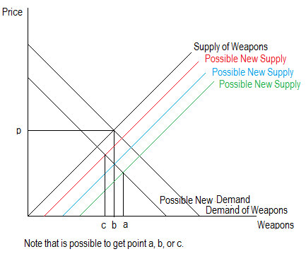

- Suppose that Metropolis is currently served by a single newspaper, The Daily Planet, and that the market for this newspaper follows the Laws of Supply and Demand. Furthermore, suppose that this market currently is in equilibrium. If a new firm enters this market and provides a newspaper with comparable coverage what do you predict will happen to the market price of newspapers and the market quantity of newspapers? What will happen to the quantity of newspapers produced by The Daily Planet? Explain your answer fully and provide a graph or graphs to illustrate your analysis.

Answer:
When the new firm enters this market this will cause the market supply curve to shift to the right (greater productive capacity) and result in a greater equilibrium quantity of newspapers and a lower equilibrium price for newspapers. Since the supply curve for The Daily Planet has not changed, we know that this change in price must reduce the quantity of newspapers produced and sold by The Daily Planet. Below are two graphs to illustrate this concept, where (Q0, P0) is the initial equilibrium and (Q1, P1) is the new market equilibrium. Note that since The Daily Planet is the only firm in the market initially, q0 = Q0. After the new firm enters The Daily Planet produces q1 < q0, while the new firm produces Q1 – q1.

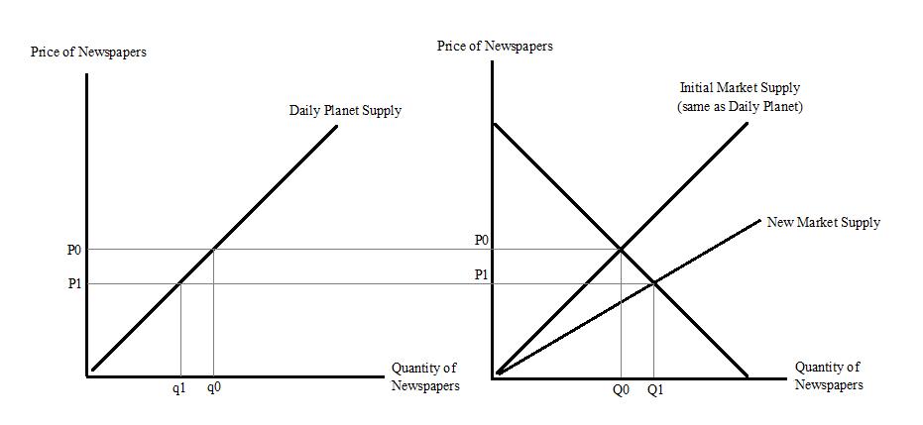
- Consider the market for purple tokens that initially is in equilibrium. The Joker likes to consume poker cards with purple tokens. If the price of poker cards goes up, what will happen to the number of purple tokens that he buys?

Answer:
Poker cards and purple tokens are complements to one another given the above information. So, we know that if the price of one of these complementary goods increases (poker cards get more expensive) then less of that good, the poker cards, will be consumed. As the Joker decreases his consumption of poker cards this will result in a leftward shift of his demand curve for purple tokens. Therefore, we can predict that as the price of poker cards increases, the Joker will consume fewer purple tokens. The graph below illustrates this answer.

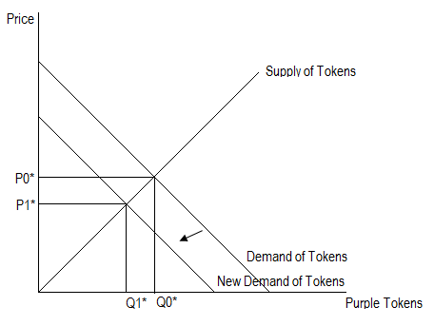

- Bruce Banner works in the university lab and he can produce a perfect substitute for milk. His principal input is gamma radiation: this input is green and it’s called gamma milk. Imagine that the university builds a better machine to produce gamma radiation. At the same time the university decides to implement a subsidy on the price of milk for all undergrads (that is, this subsidy will effectively make it possible for students to be able to afford more milk at every price). Given this information and holding everything else constant, what will happen to the quantity demanded of gamma milk?

Answer:
With the new technology for producing gamma radiation, Bruce will be able to produce more gamma radiation and hence, gamma milk from his existing resources. We can model this as a rightward shift of the supply curve in the market for gamma milk. At the same time, the subsidy that the government pays students for consuming regular milk will result in a rightward shift of the demand curve for milk: in the market for milk, this shift will cause the price of each unit of milk to rise holding everything else constant. As the price of milk rises, this will cause the demand curve for gamma milk to shift to the right: since both the supply curve and the demand curve for gamma milk have shifted this will result in a case of indeterminancy. This time we know with certainty that the equilibrium quantity of gamma milk increases relative to its initial equilibrium level, but the equilibrium price may increase, decrease or remain the same as the initial equilibrium price. The price of gamma milk is therefore indeterminate. The graph below illustrates this answer.

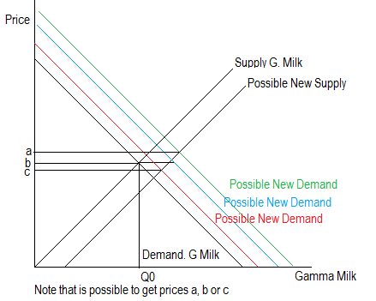

4. Consider the case of Transylvania. This town has the best vampire killing stakes in the world. Recently an adventurous explorer gathered this information about the market for stakes in Transylvania where P is the price per stake and Q is the quantity of stakes:

Demand of Stakes: P = 50 – (1/2)Q
Supply of Stakes: P = 20 + (1/2)Q
Help this adventurous explorer answer these questions with your new econ 101 tools.

- First find the equilibrium price and the equilibrium quantity.

Making Supply and Demand equal we find that
50 – (1/2)Q = 20 + (1/2)Q
Q = 30
Plug this quantity back into either the demand equation or the supply equation to find the equilibrium price: thus,
P = 50 – (1/2)Q
P = 50 – (1/2)(30) or P = $35; or
P = 20 + (1/2)Q P = 20 + (1/2)(30) or P = $35 (Note: that you do need to get the same equilibrium price from both of these equations-if you don’t that’s a sign that you have made some kind of error)

- Calculate the value of the vampire hunters’ consumer surplus (CS) and the stake producers’ producer surplus (PS). Show your work in calculating this answer.

To find the consumer surplus (CS) of the vampire hunters we just need to find the area that is beneath the demand curve and above the equilibrium price (see the blue area in the graph below). Then, CS = (1/2)($50 per stake - $35 per stake)(30 stakes) = $225. For the producer surplus (PS) we just need to find the area that is above the supply curve and below the equilibrium price (see the green area in the graph below). Then, PS = (1/2)($35 per stake - $20 per stake)(30 stakes) = $225.

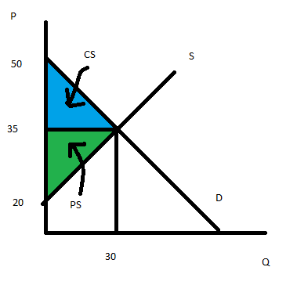
- The explorer tells you that Count Dracula (Lord of Transylvania) wants to establish a price support program that will help the producers of stakes. He wants to set a price floor of $50 per stake. To maintain this in the market for stakes Count Dracula plans to buy any surplus stakes produced in the market. How many stakes will the vampire hunters buy once this price support program is enacted? How many stakes will the stake producers sell once this price support program is enacted? How many stakes will Count Dracula buy once this price support program is enacted? Provide a graph to illustrate your answer: make sure your graph is clearly and completely labeled.

Answer:
To find the quantity that the vampire hunters will buy we just plug in the price floor price of $50 into the demand curve equation:
P = 50 – (1/2)Q
50 = 50 - (1/2)Q
Q = 0
This means that the vampire hunters will buy no stakes when this price floor program is implemented by Count Dracula.
To find the quantity of stakes produced, plug in the price support price of $50 per stake into the supply curve. Thus,
P = 20 + (1/2)Q
50 = 20 + (1/2)Q
Q = 60
This quantity is the level of production by the stake producers, but it is also the amount of vampire stakes that Count Dracula will buy when the price support program is implemented.

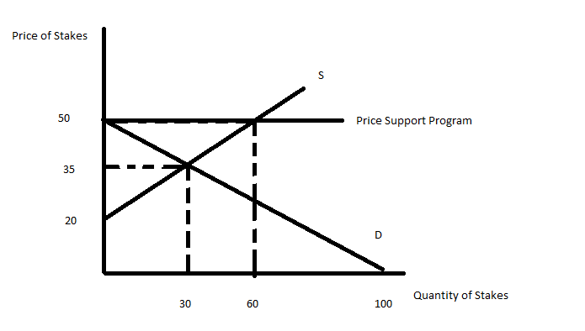

- Actually Count Dracula is a Vampire, so after buying the stakes he burns them (making him unable to sell them to anyone else). How costly is the price support program for Count Dracula?

We just have to multiply the (number stakes he buys)(the price he agreed to pay) or (60 stakes)($50 per stake) = $3000.

- On his last day in Transylvania our adventurous explorer decided to propose a different measure to Count Dracula. He proposes that a price guarantee program be implemented in the stake market. This program would provide a subsidy to the stake producers that results in their receiving a total price of $50 per stake. The stake producers would be told to determine how many stakes they are willing to produce at this subsidized price. Once they determine how many stakes to produce, they are then instructed to go and sell these stakes at whatever price they need to in order to sell all of the stakes they produced. Then Count Dracula will pay them the difference per stake between the promised subsidized price and the actual price the stake sells for in the market. Given this program how many stakes will the producers produce? How many stakes will the vampire hunters buy? What will be the price that the vampire hunters pay per stake? What is the total amount that Count Dracula will have to pay the stake producers once this program is implemented? Provide a graph to illustrate your answer.

Answer:
First note that the vampire hunters will buy as many stakes as the producers are willing to supply when they are promised a subsidized price of $50 per stake. To calculate how many stakes the producers are willing to pay we therefore need to plug a price of $50 per stake into the supply equation. Thus,
P = 20 + (1/2)Q
50 = 20 + (1/2)Q or Q = 60 stakes

To calculate the price that the vampire hunters are willing to pay for this quantity we need to plug Q = 60 stakes into the demand equation. Thus,
P = 50 – (1/2)Q
P = 50 – (1/2)(60) or P = $20 per stake. That is, the demanders of these stakes are willing to demand 60 stakes (the total produced) when they pay $20 per stake.

Count Dracula will need to pay the difference between the subsidized price of $50 per stake and the price the vampire hunters actually pay of $20 per stake: the subsidy per stake will be $30 per stake. The total amount the Count must pay for this price guarantee program will be ($30 per stake)(60 stakes) = $1800.
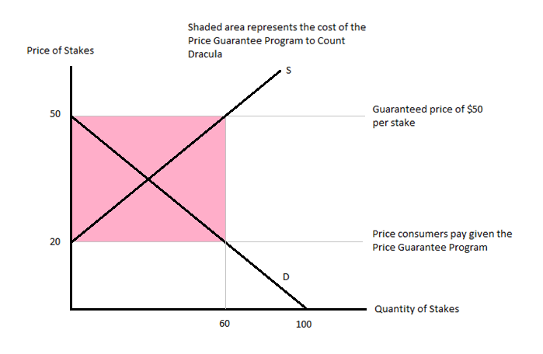

- How many stakes will the count buy?

Answer:
The Count buys no stakes since in this mechanism the vampire hunters buy all the stakes produced while the Count simply pays the producers the total subsidy amount.

- Given the two programs described in (d) and (e), which program do the producers of stakes prefer? Explain your answer.

Answer: The revenue of the producers in the price support program is ($50 per stake)(60 stakes) = $3000. The revenue of the producers in the price guarantee program is ($50 per stake)(60 stakes) = $3000. Since the revenue that the producers receive in the two programs is equivalent, the producers are indifferent as to which program is implemented.

- Which program is less costly for the count? Which program is safer for him if his goal is to insure that he is not killed?

Answer:
The price support program costs the Count $3000 while the price guarantee program costs him $1200: so the price guarantee program is cheaper for the Count. However, with the price support program the Count ends up with all the vampire hunting stakes and that makes his life considerably safer than it is with the price guarantee program where the vampire hunters have 60 stakes which is an even larger number of stakes then the market provided before the implementation of either program. So, the Count wanting to insure his life will prefer the first program (the price support program) even though it costs more than the price guarantee program.

5. You are the new manager at Starbucks. Suppose that the demand and supply curves for coffee is given by the following two equations where P is the price per cup in Mexican Pesos (13 pesos is a dollar) and Q is the quantity of cups:
Market Demand: P = 60 – Q
Market Supply: P = 40 +Q
- Given this information, what is the equilibrium price and the equilibrium quantity?

Answer:
As usual, we equate both equations. 40 + Q = 60 – Q. Q = 10 cups of coffee. Then substitute this in either equation and you get that P = 50 pesos.

- Given this information, what is the value of consumer surplus (CS) in this market? What is the value of producer surplus (PS) in this market? Illustrate your answer with a graph that is well labeled and complete.

Answer:
The consumer surplus (CS) is the area that is beneath the demand curve and above the equilibrium price (the blue area in the provided graph). Thus CS = (1/2)(60 pesos per cup – 50 pesos per cup)(10 cups) = 50 pesos. The producer surplus (PS) is the area that is above the supply curve and beneath the equilibrium price (the green area in the provided graph). PS = (1/2)(50 pesos per cup – 40 pesos per cup)(10 cups) = 50 pesos.
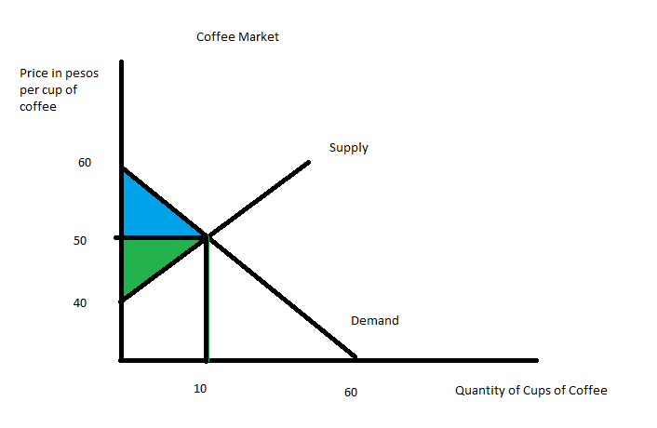

- Suppose that the mayor in Mexico City decides that the current price of Starbucks is too high. The government sets a price ceiling, the price of Starbucks’ coffee now is set at 44 pesos per cup. Given this price ceiling, how many cups will be demanded? Given this price ceiling, how many cups will be supplied? Who represents the short side of the market?

Answer:
With a price ceiling of 44 pesos per cup of coffee we see that demanders will now demand 16 cups of coffee. To see this plug P = 44 into the demand equation: thus,
44 = 60 – Qd where Qd is the quantity of coffee demanded by consumers
Qd = 16 cups of coffee

With a price ceiling of 44 pesos per cup of coffee we see that suppliers will now supply 4 cups of coffee. To see this plug P = 44 into the supply equation: thus,
44 = 40 + Qs where Qs is the quantity of coffee supplied by producers
Qs = 4 cups of coffee

The short side of the market is the supply side since Qd>Qs. That is, with the effective price ceiling there is excess demand in this market. Hence, Starbucks-the producer- is on the short side of the market.

- What is the value of consumer surplus (CS’) with the price ceiling described (c)? What is the value of producer surplus (PS’) with this price ceiling? Provide a well labeled graph to illustrate your answer.

Answer:
Now with the price ceiling our area of CS’ is the blue area in the provided graph: the value of this blue area can be calculated as the sum of a triangle plus a rectangle. CS’ = (1/2)(60 pesos per cup – 56 pesos per cup)(4 cups) + (56 pesos per cup – 44 pesos per cup)(4 cups) = 56 pesos.

The area of PS’ with the price ceiling is the green area in the provided graph: the value of this area can be calculated as PS’ = (1/2)(44 pesos per cup – 40 pesos per cup)(4 cups) = 8 pesos.

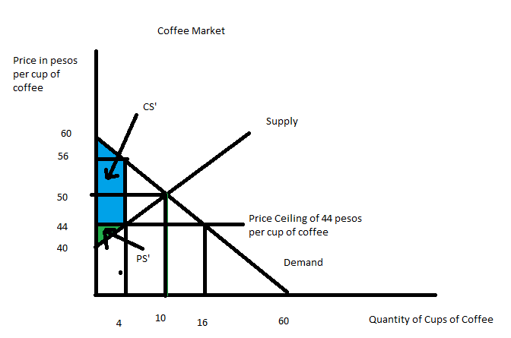

e. What is the value of the deadweight loss due to the implementation of this program? The deadweight loss will be equal to the total loss in (consumer surplus and producer surplus) due to the implementation of this program. Provide a graph to illustrate the deadweight loss (DWL) due to the program.

Answer:
The sum of CS + PS initially is 100 pesos. The sum of CS’ + PS’ is 64 pesos. So, the DWL should be equal to 100 pesos – 64 pesos or 36 pesos. Let’s see if that is the value of the area designated DWL in the graph below: DWL = (1/2)(56 pesos per cup – 44 pesos per cup)(10 cups – 4 cups) = 36 pesos!
