Econ 100
Spring 2015
Practice Questions
March 12, 2015

- Use the following diagram of a production possibilities frontier for Macroland to answer the following set of questions. Assume that Macroland produces only two types of goods, capital goods (K) and consumer goods (C).
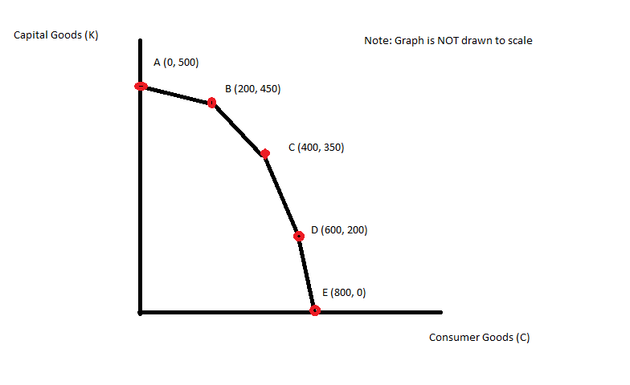
  - What is the opportunity cost of producing 50 more units of capital goods if the economy of Macroland is currently producing at point B?
  - What is the opportunity cost of producing 50 more units of consumer goods if the economy of Macroland is currently producing at point B?
  - What is the opportunity cost of producing 1 more unit of capital goods if the economy of Macroland is currently producing at point C?
  - What is the opportunity cost of producing 1 more unit of consumer goods if the economy is currently producing at point D?
  - Suppose that there is a technological improvement in producing consumer goods that results in twice as many units of consumer goods being produced from the available resources in Macroland. Draw the new production possibility frontier for Macroland given this change. Assume that there are no changes in technology with regard to capital good production.
Answers:
- 200 units of consumer goods
- 25 units of capital goods
- ½ unit of consumer goods
- 1 unit of capital goods

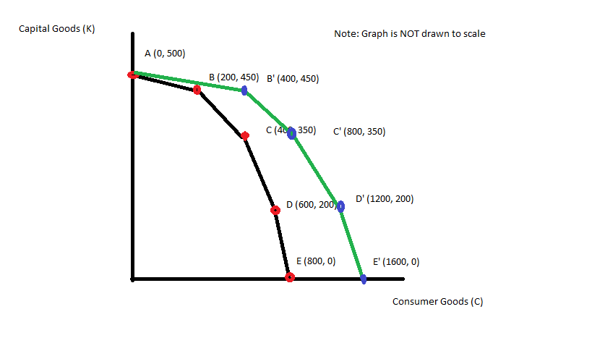
- Amazonia and Noblia are two countries that each produce zippers (Z) and hats (H). From its available resources and technology Amazonia can produce 100 zippers and 0 hats or 0 zippers and 200 hats or any combination of zippers and hats that sits on Amazonia’s linear PPF. From its available resources and technology Noblia can produce 50 zippers and 0 hats or 0 zippers and 50 hats or any combination of zippers and hats that sits on Noblia’s linear PPF.
  - On two separate graphs draw the PPF for Amazonia and Noblia. Measure zippers on the vertical axis and hats on the horizontal axis.
  - Write an equation in slope-intercept form for the PPF for Amazonia.
  - Write an equation in slope-intercept form for the PPF for Noblia.
  - What is Amazonia’s opportunity cost of producing 1 hat? What is Noblia’s opportunity cost of producing 1 hat? Which country has the comparative advantage in producing hats?
  - What is Amazonia’s opportunity cost of producing 1 zipper? What is Noblia’s opportunity cost of producing 1 zipper? Which country has the comparative advantage in producing zippers?
  - Draw the joint PPF for Amazonia and Noblia. On this graph make sure you identify the coordinates of any endpoint as well as the coordinates for any “kink” point.
  - What is the range of trading prices that are acceptable to both countries for 10 zippers?
  - What is the range of trading prices that are acceptable to both countries for 5 hats?

Answers:

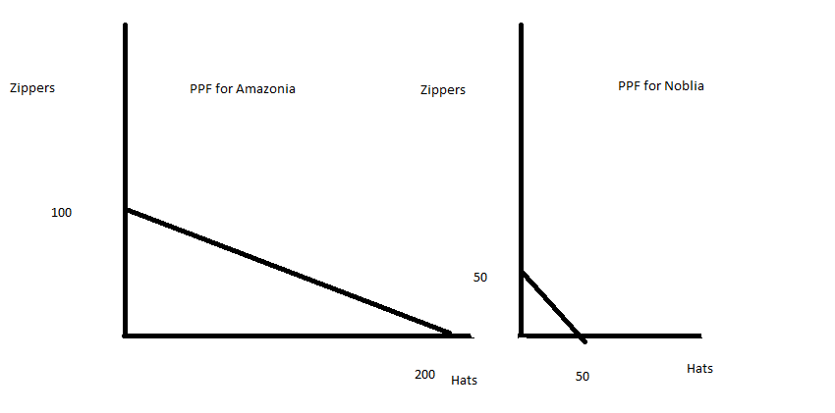
- Z = 100 – (1/2)H
- Z = 50 – H
- The opportunity cost of producing one hat in Amazonia is ½ zipper; the opportunity cost of producing one hat in Noblia is 1 zipper. Amazonia has the comparative advantage in producing hats.
- The opportunity cost of producing one zipper in Amazonia is 2 hats; the opportunity cost of producing one zipper in Noblia is a hat. Noblia has the comparative advantage in producing zippers.

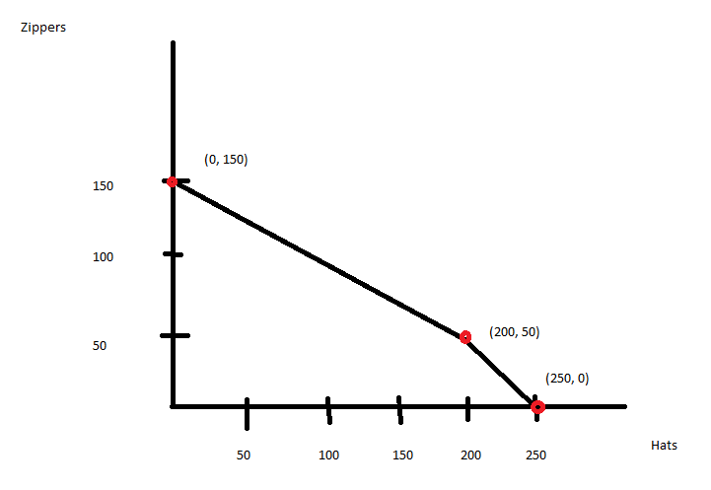
- The range of trading prices for 1 zipper is between 1 hat and 2 hats. So, the range of trading prices for 10 zippers is between 10 hats and 20 hats.
- The range of trading prices for 1 hat is between ½ zipper and 1 zipper. So, the range of trading prices for 5 hats is between 2.5 zippers and 5 zippers.

3. Each of the following situations is independent of the other situations. For each draw a graph illustrating the situation and do the requested analysis.
  - Consider the market for soft drinks that is initially in equilibrium with a market price of P1 and a market quantity of Q1. Suppose there is a successful campaign to educate the public about the caloric values in soft drinks and their contribution to obesity. At the same time suppose that the price of corn syrup, a key ingredient in many soft drinks, rises. Draw a graph illustrating the initial equilibrium and the new equilibrium after these described changes. Provide a verbal description of the outcome in this market due to these changes.
  - Consider the market for mass transit that is initially in equilibrium with a market price of P1 and a market quantity of Q1. Suppose that after Hurricane Sandy swept through the Atlantic states that New York City officials mandated that all cars coming into New York City must have at least three occupants at all times, otherwise individuals wishing to travel in New York City would need to take mass transit during the weeks of clean-up from this storm. Analyze the impact of this edict from city officials on the market for mass transit. Provide a graph of your analysis and also a verbal description of how the equilibrium price and equilibrium quantity responded to this edict.
  - Consider the market for gasoline that is initially in equilibrium with a market price of P1 and a market quantity of Q1. Suppose that there is a war in the Middle East that disrupts petroleum production (petroleum is a major input to the production of gasoline) while at the same time people’s incomes in the United States increases. Assume gasoline is a normal good. Draw a graph illustrating the initial equilibrium and the new equilibrium after these described changes. Provide a verbal description of the outcome in this market due to these changes.
  - Consider the market for noodles that is initially in equilibrium with a market price of P1 and a market quantity of Q1. Noodles are an inferior good. Suppose that people’s incomes fall due to the financial crisis. Draw a graph illustrating the initial equilibrium and the new equilibrium after the described changes. Provide a verbal description of the outcome in this market due to these changes.
Answers:
- The market demand curve for soft drinks will shift to the left and the market supply curve will shift to the left as well: equilibrium quantity will decrease and the equilibrium price may rise, fall, or remain the same. The graphs below illustrate this idea.
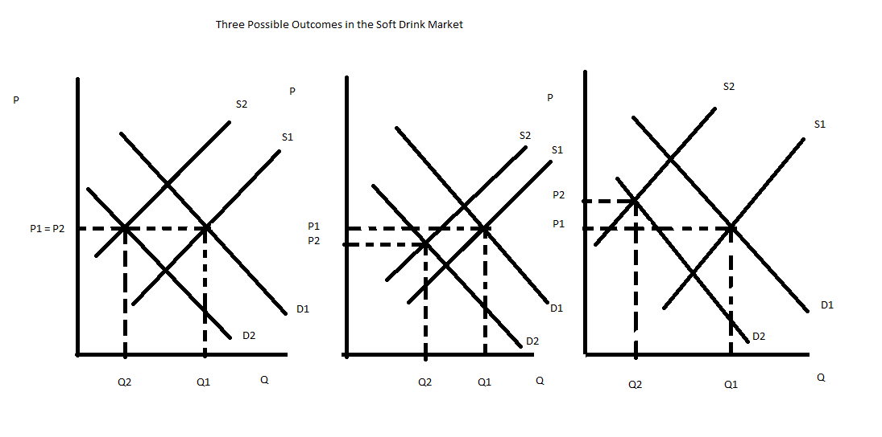
- The market demand curve for mass transit will shift to the right and the market supply will be unchanged: equilibrium quantity will increase and the equilibrium price will increase. The graph below illustrates this idea.
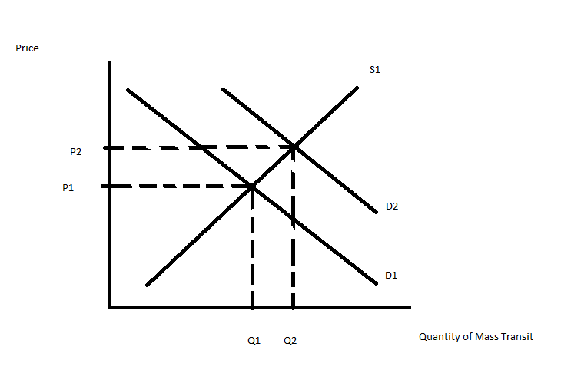
- The market demand curve for gasoline will shift to the right while the market supply curve for gasoline will shift to the left: the equilibrium quantity may rise, fall or stay the same while the equilibrium price will increase. The graphs below illustrate this idea.
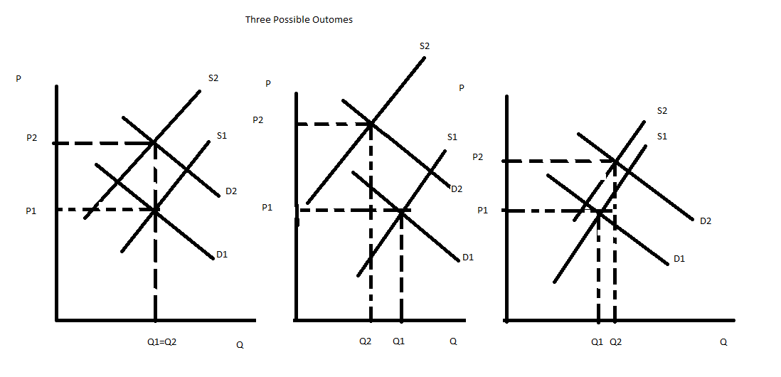
- The market demand curve will shift to the right and the market supply curve will be unchanged. The equilibrium price of noodles will increase as will the equilibrium quantity of noodles. The graph below illustrates this example.
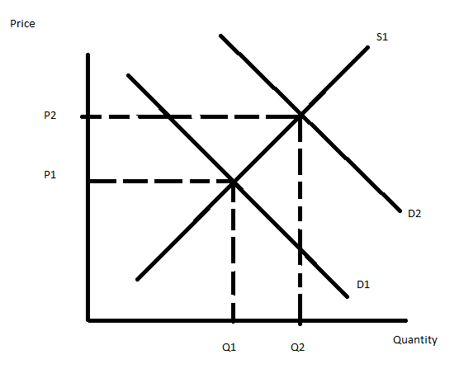

4. Romia is a small, closed economy that produces pianos. Currently the domestic demand for pianos in Romia is given by the equation P = 2000 – 2Q while the domestic supply for pianos in Romia is given by the equation P = 200 + 4Q.
  - Given the above information calculate the equilibrium price and equilibrium quantity in the market for pianos in Romia. Then, calculate the value of consumer surplus (CS) and producer surplus (PS).

Suppose that Romia is considering opening its piano market to trade and that the world price of pianos is $1500.

  - Given this information, analyze the effect on Romia of opening its piano market to trade. In your answer be sure to comment on how this decision will impact imports or exports of pianos in Romia while also commenting on how many pianos domestic consumers will purchase if the market opens to trade and how many pianos domestic producers will produce if the market opens to trade. In addition, calculate the values of CS with trade and PS with trade.
  - Is opening this market to trade beneficial for Romia? Fully explain your answer to this question.

Suppose that Romia is considering opening its piano market to trade and that the world price of pianos is $800.

  - Given this information, analyze the effect on Romia of opening its piano market to trade. In your answer be sure to comment on how this decision will impact imports or exports of pianos in Romia while also commenting on how many pianos domestic consumers will purchase if the market opens to trade and how many pianos domestic producers will produce if the market opens to trade. In addition, calculate the values of CS with trade and PS with trade.
  - Is opening this market to trade beneficial for Romia? Fully explain your answer to this question.

Now, suppose the market for pianos in Romia is opened to trade and the world price is $800 per piano. Use this information and the equations for the domestic demand and domestic supply curves to answer the net set of questions.

  - Given this information, suppose you are told that the government has enacted a tariff that resulted in the government receiving $60,000 in tariff revenue. By how much did the tariff raise the price of pianos given this information? Hint: if you do this correctly you should find that there are two different tariffs that Romia could apply in this market to get this level of tariff revenue.
  - Given your two answers in (f) go back and calculate the value of imports under each tariff price and then prove numerically that both tariffs result in tariff revenue of $60,000.

Answer:
- The equilibrium price in the market for pianos in Romia is $1400 while the equilibrium quantity is 300 pianos. To find these equilibrium values use the given domestic demand and domestic supply curves. The value of CS = (1/2)($2000 per piano - $1400 per piano)(300 pianos) = $90,000. The value of PS = (1/2)($1400 per piano - $200 per piano)(300 pianos) = $180,000.
- If this market opens to trade and the world price of pianos is $1500, then domestic consumers will demand 250 pianos at this price (P = 2000 – 2Q and then 1500 = 2000 – 2Q and therefore the quantity demanded domestically is 250 pianos) and domestic producers will supply 325 pianos at this price (P = 200 + 4Q and then 1500 = 200 + 4Q and therefore the quantity supplied domestically is 325 pianos). Since the quantity supplied domestically is greater than the quantity demanded domestically, Romia will have an excess supply of pianos at a price of $1500 per piano. The excess supply of 75 pianos (325 pianos – 250 pianos or 75 pianos) will be exported and sold to buyers elsewhere in the world for a price of $1500 per piano. CS with trade will now equal (1/2)($2000 per piano - $1500 per piano)(250 pianos) = $62,500. PS with trade will now equal (1/2)($1500 per piano - $200 per piano)(325 pianos) = $211,250.
- Yes, opening this market to trade is beneficial since total surplus (TS) increases from $270,000 to $273,750 when this market is opened to trade. However, there are winners and losers when this market opens to trade: domestic consumers will find that they are buying fewer pianos and paying a higher price for each piano while domestic producers will find that they are selling more pianos and receiving a higher price for each piano. Domestic consumers will find that their consumer surplus is lower with trade while domestic producers will find that their producer surplus is higher with trade.
- If this market opens to trade and the world price of pianos is $800, then domestic consumers will demand 600 pianos at this price (P = 2000 – 2Q and then 800 = 2000 – 2Q and therefore the quantity demanded domestically is 600 pianos) and domestic producers will supply 150 pianos at this price (P = 200 + 4Q and then 800 = 200 + 4Q and therefore the quantity supplied domestically is 150 pianos). Since the quantity supplied domestically is less than the quantity demanded domestically, Romia will have an excess demand for pianos at a price of $800 per piano. The excess demand of 450 pianos (600 pianos – 150 pianos or 450 pianos) will be imported and sold to domestic buyers in Romia for a price of $800 per piano. CS with trade will now equal (1/2)($2000 per piano - $800 per piano)(600 pianos) = $360,000. PS with trade will now equal (1/2)($800 per piano - $200 per piano)(150 pianos) = $45,000.
- Yes, opening this market to trade is beneficial since total surplus (TS) increases from $270,000 to $405,000 when this market is opened to trade. However, there are winners and losers when this market opens to trade: domestic consumers will find that they are buying more pianos and paying a lower price for each piano while domestic producers will find that they are selling fewer pianos and receiving a lower price for each piano. Domestic consumers will find that their consumer surplus is greater with trade while domestic producers will find that their producer surplus is lower with trade.
- To find the price with the tariff in this question is a really bit hard. Let’s first start by rewriting the domestic demand curve in x-intercept form: P = 2000 – 2Q can be rewritten as Q domestic demand = 1000 – (1/2)P. Let’s also rewrite the domestic supply curve in x-intercept form: P = 200 + 4Q can be rewritten as Q domestic supply = (1/4)P – 50. Then, think about the relationship between the tariff revenue, the world price, the price with the tariff, the quantity demanded domestically and the quantity supplied domestically. We could write this as Tariff Revenue = (Q demanded domestically – Q supplied domestically)(Price with the tariff – World Price). Then, let’s plug in the values or relationships we know: $60,000 = (Q demanded domestically – Q supplied domestically)(Price with the tariff – 800). But, we also know Q demanded domestically and Qsupplied domestically from our domestic demand and domestic supply equations respectively. So, 60,000 ={[ (1000 – (1/2)P] – [(1/4)P – 50]}( P – 800). Now, the math gets a little bit tedious and so let’s switch to a line per math manipulation.
60,000 = (1050 – (3/4)P)(P – 800)
60,000 = 1050P – (3/4)P² - 1050(800) + (3/4)P(800)
60,000 = 1650P – (3/4)P² – (1050)(800)
0 = (3/4)P² – 1650P – 900,000
0 = P² – 2200P + 1,200,000
Now, let’s factor this equation to find the two roots that will solve the equation:
0 = (P – 1200)(P – 1000)
Or, 0 = P – 1200 implies that P = 1200 or 0 = P – 1000 implies that P = 1000. So, when the tariff increases the world price to $1200 per piano or when the tariff increases the world price to $1000, the government will collect $60,000 in tariff revenue.
- Let’s start with a tariff that raises the price of pianos to $1200 in Romia. At a price of $1200, domestic demand will equal 400 pianos while domestic supply will equal 250 pianos and therefore Romia will import 150 pianos. Each of these imported pianos will pay the tariff of $400 per piano (the difference between the tariff price of $1200 per piano and the world price of pianos of $800). Tariff revenue will therefore equal ($400 per piano)(150 pianos) = $60,000.
Now, let’s try the same thing with a tariff that raises the price of pianos to $1000 in Romia. At a price of $1000, domestic demand will equal 500 pianos while domestic supply will equal 200 pianos and therefore Romia will import 300 pianos. Each of these imported pianos will pay the tariff of $200 per piano (the difference between the tariff price of $1000 per piano and the world price of pianos of $800). Tariff revenue will therefore equal ($200 per piano)(300 pianos) = $60,000.
5. Consider the small, closed economy of Exurbia. Exurbia produces mittens and the domestic market demand and domestic market supply curves for mittens in Exurbia are as follows where Q is pairs of mittens and P is the price per pair of mittens:
Domestic Demand: Q = 20,000 – 2000P
Domestic Supply: Q = 2000P – 4000
  - For the closed economy of Exurbia calculate the equilibrium price and equilibrium quantity of mittens, as well as the value of consumer surplus (CS) and producer surplus (PS). Then draw and label a graph depicting the closed market for mittens in Exurbia.
  - Now, suppose that the economy of Exurbia opens its mittens market to trade. Furthermore suppose that the world price of mittens is $3 per pair of mittens. Find the level of imports when Exurbia opens this market to trade. In addition find the quantity demanded domestically, the quantity supplied domestically, the value of CS with trade, and the value of PS with trade. Then draw and label a graph depicting the open market for mittens in Exurbia. Is opening this market to trade beneficial for Exurbia? Explain your answer.
  - Now, after opening this market to trade, the government of Exurbia decides to implement a quota in this market. They decide to impose a quota of 2000 pairs of mittens in this market. Find the level of imports when Exurbia opens this market to trade and imposes this quota. In addition find the quantity demanded domestically, the quantity supplied domestically, the value of CS with the quota, the value of PS with the quota, the license holder revenue due to the quota, and the deadweight loss associated with the quota. Then draw and label a graph depicting this quota in the market for mittens in Exurbia.

Answer:
- To find the equilibrium price and equilibrium quantity of mittens in Exurbia use the provided domestic demand and domestic supply curves. Thus,
20,000 – 2000P = 2000P – 4000
24,000 = 4000P
P = $6 per pair of mittens
Q = 20,000 – 2000(6) = 8,000 pairs of mittens
CS with a closed economy = (1/2)($10 per pair of mittens - $6 per pair of mittens)(8000 pairs of mittens) = $16,000
PS with closed economy = (1/2)($6 per pair of mittens - $2 per pair of mittens)(8000 pairs of mittens) = $16,000
The graph below represents this closed economy.
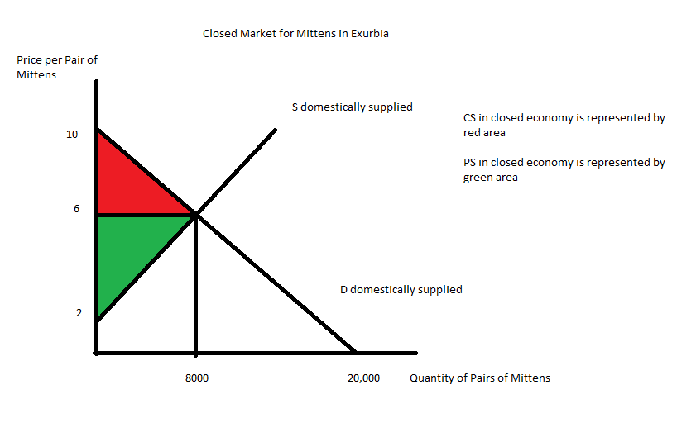
- Now the mitten market is open to trade with the world price of $3 per pair of mittens. When the price is $3 per pair of mittens, the quantity demanded domestically is equal to:
Q demanded domestically = 20,000 – 2000(3) = 14,000 pairs of mittens
When the price is $3 per pair of mittens, the quantity supplied domestically is equal to:
Q supplied domestically = 2000(3) – 4000 = 2000 pairs of mittens
Exurbia will import the difference between the quantity demanded domestically and the quantity supplied domestically or
Imports = 14,000 – 2,000 = 12,000
CS with trade = (1/2)($10 per pair of mittens - $3 per pair of mittens)(14,000 pairs of mittens) = $49,000
PS with trade = (1/2)($3 per pair of mittens - $2 per pair of mittens)(2000 pairs of mittens) = $1000
Opening this market to trade is beneficial since the area of total surplus (CS with trade + PS with trade) is greater than the area of total surplus (CS + PS) when the economy is a closed economy. Domestic consumers consume more of the good and purchase it at a lower price when the market is open to trade: opening this market to trade provides positive distributional consequences to domestic consumers. Domestic producers sell fewer units of the good and sell it at a lower price when the market is open to trade: opening this market to trade provides negative distributional consequences to domestic producers.
Here is a graph representing this market when it opens to trade:
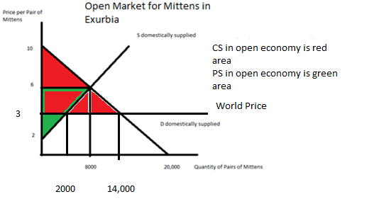
- Now the market is open to trade but with a quota of 2000 units. So, we know that the quantity supplied domestically plus the quota is equal to the quantity demanded domestically. Or,
Q _{supply domestic} + quota = Q _{demand domestic}
Or, 2000P – 4000 + 2000 = 20,000 – 2000P
4000P = 22,000
P = $5.50 per pair of mittens
Q _{supply domestic} = 2000P – 4000 = 2000(5.50) – 4000 = 7,000 pairs of mittens
Q _{demand domestic} = 20,000 – 2000P = 20,000 – 2000(5.5) = 9,000 pairs of mittens
Imports = Quantity demanded domestically with the quota – Quantity supplied domestically with the quota = 9,000 – 7,000 = 2,000 = amount of the quota
CS with quota = (1/2)($10 per pair of mittens - $5.50 per pair of mittens)(9,000 pairs of mittens) = $20,250
PS with quota = (1/2)($5.50 per pair of mittens - $2 per pair of mittens)(7,000 pairs of mittens) = $12,250
License Holder Revenue = ($5.50 per pair of mittens - $3 per pair of mittens)(2000 pairs of mittens) = $5000
Deadweight Loss due to the quota = DWL = (1/2)($5.50 per pair of mittens - $3 per pair of mittens)(7000 pairs of mittens – 2000 pairs of mittens) + (1/2)($5.50 per pair of mittens - $3 per pair of mittens)(14,000 pairs of mittens – 9,000 pairs of mittens) = $12,500
Here is a graph representing this quota:
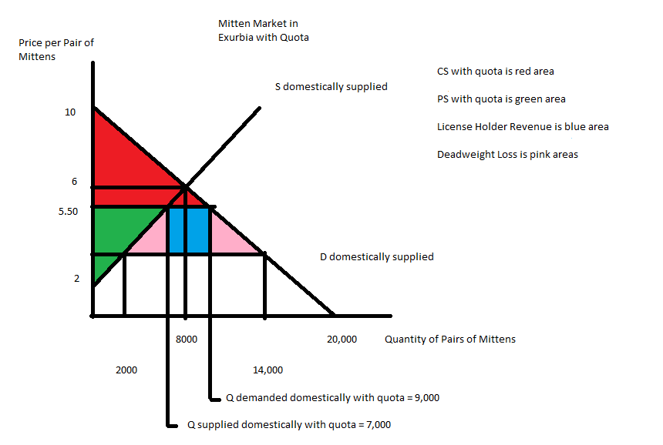
6. In Boomtown government officials are considering implementing an excise tax on the producers of tennis balls. They have called you in to analyze the impact of this proposed tax. Currently (before the excise tax) market demand and market supply of tennis balls is given in Boomtown are given by the following equations where P is the price per case of tennis balls and Q is the quantity of cases of tennis balls:
Market Demand: P = 90 – (3/2)Q
Market Supply: P = 20 + (1/4)Q
The government officials propose implementing an excise tax of $7 per case of tennis balls on producers. Use this information to answer the following set of questions. Be sure to show how you got your answers.
  - Intuitively, implementation of this tax will cause which curve in our demand and supply graph to shift? Explain the direction of this shift and how this shift will impact equilibrium price and equilibrium quantity in this market once the excise tax is imposed.
  - With the imposition of this excise tax, how much tax revenue will be collected by the government in Boomtown?
  - With the imposition of this excise tax, what will be the change in consumer surplus relative to the initial level of consumer surplus?
  - With the imposition of this excise tax, what will be the change in producer surplus relative to the initial level of producer surplus?
  - What is the deadweight loss due to this excise tax? Verify that the sum of (CS with the tax + PS with the tax + Tax revenue + Deadweight Loss) is equal to the value of total surplus prior to the imposition of the excise tax. (If it is not, then you have made a math error and you need to redo the problem to correct this error.)
  - Calculate the consumer tax incidence (CTI) and the producer tax incidence of this excise tax. Who bears the greater economic burden of this excise tax? Explain your answer.
  - Suppose the government would like to decrease consumption of tennis balls to 28 cases. How big an excise tax would the government need to implement to reach this goal?

Answer:
- When the government implements an excise tax on producers of tennis balls this will cause the supply curve to shift to the left: the excise tax effectively increases the cost of producing tennis balls since producers must now pay the government the excise tax on each case of tennis balls that they sell. The equilibrium price in the market for tennis balls will increase while the equilibrium quantity of cases of tennis balls will decrease with the imposition of this excise tax.
- To find the tax revenue from the excise tax we must first find the new equilibrium price and new equilibrium quantity in this market once the excise tax is implemented. First, find the new supply curve with the excise tax: the new supply curve will shift to the left and the y-intercept of this new supply curve will be equal to the initial y-intercept plus the amount of the excise tax per unit. The y-intercept of the original supply curve is 20, so the new y-intercept of the supply curve with the excise tax will be 20 + 7 or 27. The new supply curve with the excise tax will therefore be equal to P = 27 + (1/4)Q. Use this new supply curve and the original demand curve to solve for the equilibrium price and quantity in the market for cases of tennis balls once the excise tax is implemented. Thus,
90 – (3/2)Q = 27 + (1/4)Q
63 = (7/4)Q
Qe with the excise tax = 36 cases of tennis balls
Pe with the excise tax = 90 – (3/2)Q = 90 – (3/2)(36) = $36 per case of tennis balls
To find the tax revenue, recognize that tax revenue = (tax per case of tennis balls)(number of cases of tennis balls sold) = ($7 per case of tennis balls)(36 cases of tennis balls) = $252
- To answer this question you must first calculate the value of consumer surplus before the imposition of the excise tax; then you must calculate the value of consumer surplus once the excise tax is implemented; and then you must compare these two values. You will find it necessary to find the equilibrium price and quantity in this market prior to the implementation of the excise tax; you will also find it necessary to know the y-intercept of both the demand and supply of cases of tennis balls in this market. The value of consumer surplus before the excise tax is equal to (1/2)($90 per case of tennis balls - $30 per case of tennis balls)(40 cases of tennis balls) = $1200. (Note: the equilibrium price and equilibrium quantity in this market prior to the tax is $30 per case of tennis balls with 40 cases of tennis balls being purchased.) The value of consumer surplus after the imposition of the excise tax will equal (1/2)($90 per case of tennis balls - $36 per case of tennis balls)(36 cases of tennis balls) = $972. When the excise tax is implemented consumer surplus decreases by $228.
- To answer this question you must first calculate the value of producer surplus before the imposition of the excise tax; then you must calculate the value of producer surplus once the excise tax is implemented; and then you must compare these two values. The value of producer surplus before the excise tax is equal to (1/2)($30 per case of tennis balls - $20 per case of tennis balls)(40 cases of tennis balls) = $200. The value of producer surplus after the imposition of the excise tax will equal (1/2)($29 per case of tennis balls - $20 per case of tennis balls)(36 cases of tennis balls) = $162. Produce surplus decreases by $38 with the imposition of the excise tax.
- The deadweight loss due to the imposition of the excise tax can be calculated as DWL = (1/2)($7 per case of tennis balls)(40 cases of tennis balls – 36 cases of tennis balls)
DWL = $14
Total surplus before the imposition of the tax = CS + PS = $1400
The sum of (CS with the excise tax + PS with the excise tax + Tax Revenue + Deadweight Loss) = $972 + $162 + $252 + $14 = $1400
- CTI = (Price with the tax – Initial equilibrium price)(Quantity with the tax) = ($36 per case of tennis balls - $30 per case of tennis balls)(36 cases of tennis balls) = $216
PTI = (Initial equilibrium price – Net price with the tax)(Quantity with the tax) = ($30 per case of tennis balls - $29 per case of tennis balls)(36 cases of tennis balls) = $36
Consumers of tennis balls bear the greater economic burden of this tax since consumers end up paying an excise tax of $6 per case of tennis balls consumed while producers only pay an excise tax of $1 per case of tennis balls produced.
- The government would like the equilibrium quantity in the market for tennis balls to be 28 cases of tennis balls. Use this quantity to find out what price producers must get in order to supply only 28 cases of tennis balls: P = 20 + (1/4)(Q) = 20 + (1/4)(28) = $27 per case of tennis balls. Use this quantity to find out what price consumers must pay in order to demand only 28 cases of tennis balls: P = 90 – (3/2)Q = 90 – (3/2)(28) = $48 per case of tennis balls. The excise tax will be the difference between these two prices: the excise tax should be equal to $48 per case of tennis balls - $27 per case of tennis balls or $21 per case of tennis balls.

