Econ 100 Student Name ________________________
Spring 2015
Answers to Second Mid-term
Date: April 14, 2015

Version 1

READ THESE INSTRUCTIONS CAREFULLY.

DO NOT BEGIN WORKING UNTIL THE PROCTOR TELLS YOU TO DO SO
You have 75 minutes to complete this exam. The exam consists of three parts: Part I is 10 binary response questions worth 2 points each for a total of 20 points; Part II is 15 multiple choice questions worth 4 points each for a total of 60 points; and Part III is two problems worth 10 points each for a total of 20 points. Total number of points on the exam is 100 points.
DO NOT PULL THE EXAM APART OR REMOVE THE STAPLE.

WARNING: NO COMMUNICATION OR CALCULATING DEVICES, OR FORMULA SHEETS ARE ALLOWED. NO CONSULTATION AND CONVERSATION WITH OTHERS ARE ALLOWED WHILE YOU ARE TAKING EXAM OR IN THE EXAM ROOM. PLAGIARISM IS A SERIOUS ACADEMIC MISCONDUCT AND PUNISHABLE TO THE FULLEST EXTENT.

PICK ONLY ONE BEST ANSWER FOR EACH BINARY CHOICE OR MULTIPLE CHOICE QUESTION.

- If you believe there is an error on the exam or you do not understand something, make a note on your exam booklet and the issue will be addressed AFTER the examination is complete. No questions regarding the exam can be addressed while the exam is being administered.
- When you are finished, please get up quietly and bring your scantron sheet and this exam booklet to the place indicated by the proctor.

Binary Choice (20 points) _______
Multiple Choice (60 points) _______
First Problem (10 points) _______
Second Problem (10 points) _______
TOTAL (100 POINTS) _______
(This page is intentionally left blank as an extra work sheet.)

DO NOT DETACH THIS SHEET FROM THIS EXAM BOOKLET!

I, , agree to neither give nor receive any help on this exam from others. I understand that the use of a calculator or communication device on this exam is academic misconduct. I also understand that providing answers to questions on this exam to other students is academic misconduct, as is taking or receiving answers to questions on this exam from other students. Thus, I will cover my answers and not expose my answers to other students. It is important to me to be a person of integrity and that means ALL ANSWERS on this exam are my answers. Any violation of these guidelines will result in a penalty of at least receiving a zero on this exam.

Signed

Section I. Binomial Choice (10 questions @ 2 points each = 20 points)

1. Education is said to have positive externalities. This statement refers to:
a. the private benefits the person getting the education receives.
b. the benefits to society of a more educated population.

2. Driving a car is said to have negative externalities. This statement refers to:
a. the negative effect imposed on society by the pollution produced by cars.
b. the negative impacts on the driver’s health when the driver chooses to drive instead of walking to their destination.

3. The optimal amount of pollution is:
a. as low as is technologically possible.
b. the amount of pollution that equates the marginal social cost of reducing pollution to the marginal social benefit from reducing pollution.

4. To solve externality problems privately requires:
a. well defined property rights, low transactions costs, and enforceable agreements.
b. well-intentioned people, low transactions costs, and enforceable agreements.

5. Consider the warning sirens in Madison that alert people to tornadoes. The warning sirens are public goods because:
a. there is no excludability and no rivalry in consumption of the tornado sirens.
b. the sirens are provided by the government for the use of the public.

6. Which of the following two types of retirement plans have no guaranteed amount of pension at the end?
a. Defined contribution
b. Defined benefit

7. Consider the market for avocados in a small economy that is closed to trade. Suppose that currently the price of avocados in this small economy is lower than the world price of avocados. If this economy opens its avocado market to trade then:
a. this small country will import avocados.
b. total surplus in the market for avocados in this small economy will increase.

8. Consider the market for lemons in a small economy that has recently opened this market to trade. At the same time the government of this economy imposed an effective tariff on the market for lemons. From this information we know:
a. that the domestic price of lemons in the closed economy was greater than the world price of lemons.
b. that the tariff created deadweight loss stemming from the decision to have higher cost domestic producers produce the good and from the encouragement of greater consumption of lemons by domestic consumers.

9. Consider the market for avocados in a small economy that is closed to trade. Suppose that currently the price of avocados in this small economy is higher than the world price of avocados. If this economy opens its avocado market to trade then _____ will benefit from this market being opened to trade.
a. domestic producers
b. domestic consumers

10. In class we discussed that the market will fail to produce the socially optimal amount of the public good. This is due to the free rider problem that arises from the _____ nature of the public good.
a. non-rival
b. non-excludable

Section II. Multiple choice (20 questions @ 3 points each = 60 points)

11. For Americans aged 65 and over, which of the following sources of income provides the largest percentage of their income?
a. Earnings from work after age 65
b. Social Security
c. Public and private defined benefit pensions
d. Public and private defined contribution pensions
e. Income from accumulated savings

Use the following information for the next TWO (2) questions.

An employer has a retirement plan that works as follows. Each employee decides how much of each paycheck to put into a tax-sheltered account to be invested and used for her retirement. The employee also decides how these funds are to be invested, based on choosing from options provided by the plan. The employee is automatically enrolled in the plan with a 5% contribution, which they can change to any different amount they chose including zero. If the employee leaves the company, she can take her retirement savings with her.

12. This type of retirement plan is called:
a. A defined benefit plan.
b. A defined contribution plan.
c. A social security plan.
d. A guaranteed income plan.

13. This plan is set up as an ________ plan. This type of plan results in employees enrolling ____________.
a. “Opt In”; less often than with an “Opt Out” plan
b. “Opt In”; more often than with an “Opt Out” plan
c. “Opt Out”; less often than with an “Opt In” plan
d. “Opt Out”; more often than with an “Opt In” plan

14. Last month Professor Kelly traveled to Chicago twice. The first time she traveled to Chicago she left Madison at 3:15 in the morning in order to get to O'Hare Airport in time for a very early flight. She took the deserted toll road down to Chicago. The second time she traveled to Chicago she left Madison at 7:30 in the morning in order to attend an event in downtown Chicago. She took the very busy toll road down to Chicago for this trip as well. The first trip took just over two hours travel time and the second trip took just over three hours of travel time. Using our vocabulary developed in class, the first trip is an example of a _____ good while the second example is an example of a _____.
a. private; public
b. public; private
c. private; common resource
d. club; private

15. Consider the following four scenarios:
Scenario 1: Bob wants his child to have a great soccer experience so he signs him up for the all-volunteer neighborhood soccer league and drops him off for practice three times a week. In the past three years Bob has never donated any of his time, resources, or financial support to keep this league going.
Scenario 2: Susie and Meg share an apartment and Susie knows that Meg's parents are coming to town this weekend for a visit. So, while Meg is at work Susie cleans the apartment for two hours to make sure that it looks as good as it can for this visit.
Scenario 3: Henry is a pacifist and he refuses to pay any taxes that support military operations in his country. Since the military budget represents 30% of his country's government budget he remits only 70% of the total amount of tax he is legally obligated to pay.
Scenario 4: Mariyana studies economics every single day and believes she is well prepared for the midterm next week. Her friend, Angelo, does not study economics. On Tuesday night (a week before the midterm) Mariyana tells Angelo that she believes the hardest concept on the midterm will be comparative advantage. Angelo immediately goes home and studies this concept.
In the above scenarios, the following people are free-riders:
a. Bob, Henry, and Mariyana
b. Bob, Henry, and Angelo
c. Bob, Meg, and Mariyana
d. Henry, Meg, Bob, Mariyana, and Susie

16. Consider the market for labor. If the government imposes an effective minimum wage in this market this is an example of a _____ and we know that the market wage rate is _____ the implemented minimum wage.
a. price ceiling; below
b. price ceiling; above
c. price floor; below
d. price floor; above

17. Consider the following market for milk where an effective price ceiling, Pc, has been imposed on this market. Which graph is an accurate representation of the effect of this price ceiling?
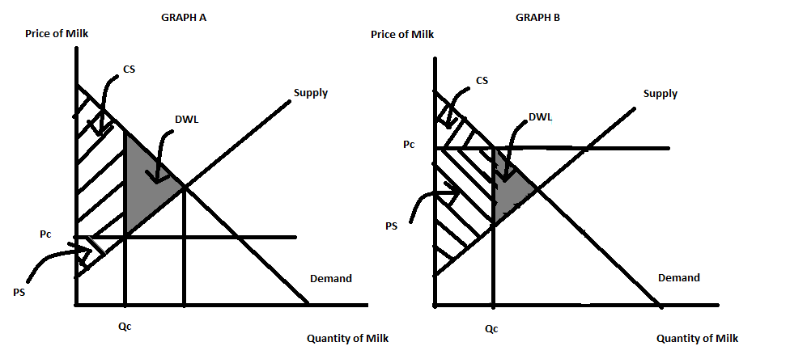
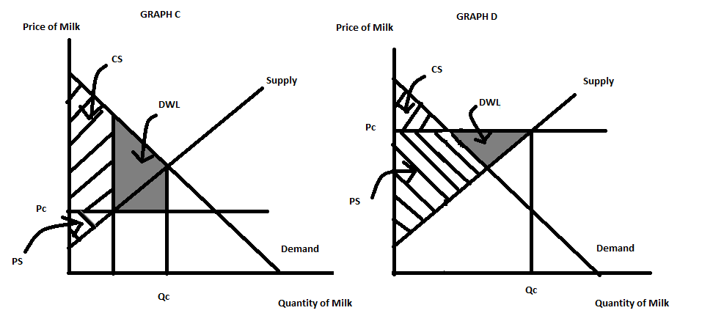

a. Graph A
b. Graph B
c. Graph C
d. Graph D

18. On April 1, 2015 McDonald's announced "that it would give workers a raise" (NY Times 4/3/15 in Paul Krugman editorial "Power and Paychecks"). Krugman goes on to write:
"Even more important is the fact that the market for labor isn't like the market for soybeans or pork bellies. Workers are people; relations between employers and employees are more complicated than simple supply and demand. And this complexity means that there's a lot more wiggle room in wage determination than conventional wisdom would have you believe.....Every time a state raises its minimum wage while neighboring states don't, it, in effect, performs a controlled experiment. And the overwhelming conclusion is that the effect you might expect to see-higher minimum wages leading to fewer jobs-is weak to nonexistent. Raising the minimum wage makes jobs better; it doesn't seem to make them scarcer...decently paid workers tend to do a better job, not to mention being less likely to quit and require replacement, than workers paid the absolute minimum an employer can get away with."
Krugman's argument supports the idea that:
a. paying an "efficiency wage"-one that is higher than the minimum wage reduces costs to businesses since it promotes better work effort, less turnover, and more worker loyalty.
b. paying a wage rate greater than the minimum wage will increase the cost of doing business and causes businesses to relocate to neighboring states that have lower wage rates.
c. paying a wage rate that exceeds the minimum wage is liberal nonsense proposed by people who lack business sense.
d. paying the minimum wage is all that the law requires: businesses that pay wages greater than the minimum wage, like Costco, will be driven out of business.

Use the following information to answer the next THREE (3) questions.

Consider the market for bananas that can be described by the following demand and supply equations where P is the price per unit of bananas and Q is the number of units of bananas:
Demand: P = 100 - Q
Supply: P = 20 + Q

19. Given the above information, when this market is in equilibrium, the equilibrium price is _____; the equilibrium quantity is _____; and the value of total surplus is _____.
a. $40 per unit of bananas; 60 units of bananas; $1600
b. $50 per unit of bananas; 50 units of bananas; $2000
c. $20 per unit of bananas; 80 units of bananas; $3200
d. $60 per unit of bananas; 40 units of bananas; $1600

20. Suppose the government imposes an excise tax in this market for bananas. This excise tax results in 20 units of bananas being consumed. Given this information, the excise tax is equal to _____; the value of consumer surplus with this excise tax is _____; and the deadweight loss due to the tax is _____.
a. $60 per unit of bananas; $200; $400
b. $40 per unit of bananas; $400; $400
c. $40 per unit of bananas; $200; $400
d. $60 per unit of bananas; $400; $400

21. Suppose the government imposes an excise tax in this market for bananas. Given the above information which of the following statements is true for this market?
a. The economic burden of this excise tax will fall evenly between consumers and producers of bananas.
b. The economic burden of this excise tax will fall more heavily on consumers since their demand is less elastic than the supply elasticity.
c. The economic burden of this excise tax will fall more heavily on producers since their supply is less elastic than the demand elasticity.
d. It is impossible to determine the relative size of the economic incidence of this excise tax given the provided information. We would need to know more to determine who pays the greater share of the excise tax.

22. In Chapter 5 of Naked Economics the Hope Scholarship Program is discussed. This program was based on the idea that "students could borrow money for college and then repay the loans after graduation with a percentage of their annual income rather than the usual fixed payments of principal plus interest." (page 104) This program was NOT successfully implemented due to:
a. government refusal to support a program that could actually benefit students carrying large amounts of student debt.
b. a large asymmetric information problem where students possessed greater information about their future career paths than the government possessed-this adverse selection problem meant that the Hope Scholarship Program would attract primarily those individuals who would have future low levels of earnings.
c. a belief that individuals should be self-sufficient and that society had no obligation to help individuals pay for their higher education.
d. the costs of this scholarship program proved impossibly high due to administrative costs as well as levels of repayment that proved far short of projected repayments due to the presence of a moral hazard problem.

23. Suppose you expect to work for 40 years and live 25 years after retirement. You want to have $40,000 a year in real terms available for your retirement. Suppose your investments to support this earn zero percent beyond what is needed to keep up with inflation. Then by the time you retire you would need to have accumulated ________________ in real dollars and to do this, you would have had to save ________________ per year.

a. $1,600,000; $64,000
b. $160,000; $2,000
c. $160,000; $6,400
d. $100,000; $2,500
e. $1,000,000; $25,000

24. Wheelan, in Chapter 12 of Naked Economics, argues that life without trade would result in a lower standard of living. Which of the following statements support his argument?
a. People trade with one another because this trade makes both parties to the trade better off.
b. Trade, provided it does not involve the crossing of any international boundaries, will make all the parties to that trade better off.
c. Globalization has hurt relatively poor countries while enriching relatively rich countries.
d. An increase in the economic interdependence of countries reduces the overall level of production in the world.

25. Wheelan, in Chapter 12 of Naked Economics, argues that trade creates winners and losers. In a simple demand and supply graph depicting international trade for a particular good we can see this idea of winners and losers by measuring the impact of trade on:
a. domestic consumer and producer surplus.
b. deadweight loss due to that trade.
c. total surplus.
d. a market when an import quota or tariff has been implemented in that market.

26. Wheelan, in Chapter 13 of Naked Economics, writes about the importance of good governance. He argues that corruption, particularly political corruption, is a "cancer that misallocates resources, stifles innovation, and discourages foreign investment" (page 292). Which of the following statements is NOT true?
a. Colonization based upon extractive industries resulted in a legacy of weak, corrupt governance.
b. When colonizers could comfortably live in a colony and face little challenge in the form of climate and disease, these colonizers helped to establish patterns of governance based upon integrity and honesty.
c. A World Bank study of 150 countries found that measures of governance like "accountability, regulatory burden, rule of law, graft (corruption), etc." (page 297) did not matter when considering the economic development of the countries.
d. Property rights are important for both rich individuals as well as poor individuals.

27. Wheelan, in Chapter 13 of Naked Economics, writes about excessive regulation. Today we see this issue being discussed with regard to Uber and Lyfe, two ride-sharing companies made possible through the development of wifi and apps. Communities in the U.S. are passing legislation that often limits these two companies due to pressure from established ride-sharing companies (taxicab companies primarily). Wheelan would most likely view these legislative limitations on the entry of Uber and Lyfe into these markets as:
a. a necessary evil to insure that both drivers and riders are protected from adverse outcomes from using these services.
b. an inappropriate limit on competition and innovation.
c. a reasonable market limitation to insure that all companies have suitable liability coverage.
d. potentially a sign of good governance by government officials as they work to serve a particular constituency-consumers of cab rides provided by the traditional type of cab companies.

28. Wheelan, in Chapter 5 of Naked Economics, argues that the health care market is "plagued with information problems". Which of the following represent information problems in this market?
a. Patients have more information about the care they need than do the doctors who are providing that care to the patients.
b. Doctors face incentives that encourage them to do fewer tests rather than more tests.
c. After seeing a doctor, a patient may still not know if they got adequate treatment for their medical issue.
d. The establishment of HMOs (Health Maintenance Organizations) was meant to reduce the cost of providing health care but has instead resulted in the use of more diagnostic tests rather than fewer diagnostic tests.

29. The tax incidence of an excise tax will:
a. fall most heavily on consumers of the product if demand is relatively more inelastic than supply.
b. fall most heavily on consumers of the product if demand is relatively more elastic than supply.
c. fall most heavily on consumers of the product no matter what the relative elasticity of the demand curve is relative to the elasticity of the supply curve.
d. fall most heavily on producers of the product no matter what the relative elasticity of the demand curve is relative to the elasticity of the supply curve.

30. Consider a small, closed economy that is considering opening its market for notebooks to trade. Assume that the demand and supply curves for notebooks in this economy are linear and follow the Laws of Demand and Supply. If the world price of notebooks is greater than the closed price of notebooks in this small economy than which of the following statements is true?
I. This country will export notebooks if it opens this market to trade.
II. Domestic consumers will be against this trade policy of opening this market to trade.
III. Domestic producers will favor this trade policy of opening this market to trade.
IV. The amount domestic consumers spend on this good after the market opens to trade may increase, decrease, or remain unchanged.
V. The amount of revenue domestic producers receive from selling this good after the market opens to trade will increase only if the demand for this product is elastic.
a. Statements I and II are true.
b. Statements I and III are true.
c. Statements I, II, III and IV are true.
d. Statements I, II, III, IV and V are true.
e. Statements II and III are true.

III. Problems: 2 Problems @ 10 points each = 20 points
For full credit make sure you show all your work: numerical answers need to be supported with logical, organized math!

Problem 1 (10 points):

Consider the market for kilowatt hours (kWh) of electricity produced by coal in the United States. Suppose that the market demand and supply curves for this type of electricity are given by the following demand and supply curves where P is the price per kilowatt hour in cents and Q is the quantity of kilowatt hours measured in billions:
Market Demand: P = 5.1 - 0.5Q
Market Supply: P = 0.6 + Q
Furthermore, suppose that using coal to produce electricity generates carbon dioxide which is thought to contribute to climate change. Congress in 2013 proposed a 1.2 cents per kilowatt hour excise tax on electricity produced by burning coal. The market supply curve you have been given does not include the cost to society of the carbon dioxide produced by burning coal to generate electricity and it does not include the proposed excise tax that would effectively "internalize" the climate cost due to generating electricity from coal.

a. (2 points) Prior to the imposition of the proposed excise tax what is the equilibrium price and quantity of electricity in this market? Show your work and make sure you include the units of measurement for both of your answers here.

Answer:
To find the equilibrium set the demand curve equal to the supply curve:
5.1 - 0.5Q = 0.6 + Q
4.5 = 1.1Q
Q = 3 billion kilowatt hours
P = 5.1 - 0.5Q = 5.1 - 0.5(3) = 5.1 - 1.5 = 3.6 cents per kilowatt hour
Or, P = 0.6 + Q = 0.6 + 3 = 3.6 cents per kilowatt hour

b. (2 points) The provided supply curve represents the MPC (marginal private cost) of providing electricity from burning coal. The MSC (marginal social cost) of providing electricity from burning coal would include the externality of this activity. We know that the proposed excise tax equals the externality cost per unit of electricity produced by burning coal. Use this information to calculate what the socially optimal amount of electricity from burning coal is. Then calculate the price that consumers should pay for each unit of electricity produced from burning coal if the externality is completely accounted for in the market. Show your work and make sure you provide the units of measurement in your final answers.

Answer:
To find the socially optimal amount of this good we need to first write the supply curve so that it reflects not the MPC but the MSC. We know that an excise tax of 1.2 cents per kilowatt hour for this type of electricity is the amount of excise tax that will fully internalize the externality. So, the MSC is P = 1.8 + Q. Use this MSC curve and the demand curve to find the socially optimal amount of electricity produced by burning coal and the price per unit of this electricity.
So, 1.8 + Q = 5.1 - 0.5Q
1.5Q = 3.3
Q = Qsocially optimal = 2.2 billion kilowatt hours of electricity produced by burning coal
P = 1.8 + Q = 1.8 + 2.2 = 4 cents per kilowatt hour of electricity
Or, P = 5.1 - 0.5Q = 5.1 - 0.5(2.2) = 4 cents per kilowatt hour of electricity

c. (2 points) Given that there is an uncorrected externality in this market this tells us that there is a deadweight loss due to the provision of this good. Calculate the deadweight loss that occurs in this market when there is no excise tax imposed on the provision of electricity produced by burning coal (that is, assume that the externality is not corrected for in this market). Show your work and provide the units of measurement for your final answer.

Answer:
From (a) we know that the market equilibrium quantity is Q = 3 billion kilowatt hours of electricity produced by burning coal and from (b) we know that the socially optimal amount of electricity from burning coal is 2.2 billion kilowatt hours. We can calculate the deadweight loss as the area of the triangle = (1/2)(Market provided quantity - Socially optimal amount of the good)(Externality Cost per unit) = (1/2)(3 billion kWh - 2.2 billion kWh)(1.2 cents per kWh) = .48 billion cents = $4.8 million
DWL = $4.8 million

d. (2 points) Failure to tax electricity generated from burning coal generates a deadweight loss on society. This deadweight loss from not taxing this production is the result of the market producing ________________ (too much, too little) of the good.

Answer:
Too much

e. (2 points) Provide a graph that illustrates this market: in your graph make sure you show the MSB (the marginal social benefit curve), the MPC (the marginal private cost curve), the MSC (the marginal social cost curve), the market quantity of the good, the socially optimal amount of the good, and the deadweight loss that occurs when this good is produced by the market and the externality is not corrected through the imposition of an excise tax. Make sure your graph is completely and fully labeled.

Answer:
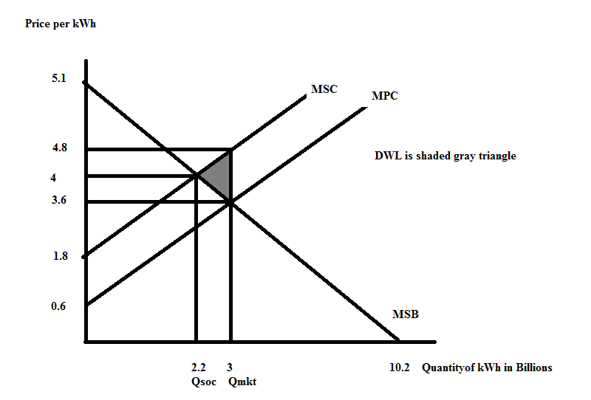

Problem 2 (10 points):

Consider the market for gadgets in a small economy. The domestic demand and supply curves for gadgets are given by the following equations where P is the price per gadget and Q is the number of gadgets:
Domestic Demand: P = 100 – 4Q
Domestic Supply: P = 10 + 2Q
Note: although this set of questions does not ask you to provide a graph, you may find that a graph aids you in thinking about the set of questions.

a. (2 points) Assume this market is closed to trade. Calculate the equilibrium price, equilibrium quantity, the value of consumer surplus (CS), the value of producer surplus (PS), and the value of total surplus (TS). Show all your work to get full credit, but record your final answers in the blanks supplied.
P = _________
Q = _________
CS = ________
PS = ________
TS = ________

Answer:
To find the equilibrium, set the demand curve equal to the supply curve:
100 – 4Q = 10 + 2Q
90 = 6Q
Q = 15 gadgets
P = 100 – 4Q = 100 – 4(15) = $40 per gadget
Or, P = 10 + 2Q = 10 + 2(15) = $40 per gadget
CS = (1/2)(100 – 40)(15) = $450
PS = (1/2)(40 – 10)(15) = $225
TS = $675
P = ___$40 per gadget______
Q = ___15 gadgets______
CS = ___$450_____
PS = ____$225____
TS = ____$675____
Here's a graph illustrating this:
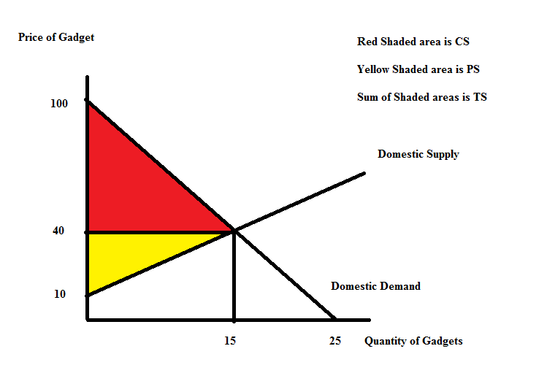

b. (3 points) Suppose the world price of a gadget is $20. If this small economy opens this market to trade, what will be the impact on exports or imports, consumer surplus, producer surplus and total surplus? Describe the impact verbally and not numerically. Be complete in your description and use complete sentences.

Answer:
Since the world price is below the domestic price of gadgets we know that when this market is opened to trade that the small economy will import gadgets. The total number of domestically produced gadgets will decrease while the total number of gadgets consumed domestically will increase relative to their initial levels. Consumer surplus will increase while producer surplus will decrease. Overall total surplus will increase, but domestic producers will be hurt by opening this market to trade while domestic consumers will benefit. Here is a graph to represent the impact of opening this market to trade.
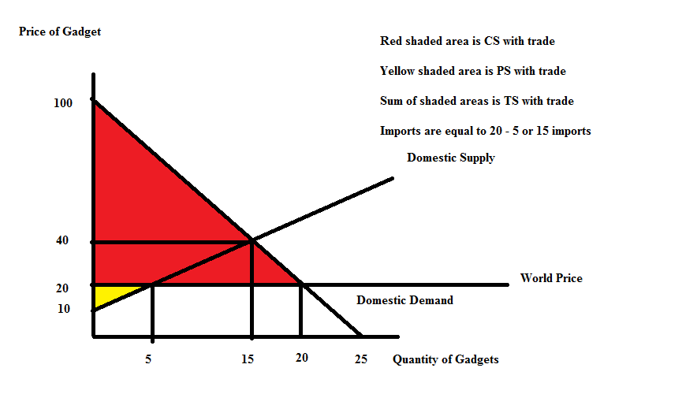
Numerical values with trade:
Imports = Qd – Qs at world price
Imports = 20 – 5 = 15 gadgets
CS with open economy = (1/2)(100 – 20)(20) = $800 [Note: CS increases with trade]
PS with open economy = (1/2)(20 – 10)(5) = $25 [Note: PS decreases with trade]
TS with open economy = CS with open economy + PS with open economy = $825 [Note: TS increases with trade]

c. (5 points) Suppose that the world price of gadgets is $20 per gadget and that this market has been opened to trade. But, the government in this small economy has also implemented a tariff that results in the price of a gadget being $32. Given this tariff, calculate the level of imports or exports, the value of consumer surplus with the tariff (CS'), the value of producer surplus with the tariff (PS'), the value of government tariff revenue, and the value of deadweight loss (DWL) due to the implementation of the tariff. Show all your work for full credit, but record your final answers in the blanks provided.

Imports with tariff = _____
Exports with tariff = _____
CS' = _____
PS' = _____
Govt. tariff revenue = _____
DWL = _____

Answer:
Since the tariff price is less than the closed economy price of a gadget we know that this economy will still be importing gadgets once the tariff is implemented. To find the number of gadgets imported use the tariff price and the provided demand and supply curves to find the quantity demanded domestically and the quantity supplied domestically: thus,
32 = 100 – 4Q or the Q demanded domestically = 17 gadgets
32 = 10 + 2Q or the Q supplied domestically = 11 gadgets
Imports = Q demanded domestically – Q supplied domestically at tariff price of $32
Imports = 17 – 11 = 6 gadgets
CS' = (1/2)(100 – 32)(17) = (34)(17) = $578
PS' = (1/2)(32 – 10)(11) = (11)(11) = $121
Govt. Tariff Revenue = ($12 per gadget)(6 gadgets) = $72
TS' = CS' + PS' + Govt. Tariff Revenue = $578 + $121 + $72 = $771
Since TS with open economy was $825, this suggests that DWL = $825 - $771 = $54
So, let's check to make sure that is what we get for DWL:
DWL = (1/2)(32 – 20)(11 – 5) + (1/2)(32 – 20)(20 – 17) = (6)(6) + 6(3) = 36 + 18 = $54

Imports with tariff = __6 gadgets___
Exports with tariff = __0 gadgets___
CS' = __$578___
PS' = ___$121__
Govt. tariff revenue = __$72___
DWL = __$54___

Here's a graph to illustrate the problem:
