Economics 100 Name _________________________
Spring 2015
Answers to Quiz #3

In answering this question refer to the figure below. The figure depicts the market for bananas in a small, closed economy. The figure also provides the world price of bananas, $1. Assume that both the demand and the supply curves are linear in this market.
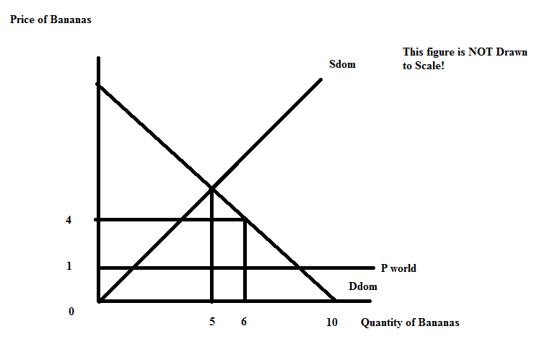
a. (1 point) Given the above figure, write an equation for the domestic demand curve, Ddom. Show your work.

Answer:
We know the points (Q, P) = (10, 0) and (6, 4) sit on the demand curve. So, use these points to compute the slope:
slope = rise/run = -1
Then, use one of the points to find the y-intercept:
y = mx + b
P = -Q + b
0 = -10 + b
b = 10
The domestic demand curve can be written as P = 10 - Q

b. (1 point) Given the above figure, write an equation for the domestic supply curve, Sdom. Show youar work.

Answer:
The point of equilibrium of the demand and supply curves is (Q, P) = (5, ?). We can find the missing price by plugging a quantity of 5 into the demand equation: P = 10 – 5 = 5. So, the point (Q, P) = (5, 5) sits on the supply curve as does the point (0, 0). We can write the domestic supply equation as P = Q.

c. (1 point) Given the above figure, if this market for bananas opens to trade, what is the value of consumer surplus, CSopen? Show your work.

Answer:
CSopen = (1/2)($10 per banana - $1 per banana)(9 bananas) = $40.50

d. (1 point) Given the above figure, if this market for bananas opens to trade, what is the value of producer surplus, PSopen? Show your work.

Answer:
PSopen = (1/2)($1 per banana - $0 per banana)(1 banana) = $0.50

e. (1 point) Suppose the market for bananas opens to trade, but a tariff is placed on bananas so that the price of the bananas with the tariff is now $3. How many bananas will be imported with this tariff? Show your work.

Answer:
If the price with the tariff is $4, the quantity supplied domestically will be 4 bananas and the quantity demanded domestically will be 6 bananas. The level of banana imports will be equal to the quantity demanded domestically minus the quantity supplied domestically, or imports of 2 bananas.

f. (1/2 point) Given the tariff described in (e), what is the value of consumer surplus with the tariff, CStariff? Show your work.

Answer:
CStariff = (1/2)($10 per banana - $4 per banana)(6 bananas) = $18

g. (1 point) Given the tariff described in (e), what is the value of producer surplus with the tariff, PStariff? Show your work.

Answer:
PStariff = (1/2)($4 per banana - $0 per banana)(4 bananas) = $8

h. (1 point) Given the tariff described in (e), what is the value of government tariff revenue with the tariff, Govt. Tariff Rev.? Show your work.

Answer:
Govt. Tariff Rev. = ($4 per banana - $1 per banana)(2 bananas) = $6

i. (1 point) What is the value of total surplus with the tariff, TSsurplus? Show your work.

Answer:
TStariff = CStariff + PStariff + Govt. Tariff Revenue = $18 + $8 + $6 = $32

j. (1 point) What is the value of the deadweight loss due to using a less efficient, higher cost producer? Show your work.

Answer:
DWL due to using less efficient, higher cost producer = (1/2)($3 per banana - $1 per banana)(3 bananas – 1 banana) = $2.00

