Economics 100
Spring 2015
Answers to Homework #5
Due May 7, 2015

Directions: The homework will be collected in a box before the lecture. Please place your name on top of the homework (legibly). Make sure you write your name as it appears on your ID so that you can receive the correct grade. Late homework will not be accepted so make plans ahead of time. Please show your work. Good luck!

Please realize that you are essentially creating “your brand” when you submit this homework. Do you want your homework to convey that you are competent, careful, and professional? Or, do you want to convey the image that you are careless, sloppy, and less than professional. For the rest of your life you will be creating your brand: please think about what you are saying about yourself when you do any work for someone else!

1. In Naked Economics in Chapter 6 Wheelan discusses "human capital". In your own words what is human capital? What are you doing to alter your own human capital: be specific about the skills and specifics of what you are doing? How does going to college alter human capital? How is it altering your human capital?

Answer:
Human capital refers to the educational attainment, skill acquisition, and development of talent that humans undergo. With greater human capital, the individual worker is a more productive worker. In college you may be acquiring very specific professional skills (for instance if you are studying engineering or pharmacy); some softer skills like public speaking, writing, leading organizations; and some, more difficult to quantify skills like knowing your own strengths and weaknesses better than you did before you started this college process, learning your likes and dislikes, improving your logic and critical thinking skills.

2. In Naked Economics in Chapter 7 Wheelan discusses some basic ideas with regard to personal investing. After reading the chapter, did you learn anything you did not already know? Specify what you learned and why you found this interesting. Try to specify at least three items in your essay. In this course we have talked a bit about saving for retirement and now Wheelan addresses some basic ideas about personal investing: these ideas are, of course, related. What have you learned from this classroom discussion as well as the readings you have done this semester? Do you have new ideas as well as new questions after our study of these topics? (Don't worry-having new questions is actually a really good sign! Means you are thinking...and there is no teacher that does not celebrate that!)

Answer:
Personal investment ideas remind me of several aphorisms:
- If it's too good to be true, it's too good to be true. That is, if someone is offering you a deal that seems incredible, you should be very, very suspicious.
- There's no such thing as a free lunch. Having higher future consumption requires less current consumption. You are unlikely to be able to have everything you want today and also everything you want in the future: there is a trade-off between current and future consumption
- Do not put off tomorrow what you can do today. Saving early and often will make a substantial difference in your future prospects.
- A stitch in time saves nine. Do not put off today those tasks that need to be taken care of-with regard to retirement saving, start this as early as possible.

3. In Naked Economics in Chapter 8 Wheelan writes citing Gary Becker's work on page 179 "When it comes to interest group politics, it pays to be small." Explain this quote in your own words. Can you provide at least two current examples of small interest groups that seem to be benefitting politically? Identify the group and then explain what you think is happening politically to that group. You might find it helpful to read a few days of The New York Times before you answer this question.

Answer:
Becker's insight is that it is easier for a small, number of people to organize themselves and push forward a political agenda than it is for a large number of people to organize. He also recognizes that if the cost of a program is spread among a large number of people the cost per person will be low and this lessens the incentive for members of the large group to push against the program. In contrast, the beneficiaries of the program if they are a small group obviously will see a large amount of payout per person (relative to the cost spread over the larger group) and will therefore have a larger incentive to push for the program.

In recent days we could certainty point to the financing of political campaigns and political positions by the very wealthy who are eager to have laws and policies implement that benefit them. We could also note that children, too young to organize and numerous, have little political clout or power. This would also be true for the poor. Some might cite the distinction between the 1% and the 99%. When you start looking for these kinds of examples they are plentiful.

4. In Naked Economics in Chapter 9 Wheelan writes GDP. Provide a brief summary of how real GDP is not a complete measure of how an economy is doing.

Answer:
Real GDP does not include work that is done at home so it fails to include a lot of productive activity. Real GDP does not include work done in the underground or illegal economy. Real GDP does not account for negative impacts of production on the environment. Real GDP does not include a value for leisure. Real GDP does not take into account the distribution of income.

5. In Naked Economics in Chapter 9 Wheelan writes on page 199 the research suggests that people have greatest happiness from "experiences over commodities, pastimes over knick-knacks, doing over having." Write a short essay on your own experience with regard to your choices and your happiness. Be thoughtful now!

Answer:
My answer: I think as I have grown older I am less and less enamored of "stuff": stuff needs to be dusted, taken care of, protected, dealt with. I find that my happiness is usually higher from time spent hiking, being with my children and grandchildren, seeing new places, learning new things, enjoying a new thought or a lovely book. I don't need to own these things and I find that having less to take care of is highly appealing. I wish I had been more aware of this when I was younger, but I suspect that the peer pressure, the "keeping up with the Jones'", the worry about "getting ahead" made it difficult to hear clearly these other thoughts.

6. This is a series of questions on GDP measurement.
a. Susie takes care of Rachel's children and earns $30,000 a year that she reports on her income taxes. Rachel works as a tutor for neighborhood students and earns $20,000 a year in cash that she does not report on her taxes. Robert runs a car repair shop and earns $60,000 a year and reports to the Internal Revenue Service that his business earned $40,000: the other $20,000 is money he earned but kept no record of.
What is the annual contribution to GDP given this information? Be specific in your answer.

b. Michael runs Heirloom Repairs and recently repaired a desk built in 1875. The value of the desk in the antiques market is $1200 and Michael's repair bill was $235. Susie recently purchased a quilt sewn in 1948 for $125 and sold 10 pillows made from this quilt for $40 per pillow. Assume that both Michael and Susie comply with all income tax reporting requirements for these activities. What is the contribution to GDP from these activities? Be specific in your answer.

c. Harriet runs a drug ring out of her house and this year she earned $235,000 from her drug operation. Finley manufactures tires and this year he produced 5000 tires that were valued at $100 per tire. Of these 5000 tires, 3200 went on new cars while the rest were sold to tire dealerships where they eventually found their way to old cars that needed replacement tires. What was the contribution to GDP from these activities? Be specific in your answers.

Answer:
a. Susie's $30,000 a year is part of GDP since she reports it on her taxes. Rachel's $20,000 a year is NOT part of GDP since she does not report it on her taxes. Robert's $40,000 a year is part of GDP while the $20,000 he does not report is NOT part of GDP. So, total contribution to GDP is $70,000.

b. Michael's repair of $235 gets counted in GDP since this is production that was done in the current time period. The value of the antique desk does not get counted since the desk was produced and valued in GDP in 1875. Susie's purchase of the quilt does not count since the quilt was produced in 1948; but the $400 worth of pillows she creates from the quilt does get included in GDP for this period. Total contribution to GDP from these activities is $635.

c. Harriet's drug activities do not get counted in GDP since these are illegal activities and are transactions in a legal market. Finley produces $500,000 worth of tires: 5000 tires times $100 per tire. We can simply note that the value of tire production is $500,000 and that this is reflected in two ways: as part of the price of the new car and as $180,000 in the value of tires sold as replacement tires. Contribution to GDP is $500,000 from these two activities.

7. Consider the economy of Parland. Parland produces three goods: houses, cars, and food (measured as units of food). Parland is an open economy that trades with other countries. You are given the following, rather jumbled, set of information about Parland's economy for 2014.
CATEGORY | Numeric Values
Consumption Spending | $100 million
Wages | $90 million
Quantity of Houses Built During Year | 200
Investment Spending | $20 million
Price per House | $350,000 per house
Exports | $20 million
Quantity of Cars Built During Year | 1000
Government Spending | $10 million
Interest | $20 million
Price of Cars Built During Year | (A)
Imports | $10 million
Rent | $5 million
Quantity of Food Produced During Year | 10,000 units of food
Profit | (B)
Price of Food | $3,500 per unit of food

a. Given the above information, calculate the value of GDP. Show your work. Identify the method you are using to do this calculation.

Answer:
To find GDP you need to decide which measurement approach you want to use:
a) The Expenditure Approach: GDP = C + I + G + (X - M)
b) The Factor Payment Approach: GDP = wages + interest + rent + profits
c) The Value of Final Goods and Services = sum of the product of each good's price times each good's quantity
From the table we can see that we are missing the price of cars, (A), and the level of profits, (B). Given these missing entries, that rules out using the value of final goods and services approach and the factor payment approach. So, we use the expenditure approach.
GDP = C + I + G + (X - M) = 100 + 20 + 10 + (20 - 10) = $140 million

b. Calculate the value of (A), the price of cars. Show your work.

Answer:
GDP = (price of cars)(quantity of cars) + (price of houses)(quantity of houses) + (price of food)(quantity of food)
$140 million = (price of cars)(1000 cars) + ($350,000 per house)(200 houses) + ($3,000 per unit of food)(10,000 units of food)
$140 million = (price of cars)(1000 cars) + $70 million + $30 million
$40 million = (price of cars)(1000 cars)
Price of cars = $40,000 per cars

c. Calculate the value of (B), the level of profits. Show your work.

Answers:
GDP = wages + interest + rent + profits
$140 million = $90 million + $20 million + $5 million + profits
profits = $25 million

8. Consider an economy that has 1000 people. Of these 1000 people 200 are children that are less than 16 years old, 100 are retired but who are all under age 65, 50 are full-time students over age 16 that are not seeking work, and 100 are homemakers who are not actively seeking work outside the home. In addition, there are 100 people who are currently not working, available to work, and actively applying for jobs every week. The economy also has 300 people who are working full-time; 50 people who are working part-time but who would prefer to work full-time and are seeking full-time employment; and 50 people who are happily working part-time. Any other people not accounted for are discouraged workers who have been unemployed for some time and have given up actively seeking employment since they believe there are no jobs available for them.

a. Given the above information what is the size of the labor force? Show how you calculated the value of this number.

Answer:
The labor force is equal to the number of employed plus unemployed. To find the number of employed look for those people who are currently working, either full-time or part-time: in this example there are 300 people who are working full-time, and 100 people who are working part-time. Thus, there are 400 employed people.

To find the unemployed look for those people who are currently not working, are available to work, and are actively seeking employment: in this example that would be 100 people.

Thus, the labor force is equal to 500 people.

b. What is the labor force participation rate? Show your work.

Answer:
The labor force participation rate = [(number of people in the labor force)/(number of people at least 16 years old and under 65)]*(100%) = [(number of employed + number of unemployed)/(number of people at least 16 years old and under 65)]*(100%) = [500/800]*(100%) = 62.5%

c. What is the unemployment rate? Show your work.

Answer:
The unemployment rate = [(number of unemployed)/(number in the labor force)]*(100%) = (100/500)*(100%) = 20%

d. Suppose that the government of this economy decides to start counting people who have given up the job search due to discouragement as unemployed people. How will this decision affect the number of unemployed, the number in the labor force, and the unemployment rate? Show your work.

Answer:
The number of unemployed people will now equal the original 100 unemployed people plus 50 more people who are discouraged workers. To get this 50 start with the population of 1000 and subtract out the people under age 16, the retired, the homemakers, the unemployed, the full-time workers, the part-time workers (irrespective of whether or not they are happy), and the full-time students over age 16. What you have left are the discouraged workers. Thus, 1000 - 200 - 100 - 100 - 100 - 300 - 100 - 50 = discouraged workers = 50 discouraged workers. With this new definition of unemployed, the number of unemployed people will increase to 150 people.

The number in the labor force will now equal the new number of unemployed plus the employed: or, 150 plus 400 for a new labor force of 550 people.

The unemployment rate using this new definition = (150/550)*100% = 27.3%

The unemployment rate rises when the definition of unemployed is changed to include discouraged workers.

e. Suppose that the definition of unemployed is changed to include discouraged workers as well as part-time workers who want to work full-time but who have not secured full-time jobs. Recalculate the number of unemployed, the number in the labor force, and the new unemployment rate using this new definition. Show your work.

Answer:
The new number of unemployed = original number of unemployed + discouraged workers + part-time workers who would like full-time employment = 100 + 50 + 50 = 200 unemployed people using this new definition.

The new number of people in the labor force = the number of unemployed with new definition plus the number of employed given the new definition of unemployed = 200 + 350 = 550 people. Notice that the 50 part-time workers who wish to work full-time change their status in the calculation of the labor force from being considered "employed" to now being considered "unemployed" due to the change in the definition of unemployed.

New unemployment rate = [(new number of unemployed using this new definition)/(new number in the labor force using the new definition of unemployment)]*(100%) = (200/550)*100% = 36.4%. Notice that this change in the definition of the unemployed results in a higher unemployment rate.

f. Does the definition of who is unemployed make a difference with regard to the numerical value of the unemployment rate? Explain your answer.

Answer:
In (d) and (e) we see the impact of a change in the definition of unemployment on the numeric value of the unemployment rate. So, yes the definition matters. It particularly matters if you are measuring unemployment when there is an unusually large amount of discouraged workers: the unemployment rate may fall despite the fact that there are still many people who are not employed and who have actually gotten discouraged about the possibility of ever finding a job.

9. You are given the following information about the economy of Macroland.
 | Price in 2012 | Quantity in 2012 | Price in 2013 | Quantity in 2013 | Price in 2014 | Quantity in 2014
Bikes | $100 | 100 | $120 | 100 | $90 | 120
Sweaters | $20 | 40 | $30 | 50 | $20 | 60
Sandwiches | $5 | 20 | $6 | 20 | $7 | 30
Books | $4 | 100 | $5 | 80 | $5 | 90

a. Using the above information calculate nominal GDP for 2012, 2013, and 2014 in Macroland. Provide any formulas that you use and show your work. Consolidate your answers in the following table:
Year | Nominal GDP
2012
2013
2014

Answer:
Nominal GDP in year a = Sum of (price of good i in year a)(quantity of good i produced in year a) for all goods i through n
Nominal GDP for 2012 = ($100 per bike)(100 bikes) + ($20 per sweater)(40 sweaters) + ($5 per sandwich)(20 sandwiches) + ($4 per book)(100 books) = $11,300
Nominal GDP for 2013 = ($120 per bike)(100 bikes) + ($30 per sweater)(50 sweaters) + ($6 per sandwich)(20 sandwiches) + ($5 per book)(80 books) = $14,020
Nominal GDP for 2014 = ($90 per bike)(120 bikes) + ($20 per sweater)(60 sweaters) + ($7 per sandwich)(30 sandwiches) + ($5 per book)(90 books) = $12,660
Year | Nominal GDP
2012 | $11,300
2013 | $14,020
2014 | $12,660

b. Using the above information calculate real GDP for 2012, 2013, and 2014 in Macroland using 2012 as the base year. Provide any formulas that you use and show your work. Consolidate your answers in the following table.
Year | Nominal GDP | Real GDP with base year 2012
2012
2013
2014

Answer:
Real GDP in year a = Sum of (price of good i in base year)(quantity of good i produced in year a) for all goods i through n
Real GDP for 2012 with base year 2012 = Nominal GDP for 2012 = ($100 per bike)(100 bikes) + ($20 per sweater)(40 sweaters) + ($5 per sandwich)(20 sandwiches) + ($4 per book)(100 books) = $11,300
Real GDP for 2013 with base year 2012 = ($100 per bike)(100 bikes) + ($20 per sweater)(50 sweaters) + ($5 per sandwich)(20 sandwiches) + ($4 per book)(80 books) = $11,420
Real GDP for 2014 with base year 2012 = ($100 per bike)(120 bikes) + ($20 per sweater)(60 sweaters) + ($5 per sandwich)(30 sandwiches) + ($4 per book)(90 books) = $13,710
Year | Nominal GDP | Real GDP with base year 2012
2012 | $11,300 | $11,300
2013 | $14,020 | $11,420
2014 | $12,660 | $13,710

c. Compute the GDP deflator for 2012, 2013, and 2014 using 2012 as the base year and a l00 point scale. Show any formulas you use. Use a calculator for these calculations and round your answer to the nearest hundredth. Consolidate your answers in the table below.
Year | Nominal GDP | Real GDP with base year 2012 | GDP Deflator with base year 2012
2012
2013
2014

Answer:
To find the GDP deflator recall that:
Real GDP = [(Nominal GDP)/(Inflation Index)](scale factor)
Since the GDP deflator is an inflation index we can rewrite the above formula as:
Real GDP = [(Nominal GDP)/(GDP Deflator)](100)
We can rearrange this formula to have:
GDP Deflator = [(Nominal GDP)/(Real GDP)](100)

Year | Nominal GDP | Real GDP with base year 2012 | GDP Deflator with base year 2012
2012 | $11,300 | $11,300 | 100
2013 | $14,020 | $11,420 | 122.77
2014 | $12,660 | $13,710 | 92.34

d. Using the GDP Deflator you calculated in (c), calculate the rate of inflation between 2012 and 2013 and between 2013 and 2014. Show any formulas you use and provide your work. Use a calculator and round your answer to the nearest hundredth. Consolidate your answers in the following table. If you get a negative percentage this indicates that there was deflation in this economy.
Period of Time | Rate of Inflation
2012-2013
2013-2014

Answer:
Rate of Inflation = [(Current Year Value – Previous Year Value)/(Previous Year Value)](100%)
Rate of Inflation from 2012 to 2013 = [(122.77 – 100)/100](100%) = 22.77%
Rate of Inflation from 2013 to 2014 = [(92.34 – 122.77)/122.77](100%) = -24.79%
Note that a negative percentage here indicates deflation.
Period of Time | Rate of Inflation
2012-2013 | 22.77%
2013-2014 | -24.79%
e. Suppose that the market basket for purposes of computing the CPI in this economy is given as 10 bikes, 5 sweaters, 5 sandwiches, and 10 books. Compute the cost of the market basket for 2012, 2013 and 2014. Provide any formulas you use and consolidate your answers in the following table.
Year | Cost of Market Basket
2012
2013
2014

Answer:
To find the cost of the market basket in year n multiply the price of the good times the quantity of the good in the market basket and sum these products for all the goods that are in the basket. Thus,
Cost of market basket in year n = (Price of bikes in year n)(10 bikes) + (Price of sweaters in year n)(5 sweaters) + (Price of sandwiches in year n)(5 sandwiches) + (Price of books in year n)(10 books)
Cost of market basket in year 2012 = ($100 per bike)(10 bikes) + ($20 per sweater)(5 sweaters) + ($5 per sandwich)(5 sandwiches) + ($4 per book)(10 books) = $1165
Cost of market basket in year 2013 = ($120 per bike)(10 bikes) + ($30 per sweater)(5 sweaters) + ($6 per sandwich)(5 sandwiches) + ($5 per book)(10 books) = $1430
Cost of market basket in year 2014 = ($90 per bike)(10 bikes) + ($20 per sweater)(5 sweaters) + ($7 per sandwich)(5 sandwiches) + ($5 per book)(10 books) = $1085
Year | Cost of Market Basket
2012 | $1165
2013 | $1430
2014 | $1085

f. Using the values you calculated in (e), construct the CPI using 2014 as your base year and a 100 point scale. Show any formulas you use and round your answer to the nearest hundredth. Consolidate your answers in the table below.
Year | CPI with base year 2014 on a 100 point scale
2012
2013
2014

Answer:
To find the CPI for year n:
CPI for year n = [(cost of market basket in year n)/(cost of market basket in base year)](scale factor)
CPI for year 2012 with base year 2014 = [(1165)/(1085)](100) = 107.37
CPI for year 2013 with base year 2014 = [(1430)/(1085)](100) = 131.8
CPI for year 2014 with base year 2014 = [(1085)/(1085)](100) = 100

Year | CPI with base year 2014 on a 100 point scale
2012 | 107.37
2013 | 131.8
2014 | 100

g. Using the CPI values you calculated in (f), compute the rate of inflation between 2012 and 2013 and between 2013 and 2014. Show your work. Use a calculator and round your answers to the nearest hundredth. Consolidate your answers in the following table.
Period of Time | Rate of Inflation
2012-2013
2013-2014

Answer:
Rate of inflation = [(Current year value – Previous year value)/(Previous year value)](100%)
Rate of inflation between 2012 and 2013 = [(131.8 – 107.37)/107.37](100%) = 22.75%
Rate of inflation between 2013 and 2014 = [(100 -131.8)/(131.8)](100%) = -24.13%
Period of Time | Rate of Inflation
2012-2013 | 22.75%
2013-2014 | -24.13%

h. Compare the rates of inflation you got in (d) with the rates of inflation you got in (g). Are they the same? Would you expect them to be the same?

Answer:
The rates are similar but not the same. You would not expect them to be the same, but they should show some similar prediction. Both indicate inflation between 2012 and 2013 of around 23% and both indicate deflation between 2013 and 2014 of around 24.5%. Although I did not design this example with a particular numeric outcome in mind it is interesting to see how closely these two measures approximate one another.

10. Use the aggregate demand/aggregate supply (AD/AS) model as discussed in class to answer this set of questions.
a. The graph below depicts the short-run situation for an economy where AD is the aggregate demand curve, SRAS is the short-run aggregate supply curve, LRAS is the long-run aggregate supply curve, and Yfe is potential GDP or full employment GDP.
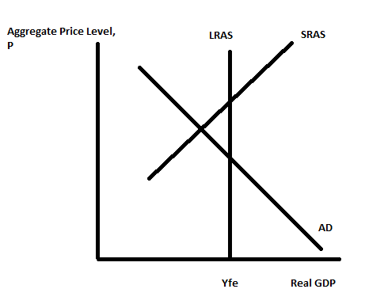
i. On the graph, label the short-run level of real GDP as Y1. Label the short-run aggregate price level as P1.
ii. Based upon the graph, describe how the economy is performing in the short-run. Be sure in your answer to comment on the level of production in the short-run, and the level of unemployment in the short-run.
iii. In the long-run if there is no fiscal or monetary policy intervention into this economy, what do you predict will happen? Make sure you identify if any curves are shifting and if they are shifting, identify the direction of that shift. Also, in your answer write about what will happen to the level of real GDP in the long run and what will happen to the unemployment rate in the long run. Draw a graph to illustrate this long-run adjustment.
iv. Suppose that the government decides that the short-run situation is worthy of government intervention in the form of fiscal policy. What kind of fiscal policy is the government likely to engage in given the short-run situation that is presented in the graph? How will this fiscal policy affect the economy according to this model?
v. Suppose that the government decides that the short-run situation is worthy of government intervention in the form of monetary policy. What kind of monetary policy is the central bank likely to engage in given the short-run situation that is presented in the graph? How will this monetary policy affect the economy according to this model?

Answer:
i.
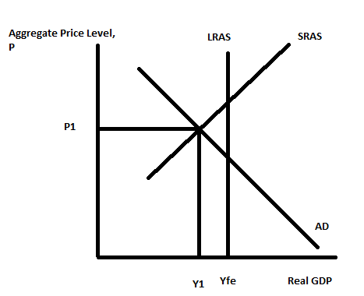
ii. In the short-run the economy is in a recession since Y1<Yfe. This also tells us that the unemployment rate is above the natural rate of unemployment.
iii. In the long run nominal wages will fall shifting the SRAS curve to the right returning the economy to Yfe and the aggregate price level to P2.
iv. Since the economy is in a recession the fiscal policy intervention is likely to be expansionary fiscal policy. This means that the government will either increase government spending or decrease taxes or some combination of these two policies. This will cause the AD curve to shift to the right, resulting in an increase in the level of real GDP and an increase in the aggregate price level.
v. Since the economy is in a recession the central bank if it uses monetary policy will engage in expansionary monetary policy. This will entail the central bank buying Treasury bills from the public which will inject new monetary reserves into the banking system. This will lead to an expansion of the money supply, a decrease in interest rates, and an increase in both consumption and investment spending. The result will be a rightward shift in the AD curve and an increase in both real GDP and the aggregate price level.

b. The graph below depicts the short-run situation for an economy where AD is the aggregate demand curve, SRAS is the short-run aggregate supply curve, LRAS is the long-run aggregate supply curve, and Yfe is potential GDP or full employment GDP.
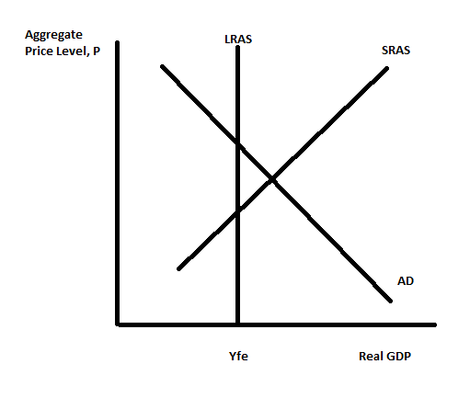
i. On the graph, label the short-run level of real GDP as Y1. Label the short-run aggregate price level as P1.
ii. Based upon the graph, describe how the economy is performing in the short-run. Be sure in your answer to comment on the level of production in the short-run, and the level of unemployment in the short-run.
iii. In the long-run if there is no fiscal or monetary policy intervention into this economy, what do you predict will happen? Make sure you identify if any curves are shifting and if they are shifting, identify the direction of that shift. Also, in your answer write about what will happen to the level of real GDP in the long run and what will happen to the unemployment rate in the long run. Draw a graph to illustrate this long-run adjustment.
iv. Suppose that the government decides that the short-run situation is worthy of government intervention in the form of fiscal policy. What kind of fiscal policy is the government likely to engage in given the short-run situation that is presented in the graph? How will this fiscal policy affect the economy according to this model?
v. Suppose that the government decides that the short-run situation is worthy of government intervention in the form of monetary policy. What kind of monetary policy is the central bank likely to engage in given the short-run situation that is presented in the graph? How will this monetary policy affect the economy according to this model?

Answer:
i.
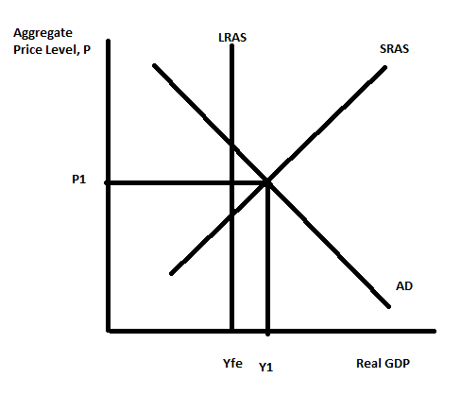
ii. In the short-run the economy is in an expansion since Y1>Yfe. This also tells us that the unemployment rate is below the natural rate of unemployment.
iii. In the long run nominal wages will rise shifting the SRAS curve to the left returning the economy to Yfe and the aggregate price level to P2.
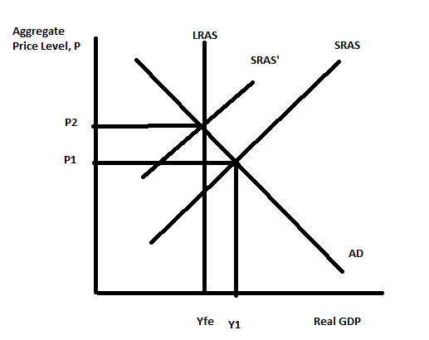
iv. Since the economy is in an expansion the fiscal policy intervention is likely to be contractionary fiscal policy. This means that the government will either decrease government spending or increase taxes or some combination of these two policies. This will cause the AD curve to shift to the left, resulting in a decrease in the level of real GDP and a decrease in the aggregate price level.
v. Since the economy is in an expansion the central bank if it uses monetary policy will engage in contractionary monetary policy. This will entail the central bank selling Treasury bills to the public which will reduce monetary reserves in the banking system. This will lead to an contraction of the money supply, an increase in interest rates, and a decrease in both consumption and investment spending. The result will be a leftward shift in the AD curve and a decrease in both real GDP and the aggregate price level.

c. Consider the economy that is represented in the figure below. This economy is currently in long run equilibrium producing Yfe at an aggregate price level of P1.
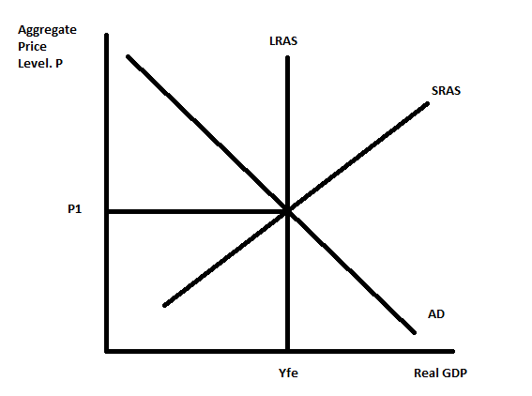
Suppose that there is a negative supply shock that results in oil prices increasing.
i. Draw a graph that depicts the short-run effect of this negative supply shock; in your graph indicate the new aggregate price level as P2 and the new level of real GDP as Y2. Verbally describe the short-run economy making note of whether the economy is in a boom or a recession, what you know about the direction of prices, and what you know about the unemployment rate.
ii. Given the negative supply shock, describe the impact of expansionary fiscal policy on this economy. Make sure your answer describes any shifts of curves in the AD/AS model; the impact on the aggregate price level and the impact on the level of real GDP. Are there any negative impacts from the government of this economy pursuing expansionary fiscal policy?
iii. Given the negative supply shock, describe the impact of contractionary fiscal policy on this economy. Make sure your answer describes any shifts of curves in the AD/AS model; the impact on the aggregate price level and the impact on the level of real GDP. Why would the government consider implementing contractionary fiscal policy as a remedy for this negative supply shock?
iv. Given the negative supply shock, describe the impact of expansionary monetary policy on this economy. Make sure your answer describes any shifts of curves in the AD/AS model; the impact on the aggregate price level and the impact on the level of real GDP. Are there any negative impacts from the central bank of this economy pursuing expansionary monetary policy?
v. Given the negative supply shock, describe the impact of contractionary monetary policy on this economy. Make sure your answer describes any shifts of curves in the AD/AS model; the impact on the aggregate price level and the impact on the level of real GDP. Why would the central bank consider implementing contractionary monetary policy as a remedy for this negative supply shock?

Answer:
i. The negative supply shock will shift the SRAS curve to the left to SRAS' due to the increase in oil prices. Since Y2 < Yfe we know this economy is in a recession. Since P2> P1 we know that the aggregate price level is rising: a sign of inflation. Since Y2 < Yfe we know that the unemployment rate is greater than the natural rate of unemployment.
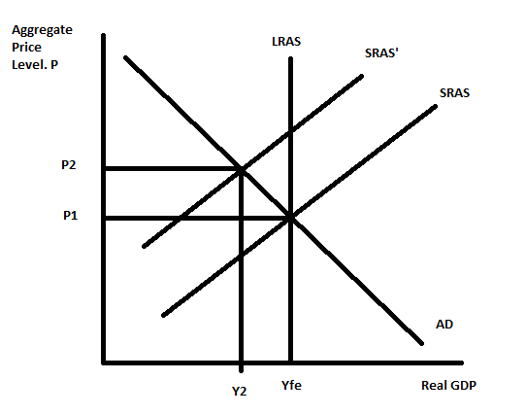
ii. Expansionary fiscal policy will take the form of either increases in government spending, decreases in taxes, or some combination of these two types of changes. This will cause the AD curve to shift to the right increasing the level of real GDP from Y2 towards Yfe and causing the aggregate price level to rise above P2. The negative impact of this expansionary fiscal policy is that it will cause there to be more inflation in this economy.
iii. Contractionary fiscal policy will take the form of either decreases in government spending, increases in taxes, or some combination of these two types of changes. This will cause the AD curve to shift to the left decreasing the level of real GDP to a level lower than Y2. This will make the recession worse and cause the unemployment rate to rise even higher. However, this policy will have the benefit of causing the aggregate price level to fall back toward P1: this policy will provide a means of fighting against inflation.
iv. Expansionary monetary policy entails the central bank buying Treasury bills and injecting new monetary reserves into the financial system. This will cause the AD curve to shift to the right increasing the level of real GDP from Y2 towards Yfe and causing the aggregate price level to rise above P2. The negative impact of this expansionary monetary policy is that it will cause there to be more inflation in this economy.
v. Contractionary monetary policy entails the central bank selling Treasury bills and thus, removing monetary reserves from the financial system. This will cause the AD curve to shift to the left decreasing the level of real GDP to a level lower than Y2. This will make the recession worse and cause the unemployment rate to rise even higher. However, this policy will have the benefit of causing the aggregate price level to fall back toward P1: this policy will provide a means of fighting against inflation.

11. a. Suppose that Tim invests $2,000 in a financial asset that pays a constant 7% a year. Provide a number line that illustrates how this investment will grow over time starting at year 0 and ending at year 70.

Answer:
From the rule of 70 we know that we can approximate the number of years it takes this investment to double by dividing 70 by the constant interest rate being earned. Thus, 70/7 tells us that in 10 years Tim's investment will double. So let's see what happens over a 70 year time span to that investment of his.
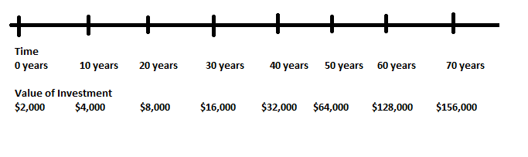
b. Suppose that Jane invests $5,000 in an investment that earns 5% a year over time. Provide a number line that illustrates how this investment will grow over time starting at year 0 and ending at year 70.

Answer:
From the rule of 70 we know that we can approximate the number of years it takes this investment to double by dividing 70 by the constant interest rate being earned. Thus, 70/5 tells us that in 14 years Jane's investment will double. So let's see what happens over a 70 year time span to that investment of hers.
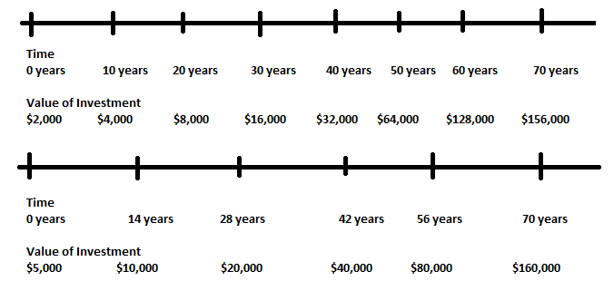

c. Henry is trying to decide whether to invest in the same financial instrument as Tim or the same financial instrument as Jane. He would make exactly the same investment as Tim or Jane and his only concern is the value of this investment 40 years from today. What would you recommend?

Answer:
From our time line in (a) and (b) we can see that Tim's investment has a value of $32,000 forty years from now while Jane's investment has a value of $40,000 forty two years from now. From our approximation we can see that Henry would be better off he is chooses to make the same investment as Jane if he only cares about the return forty years from now.

