Economics 100
Spring 2015
Answers to Homework #2
Due February 19, 2015

Directions: The homework will be collected in a box before the lecture. Please place your name on top of the homework (legibly). Make sure you write your name as it appears on your ID so that you can receive the correct grade. Late homework will not be accepted so make plans ahead of time. Please show your work. Good luck!

Please realize that you are essentially creating “your brand” when you submit this homework. Do you want your homework to convey that you are competent, careful, and professional? Or, do you want to convey the image that you are careless, sloppy, and less than professional. For the rest of your life you will be creating your brand: please think about what you are saying about yourself when you do any work for someone else!

1. Consider three individuals: Bob, Mary and Sue. Their PPFs for producing jam and bread are given in the graphs below. The numbers refer to jars of jam and loaves of bread. Assume that Bob, Mary and Sue all have equivalent resources available to produce jam and bread.
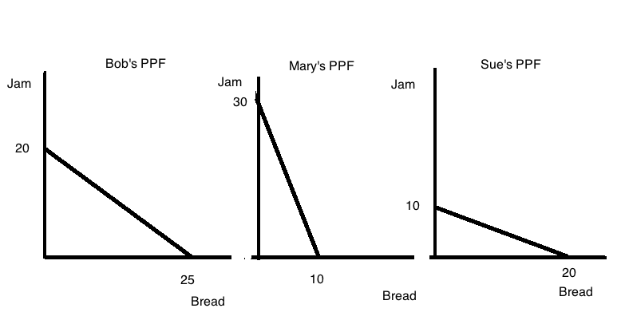
a. Given the above information, who has the absolute advantage in the production of jam? Explain your answer.

b. Given the above information, who has the absolute advantage in the production of bread? Explain your answer.

c. Given the above information, who has the comparative advantage in the production of jam? Explain your answer.

d. Given the above information, who has the comparative advantage in the production of bread? Explain your answer.
e. Draw the joint PPF for these three individuals based upon the given information. Measure jam on the vertical axis and bread on the horizontal axis. Identify the coordinate values (bread, jam) for any kink point or axis intercept. Also, at each kink point identify the good and level of production that each individual is contributing.

Answers:
a. Mary has the absolute advantage in the production of jam since Mary can produce the largest amount of jam (30 jars) from her available resources.

b. Bob has the absolute advantage in the production of bread since Bob can produce the largest amount of bread (20 loaves) from his available resources.

c. Mary has the comparative advantage in the production of jam: each jar of jam costs Sue 1/3 loaf of bread while a jar of jam costs Bob 5/4 loaves of bread and Sue 2 loaves of bread. Mary can produce a loaf of bread at lower opportunity cost than can Bob or Sue.

d. Sue has the comparative advantage in the production of bread: each unit of bread costs Sue ½ jar of jam while a unit of bread costs Bob 4/5 jar of jam and Mary 3 jars of jam. Sue can produce a loaf of bread at lower opportunity cost than can Bob or Mary.

e.
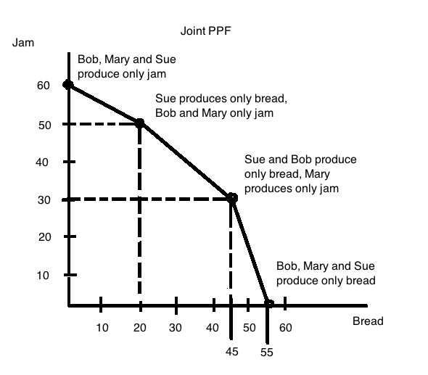

2. Analyze the following scenarios using the demand and supply model.
a. Consider the market for bicycles in Seattle. Seattle has recently imposed a large carbon tax on gasoline and this tax effectively increases the cost of driving a car by 25%, and taking the bus or metro transportation by 20%. What effect on the market for bicycles do you think this carbon tax will have? Explain your answer fully and provide a prediction about both the price and quantity of bicycles in this market. Assume that everything else is held constant in this market scenario except for this excise tax. Provide a graph to illustrate your answer.

b. Consider the market for fig jam that is initially in equilibrium. Suppose that there is a hard freeze that destroys 60% of the fig crop for this year (figs are very sensitive to cold!) while at the same time a well-respected health report publishes a study showing that consumption of fig jam reduces stress and therefore benefits overall health. Analyze the impact of this information on the market for fig jam: in particular, identify what happens to the equilibrium price and equilibrium quantity in this market. Assume that everything else is held constant in this market scenario. Provide a graph to illustrate your answer. As usual use P1, Q1 to indicate the initial situation and P2, Q2 to indicate the new levels.

c. Consider the market for Starbuck’s Coffee. Yesterday while traveling I stopped to buy a cup of coffee and after making my purchase I was told by the barista that if I stopped after one later in the same day at any Starbuck’s I could get a pastry for just a $1 with my receipt. Examine this offer and analyze its impact on the market for Starbuck’s Coffee. Provide a graph to illustrate your answer. In your answer also reflect on the effect of this policy on the company’s revenue.

Answer:
a. This excise tax will raise the price of alternative modes of transportation relative to using a bicycle. This will result in an increase in the demand for bicycles since these alternative forms of transportation are substitute goods for bicycling. Thus, we can predict that the demand for bicycles will shift to the right and that the equilibrium price of bikes will increase as will the equilibrium quantity of bikes. Here’s a graph to illustrate the outcome where P1 and Q1 are the initial equilibrium price and quantity and P2 and Q2 are the new equilibrium price and equilibrium quantity once this market adjusts to the implementation of this excise tax.
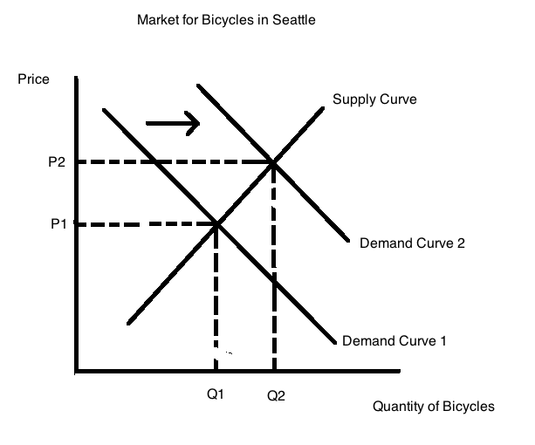
b. This scenario is tougher than the first one: you have two changes happening and both changes are going to cause a shift in one of the curves. The freeze will cause the supply curve to shift to the left: at every price, there will be less fig jam than there was before the freeze (if we only considered this change, we would predict that price would rise and quantity would fall). The health report will cause the demand curve to shift to the right: at every price, there will be more fig jam demanded than there was before the release of the report (if we only considered this change, we would predict that the price would rise and quantity would rise). Putting this together we can see that both shifts cause the equilibrium price to increase but the effect on quantity is not determinate since the supply shift causes quantity to fall while the demand shift causes quantity to rise. Thus, these two changes result in a situation where we know that the equilibrium price rises while the equilibrium quantity is indeterminate. Here are two graphs to illustrate this idea: pay close attention to what is happening to quantity in the two graphs!
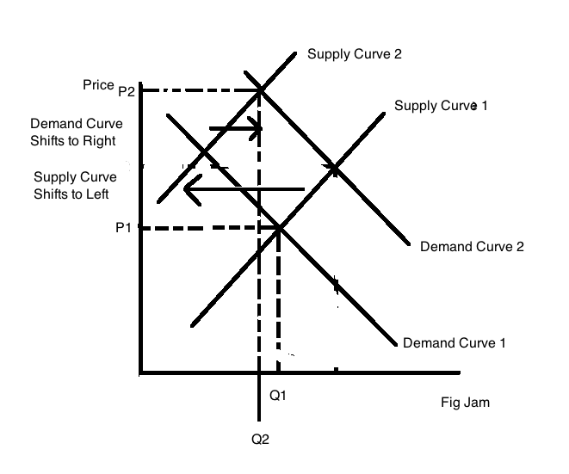
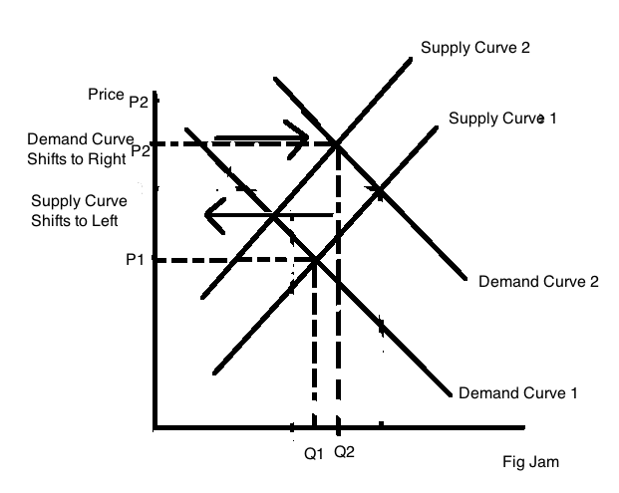
c. Starbuck’s has set the price of a cup of coffee and this price is not going to change, at least it is not going to change in the short-run. So, this offer of a cheap pastry is not going to alter the price of the cup of coffee. But, the cheap pastry is a complementary good to a cup of coffee and Starbuck’s is likely hoping that the offer will cause the traveler to stop later in the day to get that cheap pastry. And, after stopping to get that cheap pastry, it is likely the traveler will opt to also get a cup of coffee to go with that pastry. So, the effect of the offer is to shift the demand curve for Starbuck’s Coffee to the right. The company will sell a greater quantity of coffee and hence will increase its revenues with this policy. Here’s a graph to illustrate the effect: note that the area P1*Q1 is the revenue initially and the area P1*Q2 is the revenue with the implementation of this program.
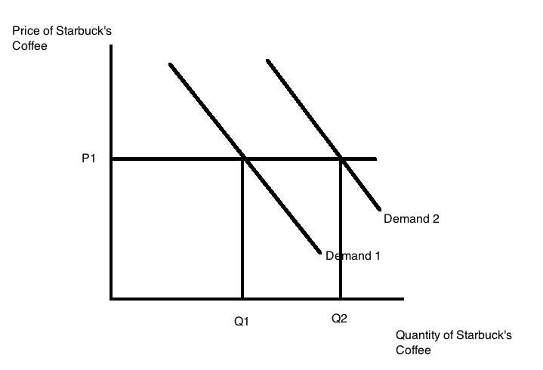
3. Suppose you are given the following information about the market for turkey sandwiches:

Name of Individual | Willingness to Pay for One Sandwich
Bob | $10
Ellen | $8
Susie | $4
Carlos | $12
Van | $20

Name of Individual | Lowest Price Willing to Accept for One Sandwich
Elise | $6
Rachael | $12
Morgan | $8
Sanjay | $4
Evan | $10

a. Given the above information, if the market provides only one sandwich, who will purchase that sandwich and who will provide that sandwich?

b. Given the above information, how many sandwiches will the market provide? Who will provide sandwiches? Explain your answer.

c. Given the above information, who will get sandwiches in this market? Explain your answer.

d. Given the above information, calculate the value of total surplus in the market for sandwiches.

Answer:
a. If only one sandwich is provided, then that sandwich will go to the individual willing to pay the most for that sandwich-that will be Van. And, if only one sandwich is provided, it will be provided by the individual willing to accept the lowest price-in this case, it will be Sanjay providing the sandwich.

b. The market will provide 3 sandwiches: the first sandwich has a value of $20 to Van and a cost of $4 for Sanjay; the second sandwich has a value of $12 to Carlos and a cost of $6 for Elise; and the third sandwich has a value of $10 for Bob and a cost of $8 for Morgan. Note that for the first three sandwiches there are individuals who are willing to pay more for the sandwich than it costs to produce the sandwich. The sandwiches will be provided by Sanjay, Elise, and Morgan.

Then, let’s look at what happens with the fourth sandwich: Ellen is willing to pay $8 for that sandwich, but Evan is only willing to provide the sandwich if he gets $10 for it. Since the value the buyer is willing to pay is less than the amount the seller must get to provide the good, the good does not get provided.

c. The sandwiches will go to Van, Carlos, and Bob: see the explanation in (b).

d. Total surplus will be equal to the sum of the difference between the price consumers are willing to pay and the price suppliers must receive. So, in this example, the total surplus from the first sandwich is equal to ($20 - $4) or $16; the total surplus from the second sandwich is equal to ($12 - $6) or $6; and the total surplus from the third sandwich is equal to ($10 - $8) or $2. The sum of these is therefore $16 + $6 + $2 or $24.

4. Examine the table below that provides data about the price of gadgets and the quantity demanded and the quantity supplied of gadgets at these various prices.
Price Per Gadget | Quantity of Gadgets Demanded | Quantity of Gadgets Supplied
$1 | 100 | 10
$3 | 80 | 25
$5 | 55 | 40
$7 | 30 | 60
$8 | 5 | 70
a. Given the above information, if the price of a gadget is $3, then this market will have ___________________.

b. Given the above information, if the price of a gadget is $7, then this market will have ___________________.

c. Given the above information, the equilibrium price in this market must be greater than _____ and less than _________.

d. Given the above information, the equilibrium quantity in this market must be less than ________ and greater than _________. In your answer determine the narrowest range of quantities!

Answer:
a. Excess demand of 55 gadgets. To see this, when the price of the gadget is $3, the quantity demanded is 80 gadgets and the quantity supplied is 25 gadgets: an excess demand of 55 gadgets.

b. Excess supply of 30 gadgets. To see this, when the price of the gadget is $7, the quantity demanded is 30 gadgets and the quantity supplied is 60 gadgets: an excess supply of 30 gadgets.

c. The equilibrium price in this market must be greater than $5 and less than $7. When the price is $5, the quantity demanded is 55 gadgets and the quantity supplied is 40 gadgets: there is an excess demand of 15 gadgets. When the price is $7, the quantity demanded is 30 gadgets and the quantity supplied is 60 gadgets: there is an excess supply of 30 gadgets. The equilibrium price must therefore fall between $5 and $7 per gadget since we go from a situation of excess demand when the price is too low at $5 to a situation of excess supply when the price is too high at $7.

d. Given the above information, the equilibrium quantity in this market must be less than ____55____ and greater than ____40_____. From answer (c) we know that the quantity must be greater than 40 and less than 55 (these are the quantities supplied and demanded respectively at $5 per gadget). At a price of $7 per gadget the quantity demanded is 30 and the quantity supplied is 60 and this is not as narrow a range of quantities as we get when the price is $5 per gadget. So, for the narrowest range of possible equilibrium quantities we get that the quantity must be greater than 40 gadgets and less than 55 gadgets.

5. Use the graph below of the market demand curve for widgets to answer the following set of questions.
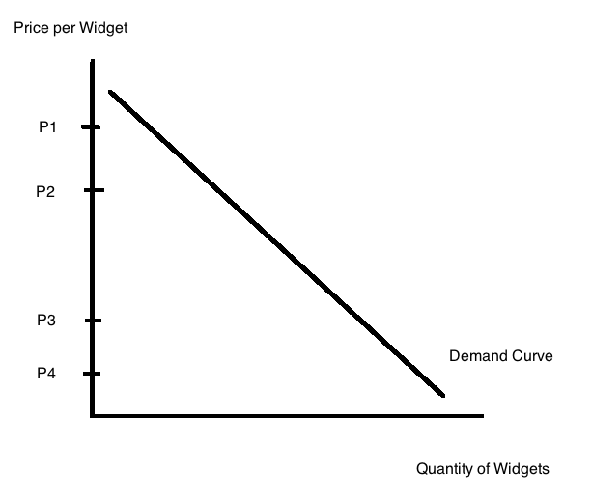
a. In the above graph determine the quantity demanded at each of the four given prices: P1, P2, P3, and P4. Label these quantities Q1, Q2, Q3, and Q4 respectively.

b. If the price is initially P1 and then it falls to P2, how much revenue is lost due to this price change? Show this revenue lost in a well-labeled graph. How much revenue is gained due to this price change? Show this revenue gained in the same well-labeled graph.

c. Suppose the price is initially P4 and then it rises to P3. What happens to total revenue in this market with this price change? Give a complete verbal explanation of this change in your answer. And, provide a graph to illustrate what is happening to total revenue.

d. When price falls and total revenue increases this tells us that the demand for the good is ____________. When price falls and total revenue decreases this tells us that the demand for the good is ____________.

e. When price rises and total revenue increases this tells us that the demand for the good is _________. When price rises and total revenue decreases this tells us that the demand for the good is _____________.

Answer:
a.
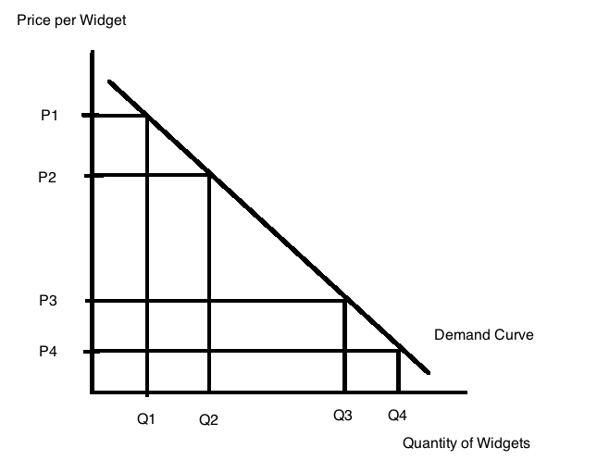
b.
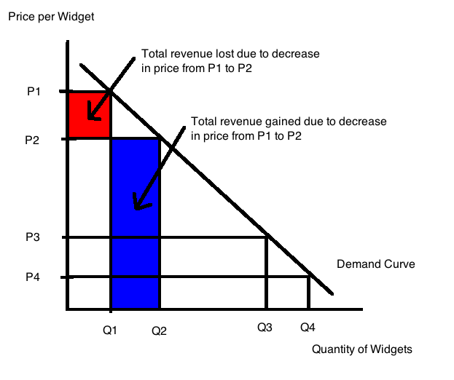
c. When the price rises from P4 to P3, fewer units are purchased and this implies that there is some lost revenue due to this smaller quantity of units. But, as the price rises from P4 to P3, the units that are sold are sold for a higher price, so there is more revenue being made from the units that are being sold. The total impact on revenue when the price increases from P4 to P3 is an increase in total revenue. The graph below illustrates these revenue effects.
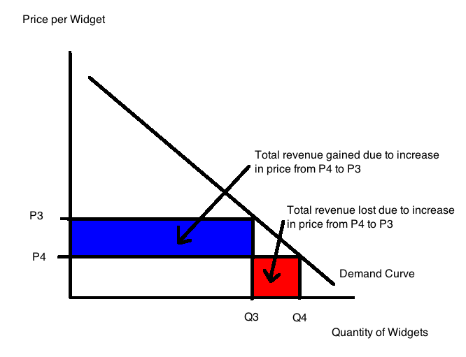
d. When price falls and total revenue increases this tells us that the demand for the good is _____elastic (this is like price decreasing from P1 to P2)_______. When price falls and total revenue decreases this tells us that the demand for the good is _____inelastic (this is like price decreasing from P3 to P4_______.

e. When price rises and total revenue increases this tells us that the demand for the good is ____inelastic (this is like price increasing from P4 to P3)_____. When price rises and total revenue decreases this tells us that the demand for the good is _____elastic (this is like price increasing from P2 to P1)________.

6. Let’s go back to that Starbuck’s Coffee example from earlier in this homework (Problem 2c in this homework). The offer from Starbuck’s Coffee yesterday while traveling was that if I took my receipt to any Starbuck’s Coffee after 1 in the afternoon on the same day I could get a pastry for $1 instead of its regular price. So, let’s try to analyze why the company might make this offer. To do this we will need to make some assumptions and we will try to keep the example as simple as possible. So, suppose you are given the following information:
- Daily number of cups of coffee sold before noon: 1000 cups
- Daily number of cups of coffee sold after noon: 400 cups
- Cost of providing a cup of coffee: $0.50 per cup of coffee
- Price of cup of coffee: $3.00 per cup of coffee
- Daily number of pastries sold before noon: 800 pastries
- Daily number of pastries sold after noon: 320 pastries
- Cost of providing a pastry: $0.40 per pastry
- Price of pastry: $3.00 per pastry
- Assume there are no other costs or revenue sources for Starbuck’s Coffee
a. Given the above information calculate the total cost of providing coffee per day, the total revenue from selling the coffee per day, and the total profit made from selling coffee per day. Show all your work.

b. Given the above information calculate the total cost of providing pastries per day, the total revenue from selling the pastries per day, and the total profit made from selling pastries per day. Show all your work.

c. Given the above information calculate the total profit made from selling coffee and pastries per day. Show all your work.

Now, suppose that Starbuck’s introduces this afternoon pastry incentive plan whereby if you buy a cup of coffee in the morning you can use your receipt later in the day to purchase a pastry for $1.00 instead of the usual $3.00 per pastry. Starbuck’s finds that with this plan it is now selling a total of 600 cups of coffee in the afternoon and a total of 480 pastries in the afternoon.

d. Calculate the additional profit from selling coffee that Starbuck’s gets per day once it institutes this plan. Show your work.

e. Calculate the additional profit from selling pastries that Starbuck’s gets per day once it institutes this plan. Show your work.

f. With this incentive plan what is the value of Starbuck’s daily profit from selling coffee and pastries? Calculate the percentage increase in profits that Starbuck’s experiences by adopting this pricing plan. Show all your work. Is it worth Starbuck’s instituting this change?

Answer:
a. Total cost of providing coffee per day = (cost per cup of coffee)(number of cups of coffee made per day) = ($0.50 per cup of coffee)(1400 cups of coffee per day) = $700
per day
Total revenue from coffee per day = (price per cup of coffee)(number of cups of coffee sold per day) = ($3.00 per cup of coffee)(1400 cups of coffee per day) = $4200 per day
Total profit from coffee per day = (Total revenue from coffee per day) – (Total cost of providing coffee per day) = $4200 - $700 = $3500 per day

b. Total cost of providing pastries per day = (cost per pastry)(number of pastries made per day) = ($0.40 per pastry)(1120 pastries per day) = $448 per day
Total revenue from pastry per day = (price per pastry)(number of pastries sold per day) = ($3.00 per pastry)(1120 pastries per day) = $3360 per day
Total profit from pastry per day = (Total revenue from pastry per day) – (Total cost of pastry per day) = ($3360 - $448) = $2912 per day

c. Total profit per day from selling coffee and pastries = (profit from selling coffee per day) + (profit from selling pastries per day) = $3500 + $2912 = $6412

d. Additional profit per day from selling coffee once the pastry incentive plan is introduced = (additional revenue from more cups of coffee being sold) – (additional cost of selling more cups of coffee)
Additional revenue from more cups of coffee being sold = (Price per cup of coffee)(Number of additional cups of coffee sold per day) = ($3.00 per cup of coffee)(200 cups of coffee per day) = $600 per day
Additional cost from more cups of coffee being sold = (Cost per cup of coffee)(Number of additional cups of coffee produced per day) = ($0.50 per cup of coffee)(200 cups of coffee per day) = $100
Additional profit per day from selling coffee once the pastry incentive plan is introduced = $600 - $100 = $500 per day

e. Additional profit per day from selling pastries once the pastry incentive plan is introduced – (additional revenue from more pastries being sold) – (additional cost of selling more pastries)
Additional revenue from selling more pastries = (Price per pastry)(Number of additional pastries being sold per day) = ($1.00 per pastry)(160 pastries) = $160 per day
Additional cost of selling more pastries = (Cost per pastry)(Number of additional pastries being sold per day) = ($0.40 per pastry)(160 pastries per day) = $64 per day
Additional profit per day from selling more pastries = $160 - $64 = $96 per day

f. Additional profit per day after instituting the pastry incentive plan = Additional profit from coffee + Additional profit from pastries = $500 + $96 = $596
Total profit once pastry incentive plan is implemented = (initial level of profits) + (addition to profits from the new plan) = $6412 + $596 = $7008
Percentage Change in Profit once Pastry Incentive Plan is introduced = [(New level of profit – Initial level of profit)/(Initial level of profit)]*(100%) = [(7008 – 6412)/(6412)] * (100%) = 9.3%
Yes, it is worth Starbuck’s instituting this pricing plan since it adds to their profitability: it is not very costly to have the barista encourage the morning customer to stop in later in the day to get a reduced-price pastry! (And to order another cup of coffee to go with that pastry!)

7. Let’s return to the task of outlining a chapter that we have read. On Homework #1 you outlined Chapter 2 of Wheelan’s book Naked Economics: in this homework outline Chapter 3 of this same book using a short outline (not the more extensive long outline). My hope is that repeating this task on another set of materials will help your skill set improve. After you do the outline, write a brief essay summarizing your experience: are you better at this, what is hard for you, does this help you retain or organize the material you have read. What is good about this task for you? What is bad about this task for you?

Answer:
Outline of Chapter 3: “Government and the Economy: Government is your friend (and a round of applause for all those lawyers)”

I. Roles of government in economy
A. Government make markets possible: defines and protects property rights
B. Government lowers cost of doing business: uniform rules and regulations, limiting fraud, providing sound monetary system
C. Government provision of public goods: basic research, law enforcement, parks and open space
D. Government redistribution of wealth through taxes and subsidies
II. Markets are not perfect: sometimes markets fail to provide the socially optimal outcome: example of externalities
A. Market left alone does not produce the optimal amount of the good or service when there is an externality
B. Crucial role for government: eliminating externalities through taxes (negative externality) or subsidies (positive externality) or regulation
C. Coase Theorem as a way to resolve externality issue
i. Need well defined property rights
ii. Need low transactions costs
III. Illustrative Examples
- Driving a Honda Civic vs. SUV
- Neighbor who plays bongo drums at all hours
- Externality of small children on airplanes, inappropriate use of cellphones, fast food litter, global warming
- Intellectual property rights
- Three men competing for the job: who should get the job?
- Behavioral economics examples
- Libertarian paternalism

Your essay will obviously reflect your experiences and your working/learning style. Here’s my experience this afternoon (remember I have read the book now several times):

Wheelan writes in a manner that holds my attention and provides me with many things to think about. But, when I go to write an outline of his chapter what always seems most challenging for me is to try to fit his writing into the standard outline format. I can see his general narrative arc for the chapter- in this case trying to illustrate the role of government in the capitalist economy, but I find that it is extremely hard to outline his approach since he weaves so many different examples and strands into this final work. Besides his organizational structure proving difficult for me to discern I also find that the sheer volume of his examples is a bit mind-boggling. I provided seven examples in my outline but I know that this omits many other examples I could have listed. I was quicker though writing the outline this time around! So, maybe my skill set is improving!!

8. Read Chapter 4 of Wheelan and then write an essay of at least five paragraphs (you will understand this number in a moment) about something that you thought was interesting in the text. In the first paragraph include a thesis sentence and a brief summary of the points you will expand on (at least three points you want to make). Then in the next three paragraphs expand on each of these points and thenyou’re your final paragraph write a conclusion. Work on your ability to express yourself. If you quote from the book note that by placing quotation marks around the quote and placing the page number in brackets (for example, [page 3]). It is good to get in the habit of attributing your sources! Remember I will be looking at your expression of ideas and evaluating this primarily on whether you convince me that you took some time writing your statement: if you do this in a slapdash manner I suspect I will know that!

9. In Chapter 5 of Wheelan identify three examples that you thought were interesting and using bullet points identify the example and a bit of description or commentary on what you found interesting. Here is an example of this task from Chapter 2:
- Hunting of black rhinos
  - Horn of black rhino prized in some cultures
  - Black rhinos are more valuable dead than alive
  - Local villagers may not think black rhinos as valuable as safari travels feel they are
Answer:

Again your answers will vary but I will do a few for the record:
- Hope Scholarships
  - On paper sounds like a great way to help students finance their education
  - Doomed to failure: those who are likely to earn high incomes will not opt to join the system resulting in an adverse selection problem
  - Adverse selection is a huge problem in some settings
- Market for used cars
  - Asymmetric information here: seller of the car knows more than the buyer of the car about the quality of the car
  - Used cars will routinely be undervalued by buyers of these cars
  - Leads to adverse selection problem: the used car market will be full of low quality used cars
  - This analysis can be applied to many areas in health care as well due to asymmetries of information
- Insurance markets
  - Asymmetric information issues are huge here
  - These asymmetric information issues may lead to a complete failure of the market: justification for the individual mandate that all must be part of the pool to be insured
- Branding
  - Solves the asymmetric information problem for consumers
  - Builds trust
  - Protects profits from the “death spiral of competition” [page 120]
  - Acts as a signal [page 120]

